Wiki-US
Upload the solution without images!
Create a Web page (HTML5 + CSS3) that looks like the screenshot below:
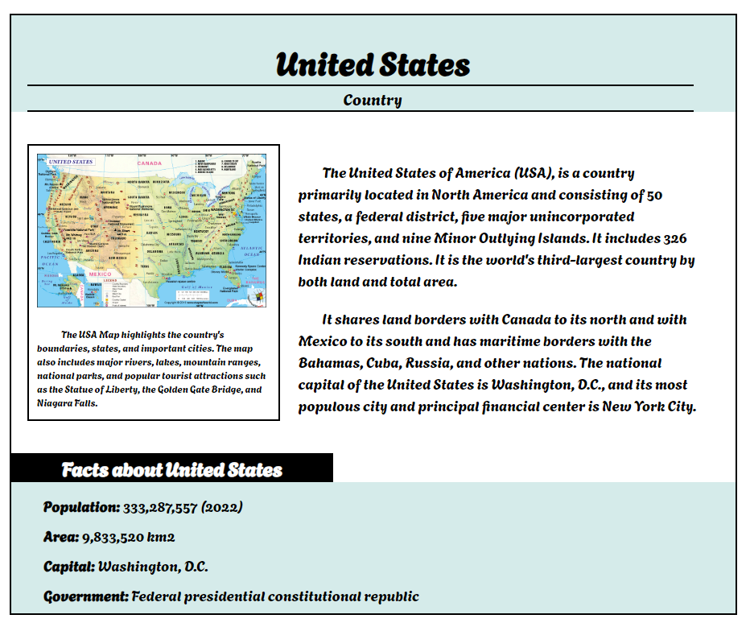

Output
The output should be valid HTML5 + CSS3 + images that implement the above web page.

Constraints
- Use font Agbalumo for the text - "https://fonts.googleapis.com/css2?family=Agbalumo&display=swap"
- The site should open correctly in the latest version of Chrome.
- Create your HTML file at the same level as the folder "images" and use the images provided in this folder. Delete the folder "images" before submitting your solutions.

