Lab: Arrays
Problems for in-class lab for the "C# Fundamentals" course @ SoftUni
You can check your solutions in Judge

Day of Week
Enter a day number [1…7] and print the name (in English) or "Invalid day!"

Examples
Input | Output
1 | Monday
2 | Wednesday
10 | Invalid day!

Print Numbers in Reverse Order
Read n numbers and print them in reverse order.

Examples
Input | Output
3  10  20  30 | 30 20 10
3  30  20  10 | 10 20 30
1  10 | 10

Hints
First, we need to read n from the console.
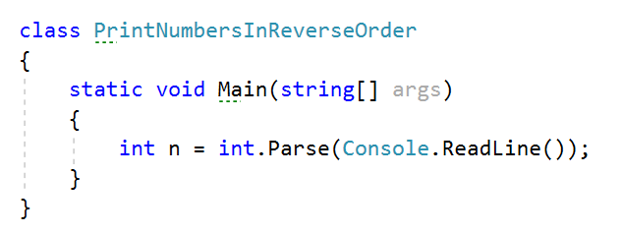
Create an array of integer with n size.
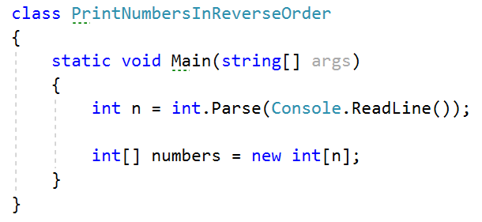
Read n numbers using for loop.
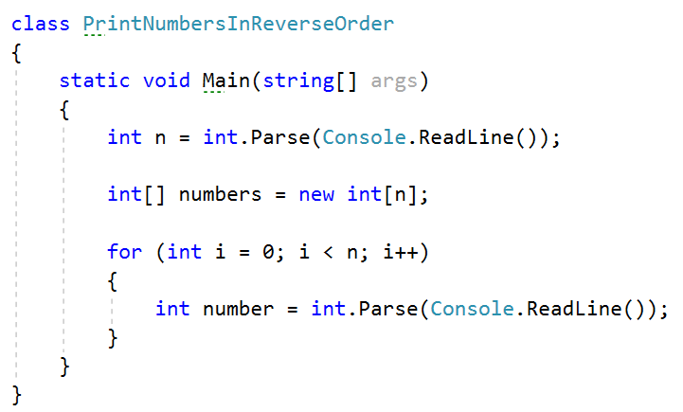
Set number to the corresponding index.
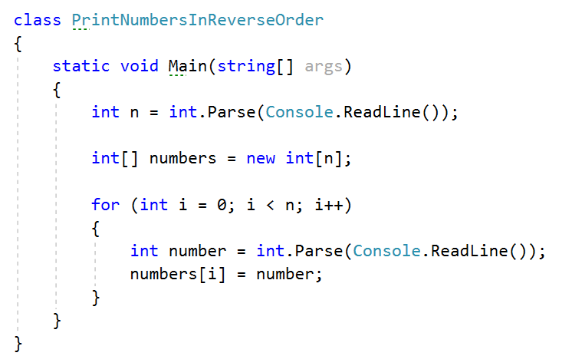
Print the array in reversed order.
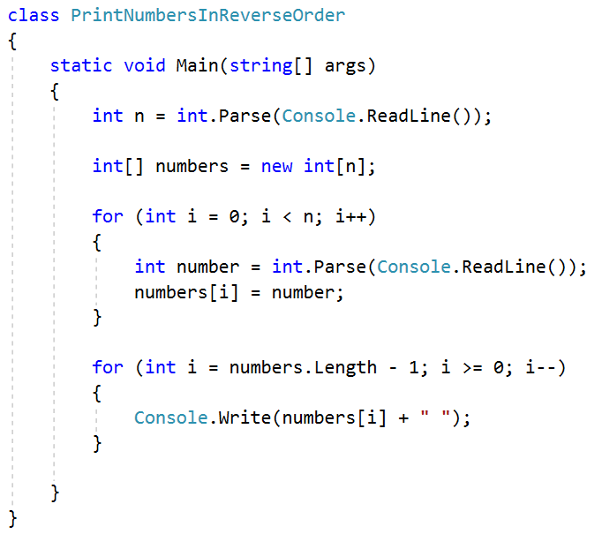

Rounding Numbers
Read an array of real numbers (space separated), round them in "away from 0" style and print the output as in the examples:

Examples
Input | Output
0.9 1.5 2.4 2.5 3.14 | 0.9 => 1  1.5 => 2  2.4 => 2  2.5 => 3  3.14 => 3
-5.01 -1.599 -2.5 -1.50 0 | -5.01 => -5  -1.599 => -2  -2.5 => -3  -1.50 => -2  0 => 0

Reverse Array of Strings
Read an array of strings (space separated values), reverse it and print its elements:

Examples
Input | Output
a b c d e | e d c b a
-1 hi ho w | w ho hi -1

Sum Even Numbers
Read an array from the console and sum only the even numbers.

Examples
Input | Output
1 2 3 4 5 6 | 12
3 5 7 9 | 0
2 4 6 8 10 | 30

Hints
First, we need to read the array.
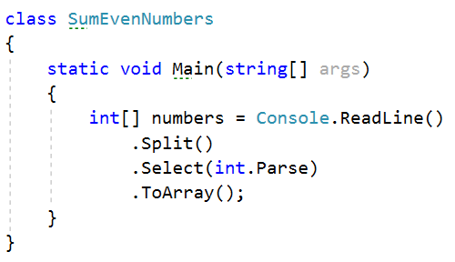
We will need a variable for the sum.
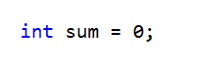
Iterate through all elements in the array with for loop.
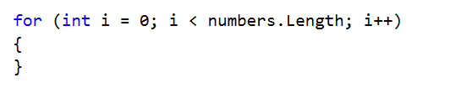
Check if the number at current index is even.
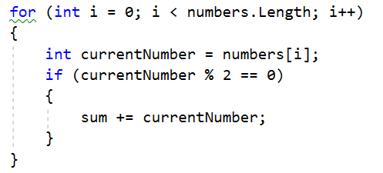
Print the total sum
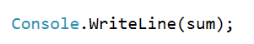

Even and Odd Subtraction
Write a program that calculates the difference between the sum of the even and the sum of the odd numbers in an array.

Examples
Input | Output | Comments
1 2 3 4 5 6 | 3 | Even: 2 + 4 + 6 = 12  Odd: 1 + 3 + 5 = 9  Result: 12 – 9 = 3
3 5 7 9 | -24 | Even: 0  Odd: 3 + 5 + 7 + 9 = 24  Result: 0 – 24 = -24
2 4 6 8 10 | 30 | Even: 2 + 4 + 6 + 8 + 10 = 30  Odd: 0  Result: 30 – 0 = 30

Hints
First, we need to read the array.
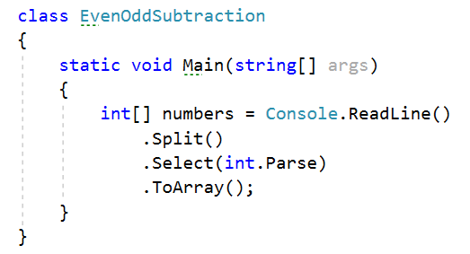
We will need two variables – even and odd sum.
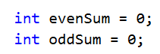
Iterate through all elements in the array with for loop.

Check the current number – if it is even add it to the even sum, otherwise add It to the odd sum.
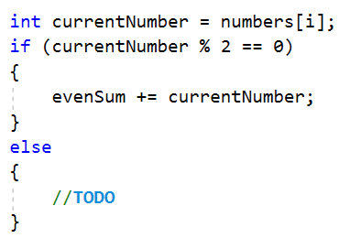
Print the difference.
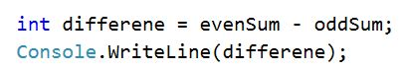

Equal Arrays
Read two arrays and print on the console whether they are identical or not. Arrays are identical if their elements are equal. If the arrays are identical find the sum of the first one and print on the console following message: "Arrays are identical. Sum: {sum}", otherwise find the first index where the arrays differ and print on the console following message: "Arrays are not identical. Found difference at {index} index".

Examples
Input | Output
10 20 30  10 20 30 | Arrays are identical. Sum: 60
1 2 3 4 5  1 2 4 3 5 | Arrays are not identical. Found difference at 2 index
1  10 | Arrays are not identical. Found difference at 0 index

Hints
First, we need to read two arrays.
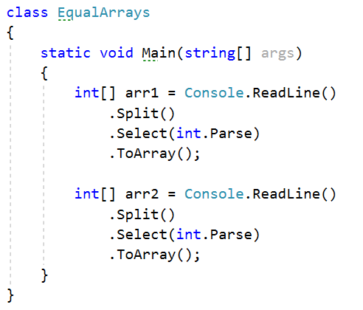
Iterate through arrays and compare element. If the elements are not equal print the required message and break the loop.

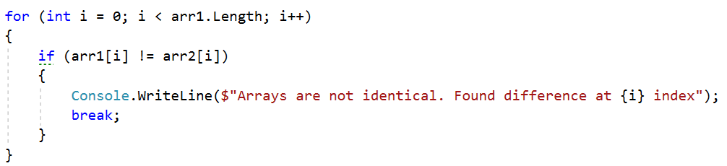
Think about how to solve the other part of the problem.

Condense Array to Number
Write a program to read an array of integers and condense them by summing adjacent couples of elements until a single integer is obtained. For example, if we have 3 elements {2, 10, 3}, we sum the first two and the second two elements and obtain {2+10, 10+3} = {12, 13}, then we sum again all adjacent elements and obtain {12+13} = {25}.

Examples
Input | Output | Comments
2 10 3 | 25 | 2 10 3 2+10 10+3 12 13 12 + 13 25
5 0 4 1 2 | 35 | 5 0 4 1 2 5+0 0+4 4+1 1+2 5 4 5 3 5+4 4+5 5+3 9 9 8 9+9 9+8 18 17 18+17 35
1 | 1 | 1 is already condensed to number

Hints
While we have more than one element in the array nums[], repeat the following:
- Allocate a new array condensed[] of size nums.Length-1.
- Sum the numbers from nums[] to condensed[]:
  - condensed[i] = nums[i] + nums[i+1]
- nums[] = condensed[]
The process is illustrated below:
