Lab: Lists
Problems for in-class lab for the "C# Fundamentals" course @ SoftUni
You can check your solutions in Judge

Sum Adjacent Equal Numbers
Write a program to sum all adjacent equal numbers in a list of decimal numbers, starting from left to right.
- After two numbers are summed, the obtained result could be equal to some of its neighbors and should be summed as well (see the examples below).
- Always sum the leftmost two equal neighbors (if several couples of equal neighbors are available).

Examples
Input | Output | Explanation
3 3 6 1 | 12 1 | 3 3 6 1 6 6 1 12 1
8 2 2 4 8 16 | 16 8 16 | 8 2 2 4 8 16 8 4 4 8 16 8 8 8 16 16 8 16
5 4 2 1 1 4 | 5 8 4 | 5 4 2 1 1 4 5 4 2 2 4 5 4 4 4 5 8 4

Solution
Read a list of numbers.
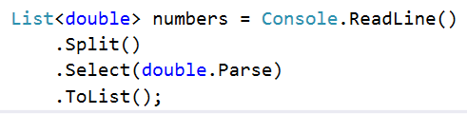
Iterate through the elements. Check if the number at the current index is equal to the next number. If it is, aggregate the numbers and reset the loop, otherwise don't do anything.
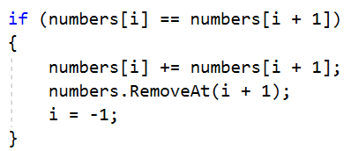
Finally, you have to print the numbers joined by a single space.

Gauss' Trick
Write a program that sums all of the numbers in a list in the following order:
first + last, first + 1 + last - 1, first + 2 + last - 2, … first + n, last - n.

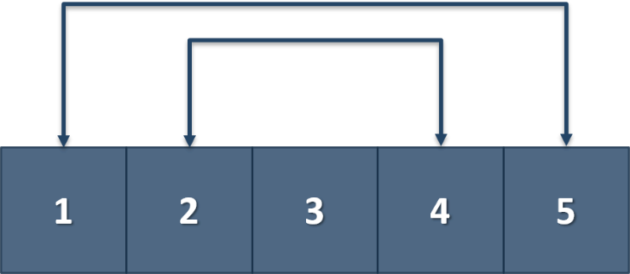

Example
Input | Output
1 2 3 4 5 | 6 6 3
1 2 3 4 | 5 5

Merging Lists
You are going to receive two lists with numbers. Create a result list, which contains the numbers from both of the lists. The first element should be from the first list, the second from the second list and so on. If the length of the two lists are not equal, just add the remaining elements at the end of the list.

Example
Input | Output
3 5 2 43 12 3 54 10 23  76 5 34 2 4 12 | 3 76 5 5 2 34 43 2 12 4 3 12 54 10 23
76 5 34 2 4 12  3 5 2 43 12 3 54 10 23 | 76 3 5 5 34 2 2 43 4 12 12 3 54 10 23

Hint
- Read the two lists
- Create a result list
- Start looping through them until you reach the end of the smallest one
- Finally add the remaining elements (if there are any) to the end of the list

List of Products
Read a number n and n lines of products. Print a numbered list of all the products ordered by name.

Examples
Input | Output
4  Potatoes  Tomatoes  Onions  Apples | 1.Apples  2.Onions  3.Potatoes  4.Tomatoes

Solution
First, we need to read the number n from the console.
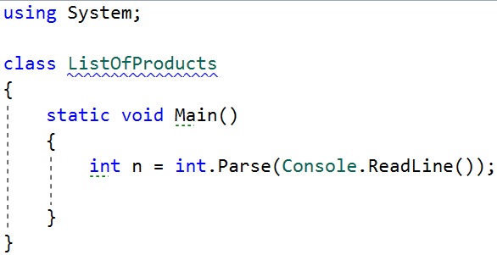
Then we need to create our list of strings, because the products are strings.
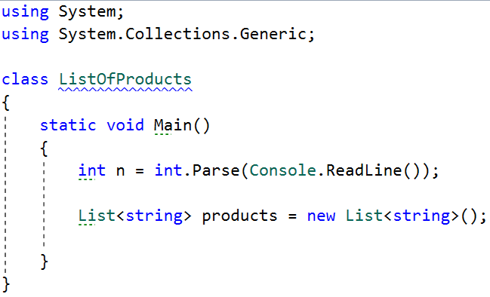
Then we need to iterate n times and read our current product.
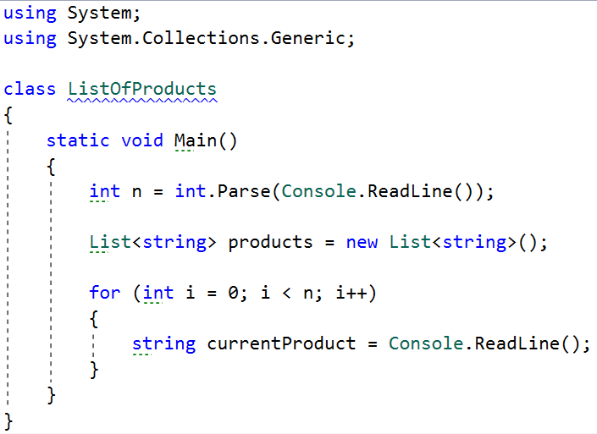
The next step is to add the current product to the list.
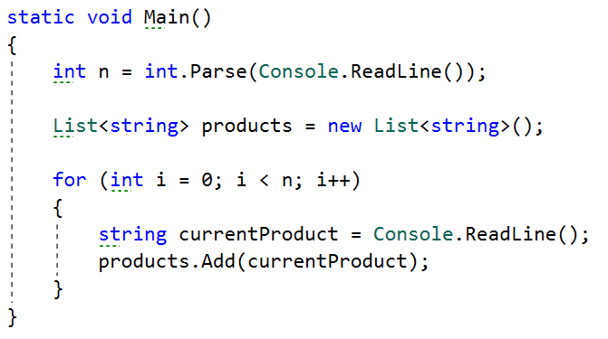
After we finish reading the products, we sort our list alphabetically.
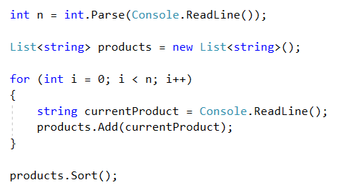
- The sort method sorts the list in ascending order.
Finally, we have to print our sorted list. To do that we loop through the list.
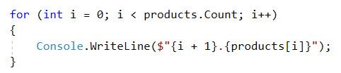
- We use i + 1, because we want to start counting from 1, we put the '.', and finally we put the actual product.

Remove Negatives and Reverse
Read a list of integers, remove all negative numbers from it and print the remaining elements in reversed order. In case there are no elements left in the list, print "empty".

Examples
Input | Output
10 -5 7 9 -33 50 | 50 9 7 10
7 -2 -10 1 | 1 7
-1 -2 -3 | empty

Solution
Read a list of integers.
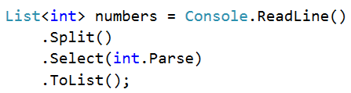
Remove all negative numbers.
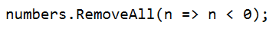
If the list count is equal to 0 print "empty", otherwise print all numbers joined by space.
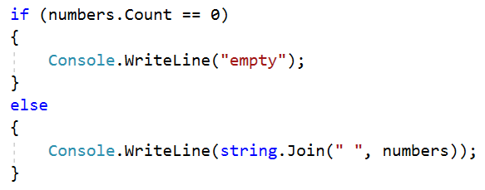

List Manipulation Basics
Write a program that reads a list of integers. Then until you receive "end", you will receive different commands:
Add {number}: add a number to the end of the list.
Remove {number}: remove a number from the list.
RemoveAt {index}: remove a number at a given index.
Insert {number} {index}: insert a number at a given index.
Note: All the indices will be valid!
When you receive the "end" command, print the final state of the list (separated by spaces).

Example
Input | Output
4 19 2 53 6 43  Add 3  Remove 2  RemoveAt 1  Insert 8 3  end | 4 53 6 8 43 3

Solution
First let us read the list from the console.
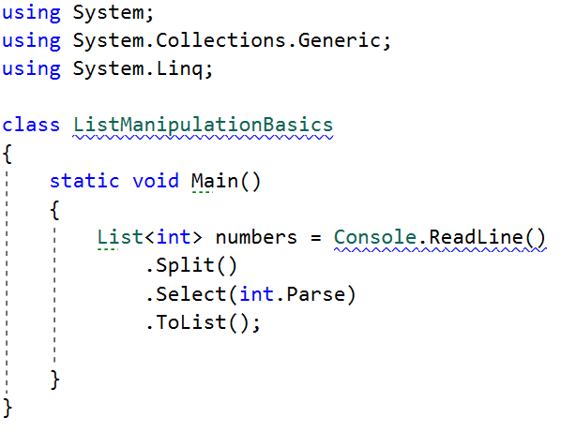
- We split the string we have received from the console, then we loop through each of the elements and parse them to integers.
- This returns IEnumarable<int> (a collection of integers) and we have to keep it in the form of a list.
Next, we go through the input using a while loop and a switch case statement for the different commands.
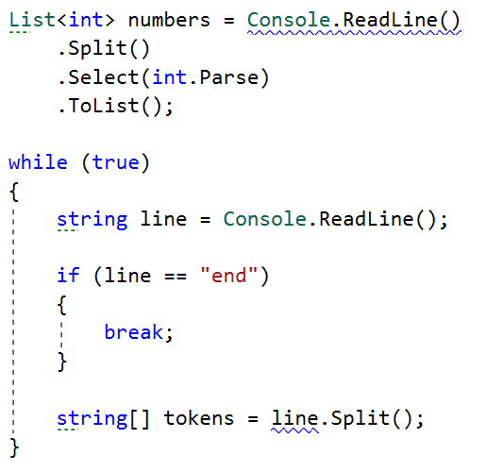
- We stop the cycle if the line is end, otherwise we split the input string into tokens.

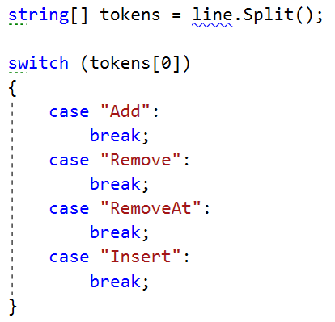
Now, let us implement each of the commands.
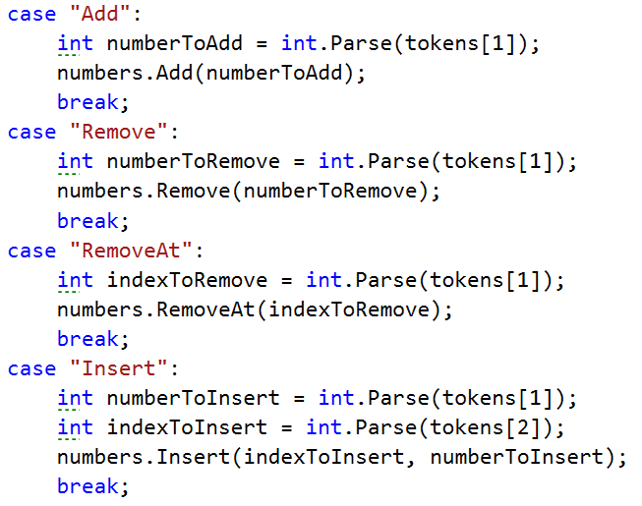
- For each of the commands, except "Insert", tokens[1] is the number/index.
- For the "Insert" command we receive a number and an index (tokens[1], tokens[2]).
Finally, we print the numbers, joined by a single space.

List Manipulation Advanced
Next, we are going to implement more complicated list commands, extending the previous task. Again, read a list and keep reading commands until you receive "end":
Contains {number} – check if the list contains the number and if so - print "Yes", otherwise print "No such number".
PrintEven – print all the even numbers, separated by a space.
PrintOdd – print all the odd numbers, separated by a space.
GetSum – print the sum of all the numbers.
Filter {condition} {number} – print all the numbers that fulfill the given condition. The condition will be either '<', '>', ">=", "<=".
After the end command, print the list only if you have made some changes to the original list. Changes are made only from the commands from the previous task.

Example
Input | Output
2 13 43 876 342 23 543  Contains 100  Contains 543  PrintEven  PrintOdd  GetSum  Filter >= 43  Filter < 100  end | No such number  Yes  2 876 342  13 43 23 543  1842  43 876 342 543  2 13 43 23

