Database First
Model the existing database by using the Database First approach.
First create a new empty .NET Core Console Application and after it is created open the Package Manager Console
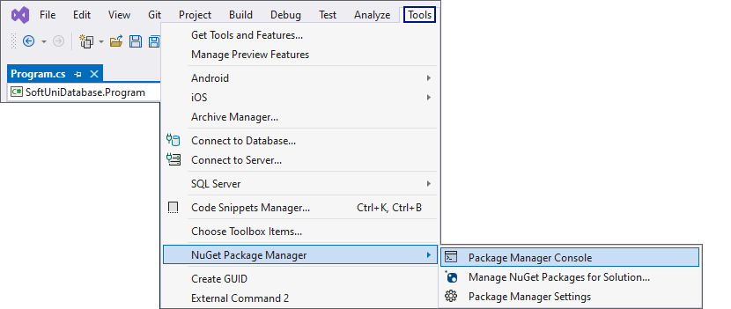
It will look something like this:
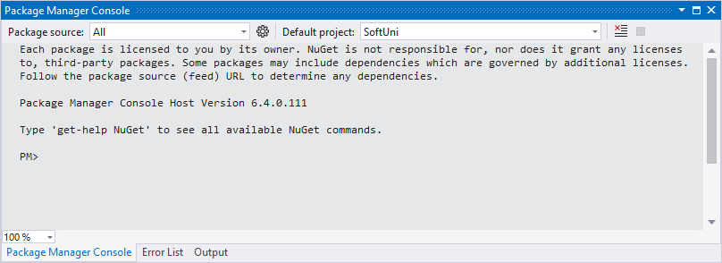
Use it to run the following commands one by one:
Install-Package Microsoft.EntityFrameworkCore.Tools –v 6.0.1
Install-Package Microsoft.EntityFrameworkCore.SqlServer –v 6.0.1
Install-Package Microsoft.EntityFrameworkCore.Design -v 6.0.1
These are the packages you will need, in order to scaffold our SoftUniContext from the SoftUni database.
NOTE: If Package Manager Console gives you any errors while trying to execute the above commands, try using the following ones:
Install-Package Microsoft.EntityFrameworkCore.Tools –Version 6.0.1
Install-Package Microsoft.EntityFrameworkCore.SqlServer –Version 6.0.1
Install-Package Microsoft.EntityFrameworkCore.Design -Version 6.0.1
NOTE: For the next steps you will need public Program class and a static void Main() method.
Next, we must execute the command to scaffold our context class. It will consist of 4 things:
- First, the name of the command:
Scaffold-DbContext
- Second, the connection we will be using (our connection string):
-Connection "Server=<ServerName>;Database=<DatabaseName>;Integrated Security=True;"
For ServerName, use the name of your local MS SQL Server instance or ".".
For DatabaseName, use the name of the database you want to use, in this case – SoftUni.
- Third, we need to declare our service provider, we'll be using Microsoft.EntityFrameworkCore.SqlServer:
-Provider Microsoft.EntityFrameworkCore.SqlServer
- And the fourth thing we'll do, is to give it a directory where all of our models will go (e.g. Models):
-OutputDir Data/Models
Our final command will look like this:
Scaffold-DbContext -Connection "Server=.;Database=SoftUni;Integrated Security=True;" -Provider Microsoft.EntityFrameworkCore.SqlServer -OutputDir Data/Models
Execute the whole command on a single line.
NOTE: You should write only one '\' in the connection string. Otherwise, an InvalidOperationException: Instance failure will be thrown.
Entity Framework Core has successfully mapped the database schema to C# classes. Use the Solution Explorer in Visual Studio to move the SoftUniContext class out of Models into the Data folder and move the Models folder out of the Data folder into the project's directory. Press OK on both of the pop-up windows that will be shown.
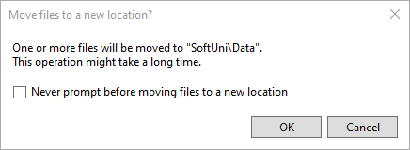
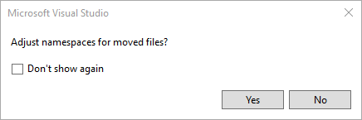
This way Visual Studio will also rename the classes everywhere they're used.
However, sometimes Entity Framework Core isn't good enough with names – all classes may have been pluralized. If this is your case, just rename all of our classes properly. Use right-click → Rename or the F2 shortcut and press OK on this pop-up window after renaming each class:
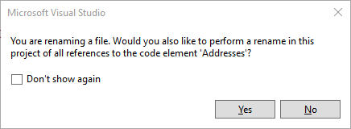
The final result should look like this:
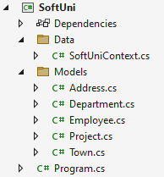
Don't forget to check the SoftUniContext's namespace after moving it and to add a reference to the Models and Data namespaces:
Make sure that your namespaces are exactly the same as these:
SoftUni
SoftUni.Data
SoftUni.Models
Finally, we want to clean up the packages we won't be using anymore from the package manager GUI or by running these commands one by one:
Uninstall-Package Microsoft.EntityFrameworkCore.Tools -r
Uninstall-Package Microsoft.EntityFrameworkCore.Design -RemoveDependencies

