Lab: Syntax, Functions and Statements
Problems for in-class lab for the "JavaScript Advanced" course @ SoftUni. Submit your solutions in the SoftUni judge system at https://judge.softuni.bg/Contests/2749/Syntax-Functions-and-Statements-Lab

Echo Function
Write a JS function that takes one string parameter and prints on two lines the length of the parameter and then the unchanged parameter itself.

Examples
Input | Output
'Hello, JavaScript!' | 18  Hello, JavaScript!
'strings are easy' | 16  strings are easy

Hints
- Write a function that receives a single parameter.
- Use the console.log function to print text on the console. Each call prints a newline automatically.
- The string’s length property is used to determine how many characters are in a given string

String Length
Write a JS function that takes three string arguments as an input. Calculate the sum of the length of the strings and the average length of the strings rounded down to the nearest integer.
The input comes as three string arguments passed to your function.
The output should be printed on the console in two lines.

Examples
Input | Output
'chocolate', 'ice cream', 'cake' | 22  7
'pasta', '5', '22.3' | 10  3

Hints
- Write a function that receives three string arguments.
- Declare two variables named sumLength and averageLength that will keep the mathematical results.
- Calculate the length of the strings using the length property.

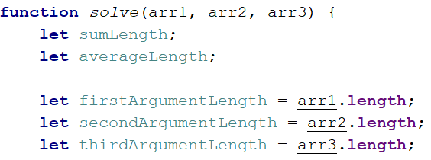
- Calculate the sum of the three lengths.
- Calculate the average length of the strings rounded down to the nearest integer. Use the Math.floor() function.
- Print the results on the console.
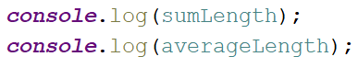

Largest Number
Write a function that takes three number arguments as input and finds the largest of them. Print the following text on the console: `The largest number is {number}.`.
The input comes as three number arguments passed to your function.
The output should be printed to the console.

Example
Input | Output
5, -3, 16 | The largest number is 16.
-3, -5, -22.5 | The largest number is -3.

Hints
- Write a function that receives three number arguments.
- Declare a variable named result that will keep the result.
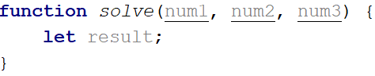
- Make several checks to find out the largest of the three numbers. Start with num1.
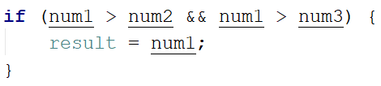
- Do the same for the others.
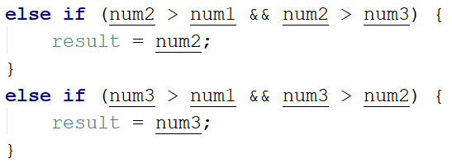
- Print the result on the console.

Circle Area
Write a function that takes a single argument as an input. Check the type of input argument. If it is a number, assume it is the radius of a circle and calculate the circle area. Print the area rounded to two decimal places.
If the argument type is NOT a number, print the following text on the console:
`We can not calculate the circle area, because we receive a {type of argument}.`
The input comes as a single argument passed to your function.
The output should be printed on the console.

Example
Input | Output
5 | 78.54
'name' | We can not calculate the circle area, because we receive a string.

Hints
- Write a function that receives a single argument.
- Declare a variable named result that will keep your result.
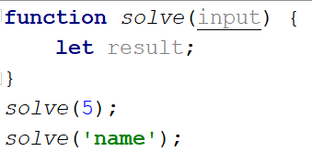
- Check the type of the input argument with the typeof operator.
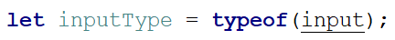
- If the type is equal to 'number', calculate the circle area and print it on the console rounded to two decimal places. To do this, use the method toFixed().
The Math.pow() function returns the base to the exponent power, that is, base exponent. You can find more information about the area here:
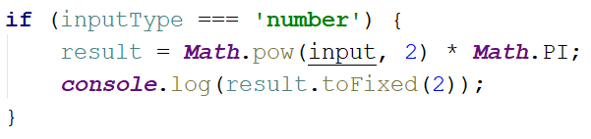
- If the type is NOT a 'number', print the following text on the console:
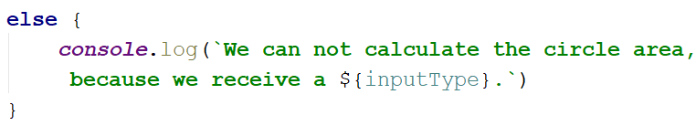

Math Operations
Write a JS function that takes two numbers and a string as an input.

The string may be one of the following: '+', '-', '*', '/', '%', '**'.

Print on the console the result of the mathematical operation between both numbers and the operator you receive as a string.
The input comes as two numbers and a string argument passed to your function.
The output should be printed on the console.

Examples
Input | Output
5, 6, '+' | 11
3, 5.5, '*' | 16.5

Hints
- Write a function which receives three arguments:
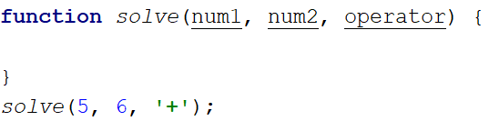
- Declare a variable named result that will keep your mathematical result.
- Write down the switch command that will take the string from your input and depending on it, perform the mathematical logic between the two numbers.

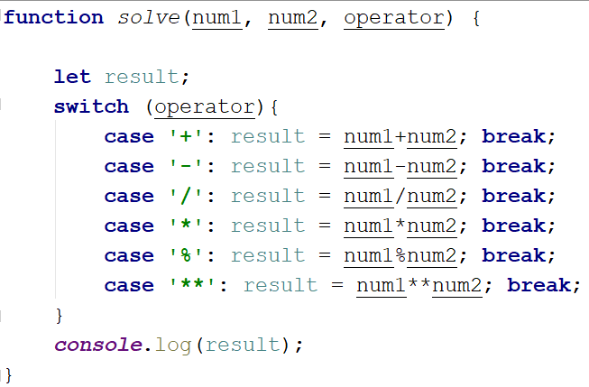
- Print the result on the console.
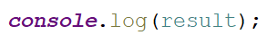

Sum of Numbers N…M
Write a JS function that takes two numbers n and m as an input and prints the sum of all numbers from n to m.
The input comes as two string elements that need to be parsed as numbers.
The output should return the sum.

Examples
Input | Output
'1', '5' | 15
'-8', '20' | 174

Hints
- Write a function that receives two string arguments and parse them as numbers. Use Number(string) function to parse the input.
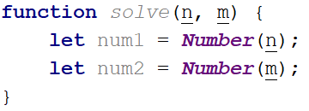
- Declare a variable named result that will keep the mathematical results.
- Write a for loop from num1 to num2 and every turn of the cycle, until it’s completed, add the current value.
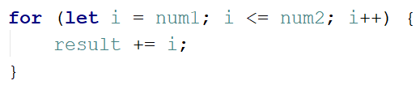
- Finally, return the result.
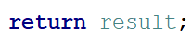

Day of Week
Write a function that prints a number between 1 and 7 when a day of the week is passed to it as a string and an error message if the string is not recognized.
The input comes as a single-string argument.
The output should be returned as a result.

Examples
Input | Output
'Monday' | 1
'Friday' | 5
'Invalid' | error

Days in a month
Write a JavaScript function to get the number of days in a month.
The input comes as two numeric parameters. The first element is the month, the second is the year.
The output must return the number of days in a month for a given year.

Examples
Input | Output
1, 2012 | 31
2, 2021 | 28

Hints
- Use Date()

Square of Stars
Write a function that prints a rectangle made of stars with variable size, depending on an input parameter. If there is no parameter specified, the rectangle should always be of size 5. Look at the examples to get an idea.
The input comes as a single number argument.
The output is a series of lines printed on the console, forming a rectangle of variable size.

Examples
Input | Output |  | Input | Output |  | Input | Output |  | Input | Output
1 | * |  | 2 | * *  * * |  | 5 | * * * * *  * * * * *  * * * * *  * * * * *  * * * * * |  | 7 | * * * * * * *  * * * * * * *  * * * * * * *  * * * * * * *  * * * * * * *  * * * * * * *  * * * * * * *

Aggregate Elements
Write a program that performs different operations on an array of elements. Implement the following operations:
- Sum(a_{i}) - calculates the sum of all elements from the input array
- Sum(1/a_{i}) - calculates the sum of the inverse values (1/a_{i}) of all elements from the array
- Concat(a_{i}) - concatenates the string representations of all elements from the array
The input comes as an array of number elements.
The output should be printed on the console on a new line for each of the operations.

Examples
Input | Output |  | Input | Output
[1, 2, 3] | 6  1.8333333333333333  123 |  | [2, 4, 8, 16] | 30  0.9375  24816

