Cocktail Party
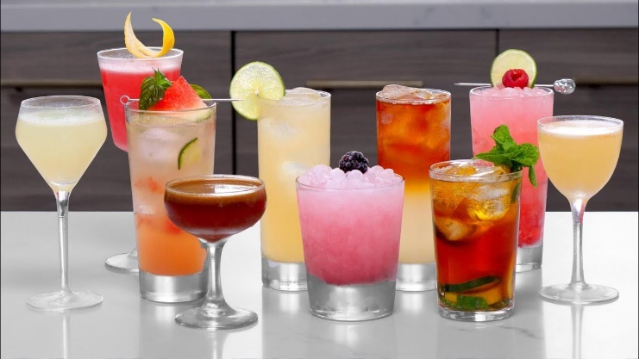

You and your friends can’t wait for the bars to open so you decide to get together for a cocktail party and try your skills as bartenders. You develop a program that ensures all cocktails recipes will meet your high standards.

Preparation
Download the skeleton provided in Judge. Do not change the StartUp class or its namespace.

Problem description
Your task is to create a cocktail which is made of different ingredients.

Ingredient
First, write a C# class, called Ingredient with properties:
- Name: string
- Alcohol: int
- Quantity: int
The constructor of Ingredient class should receive name, alcohol and quantity.
The class should also have the following methods:
- Override ToString() method in the format:
"Ingredient: {Name}
Quantity: {Quantity}
Alcohol: {Alcohol}"

Cocktail
Next step is to write Cocktail class that has a collection of type Ingredient with corresponding unique name of an Ingredient. The name of the collection should be Ingredients. All the entities of the Ingredients collection have the same properties. The Cocktail has also some additional properties:
- Name: string
- Capacity: int - the maximum allowed number of ingredients in the cocktail
- MaxAlcoholLevel: int - the maximum allowed amount of alcohol in the cocktail
The constructor of the Cocktail class should receive name, capacity and maxAlcoholLevel.
Implement the coming features:
- Method Add(Ingredient ingredient) - adds the entity if there isn't an Ingredient with the same name and if there is enough space in terms of quantity and alcohol.
- Method Remove(string name) - removes an Ingredient from the cocktail with the given name, if such exists and returns bool if the deletion is successful.
- Method FindIngredient(string name) - returns an Ingredient with the given name. If it doesn't exist, return null.
- Method GetMostAlcoholicIngredient() – returns the Ingredient with most Alcohol.
- Getter CurrentAlcoholLevel – returns the amount of alcohol currently in the cocktail.
- Method Report() - returns information about the Cocktail and the Ingredients inside it in the following format:
"Cocktail: {name} - Current Alcohol Level: {CurrentAlcoholLevel}
{Ingredient₁}
{Ingredient₂}
… "

Constraints
- The name of each Ingredient in the pool will always be unique
- Each Ingredient will have different number of Alcohol
- The Alcohol of an Ingredient and the MaxAlcoholLevel of the Cocktail will always be positive numbers
- You will always be given Ingredient added before receiving method for its manipulation

Examples
Sample code usage
//Sample Code Usage:

//Initialize Cocktail
Cocktail cocktail = new Cocktail("Pina Colada", 3, 10);

//Initialize Ingredient
Ingredient rum = new Ingredient("Rum", 2, 3);

//Print rum
Console.WriteLine(rum.ToString());

//Ingredient: Rum
//Quantity: 3
//Alcohol: 2

//Add rum
cocktail.Add(rum);

//Remove rum
Console.WriteLine(cocktail.Remove("Rum")); // true

Ingredient vodka = new Ingredient("Vodka", 2, 5);
Ingredient milk = new Ingredient("Milk", 0, 5);

//Add ingredients
cocktail.Add(vodka);
cocktail.Add(milk);

//GetMostAlcoholicIngredient
Console.WriteLine(cocktail.GetMostAlcoholicIngredient());
//Ingredient: Vodka
//Quantity: 5
//Alcohol: 2

//CurrentAlcoholLevel
Console.WriteLine(cocktail.CurrentAlcoholLevel);
//2

//Print Cocktail report
Console.WriteLine(cocktail.Report());

//Cocktail: Pina Colada - Current Alcohol Level: 2
//Ingredient: Vokda
//Quantity: 5
//Alcohol: 2
//Ingredient: Milk
//Quantity: 5
//Alcohol: 0

Submission
Zip all the files in the project folder except bin and obj folders.

