CSS Box Model and Typography – Exercise
Problems for exercises and homework for the "HTML and CSS" course @ SoftUni.

Topics Covered
Everything in CSS has a box around it, and understanding these boxes is key to being able to create more complex layouts with CSS, or to align items with other items. In this lesson, we will take a look at the CSS Box Model. You'll get an understanding of how it works and the terminology that relates to it.

Resources
- The Box Model
  - https://developer.mozilla.org/en-US/docs/Learn/CSS/Building_blocks/The_box_model
- Typography
  - https://developer.mozilla.org/en-US/docs/Learn/CSS/Styling_text/Fundamentals
- Position
  - https://developer.mozilla.org/en-US/docs/Learn/CSS/CSS_layout/Positioning

Box Model Visualised
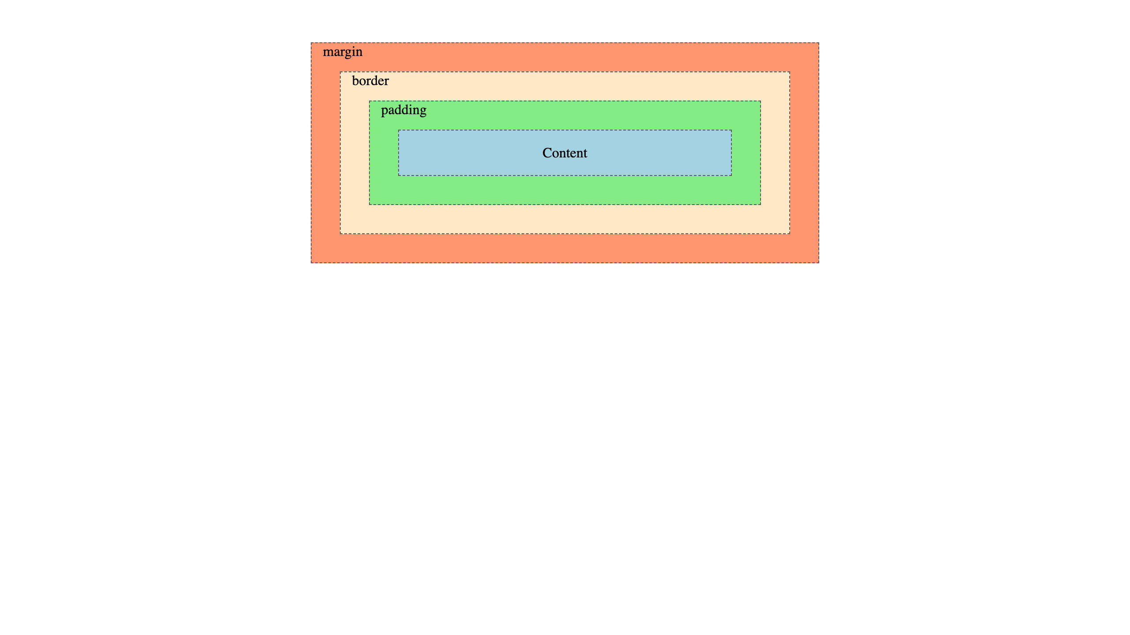
For full screenshot check the screenshot.png file in the folder for the task
Objective:
Create a webpage that looks like the screenshot above.

Requirements:
- File Setup:
  - Create an HTML document named box-model-visualised.html
  - Create a CSS file named box-model-visualised.css

Layout – Centered Container
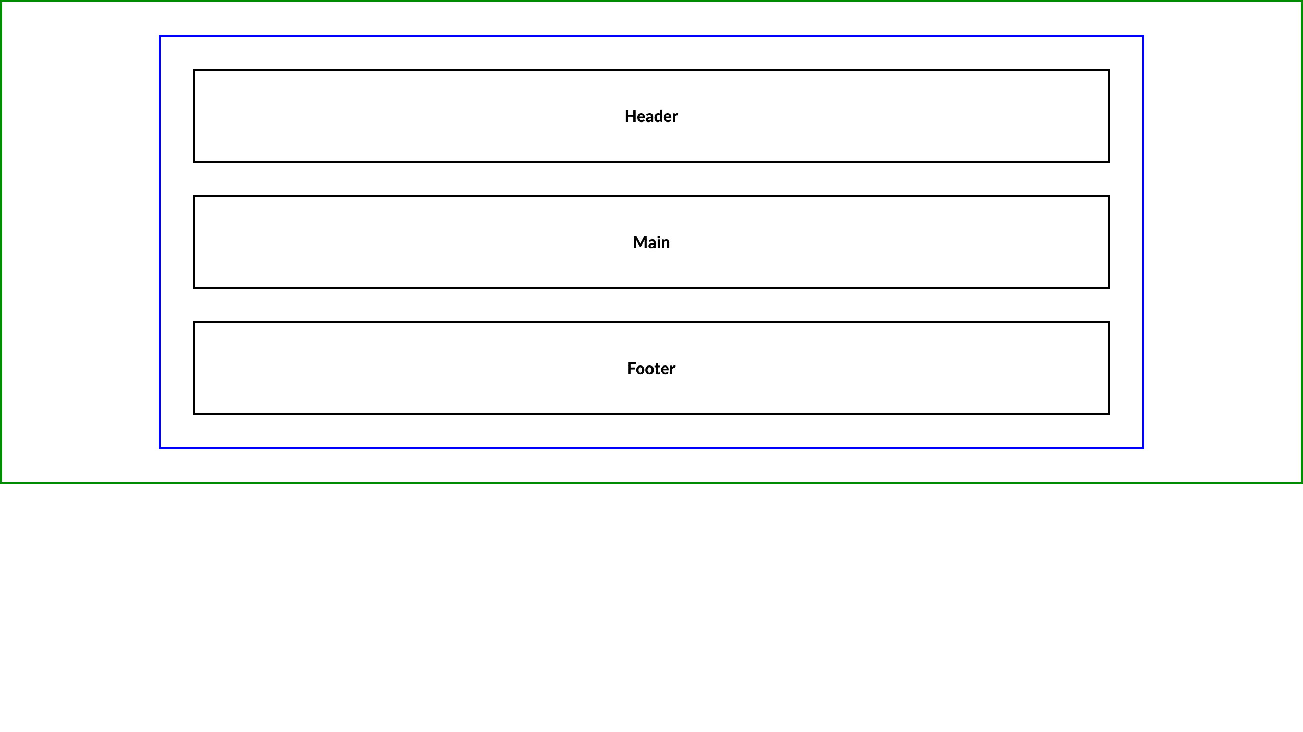
For full screenshot check the screenshot.png file in the folder for the task
Objective:
Create a webpage that looks like the screenshot above.

Requirements:
- File Setup:
  - Create an HTML document named layout-centered-container.html
  - Create a CSS file named layout-centered-container.css

Layout – Section and Wrapper
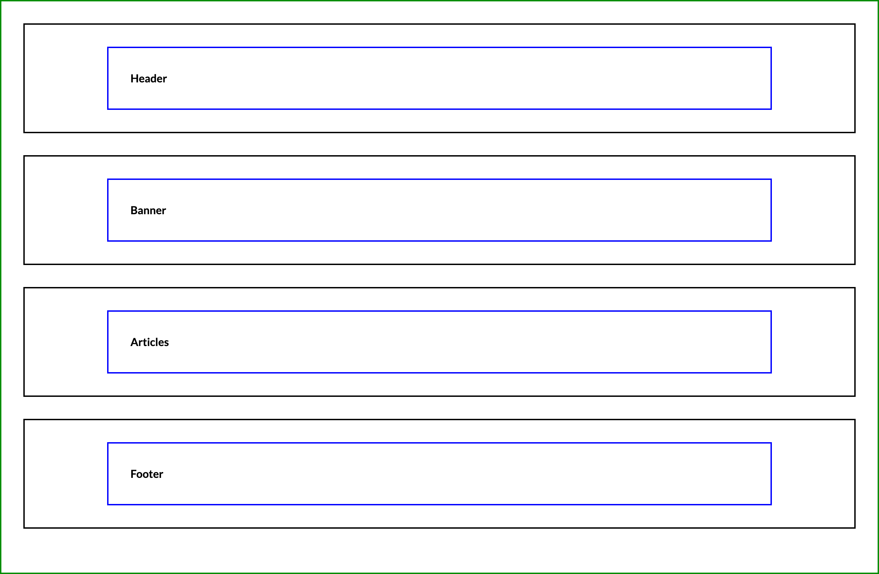
For full screenshot check the screenshot.png file in the folder for the task
Objective:
Create a webpage that looks like the screenshot above.

Requirements:
- File Setup:
  - Create an HTML document named layout-section-and-wrapper.html
  - Create a CSS file named layout-section-and-wrapper.css

Component: Card
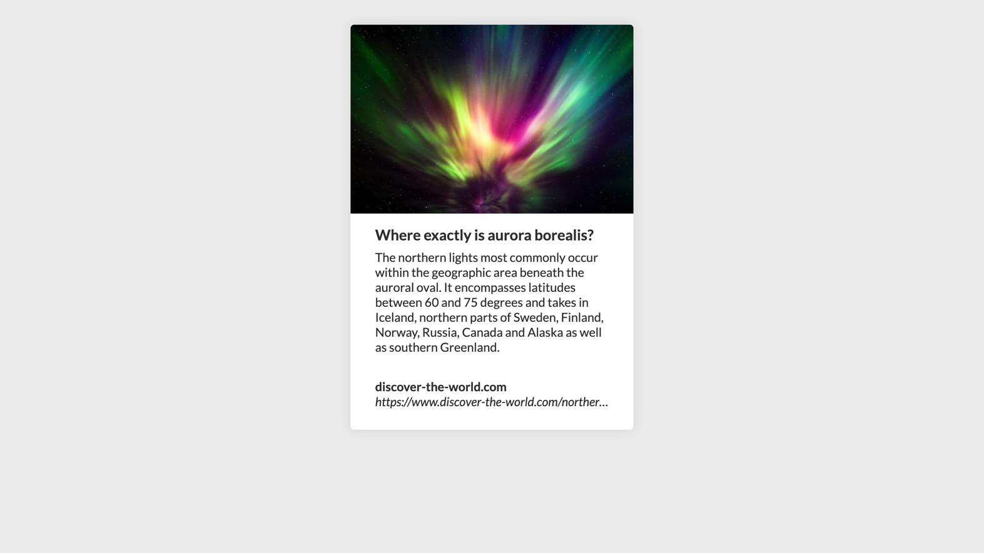
For full screenshot check the screenshot.png file in the folder for the task
Objective:
Create a webpage that looks like the screenshot above.

Requirements:
- File Setup:
  - Create an HTML document named component-card.html
  - Create a CSS file named component-card.css

Blog Post
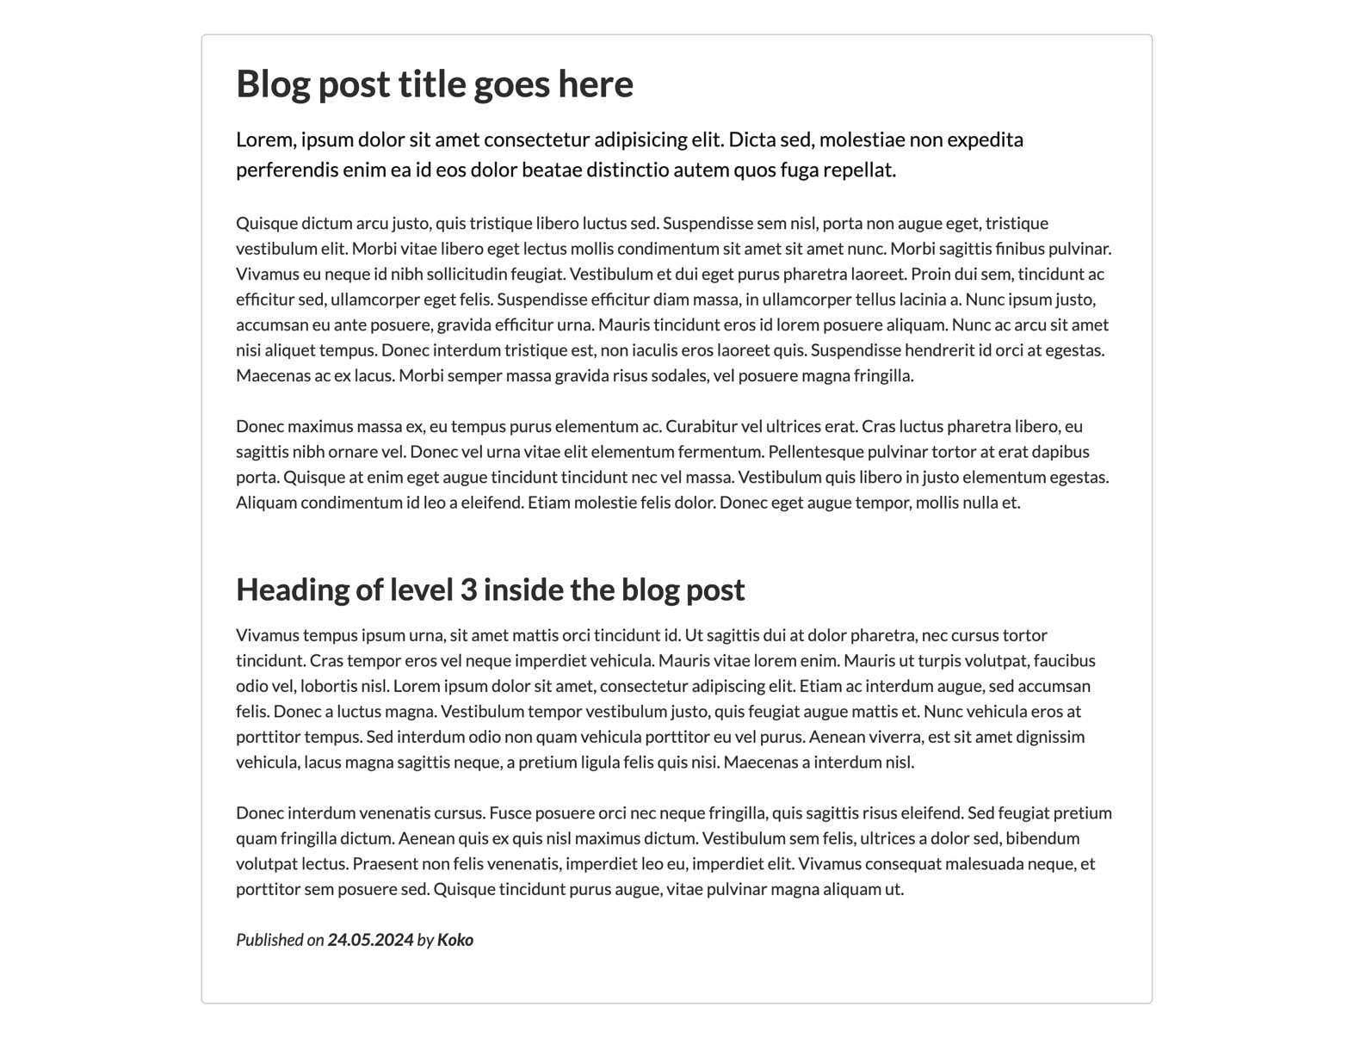
For full screenshot check the screenshot.png file in the folder for the task
Objective:
Create a webpage that looks like the screenshot above.

Requirements:
- File Setup:
  - Create an HTML document named blog-post.html
  - Create a CSS file named blog-post.css
  - Copy reset.css file from Lecture 3
  - Copy typography.css file from Lecture 3
- Tips
  - Override font family styling from typography css with Lato, sans-serif
  - Create a container element to center the layout and set max-width

Component: Accordion
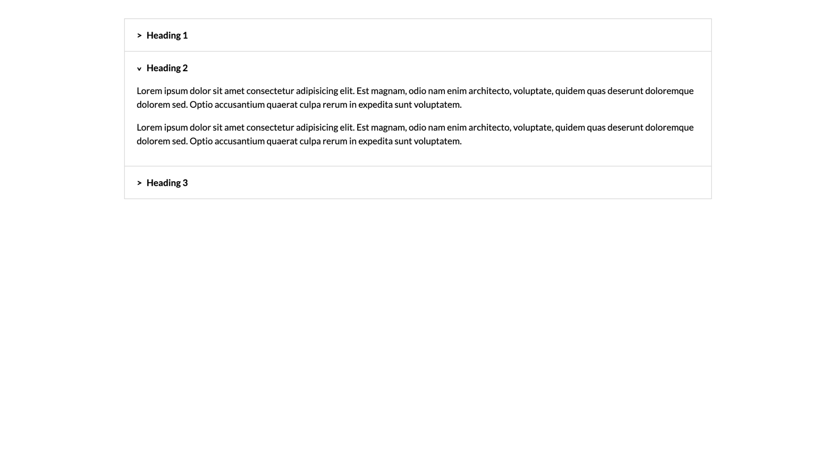
For full screenshot check the screenshot.png file in the folder for the task
Objective:
Create a webpage that looks like the screenshot above.

Requirements:
- File Setup:
  - Create an HTML document named component-accordion.html
  - Create a CSS file named component-accordion.css
- Tips
  - Use details and summary elements to achieve the open/close effect

Social Media Icons

For full screenshot check the screenshot.png file in the folder for the task
Objective:
Create a webpage that looks like the screenshot above.

Requirements:
- File Setup:
  - Create an HTML document named social-media-icons.html
  - Create a CSS file named social-media-icons.css
  - Include Font Awesome by using the following link:
    - https://cdnjs.cloudflare.com/ajax/libs/font-awesome/6.4.2/css/all.min.css

Component: Button
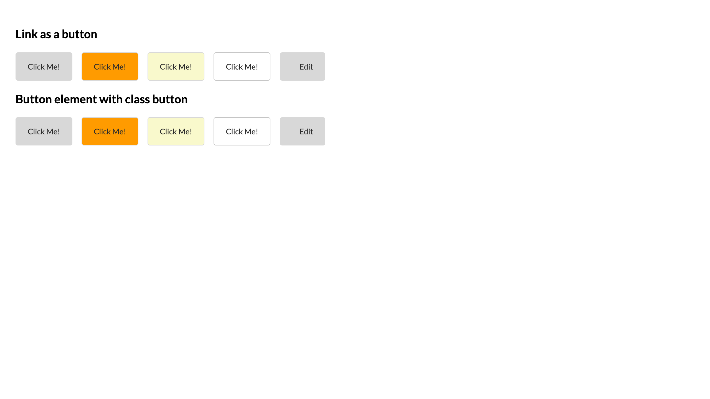
For full screenshot check the screenshot.png file in the folder for the task
Objective:
Create a webpage that looks like the screenshot above.

Requirements:
- File Setup:
  - Create an HTML document named component-button.html
  - Create a CSS file named component-button.css

  - Include Font Awesome by using the following link:
    - https://cdnjs.cloudflare.com/ajax/libs/font-awesome/6.4.2/css/all.min.css

Component: Banner
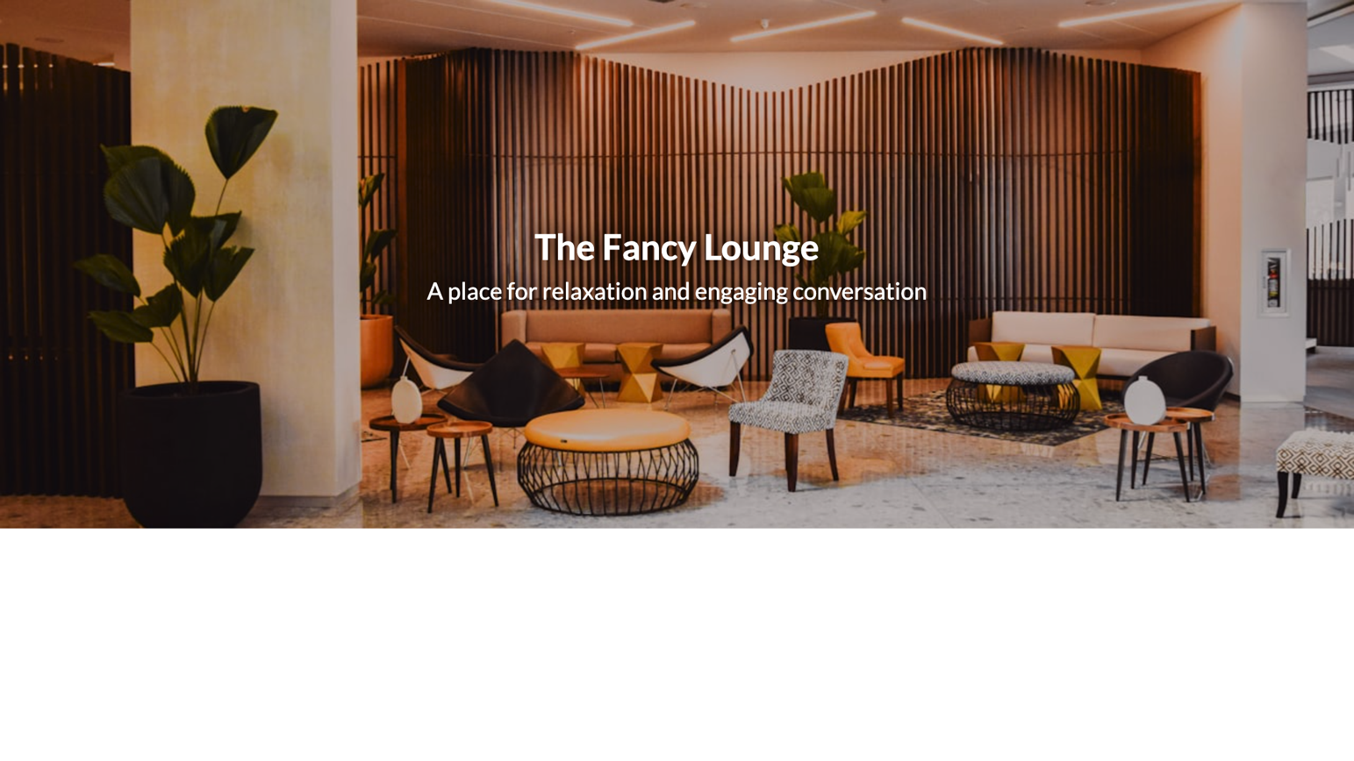
For full screenshot check the screenshot.png file in the folder for the task
Objective:
Create a webpage that looks like the screenshot above.

Requirements:
- File Setup:
  - Create an HTML document named component-banner.html
  - Create a CSS file named component-banner.css
- Tips
  - Use min-height to set height on the banner
  - Use background image on a section element that spans the entire width of the document
  - Use background-size and background-position to place the image in the center and make sure it will always fill its container
  - Use position absolute for the header text section to place it in the center of the banner

