Chillhop
Upload the solution, without images!
Create a Web page (HTML5 + CSS3) that looks like the screenshot below:
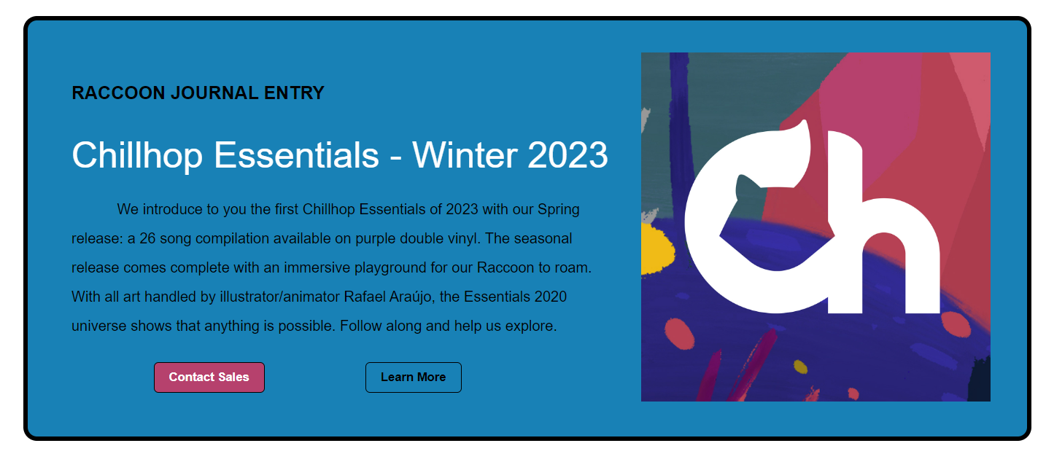

Output
The output should be valid HTML5 + CSS3 + images that implement the above web page.

Constraints
- Use font Helvetica, sans-serif for the text
- The site should open correctly in the latest version of Chrome

