Business
Upload the solution, without images!
Create a Web page (HTML5 + CSS3 + images) that looks and behaves like the screenshot below:
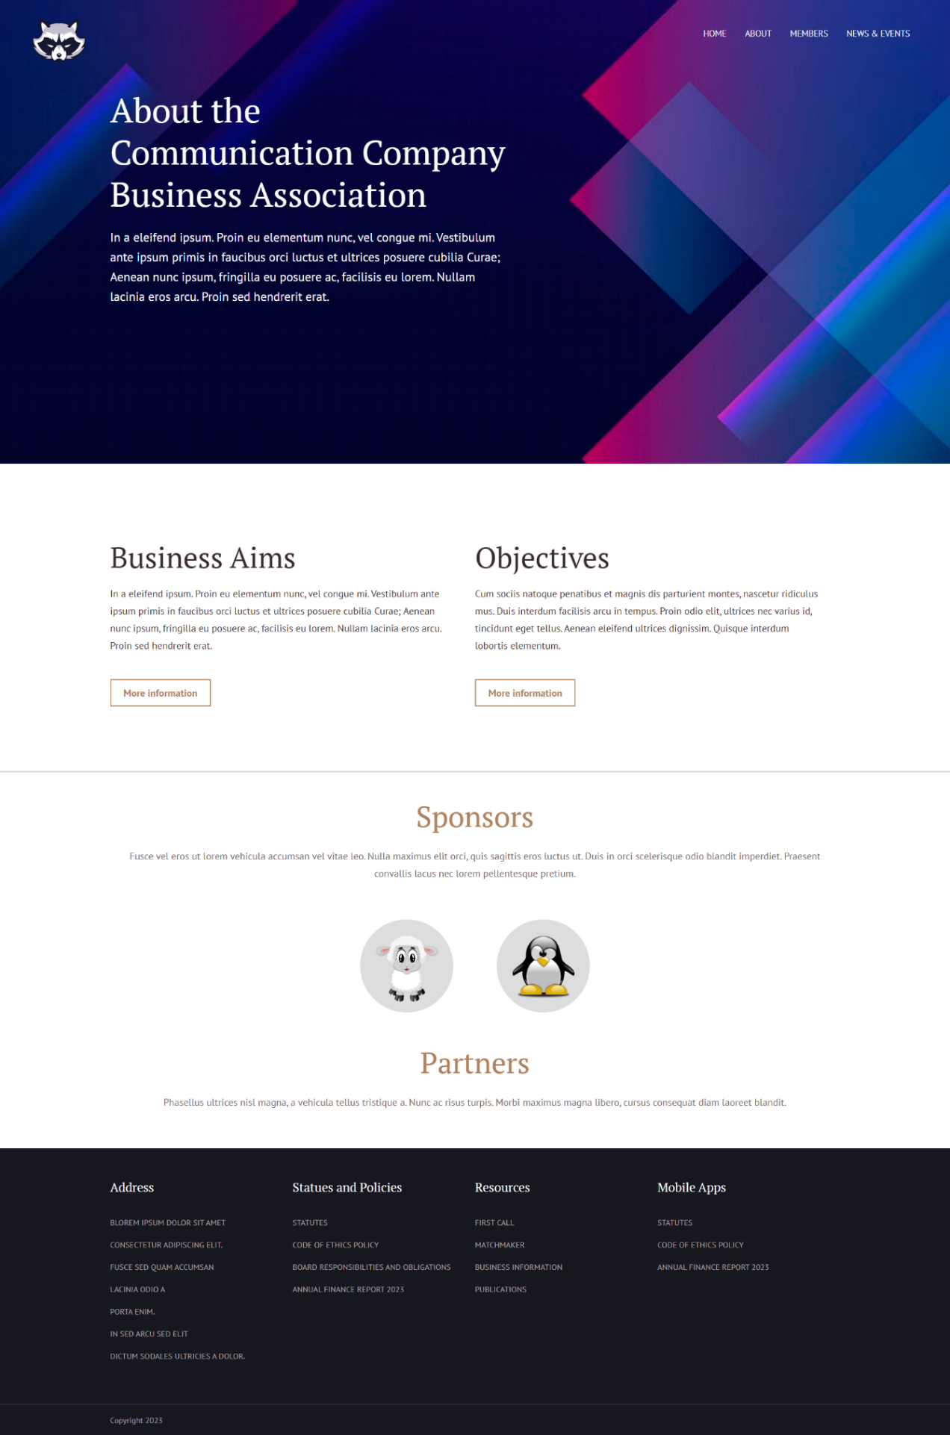
You are given the above screenshots + all required images.

Output
The output should be valid HTML5 + CSS3 + images that implement the above web page.

Constraints
- Use both fonts (PT Serif and PT Sans):
  - https://fonts.googleapis.com/css?family=PT+Serif
  - https://fonts.googleapis.com/css?family=PT+Sans:400,700
- The site should open correctly in the latest version of Chrome

