Working with Forms - Exercise
Problems for exercises and homework for the "HTML and CSS" course @ SoftUni.

Topics Covered
- Web forms are a very powerful tool for interacting with users — most commonly they are used for collecting data from users or allowing them to control a user interface.

Resources
- Web form building blocks
  - https://developer.mozilla.org/en-US/docs/Learn/Forms

Login

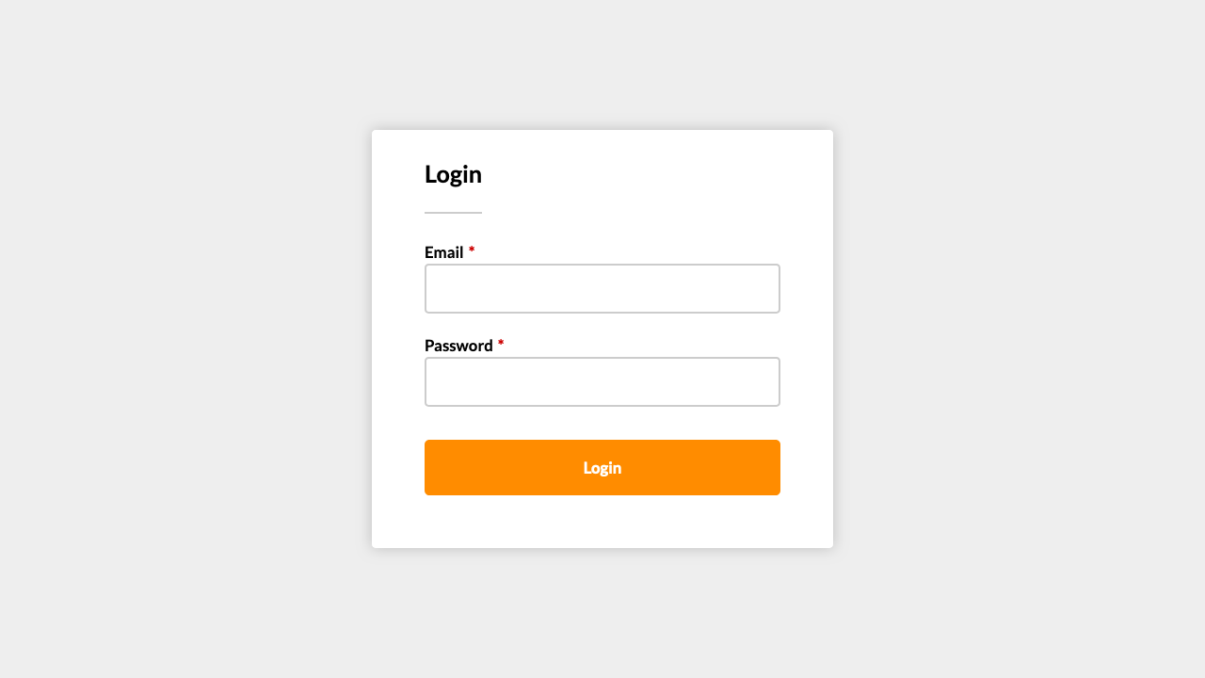
For full screenshot check the screenshot.png file in the folder for the task
Objective:
Create a webpage that looks like the screenshot above.

Requirements:
- File Setup:
  - Create an HTML document named login.html
  - Create a CSS file named login.css

Icons and State

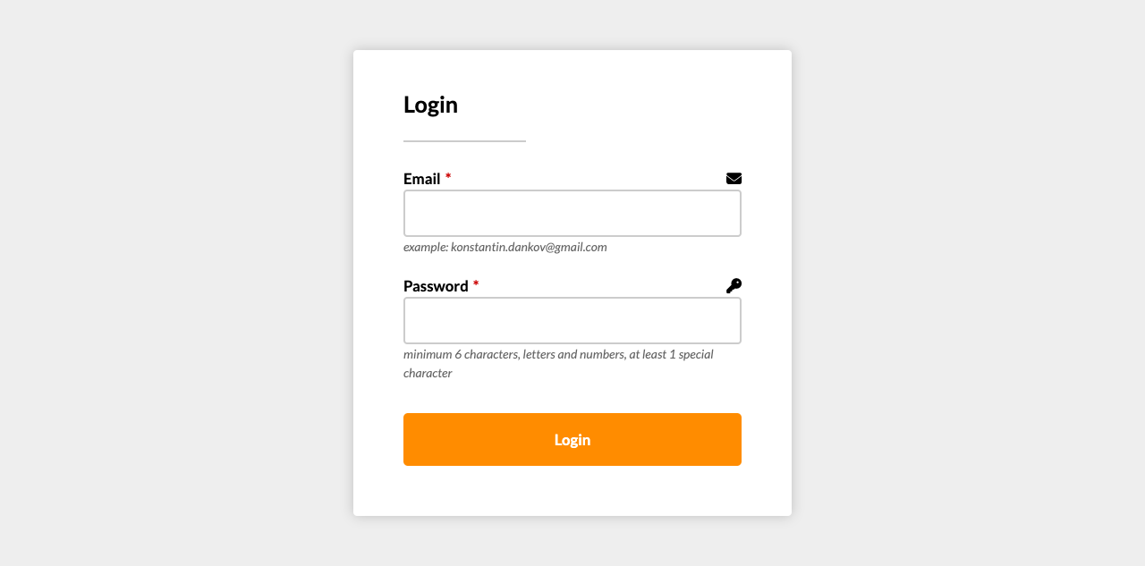
For full screenshot check the screenshot.png file in the folder for the task
Objective:
Create a webpage that looks like the screenshot above.

Requirements:
- File Setup:
  - Create an HTML document named icons-and-state.html
  - Create a CSS file named icons-and-state.css

Flexbox Responsive

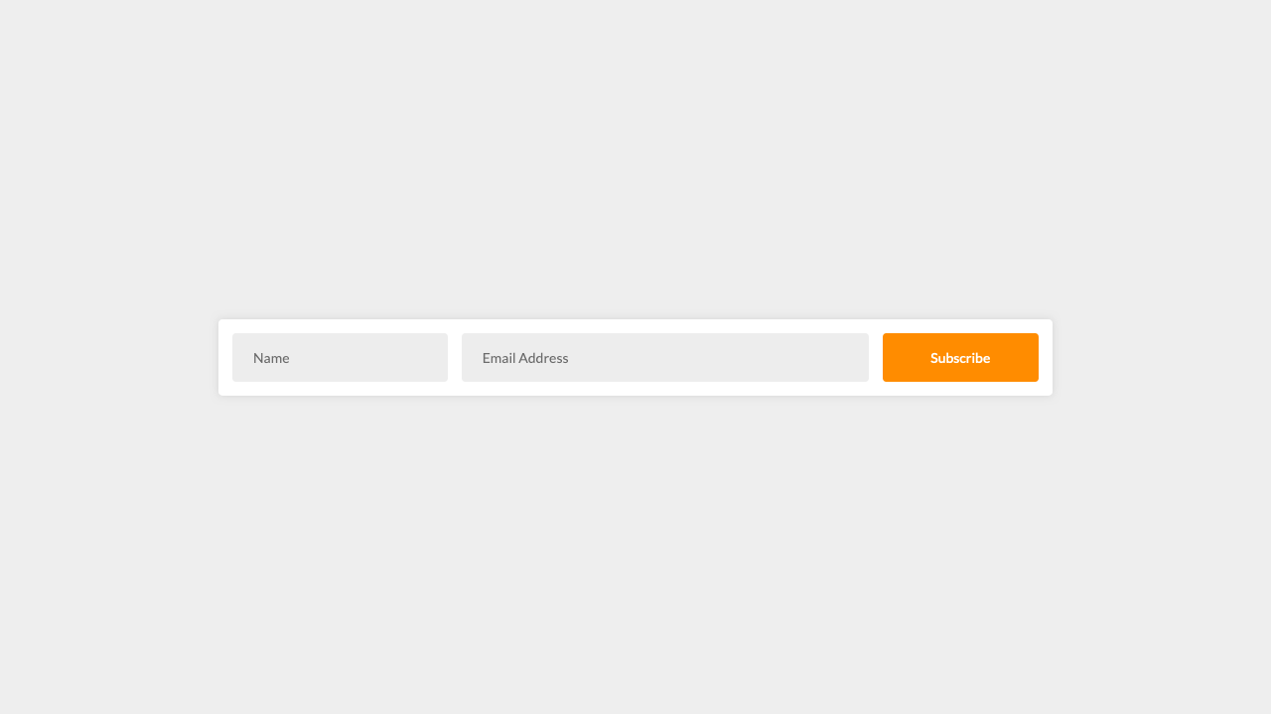
For full screenshot check the screenshot.png file in the folder for the task
Objective:
Create a webpage that looks like the screenshot above.

Requirements:
- File Setup:
  - Create an HTML document named flexbox-responsive.html
  - Create a CSS file named flexbox-responsive.css

Floating Labels

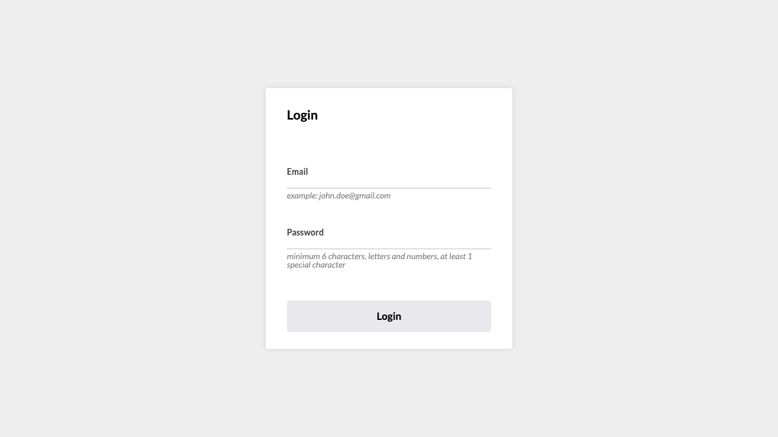
For full screenshot check the screenshot.png file in the folder for the task
Objective:
Create a webpage that looks like the screenshot above.

Requirements:
- File Setup:
  - Create an HTML document named floating-labels.html
  - Create a CSS file named floating-labels.css

Registration

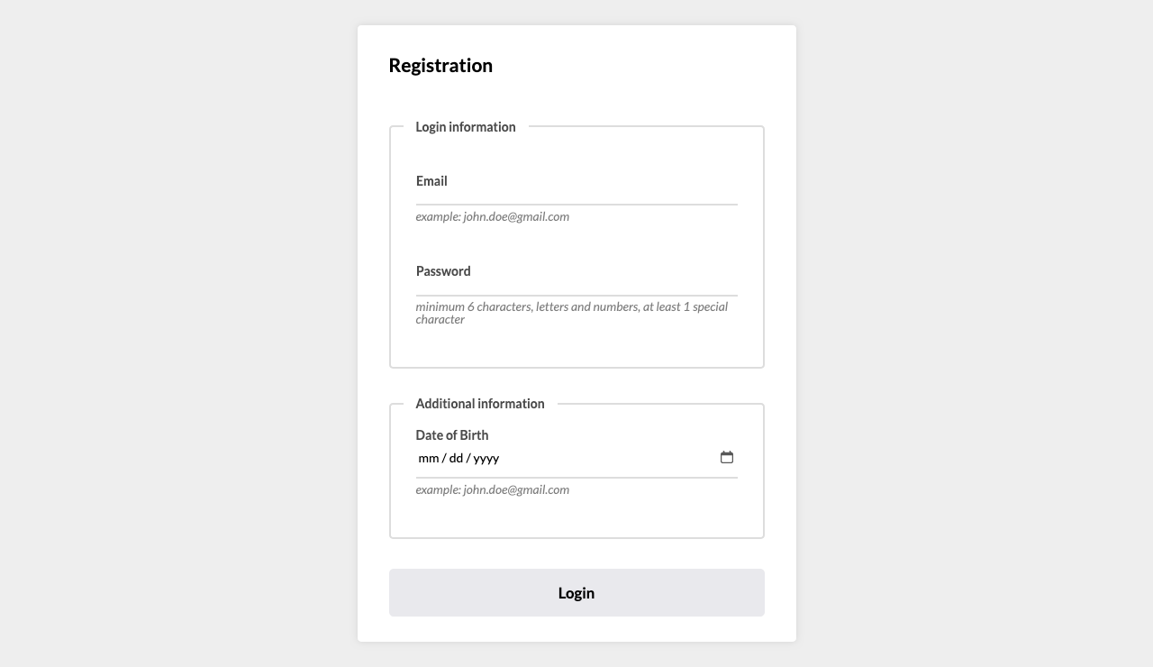
For full screenshot check the screenshot.png file in the folder for the task
Objective:
Create a webpage that looks like the screenshot above.

Requirements:
- File Setup:
  - Create an HTML document named registration.html
  - Create a CSS file named registration.css

Custom checkbox and radio

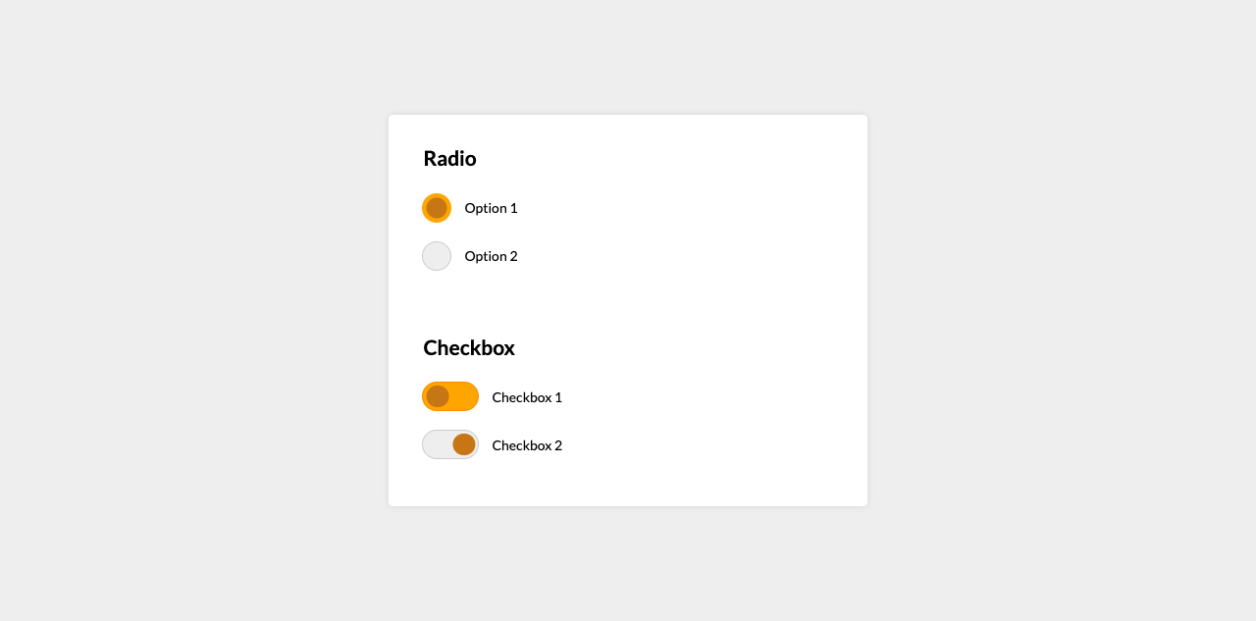
For full screenshot check the screenshot.png file in the folder for the task
Objective:
Create a webpage that looks like the screenshot above.

Requirements:
- File Setup:
  - Create an HTML document named custom-checkbox-and-radio.html
  - Create a CSS file named custom-checkbox-and-radio.css

Layout Horizontal Section – No wrapper

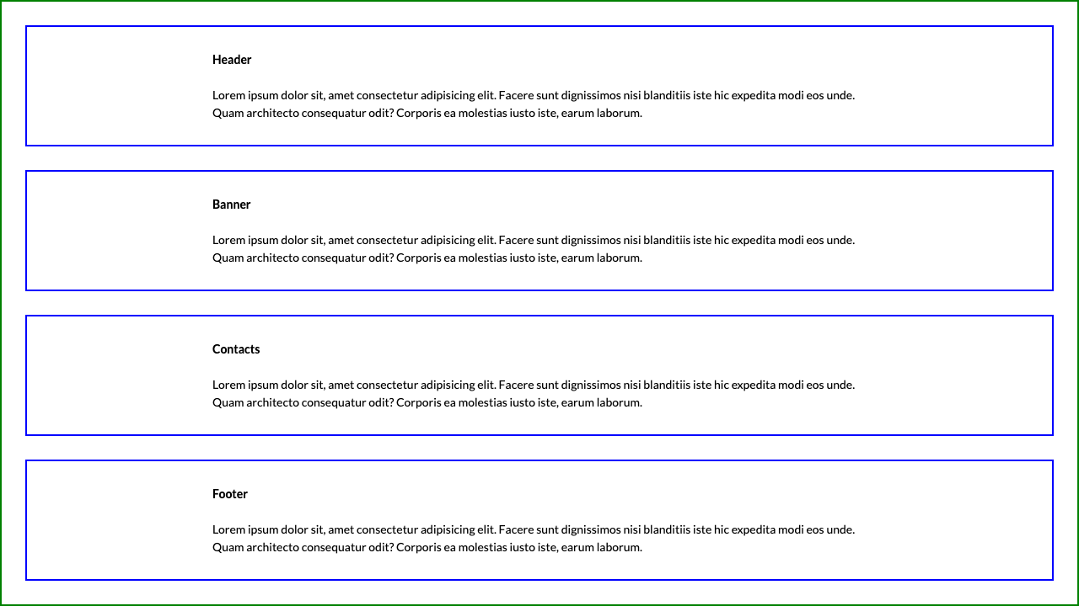
For full screenshot check the screenshot.png file in the folder for the task
Objective:
Create a webpage that looks like the screenshot above.

Requirements:
- File Setup:
  - Create an HTML document named layout-horizontal-section-no-wrapper.html
  - Create a CSS file named layout-horizontal-section-no-wrapper.css
- Styling
  - Do not use an additional HTML element to achieve the centering. Use padding, vw and calc() to get the same effect with only 1 element instead of two.

Contact form

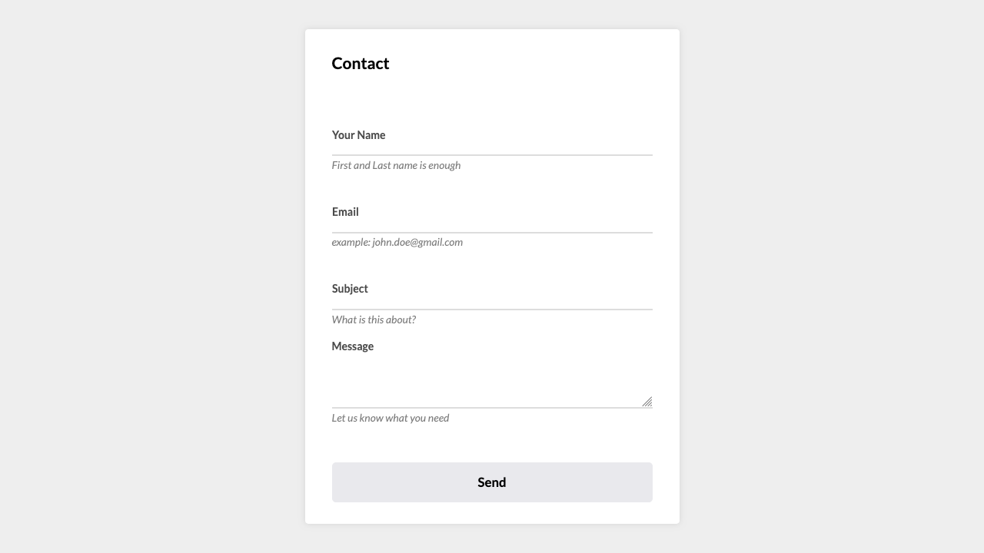
For full screenshot check the screenshot.png file in the folder for the task
Objective:
Create a webpage that looks like the screenshot above.

Requirements:
- File Setup:
  - Create an HTML document named contact.html
  - Create a CSS file named contact.css

