User’s Guide

# Introduction

This property development and management system is a platform the organization will use for the development, repair and renovations of clients’ properties.

The system effectively improves the management of their services, company-client relationship and the company’s daily activities, it is also designed to help the company to cut cost on any waste possibilities and in return it will maximize company’s profits

# The System (Describing the system)

The key features for this system is to:

* allow an administrator or a manager to login into the system using the correct username and password assigned to them.
* Subscribe clients to company’s services, log their requested jobs and select the right staff for the job in demand. Service cost may vary and it depends on the services wanted by the customer and a date will be allocated for work to start.
* Records of all jobs will be on the system with the name of the client and it will illustrate if the work is completed or on going.
* Employees can be added, edited and deleted to the system, and on the employees tab their personal details and skills will be displayed
* Suppliers can be added, edited and deleted on this system and dropdown list of all suppliers used by the company is automatically added on the system for future use.
* list of items ordered by the company from suppliers will also be on the system for reuse, i.e. (raw materials).

# Installing, Starting and Stopping the System

Process of installing, starting, stopping and suspending the system. This will take in consideration the first time users and expert users.

# Step by Step Instructions for using the system

This include the instructions on how to use the system. In addition are the conventions, errors, malfunctions, emergencies and messages.

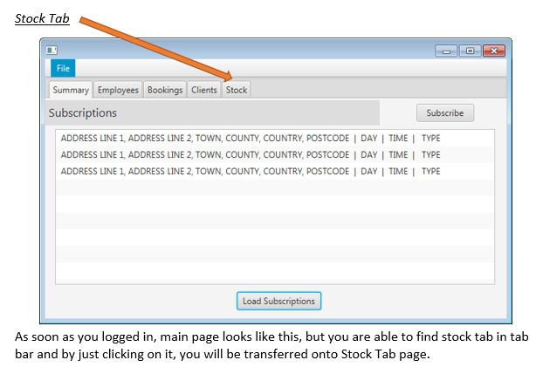

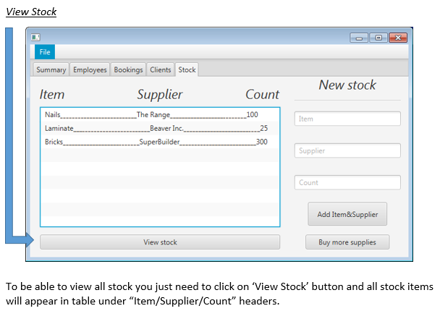

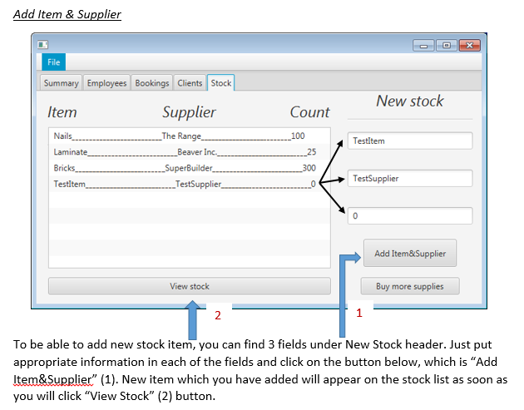 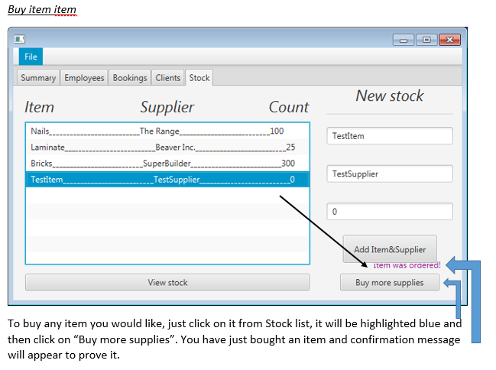

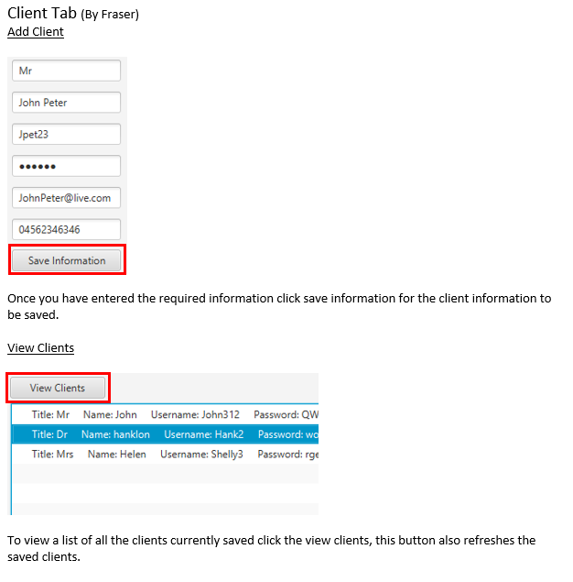

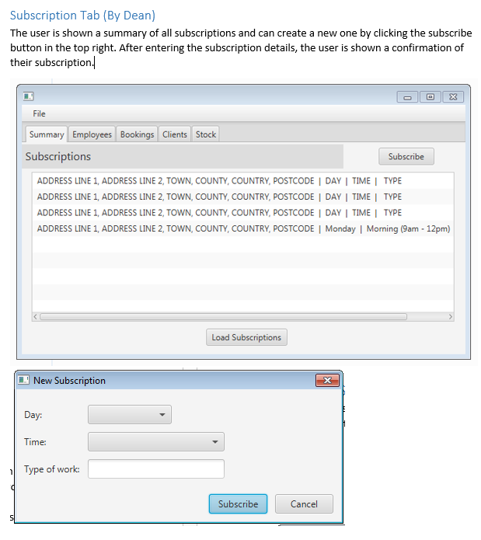

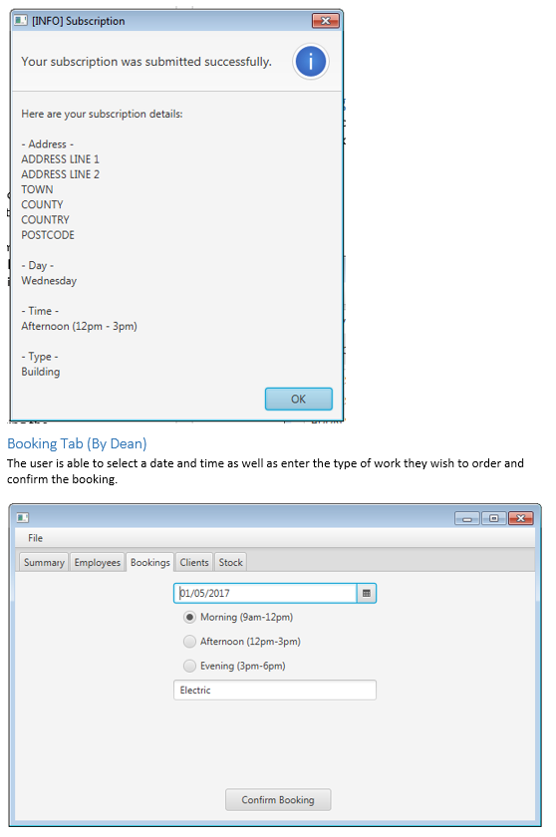

# References

Engineering Software systems case scenario 5

Trello board