PRINCE2™- Project Initiation Documentation

Project Name: | Use of Badging for Staff
Date: |  | Release: | Final
Author: | Team 1
Owner: | Team 1
Client: | Roger Emery, Head of Learning Technologies
Document Number: | 1.0

Note: This document is only valid on the day it was printed

Revision History
Date of next revision:
Revision Date | Previous Revision Date | Summary of Changes | Changes Marked
1.0 | n/a | Document created.

Approvals

This document requires the following approvals. A signed copy should be placed in the project files.
Name | Signature | Title | Date of Issue | Version

Distribution

This document has been distributed to:
Name | Title | Date of Issue | Version

Overview

Purpose | The purpose of the Project Initiation Documentation is to define the project, in order to form the basis for its management and an assessment of its overall success. The Project Initiation Documentation gives the direction and scope of the project and (along with the Stage Plan) forms the ‘contract’ between the Project Manager and the Project Board.  The three primary uses of the Project Initiation Documentation are to:  - Ensure that the project has a sound basis before asking the Project Board to make any major commitment to the project  - Act as a base document against which the Project Board and Project Manager can assess progress, issues and ongoing viability questions  - Provide a single source of reference about the project so that people joining the ‘temporary organization’ can quickly and easily find out what the project is about, and how it is being managed.  The Project Initiation Documentation is a living product in that it should always reflect the current status, plans and controls of the project. Its component products will need to be updated and re-baselined, as necessary, at the end of each stage, to reflect the current status of its constituent parts.  The version of the Project Initiation Documentation that was used to gain authorization for the project is preserved as the basis against which performance will later be assessed when closing the project.
Contents | The Project Initiation Documentation should cover the following topics.  Project Definition 4  Project Approach 5  Business Case 5  Project Management Team Structure 5  Role Descriptions 5  Quality Management Strategy 6  Configuration Management Strategy 6  Risk Management Strategy 6  Communication Management Strategy 6  Project Plan 6  Project Controls 7  Tailoring of PRINCE2 7
Advice | The Project Initiation Documentation is derived from the Project Brief and discussions with user, business and supplier stakeholders for input on methods, standards and controls.  The Project Initiation Documentation could be a single document; an index for a collection of documents; a document with cross references to a number of other documents; a collection of information in a project management tool.  The following quality criteria should be observed:  - The Project Initiation Documentation correctly represents the project  - It shows a viable, achievable project that is in line with corporate strategy or overall programme needs  - The project management team structure is complete, with names and titles. All the roles have been considered and are backed up by agreed role descriptions. The relationships and lines of authority are clear. If necessary, the project management team structure says to whom the Project Board reports  - It clearly shows a control, reporting and direction regime that can be implemented, appropriate to the scale, risk and importance of the project to corporate or programme management  - The controls cover the needs of the Project Board, Project Manager and Team Managers and satisfy any delegated assurance requirements  - It is clear who will administer each control  - The project objectives, approach and strategies are consistent with the organization’s corporate social responsibility directive, and the project controls are adequate to ensure that the project remains compliant with such a directive  - Consideration has been given to the format of the Project Initiation Documentation. For small projects a single document is appropriate.  For large projects it is more appropriate for the Project Initiation Documentation to be a collection of stand-alone documents. The volatility of each element of the Project Initiation Documentation should be used to assess whether it should be stand-alone, e.g. elements that are likely to change frequently are best separated out.

Project Definition

Our project is to innovate and institute an online system that allows a company to reward their employees via a badge-based system. It is our task to research the benefits and risks of this scheme, to verify the need for such a system, and to present these to our client within the parameters of the deadline.

Background

jason

Project objectives
(covering time, cost, quality, scope, risk and benefit performance goals - not sure what that is)

This project aims to be completed by 14th December 2017 and will involve each student to spend ~200 hours towards delivering the project. Ideally project will propose improvements to the existing badging system which will satisfy all parties involved. Possible risks involve not delivering project on time and/or proposed improvements will not satisfy interested parties.

Desired outcomes

The ideal outcome from this project will be that of satisfying the client, this will involve presenting well-researched documentation that will allow the client to have all the necessary requirements to implement this system should they want to.

Project scope and exclusions

Tim

Constraints and assumptions

Tawfik

The user(s) and any other known interested parties
Client: Roger Emery, Head of Learning Technologies
Contractor: Team 1

Interfaces

The interface involves analysing if the current system is user friendly and accessible for staff members and figuring out ways to change the interface so that it meets the client’s specifications. The interface should be easy for the users to navigate the badge system through Solent Online Learning (SOL), it should also be very obvious which badges tutors have and that they are displayed appropriately. Since an interface already exists on SOL, it is important to make sure that the interface is altered to satisfy the requirements of the client.

Project Approach
(To define the choice of solution that will be used in the project to deliver the business option selected from the Business Case, taking into consideration the operational environment into which the solution must fit)

To this project succeed our group we are meeting every week to discuss, organize and deliver tasks to everyone. Outside meeting we get in touch by messenger.
The project is organized and structured on trello, and all files are uploaded on GitHub, with a link on Trello.
In this project we are going to have a meeting with our client to understand the objectives and requirements of the project. Once the standards are stablished, we need to understand now what are now the requirements and prefences of the staff, that will be using this software more frequently. Once we have an idea of what everyone’s want, we can start defining the software requirements.

Business Case
(Describing the justification for the project based on estimated costs, risks and benefits)

Dean

Project Management Team Structure

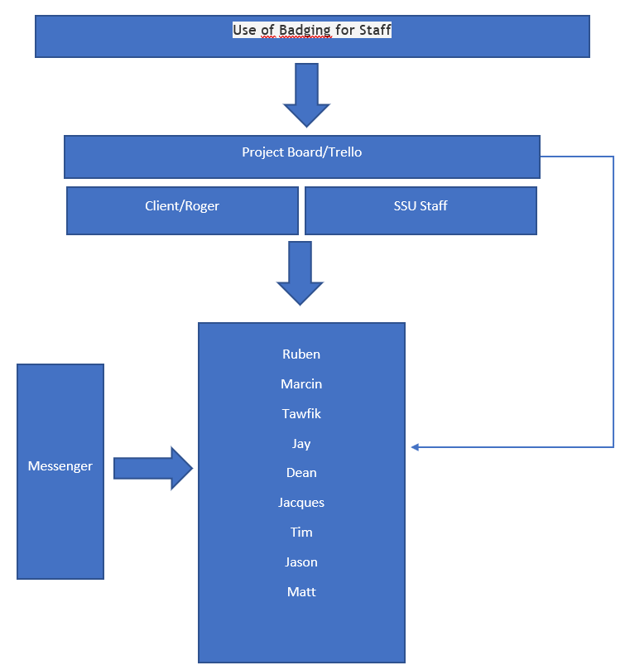

Role Descriptions

Ruben Bernardes: Team leader
Jacques Le Breuilly: Team Wiki
Jay Verma:
Tim Robinson: Team Wiki
Dean Goodyear:
Jason Sebastiao:
Marcin Wisniewski: Monitor Evaluator
Matt Stevens:
Tawfik Sabbagh:

Quality Management Strategy
(Describing the quality techniques and standards to be applied, and the responsibilities for achieving the required quality levels)

The monitor Evaluator will be responsible to view all tasks that have been completed which are uploaded on Trello. All tasks on Trello are colour coded, it will be the responsibility of the monitor evaluator to view all Blue (means that the task is done but still needs to be approved) tasks to make sure there are no substantial errors to all aspects of the project. Once evaluated the colour code can be changed to either green (means the task is done and approved) or yellow (means the task requires more changes so must be finished soon). It’s also the monitor evaluators responsibility to notify any relevant team members involved in tasks that require any changes. Team Wiki moderators will make sure that all completed tasks on Trello have been uploaded to the Team Wiki and are organised in a user friendly way.

Configuration Management Strategy
(Describing how and by whom the project’s products will be controlled and protected)

The project deliverables will be controlled and protected by the team wiki moderators.
Team wiki moderators are responsible for uploading every task to the team wiki and backing up the files to an eternal source.

Risk Management Strategy
(Describing the specific risk management techniques and standards to be applied, and the responsibilities for achieving an effective risk management procedure)

Matt Stevens

Communication
Distribution of Work
Time Management
Individual strengths/weaknesses

Communication Management Strategy

Facebook Messenger will be used to communicate with all team members and to remind team members about tasks/meetings etc. Trello Board will also be used to overview meetings, view and organise tasks as well as allocating tasks to a specific team member(s). Github repository will be used to store files to keep track of changes easily as Trello board does not seem to be best tool for the job especially for files needing lots of changes.

Project Plan
(Describing how and when the project’s objectives are to be achieved, by showing the major products, activities and resources required on the project. It provides a baseline against which to monitor the project’s progress stage by stage)

Dean

Project Controls
(Summarizing the project-level controls such as stage boundaries, agreed tolerances, monitoring and reporting)

Project will be managed, discussed and reviewed on weekly team meetings. Completed stages will also be reviewed and approved by interested parties as per agreed.
The risk mitigation plan involves taking over not completed work by other student to make sure project is delivered on time.

Tailoring of PRINCE2
(A summary of how PRINCE2 will be tailored for the project.)

Tim

