**SYNOPSIS**

**Register No:** **Name:**  
1. 126003101 Harish T  
2. 126003093 Guru Prasath M  
3. 126003184 Nishanth M V

**Project Title:** Optimizng Water Management Using LORAWAN-

Enabled IoT Framework and Behavioural Analysis

**Name of the Guide:** Dr. Manivannan D**,** Associate Dean, Infrastructure, School of Computing.

**Abstract:**

This project addresses sustainable water usage by implementing a LoRaWAN-enabled IoT system on a university campus. Smart meters installed across distribution points transmit water usage data, which is analyzed using deep learning models (LSTM) to uncover patterns influenced by occupancy and calendar events. Compared to conventional systems, this approach offers improved scalability, efficiency, and adaptability in environments with intermittent water supply.

**Specific Contribution:**

Implement a DL Model(LSTM) and Design a Circuit diagram and Build a Hardware Setup

LSTM Model:  
1. Implemented an LSTM model for time-series water flow prediction using Keras.  
2. Processed 6-hour interval data, applied normalization, and trained a sequence model.  
Hardware:  
1. Designed and built the hardware setup using ESP32, YF-S201 sensor, Raspberry Pi, relay module, and solenoid valve.  
2. Integrated sensor-actuator pipeline using MQTT protocol and tested real-time water control.

**Specific Learning:**

LSTM Model:  
1. Learned LSTM architecture, memory gating, windowing, normalization, and hyperparameter tuning.  
2. Practiced model evaluation using RMSE, MAE, and R² metrics.  
Hardware:  
1. Gained experience in IoT circuit design and firmware development.  
2. Implemented MQTT-based telemetry, actuator control, and real-time data sync.

**Technical Limitations & Ethical Challenges Faced:**

LSTM Model:  
1. Training required high compute; initial overfitting issues resolved with dropout and early stopping.  
2. Encountered temporal misalignment between real-time and training data.  
Hardware:  
1. Relay bounce and solenoid overheating mitigated with debouncing and thermal cycling.  
2. Faced MQTT packet loss due to unstable WiFi; solved with retry logic and threading.  
3. Managed voltage isolation to protect control circuitry from back EMF.

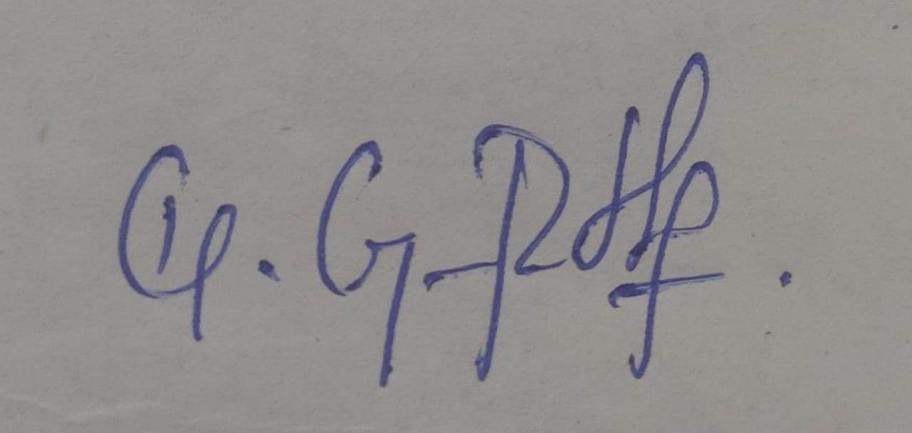

Guru Prasath M

**Name & Signature of the Student Signature of Guide**

**Date:** 05/05/2025