Justin Garcia

ME 190

Saeid Bashash

Homework #3

Due Thursday September 29, 2016

EXERCISE ONE:

A picture of your setup

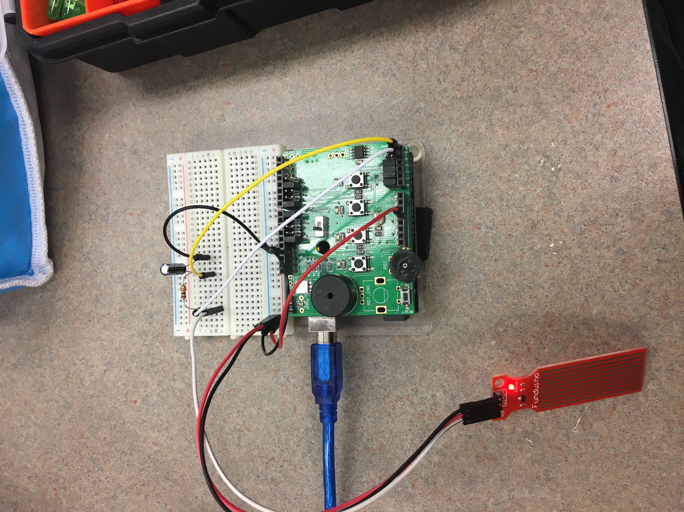

- Arduino code

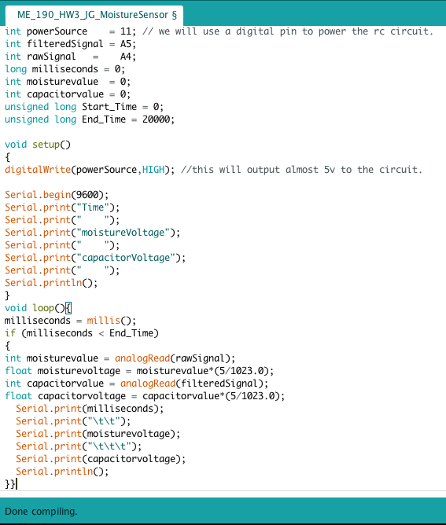

- A had drawn schematic diagram of the circuit with appropriate labels

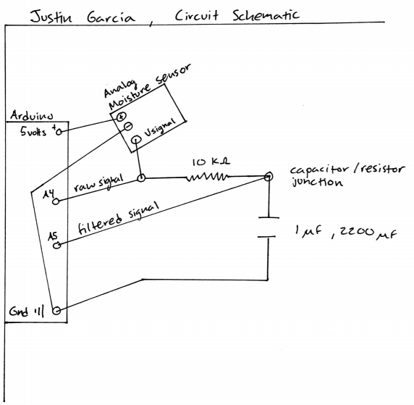

- A zoomed-in plot showing the filter has removed high-frequency noise from your data

