Fantasy Place Name Generator

By SolidSnark

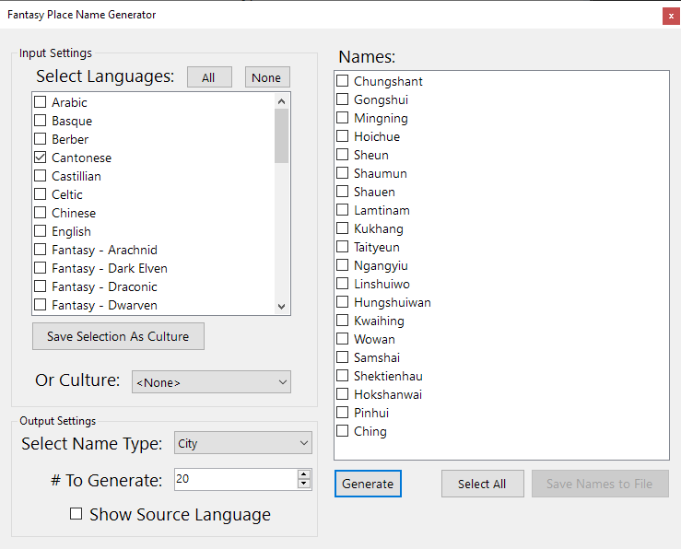

Contents

Overview 2

# Overview

dsafadf