Manel Oudjida

100945382

* tight vs loose coupling:
  + - Tight Coupling is when group of classes are extremely dependent to each other
      * + Example:

Public Class Traveller

{

Car c = neww Car();

Public Void startJurney()

{

c.move();

}

}

Public Class Car

{

Public Void move()

{

}

}

* + - Loose coupling is when a class goes by its own responsibilities and separated from the other classes. (not associated with other classes)

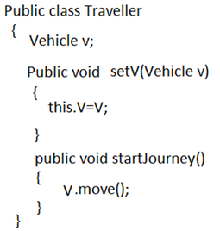

Source:

- <https://stackoverflow.com/questions/2832017/what-is-the-difference-between-loose-coupling-and-tight-coupling-in-the-object-o>

- http://javaeasy.weebly.com/types-of-coupling.html

* Encapsulation:

-hide the implemented details from the user

-wraps code and data together and make it into a single unit

- it is done by making all the encapsulated class’ data private.

Example:

**public** **class** Student{

**private** String name;

**public** String getName(){

**return** name;

}

**public** **void** setName(String name){

**this**.name=name

}

}

**class** Test{

**public** **static** **void** main(String[] args){

Student s=**new** Student();

s.setName("Sysc");

System.out.println(s.getName());

}

}

<https://www.javatpoint.com/encapsulation>

* class cohesion : -refers to what the class is going to do.
* Refers to the taks that a single unit is responsible for.
* High Cohesion: easier to understand class and method’s action

Example:

----------------------------

| Staff |

----------------------------

| -salary |

| -emailAddr |

----------------------------

| setSalary(newSalary) |

| getSalary() |

| setEmailAddr(newEmail) |

| getEmailAddr() |

----------------------------

* Low Cohesion: methods usually perform several taks

Example:

-------------------

| Staff |

-------------------

| checkEmail() |

| sendEmail() |

| emailValidate() |

| PrintLetter() |

-------------------

* law of Demeter:

-minimizes the coupling between classes for methods.

-goal: to not gain access to a 3rd object’s method.

Source: https://alvinalexander.com/java/java-law-of-demeter-java-examples