Project Problem and Proposed Model

Scale Formation Prediction & Adaptive Inhibitor Optimization
Based on: Scale Formation Presentation- Mujahed.pptx | SCE-701 Directed Research, KFUPM | Foundation for PhD Dissertation

1. Project Problem
Scale formation is not only a chemistry problem — it is a flow-assurance decision problem. Inorganic scales (CaCO₃, BaSO₄, SrSO₄, Fe-based scales) precipitate and deposit inside production tubing, flowlines and surface facilities, restricting flow, raising pressure drop, accelerating corrosion, and driving unplanned shutdowns and intervention cost. The operational decision this creates is not answered by chemistry alone: an operator needs to know where scale is forming along the line, what type it is, how severe it is, and how much inhibitor to inject and when — a real-time scale state, not a single saturation-index number.
The bibliography compiled alongside this document (Annotated_Bibliography_Scale_Formation.docx, 55 sources) shows the literature is mature in parts but fragmented in aggregate. Four streams of work exist largely in isolation:
- Thermodynamics (SI / supersaturation): fast to screen, but gives no spatial insight into where or how fast scale actually grows.
- Kinetics & MIC (induction time, tube blocking): useful lab-derived metrics, but typically static and not tied to continuously changing field conditions.
- Transport & deposition (CFD, mass transfer, adsorption): captures flow effects realistically, but is computationally heavy and data-intensive.
- AI & monitoring (ML classifiers, sensor-based thickness detection): achieves good point predictions, but with limited physical grounding and no closed-loop control.
What is missing — and what this project targets — is a closed-loop framework that fuses sensors, water chemistry, operating data and mechanistic knowledge to estimate the hidden spatio-temporal scale state and continuously optimize inhibitor dosing. This is the core research gap identified in Section 9 of the bibliography, and it is the problem this document turns into a concrete model.

2. Proposed Conceptual Framework
The proposed solution is a physics-informed AI sensor-fusion loop: operational and sensor data are fused into a coherent estimate of the hidden scale state (type, location, thickness, growth rate, severity) along the pipeline; this estimate, constrained by mechanistic knowledge (thermodynamics, kinetics, transport, adsorption), drives an adaptive optimizer that recommends inhibitor dose and timing; recommendations are surfaced through a digital decision-support platform; and the resulting change in the field is continuously re-sensed, closing the loop.
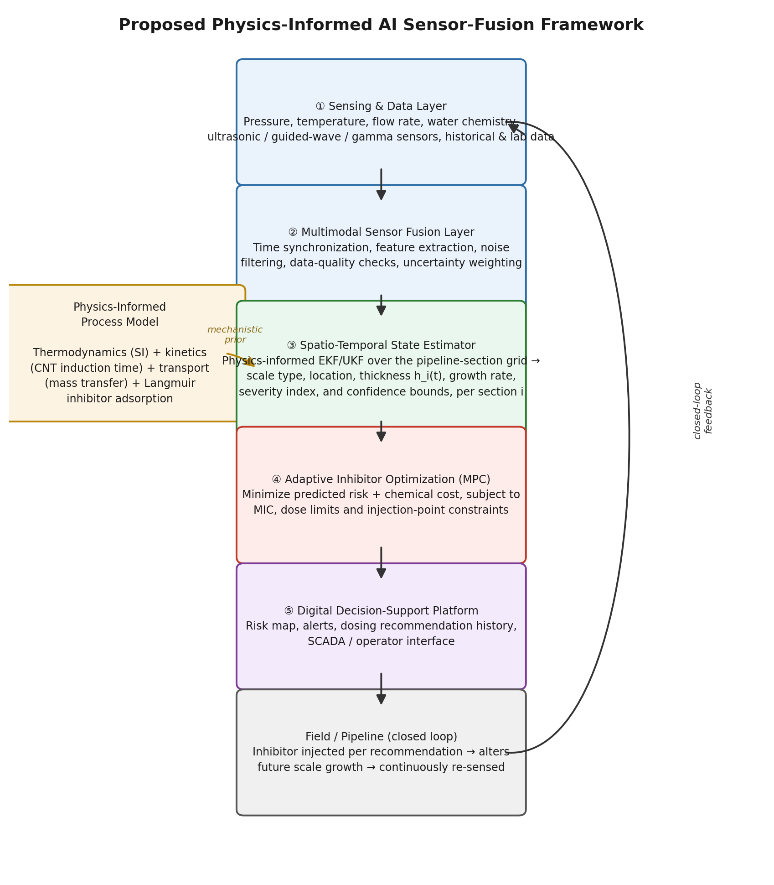

3. Mathematical / System Model
The pipeline is discretized into N sections indexed i = 1…N. Each section carries a hidden scale-state vector xᵢ(t) — scale type, thickness, growth rate and a severity index — driven by a physics-informed process model and observed through a multimodal sensor set yᵢ(t). The core equations below formalize the framework in Section 2, drawing directly on the mechanistic building blocks identified across the literature review (CNT kinetics from Section 1, mass-transfer/transport coupling from Section 2, Langmuir inhibitor adsorption from Section 3):
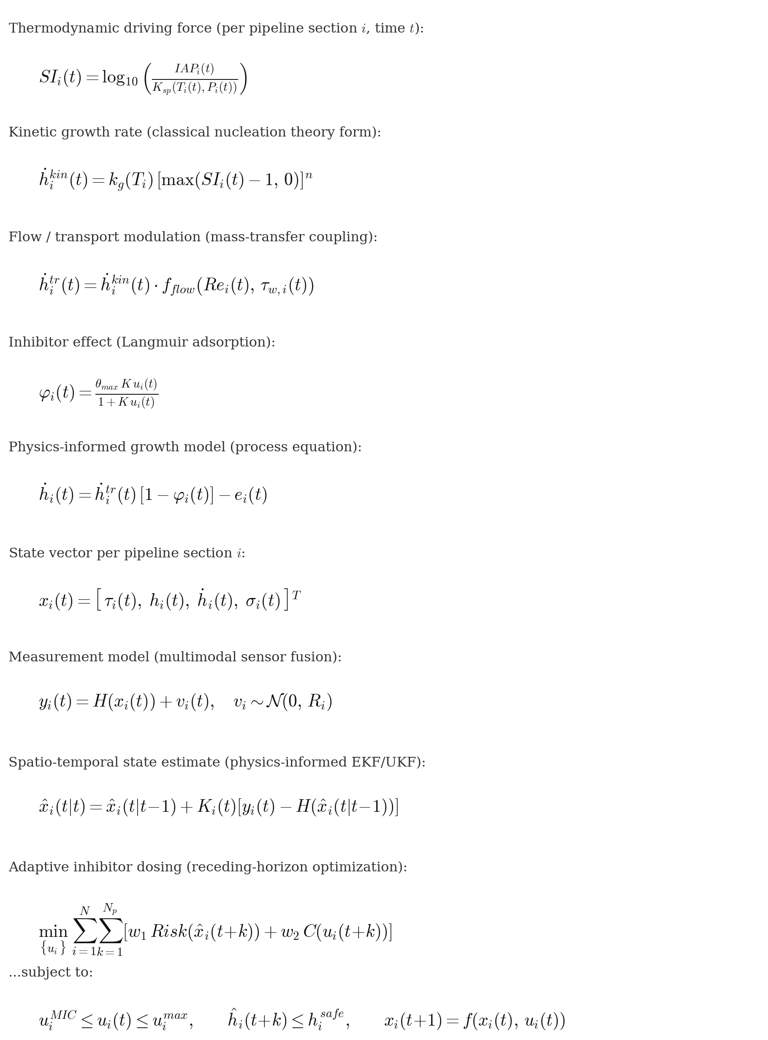

3.1 Reading the model
- Process layer (Eq. 1-5): reproduces the physics established in Sections 1-3 of the literature review — a saturation-index driving force, a classical-nucleation-theory kinetic rate, a flow/turbulence modulation term (per the finding that flow regime can dominate scaling risk), and a Langmuir-adsorption inhibitor effect. This is the 'mechanistic prior' the estimator is anchored to.
- State & measurement layer (Eq. 6-7): defines the hidden state to be estimated at each pipeline section and the (possibly sparse, multimodal, noisy) sensor observations available — pressure, temperature, flow, water chemistry, and physical sensors such as ultrasonic time-of-flight or guided-wave features.
- Estimation layer (Eq. 8): a physics-informed Kalman-family filter (EKF/UKF chosen for tractability and interpretability over a full nonlinear particle filter or PINN, at directed-research scale) fuses the process-model prediction with each new sensor observation, section by section, continuously updating the scale-state estimate and its uncertainty.
- Optimization layer (Eq. 9-10): a receding-horizon (model-predictive) controller uses the fused state estimate to recommend an inhibitor dose per section that minimizes a weighted sum of predicted scaling risk and chemical cost, subject to the minimum inhibitor concentration (MIC) from the kinetic model, dosing limits, and injection-point constraints (informed by the inhibitor-transport literature in Section 2).

4. What This Adds Beyond the Reviewed Literature
No single paper in the 55-source review combines all of the following in one framework — each piece has a direct precedent, but not the combination:
- Spatially resolved, not lumped: the section-indexed state xᵢ(t) targets the 'limited spatial understanding' gap — location and thickness per section, not a single field-level scale/no-scale label (contrast with the ML-tendency cluster, Section 4 of the bibliography).
- Physics-informed, not black-box: the estimator's prediction step is the mechanistic growth equation (Eq. 5), not a bare regression — addressing the extrapolation risk noted for the pure ML-thermodynamics cluster (Section 5).
- Continuously updated, not static: the Kalman-filter update (Eq. 8) re-estimates state every time new sensor data arrives, directly answering the 'static, lab-based, not integrated with real-time data' weakness flagged repeatedly in Sections 1-3.
- Dosing tied to estimated state, not fixed: Eq. 9-10 make inhibitor dose a function of the current estimated risk per section, rather than the conservative fixed/lab-derived dose that is current industry practice.
The closest single-paper analogues identified in the review are Stalker et al. (2024) for the physics+CFD+lab+field integration (Section 1.7), and Mangal et al. (2022) for real-time adaptive dosing in the RO/desalination analogue (Section 7); this project's contribution is to combine that pairing with explicit multimodal sensor fusion and spatial resolution, for pipeline scale specifically.

5. Validation Strategy & Phased Work Plan
A staged validation path reduces technical risk before industrial deployment, following the phased structure proposed in the source presentation. The directed-research phase of this project (SCE-701, this semester) targets Phases 1-3 at reduced scale; Phases 4-6 define the full PhD dissertation scope.
Phase | Activity | Output | Scope
1 | Data audit & baseline model | Inventory of available field/lab variables, chemistry logs, existing scale reports; baseline SI-only prediction as benchmark | Directed Research
2 | Physics-informed process model | Implement Eq. (1)-(5): thermodynamic SI, CNT kinetics, flow-transport coupling, Langmuir inhibitor term, calibrated against literature + available lab data | Directed Research
3 | State estimator (single/few sections) | Physics-informed EKF/UKF fusing simulated or available sensor channels for a reduced-scale (1-3 section) case; validated against synthetic ground truth and any lab flow-loop data | Directed Research (this deliverable)
4 | Full spatial network + multimodal sensors | Extend estimator across the full section grid; integrate ultrasonic/guided-wave/ERT-type sensing; laboratory/flow-loop validation campaign | PhD Dissertation
5 | Adaptive inhibitor optimization (MPC) | Implement and validate the receding-horizon dosing optimizer against fixed-dose baseline; quantify chemical savings and risk reduction | PhD Dissertation
6 | Digital decision-support platform & field pilot | Dashboard, alerting, SCADA-ready interface; shadow-mode field trial with Aramco/industry partner | PhD Dissertation
Validation metrics across all phases: scale/no-scale accuracy, location error, thickness error, dosing reduction relative to a fixed-dose baseline, false-alarm rate, and decision latency.

6. Directed Research Deliverable vs. PhD Dissertation Scope
To keep this semester's directed research well-scoped, the immediate deliverable is deliberately narrower than the full closed-loop vision:
- Directed research (SCE-701), this semester: implement and validate the physics-informed process model (Eq. 1-5) and a reduced-scale state estimator (Eq. 6-8) for a small number of pipeline sections, using literature-derived kinetic/thermodynamic parameters and whatever lab or simulated sensor data is available; benchmark against a saturation-index-only baseline to quantify the value of the physics + estimation layer.
- PhD dissertation, full scope: extend the estimator across the full spatial network with real multimodal sensor hardware, implement and validate the adaptive MPC dosing optimizer (Eq. 9-10) against fixed-dose practice, build the digital decision-support platform, and pursue a shadow-mode or live field pilot with an industry partner (e.g. Saudi Aramco, per the Mujahed presentation's framing).
This staging directly answers the directed-research goal stated for this deliverable: understand the project problem in depth (Section 1) and produce a concrete, defensible model for it (Sections 2-4), establishing the foundation the full PhD dissertation will build on.

