Design document

Snake game

Egor Knyazev

2021

Table of Contents

Introduction 2

# Introduction

In this document will be overview of C4 model. In addition, there will be explained main solution and designs used in this project. In this project was taken the scrum agile approach (6 sprints, each 3 weeks).

# System context(C1)

In my project there are 3 different types of user: Player, Admin, Developer. App is single page bro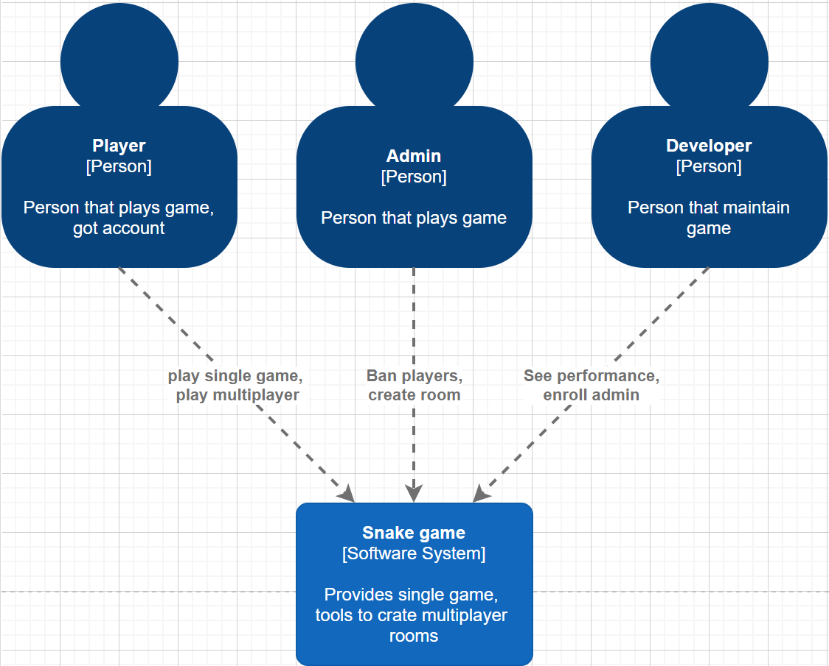wser app.

# Containers and tech choices(C2)

Admin and Developer, mainly, appear to maintain a game. Player is main person who interact with the app. All Person got the account credentials: Player can self-register; Admin and Developer can be assigned by already existed Developer. App represented by Spring boot backend server and React client side. External database keep track of data.

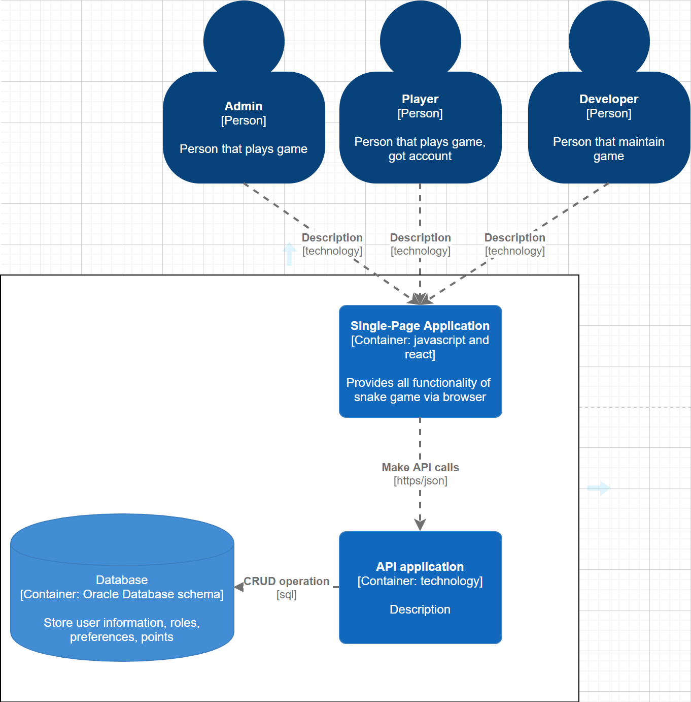

# Components(C3)

Backend communicate with fronted via Web Socket. Authorization component gets and sets at the database logins and passwords; Game provides frames to render it on fronted, after game the points will write at the database;

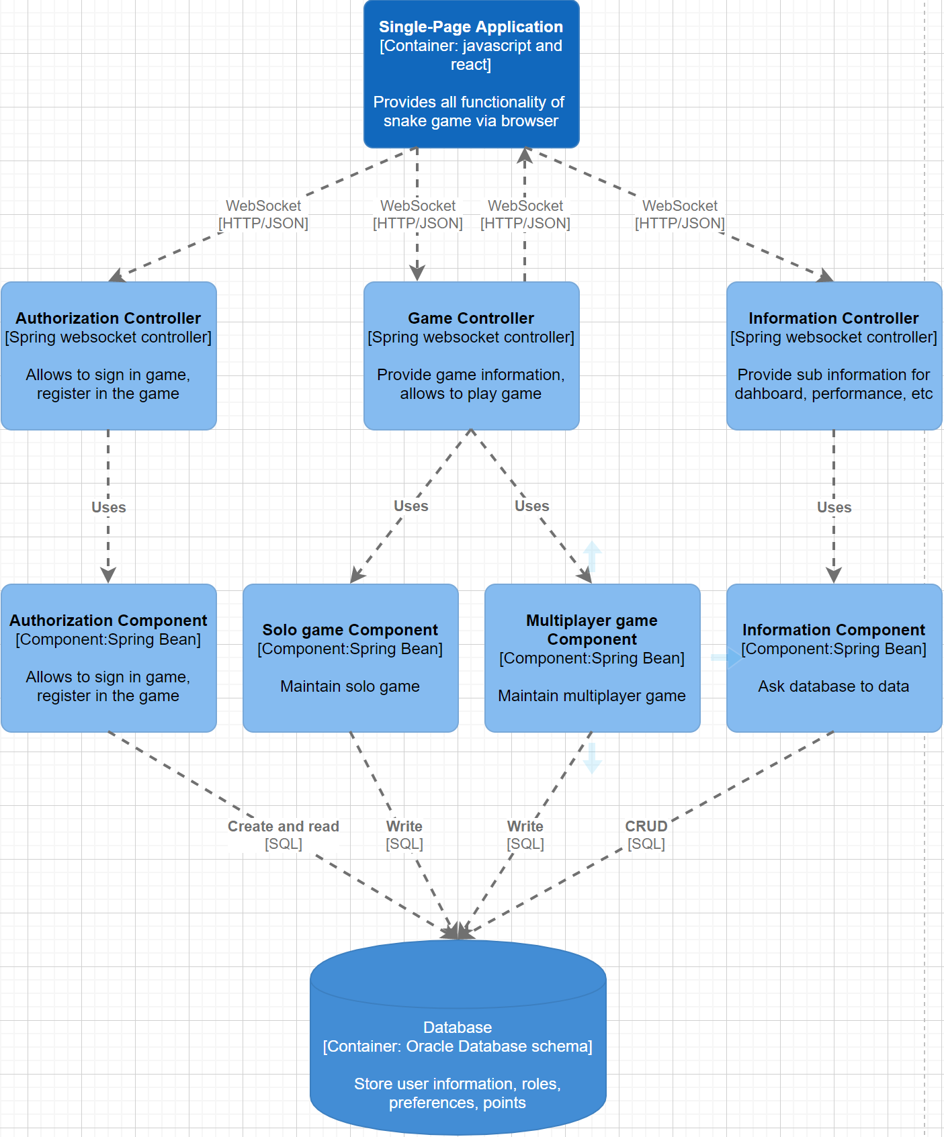

# Class diagram of Game(C4)

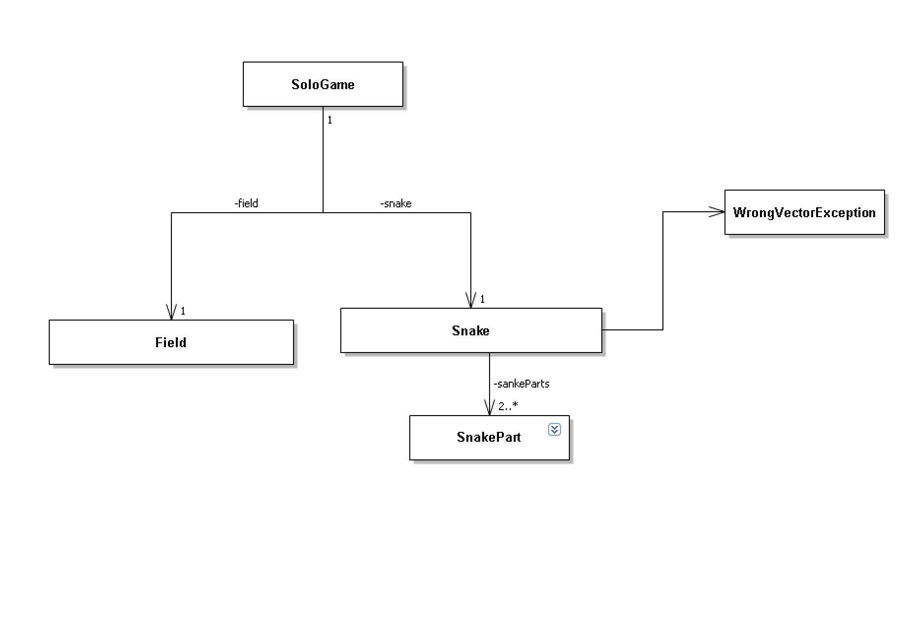

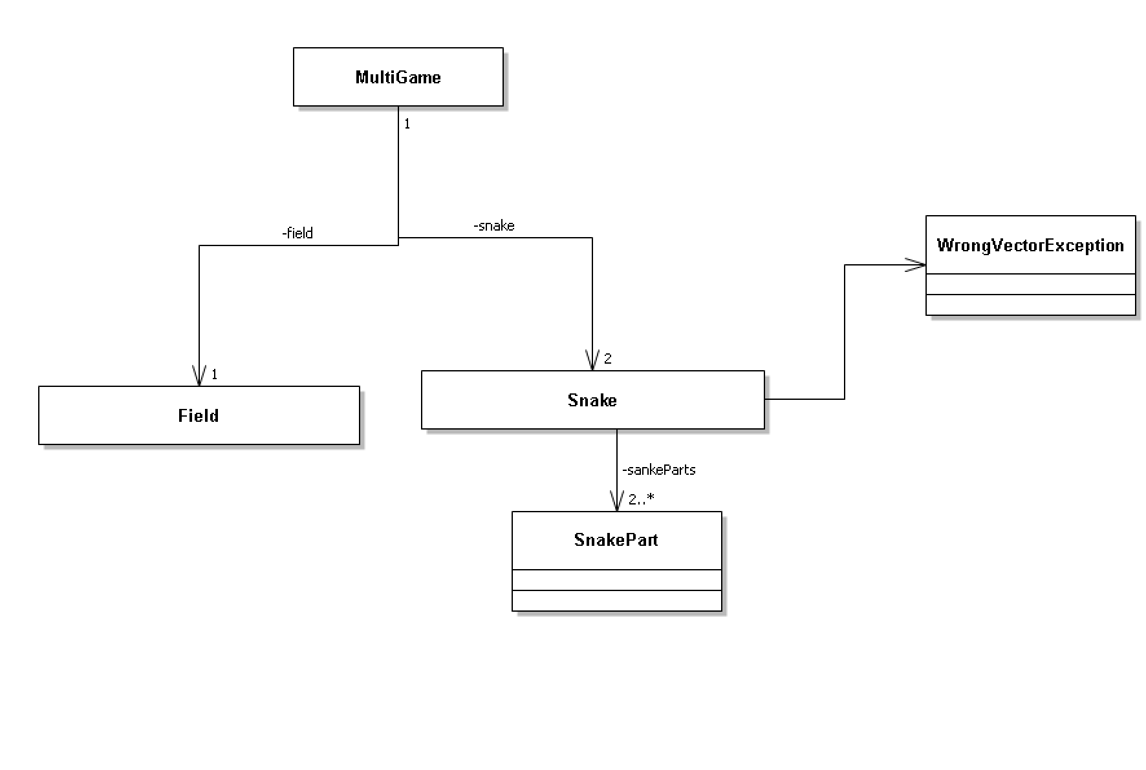

# API documentation

Currently, there is a researching of ways of realization of Web Socket. STOMP library not working with React. SockJS library probably may require convert to TypeScript. Socket.io has not normally supported version for Spring.