**A2:- Loan Amount Prediction Using Linear Regression and**

**Visualization**

**Aim**

To Develop a python program to predict the loan amount to be sanctioned using Linear Regression (LR) Model using Scikit-learn library. Visualize the features from the dataset and interpret the results obtained by the model using Matplotlib library.

## Code and output

Loading the dataset:

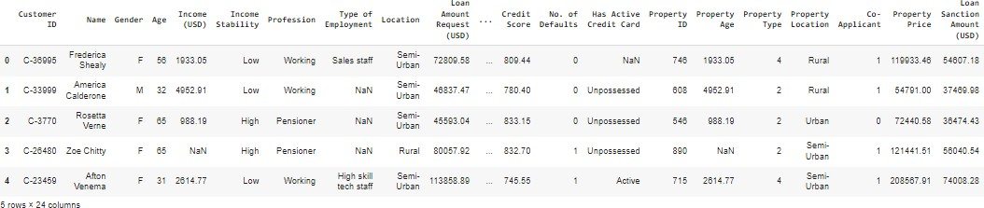

import numpy as np import pandas as pd

from sklearn.model_selection import train_test_split

from sklearn.preprocessing import StandardScaler,LabelEncoder from sklearn.linear_model import LinearRegression

from sklearn.metrics import accuracy_score,classification_report,confusion_matrix,mean_squared_error,r2

_score

import matplotlib.pyplot as plt import seaborn as sns

#Load train dataset train_df=pd.read_csv('/content/train.csv') train_df.head(5)

Pre-Processing the data (Handling missing values, Encoding, Normalization, Standardization).

#Preprocessing

indexes = train_df[train_df['Loan Sanction Amount (USD)'].isna()].index

#Loan Amount empty is removed(invalid) train_df.drop(index=indexes, inplace=True) #Loan Amount < 0

indexes1 = train_df[train_df['Loan Sanction Amount (USD)'] < 0].index train_df.drop(index=indexes1,inplace=True)

#Coapplicant < 0 is made 0

indexes10 = train_df[train_df['Co-Applicant']<0].index train_df.drop(index=indexes10,inplace=True)

#property age empty is removed

indexes11 = train_df[train_df['Property Age'].isna()].index train_df.drop(index=indexes11,inplace=True)

#credit score null is

indexes1 = train_df[train_df['Credit Score'].isna()].index train_df.drop(index=indexes1,inplace=True)

indexes2 = train_df[train_df['Income (USD)'].isna()].index train_df.drop(index=indexes2,inplace=True)

indexes4 = train_df[train_df['Current Loan Expenses (USD)'].isna()].index train_df.drop(index=indexes4,inplace=True)

indexes5 = train_df[train_df['Current Loan Expenses (USD)'] < 0].index train_df.drop(index=indexes5,inplace=True)

indexes14 = train_df[train_df['Dependents'].isna()].index train_df.drop(index=indexes14,inplace=True)

indexes3 = train_df[train_df['Property Price']<0].index

train_df.drop(index=indexes3,inplace=True)

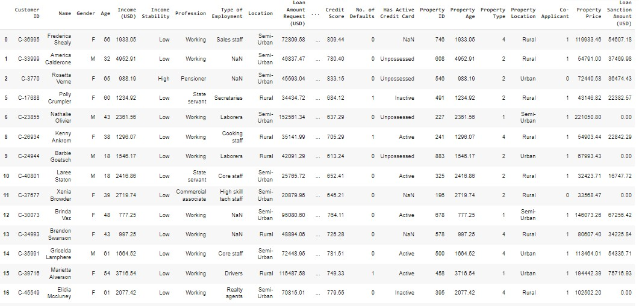

Exploratory Data Analysis.

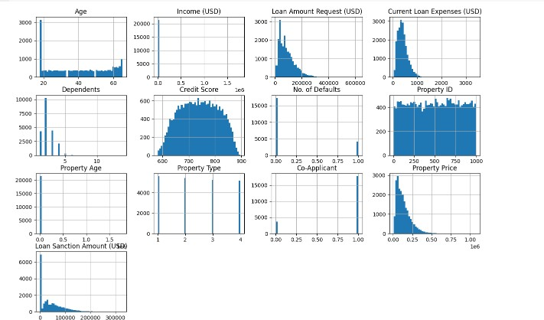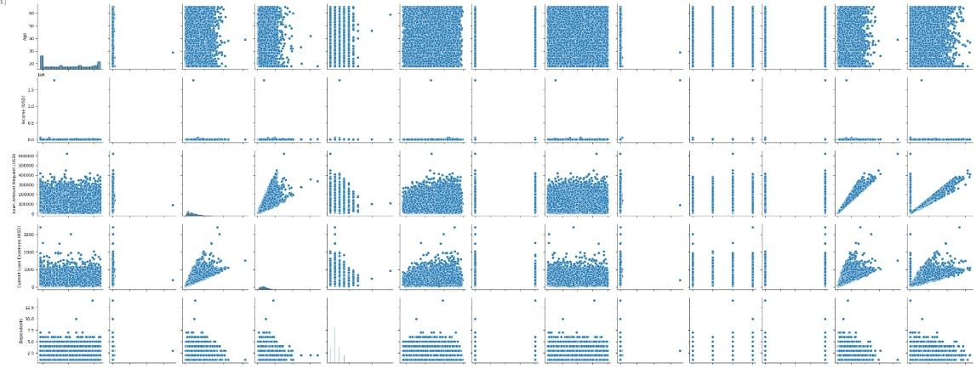

#Exploratory data analysis - Histogram train_df.hist(bins=50,figsize=(15,10))

plt.show()

#Exploratory data analysis - Pairplot sns.pairplot(train_df)

plt.show()

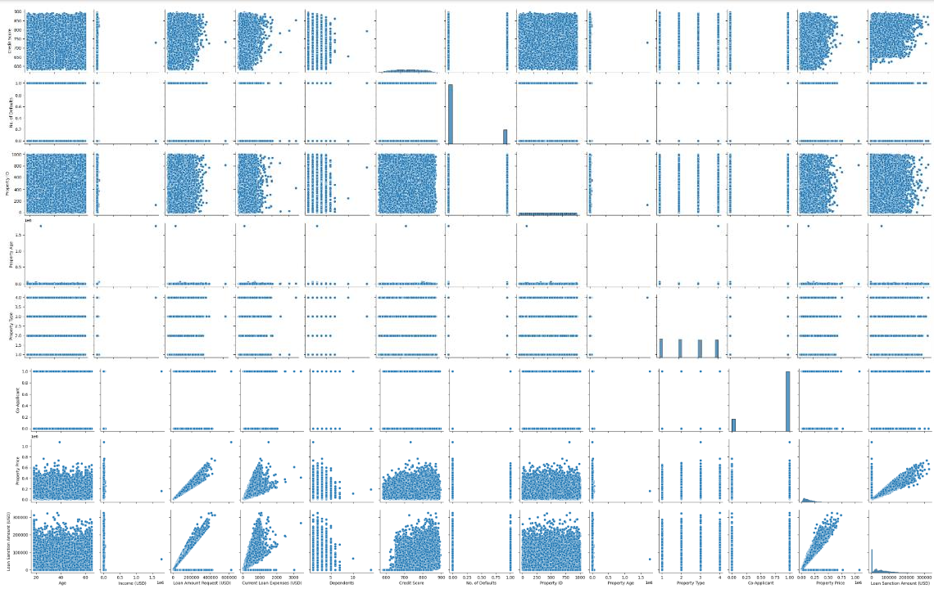

Feature Engineering techniques.

# Heatmap plt.figure(figsize=(15,15))

sns.heatmap(train_df.corr(),annot=True)

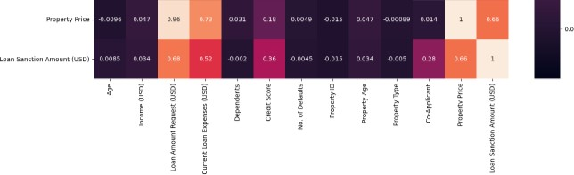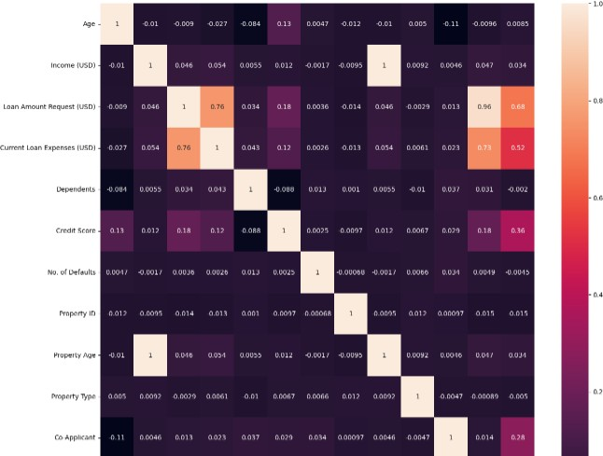

Split the data into training and testing sets.

y = train_df['Loan Sanction Amount (USD)']

x = train_df[['Loan Amount Request (USD)','Current Loan Expenses (USD)','Credit Score','No. of Defaults','Co-Applicant','Property Price']] x_train,x_test,y_train,y_test =

train_test_split(x,y,test_size=0.2,random_state=42)

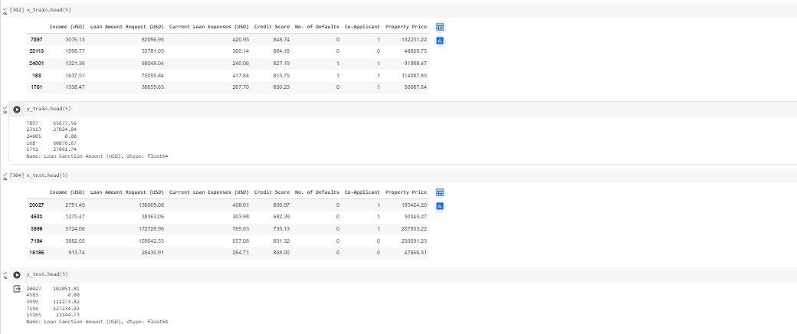

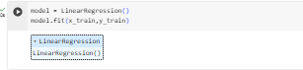Train the model

Test the model.

y_pred = model.predict(x_test)

Measure the performance of the trained model.

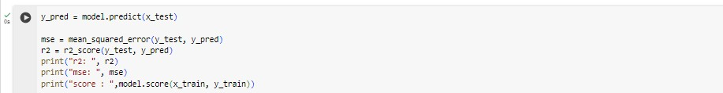

#Measure the performance of the trained model mse = mean_squared_error(y_test, y_pred)

r2 = r2_score(y_test, y_pred) print("Mean Squared Error:", mse) print("R-squared Score:", r2)



Represent the results using graphs.

# Scatter plot for actual loan amounts plt.scatter(y_test, y_test, color='blue', label='Actual')

# Scatter plot for predicted loan amounts plt.scatter(y_test, y_pred, color='red', label='Predicted')

plt.xlabel("Actual Loan Amount")

plt.ylabel("Predicted Loan Amount") plt.title("Actual vs. Predicted Loan Amount")

plt.legend() plt.show()

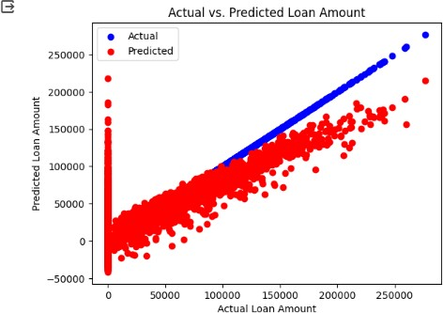

Predicting loan amount for test dataset

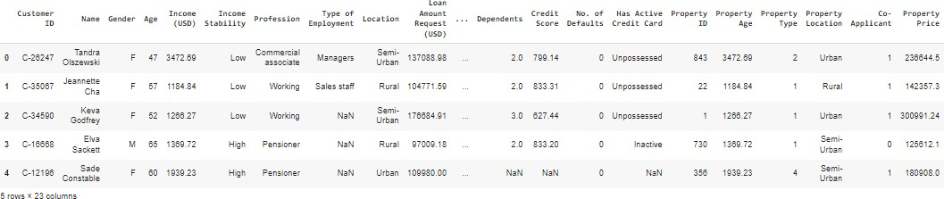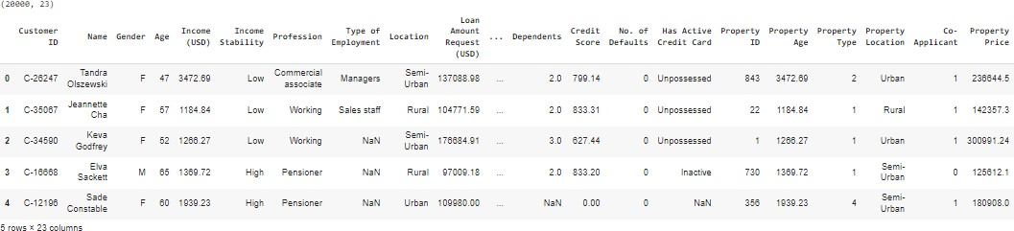

#Load test dataset

test_df = pd.read_csv('/content/test.csv')

test_df.head(5)

test_df.loc[(test_df['Co-Applicant'] == '?'),'Co-Applicant'] = 0 test_df.loc[(test_df['Co-Applicant'] == '0'),'Co-Applicant'] = 0

test_df['Property Age'].fillna(train_df['Property Age'].mean().round(2), inplace=True)

test_df['Credit Score'].fillna(0, inplace=True)

test_df1=test_df[['Loan Amount Request (USD)','Current Loan Expenses (USD)','Credit Score','No. of Defaults','Co-Applicant','Property Price']] test_pred = model.predict(test_df1)

op = pd.DataFrame({'Customer ID' : CUST_ID, 'Loan Sanction Amount (USD)':test_pred

})

op.to_csv('output.csv',index=False) op.head(10)

