Autonomous Water Quality Monitoring Boat
Smart Autonomous Monitoring System for Real-Time Water Pollution Detection
Proposal Submission to Gujarat Pollution Control Board (GPCB)

Project Objective
The proposed system aims to reduce manual sampling efforts and enable continuous real-time monitoring of water bodies using autonomous navigation and IoT-based sensing.
This project proposes a low-cost autonomous boat capable of monitoring water quality in rivers, lakes, and reservoirs.

📌 Image 1: Boat route with yellow waypoint line and red deviation tracking
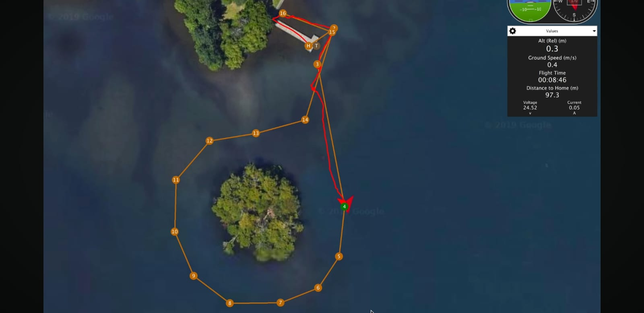
Caption: Autonomous GPS waypoint navigation and real-time path tracking using Ardu Pilot.
Proposed System
The proposed autonomous boat is based on Autonomous Surface Vehicle (USV) technology using:
- Pixhawk + ArduPilot autonomous navigation
- GPS waypoint-based movement
- Telemetry communication system
- Waterproof catamaran boat platform
- IoT-based real-time monitoring
- Water quality sensing system
Water Parameters Monitored
- pH
- Temperature
- Turbidity
- TDS / Conductivity

Working Principle
- Boat follows predefined GPS routes automatically
- Sensors continuously monitor water quality
- Data is transmitted wirelessly to monitoring station
- Real-time readings are displayed on cloud dashboard
- System supports autonomous environmental monitoring

📌 Image 2: Mission Planner telemetry monitoring image
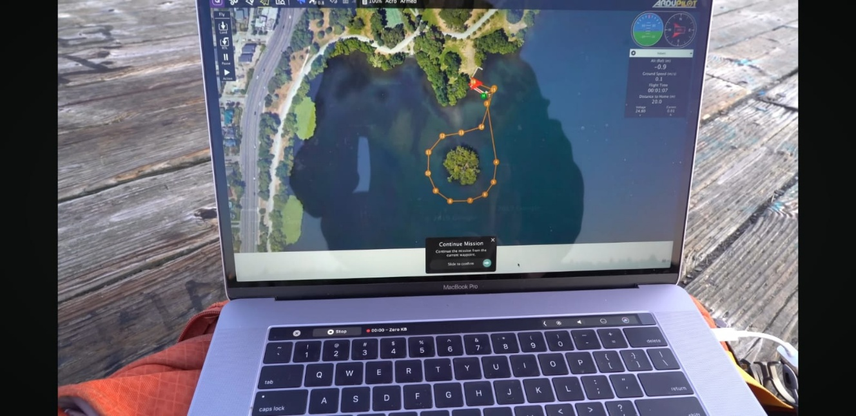

Caption: Mission Planner telemetry and live autonomous monitoring interface.

Key Features
- Autonomous GPS navigation
- Manual RC override control
- Real-time telemetry monitoring
- Continuous cloud-based sensor monitoring
- Stable catamaran hull design
- Expandable live video streaming system
- Scalable and low-cost monitoring platform

Expected Applications
- River pollution monitoring
- Lake and reservoir monitoring
- Smart environmental surveillance
- Remote water quality inspection

Expected Benefits
- Faster pollution detection
- Reduced manual sampling effort
- Real-time monitoring capability
- Monitoring of difficult-to-access water areas
- Low-cost scalable environmental monitoring solution

📌 Image 3: Firebase/cloud dashboard continuous sensor readings
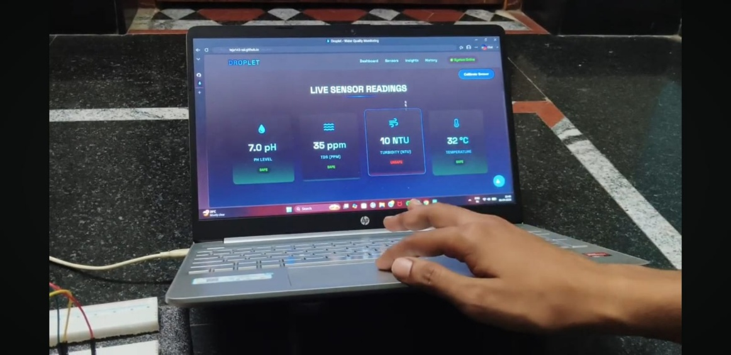
Additional Demonstration Images
📌 Image 4: Live boat tracking image
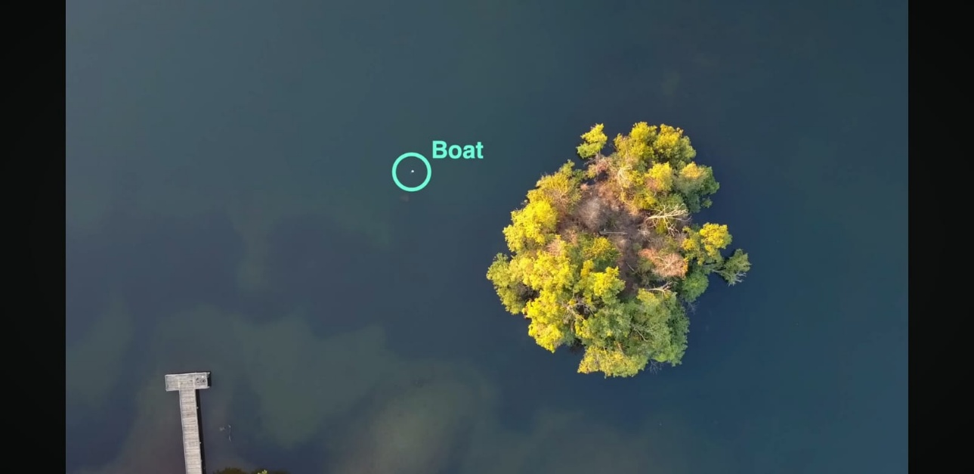
📌 Image 5: Boat CAD/prototype design image
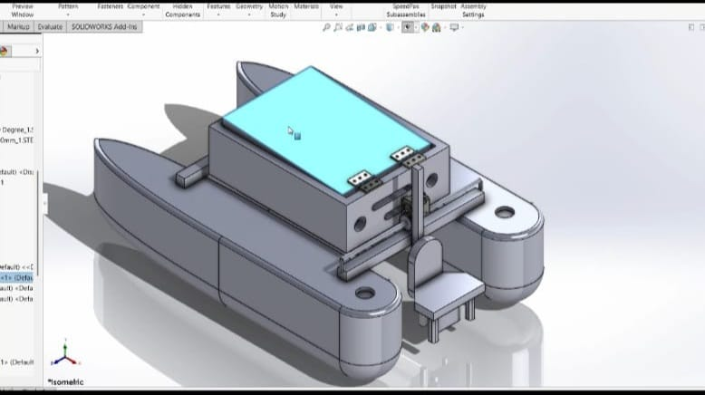
Caption: Proposed catamaran hull structure and onboard electronics layout.
📌 Image 6: Additional autonomous route/testing image
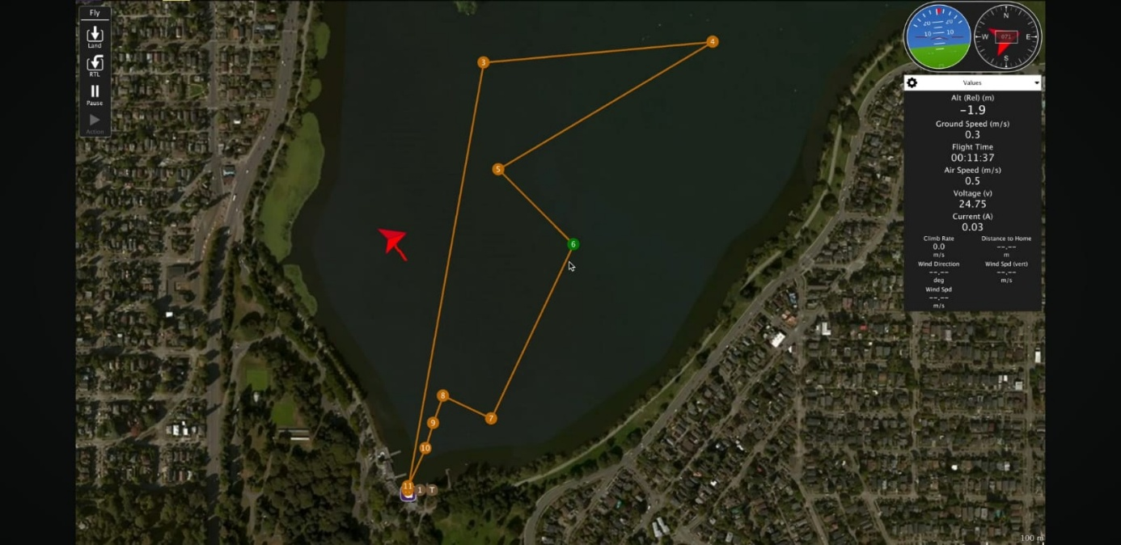
Caption: Autonomous survey route for large-area water monitoring.

Demonstration Reference
YouTube Demonstration Video
Autonomous Boat Demonstration Video

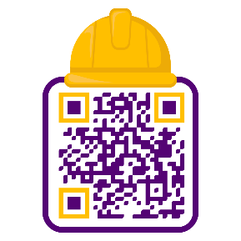

Conclusion
The proposed autonomous water quality monitoring boat provides a practical, scalable, and technology-driven solution for modern environmental monitoring. The system combines autonomous navigation, IoT-based sensing, telemetry communication, and real-time monitoring to support future smart pollution-control initiatives.
The proposed platform can assist environmental agencies and monitoring authorities in improving water pollution surveillance while reducing manual inspection efforts.

Prepared By
Name:
Institute: LD College of Engineering
Department: Instrumentation & Control Engineering

