NAME :- Nirbhay Soliya

**MODULE : 1**

**Software Engineering**

1. **What is software? What is software engineering?**

* **What is software :-**
* A set of instrusctions used to provide a specific output to reduce human efforts**.**
* Software is nothing but set of instractions or set of program are known as software
* Software is that part of a computer,which cannot be touched.
* Software tell a computer what to do and how to do it.
* **What is software engineering :-**
* Software can be developed by following some set of rules, the process is called SE.
* Software engineering is the branch of computer science that deals with the design, development, testing, and maintenance of software applications.
* Software engineers apply engineering principles and knowledge of programming languages to build software solutions for end users.
* Software engineering is a technique through which we can developed or created software for computer systems and any other electronic devices.

1. **Explain types of software**

**Types of software –**

* **System software**
  + System software is a software designed to provide a platform to other software.
  + System software control and manage the operations of computer hardware.
  + E.X. Operating System (Windows,Android,linux etc.)
  + Types of System software :
* Operating System : Computer memory,CPU,Printer
* Language Processor : Java,C,C++,Python
* Device Driver : device driver,Modem
* **Application software**

* + The software that helps you to do a specific type of works is called application softaware.
  + E.X. Ms word,Excel etc.
  + Types of System software :
    - General Purpose Software : MS-Word,MS-Excel
    - Customized Software: railway reservation system
    - Utility Software : disk fragmenter,memory tester,disk repair

1. **What is SDLC? Explain each phase of SDLC**

SDLC full from software development life cycle

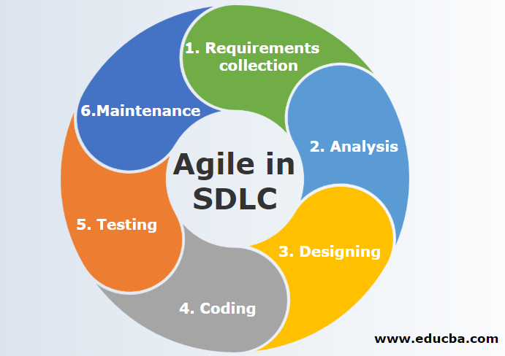

# Planning / Requirement Gathering :

* In the planning phase, project goals are determined and a high-level plan for the intended project is established.
* Planning is the most fundamental and critical organizational phase.
* The three primary activities involved in the planning phase are i. Identification of the system for development ii. Feasibility assessment iii. Creation of project plan

# Analysis :

* In the analysis phase, end-user business requirements are analyzed and project goals converted into the defined system functions that the organization intends to develop.
* The three primary activities involved in the analysis phase are i. Gathering business requirements ii. Creating process diagrams iii. Performing a detailed analysis.

# Design :

* + In the design phase, we describe the desired features and operations of the system.
  + This phase includes business rules, pseudo-code, screen layouts, and other necessary documentation.
  + E.x. DFD, ER-Diagram, Flowchart, Usecase

# Implementation :

* + In the development phase, the transformation of all the documents from the previous phase into the actual system.
  + coding/building
  + E.x. hardware/software

# Testing :

* In the testing phase, all the pieces of code are integrated and deployed in the testing environment.
* To check the errors, bugs, and defects testers follow software testing life cycle activities.
* E.x. QA-QC

# Deployment :

* During this next phase, the system is deployed to a real-life environment where the actual user begins to operate the system.
* All data and components are then placed in the production environment. This phase is also called referred to as ‘delivery.’

# Maintenance :

* To make sure the system continues to work and stay updated to meet the business goals any necessary enhancements, corrections, and changes will be made in the maintenance phase.
* The three primary activities involved in the maintenance phase are i. Support the system users ii System maintenance iii. System changes and adjustment

1. **What is DFD? Create a DFD diagram on Flipkart .**

A data flow diagram is a graphical view of how data is processed in a system in terms of input and output.

The Data flow diagram contains some symbol for drawing the data flow diagram.

* 0 Level DFD

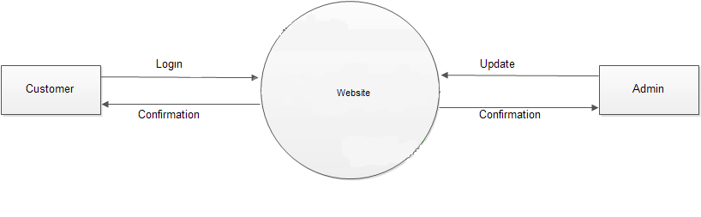

* 1 Level DFD

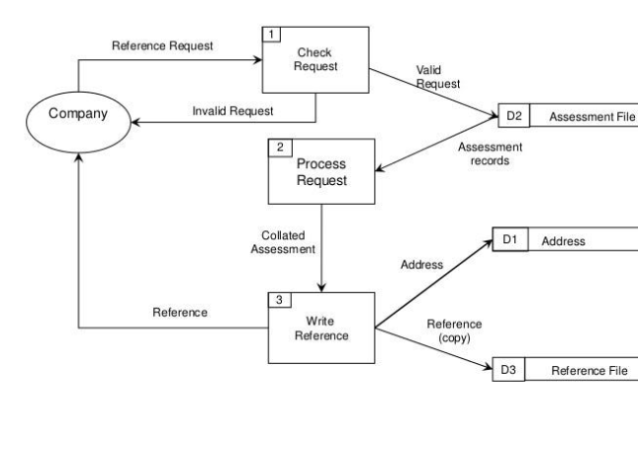

**5. What is Flow chart? Create a flowchart to make addition of two numbers.**

A flowchart is a graphic depiction of an algorithm or process that usually shows the steps in the algorithm's flow by connecting symbols with arrows. It's frequently used to show workflows, procedures, or decision-making processes in a variety of industries.

**In this flowchart:**

• "Start" is represented by an oval or rounded rectangle.

• "Input num1 and num2" is represented by a parallelogram.

• "Add num1 and num2" is represented by a rectangle.

• "Display result" is represented by a parallelogram.

• "End" is represented by an oval or rounded rectangle

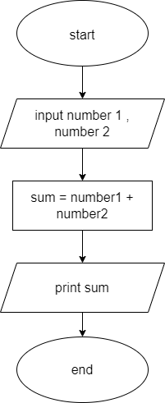

**6. What is Use case Diagram? Create a use-case on bill payment on paytm.**

* A UML use case diagram is the primary form of system/software requirements for a new software program underdeveloped.
* Use cases specify the expected behavior (what), and not the exact method of making it happen.
* Use cases once specified can be denoted both textual and visual representation.
* A key concept of use case modeling is that it helps us design a system from the end user's perspective.
* It is an effective technique for communicating system behavior in the user's terms by specifying all externally visible system behavior.

