Computer Architecture 2023
Exercise Session Report

Group:
Name and student number:
Date: May 26, 2023

Part 1: Fill in the Design Metrics
Implementation | Simulation | Backend
Implementation | Simulation | Synthesis |  |  |  | Floorplan | Signoff
Implementation | # of Cycles for MULT* | Design  area (μm²) | Critical path  (ns) | Maximum operating frequency (MHz) | Minimal time to execute the MULT (ns) | Die area (μm²) | Area utilization (%) | Maximum operating frequency (MHz)
1. Single Cycle** | 2300 | 508302 | 9.85 | 101.52 | 22655 | ***
2. Single Cycle with Multiplication | 40
3a. Basic Pipelined | 40 | 682354 | 0.66 | 1515.15 | 26.4 | 2560000 | 27 | 176.99
3b. Basic Pipelined (50MHz, preset 1)
3c. Basic Pipelined (50MHz, preset 2)
4. Pipelined with hazard logic
5. Advanced acceleration
* The program
- MULT1 is for “1. Single cycle”;
- MULT2 is for “2. Single Cycle with Multiplication” and “3a/3b. Basic Pipelined”;
- MULT3 is for “4. Pipelined with hazard logic”;
- MULT4 (or your modified version of it) is used for “5. Advanced acceleration”.
** Implementations 1, 2, 3a, 4 and 5 have a clock frequency of 10MHz and is synthesized under the default strategy “AREA 0”.
*** The grey regions are not required to fill in.
Presets 1 & 2 must be replaced by your synthesis strategy after performing the Synthesis Exploration step (e.g., DELAY 0-4/AREA 0-3).
Part 2: Answer the Questions based on Your Designs
Questions:
- What is the critical path for the single-cycle processor (simple program)? Which operation does this critical path stand for?

The critical path for the single-cycle processor is 9.85 [ns]. This path starts from a set of instructions coming from the instruction memory, to the register file. Afterwards, it goes through the MUX operand in front of the ALU and get finally passed to the ALU.

- For the single-cycle processor, what are the top-5 components in the area cost? After adding multiplication support, what are the top-5 components in the area cost then? What has the changed? What is your explanation for this?

For the single-cycle processor, without multiplication support, the 5 top components in area are:
1: Data memory [227,869.31 um^2, 44.83%]
2: Instruction memory [138,703.36 um^2, 27.28%]
3. Register file [119121.74 um^2, 23.43%]
4. ALU [18362.61 um^2, 3.61%]
5. Branch unit [5463.99 um^2, 1.07%]

And after the multiplication support

These results are explained by the fact that updates to the control_unit.vm alu_control.v and alu.v had to be made. These modification includes:

- What is the critical path after you support the MULT operation in the single-cycle processor? Is there anything changed? What is your explanation for this?
___________________________________________________________________________________________________
___________________________________________________________________________________________________
___________________________________________________________________________________________________

- Regarding to your findings in Q2 & Q3, do you think adding MULT operator support a good choice for every microprocessor? Please elaborate your answer.
__________________________________________________________________________________________________
___________________________________________________________________________________________________
___________________________________________________________________________________________________

- What is the critical path in the pipelined design? How does the critical path length change comparing to the single-cycle designs? How about the area? Try to analyze the benefits of processor pipelining according to your findings.

The critical path in our pipeline design is much shorter than in our single-cycle designs. While the single-cycle designs accommodate all instructions in one cycle, it achieves a critical path of 9.85 ns with MULT1 and [insert MULT2 single cycle cp] with MULT2. On the other hand, our pipelined design gets a critical path of only 0.66 ns.

However, in terms of area, pipelining requires more hardware resources because each pipeline stage requires pipeline registers. In other to meet the timing requirements and avoiding hold time violations as we saw by default OpenLane configuration, we had to first start with a larger die area of “0 0 2000 2000” but obtained routing congestion errors. Therefore, we decreased the die area gradually while making sure the “PL_TARGET_DENSITY” is set such that we are utilizing the extra space effectively. We finally avoided the hold time violations by increasing the die area to “0 0 1600 1600”, which increases a little the length of the wires, which adds sufficient delay. The floorplan initial core area is “5.52 10.88 1594.36 1588.48”. [add area result for MULT2 single cycle].

A first benefit of pipelining our processor is that it increases the instruction throughput as it allows multiple instructions to be processed simultaneously in different stages. This comes with a higher instruction execution rate compared to the single-cycle design.

A disadvantage of pipeling is that data hazards, control hazards can occur due to the complexity of some instructions. Indeed, some instructions that depend on each other can be at different stages in the pipeline (data hazards), and some may be branch instructions and cause control hazards.

- What techniques did you apply to accelerate MULT4? Explain under what conditions/type of workload you techniques will have the maximum/minimum performance gain.
___________________________________________________________________________________________________
___________________________________________________________________________________________________
___________________________________________________________________________________________________
___________________________________________________________________________________________________
___________________________________________________________________________________________________

- (Openlane Flow) Please explain the following terms of the backend flow: PDK, LEF, CTS, STA, GDSII. Which PDK are we using?
PDK stands for Process Design Kit. It contains all the information to design the integrated circuit. It carries the technical specifications, containing information on the manufacturing process such as the types and dimensions of the transistors that can be made, the electrical characteristics of the devices, … The PDK also gives specifications on the design rules to follow when laying out the devices on the silicon die. Moreover, the PDK provides a set of standard cells that can be used as building blocks for the design. These standard cells come with their own LEF files, which are used during the placement stage in the OpenLane flow.

LEF (Library Exchange Format) is a file carrying information on the physical layout and the interface of cells (basic building blocks such as logic gate, memory, …) used in a design. It only contains the high-level basic information required for representing the physical layout of an integrated circuit in an ASCII format. For example: the cell’s name, size, shape, the location of its ports, ... It does not contain detailed geometric information about layouts. These details are only useful after the generation of the final layout GDSII file.
In the OpenLane flow, LEF files are used to understand how much area each cell requires and how cells can connect to each other.

CTS (Clock Tree Synthesis) plays a crucial role in the synchronization of all the operations on the different components. In complex chips, where there could be billions of elements, distributing the clock signal evenly such that it arrives at all flip-flops and latches with minimal delay is a challenge. To solve that, we use CTS, which will make sure that the clock signal arrives at all components at close to the same time. Otherwise, we could see more issues like setup and hold time violations.
In the OpenLane flow,the CTS comes after the placement of the standard cells within the defined blocks, it comes to enable synchronous operating. Then the routing can start, connecting the cells following the clock tree.

STA (Static Timing Analysis) is a technique to verify the timing performance of a digital circuit without having to simulate with multiple input signals and different moments. Instead of trying all the possible path for data, STA checks all possiblie paths, considering the delays (all wires delays, cells delays,...), to make sure the circuit will be functional at a determined clock speed. If the analysis finds any path where data might not arrive in time, the design will need to be adjusted.
STA is performed after the synthesis step in the OpenLane flow. A tool called OpenSTA will do the timing analysis on the netlist and check for all timing requirements (setup, hold times, clock skew, clock gating).

GDSII is a database file in a binary format representing all the geometrics, text labels and other information on the layout of the integrated circuit. This file contains a header about information on the file itself, followed by data describing the layers and shapes to make up the design.
The GDSII file is the final layout output of the OpenLane flow. In sum, it is essentially a blueprint for manufacturing the chip. In the OpenLane flow, once the design as gone through the synthesis, floorplanning, placement, clock tree synthesis, optimization and routing, the final layout is translated into that GDSII file.

In this project, we use the SKY130 open-source PDK from Google and SkyWater. It is the interface between the foundry offered by SkyWater and the design tools like OpenLane. In enables the design, simulation, verification and fabrication of the design using SkyWater’s 130nm process technology.

- (Openlane Flow) We used lots of open-source tools for the backend. What is the difference and relationship between OpenRoad, OpenRAM and OpenLane? How are they used in our backend flow?

OpenRoad is an open-source digital layout generation tool and is an essential part of the OpenLane flow. It creates a full RTL-to-GDSII flow. Which means going from a HDL to the manufacturable layout. Goal: To provide a complete SoC design flow from high-level design to tape-out. It deals with all stages of the physical flow from placement to routing.

OpenRAM is also open-source, a python framework to create the layouts, netlists, timing and power models and placement and routing models. OpenRAM is a memory compiler for VLSI. Goal: To enable easy generation of SRAM blocks into a larger SoC design flow. It works at the memory design stage where it provides the required memory blocks for the design.

OpenLane is an automated digital ASIC design flow that includes logic synthesis, floorplanning, placement, clock tree, routing and layout finishing. OpenLane commands the whole process and uses multiple tools such as OpenRoad for different stages of the flow.

With the RTL design, we first synthesize it as a part of the OpenLane flow, then OpenLane take this synthesized design through floorplanning, clock tree synthesis and routing using tools including OpenRoad. As our design requires SRAMs, we use OpenRAM to generate the necessary layouts, netlists, timing and power models and placement and routing models. We then include these SRAMs in our design. Finally, we use the OpenLane to generate the final GDSII layout.

- (Openlane Flow) The major steps in the backend flow this exercise session focuses on are Synthesis, Floorplan, Placing and Routing. Have a look at the “runs/results/” folder. What are the output files of each step? What are the similarity and differences?
u

- (Openlane Flow) Try to compare between the three full-flow scenarios. What is the impact of the target clock frequency? What is the impact of the synthesis strategy? Please discuss the tradeoff in terms of speed and area, i.e. under what scenario will you choose which design.

The target clock frequency is proportional to the speed of the architecture, but it will consume more power due to an increase in switching. It could also lead to larger area to meet the timing requirements because we would need more buffers.

The synthesis strategy will impact the area, speed and power of the design. An area synthesis strategy will minimize the silicon area at the expense of speed. The speed synthesis strategy will ensure the design meets the timing requirements even if it results in larger area or more power consumption.

In our design, we assume that speed is more important as we would like our design to avoid hold and setup violations, we therefore choose to increase the die area to [set area].

Part 3: Post your design photos

Following the step “Analysis and Discussion #5” in Jupyter Notebook, take a screenshot of the final die photo.

Photo 1: Signoff - Basic Pipelined (10MHz)
The first two steps (Floorplan and Placement)
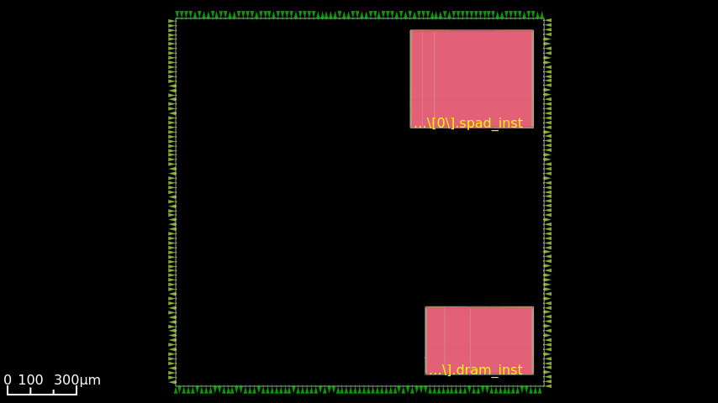
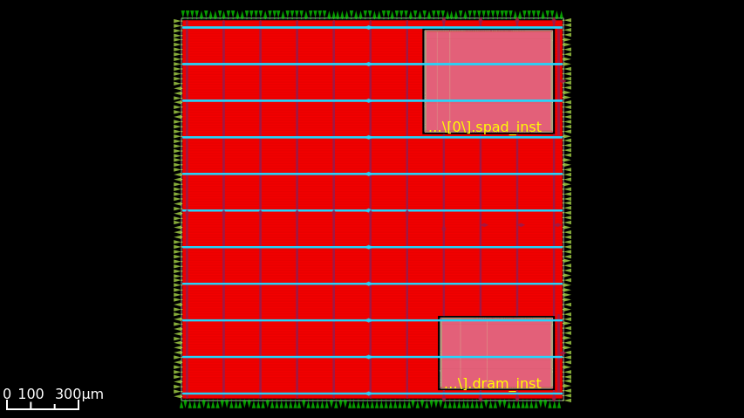

And the final die photo (after routing)
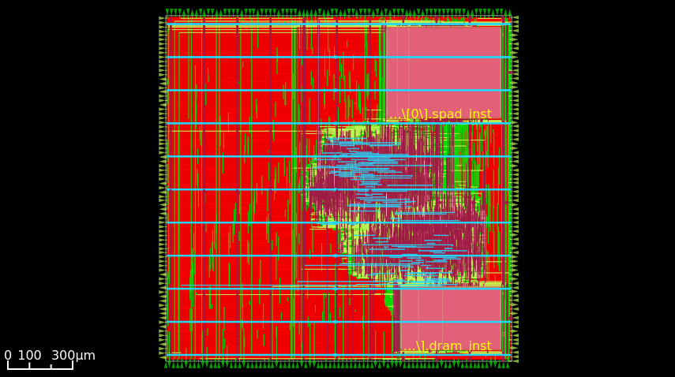
Photo 2: Signoff - Basic Pipelined (50MHz)

