**TARP Project title:**

**ESSENTIAL MEDICAL NEEDS:**

**TEAM MEMBERS:**

B. KIRAN KUMAR REDDY 🡪17MIS1019

S. SUKESH KUMAR 🡪17MIS1039

**PLAGIARISM CHECKING:**

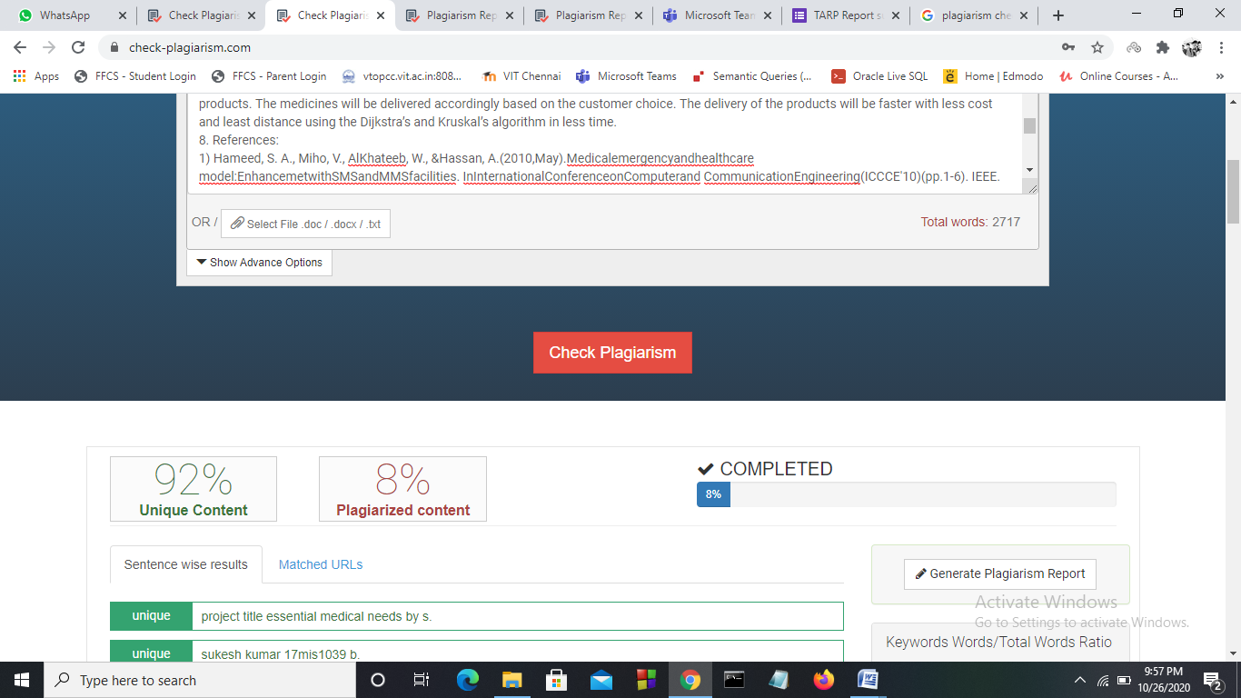

PLAGIARISM REPORT:

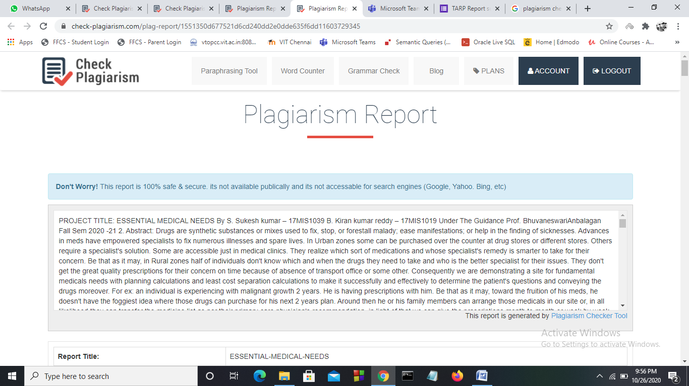

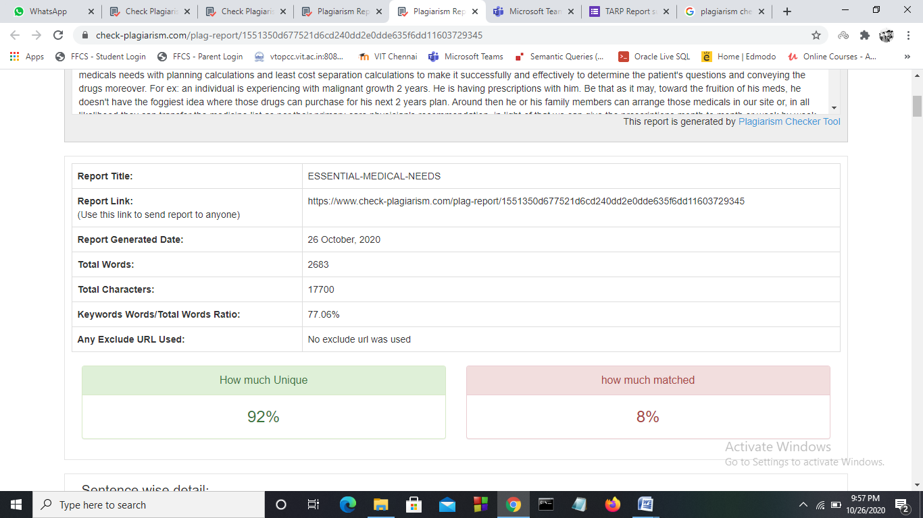

**LINK TO VIEW THE PLAGIARISM REPORT:**

https://www.check-plagiarism.com/plag-report/1551350d677521d6cd240dd2e0dde635f6dd11603729345