Intelligent Credit Card Fraud Detection
An explainable, cost-aware fraud triage prototype
BYOC Technical Report | Data Analytics | 11 October 2026

1. Executive Summary
The business problem is to prioritize suspicious card transactions without overwhelming analysts with false alarms. Fraud is rare by design in this benchmark, so accuracy alone is misleading: a classifier that always predicts legitimate transactions can score almost 100% accuracy while catching no fraud. The project builds an end-to-end, reproducible triage workflow with data profiling, exact-duplicate analysis, chronological validation, imbalanced classification, hypothesis tests, feature attribution, cost-scenario threshold analysis, and a local interactive decision interface.

Approach
- Data: the supplied ULB/Kaggle public benchmark (284,807 rows, 31 columns); the untouched raw file is retained outside the Git repository.
- Preparation: document 1,081 exact duplicate rows (19 label fraud); deduplicate for the primary modelling experiment and retain the ambiguity as a limitation because no transaction ID exists.
- Evaluation: stable chronological 60/20/20 train-validation-test split, with metrics focused on average precision, precision, recall, F1 and operational review volume.
- Models: class-weighted Logistic Regression baseline and XGBoost; use local TreeSHAP attributions to support investigation, not causal claims.
- Decision interface: Streamlit dashboard and optional FastAPI endpoint; Power BI-ready KPI/time-bucket/high-risk CSV exports.

Measured outcome on the held-out test window
Metric | Measured value | Interpretation
Average precision (XGBoost) | 0.786 | Ranking quality on rare positives; test prevalence is only 0.130%
ROC-AUC (XGBoost) | 0.980 | Discrimination across thresholds; not a business outcome by itself
Precision / recall / F1 at 0.50 | 0.414 / 0.811 / 0.548 | 60 frauds detected; 85 false alerts; 14 missed frauds
Rows scored in test | 56,746 | 74 fraud labels in chronological holdout

Quantified impact: at score threshold 0.50, the model flagged 145 of 56,746 held-out transactions, correctly identified 60 of 74 fraud labels (81.1% recall), and generated 85 false positives. In the illustrative cost scenario (false negative = 20 units, false positive = 1 unit), test cost was 365 units versus 1,480 units for an “approve everything” baseline. These are scenario units—not actual issuer losses or currency. Threshold tuned on the validation period did not improve the held-out cost, demonstrating instability that must be addressed before production.
Recommendation: use this as an offline human-in-the-loop investigation prototype. Do not auto-block transactions based on the benchmark score. Deployment would require current issuer data, calibrated scores, actual business-cost estimates, shadow testing, drift monitoring, governance and human review.

2. Introduction & Business Context

Business problem and decision
Card issuers must decide which transactions merit a closer look under limited investigation capacity. A fraud detector balances two different errors: a false negative can allow fraud to proceed, while a false positive can block a genuine customer and increase review load. The relevant question is therefore not “How accurate is the classifier?” but “At a chosen operating point, how many frauds are caught, how many legitimate transactions are escalated, and what is the estimated cost trade-off?”

Stakeholders and decisions
Stakeholder | Decision supported | What the prototype provides
Fraud operations analyst | Prioritize transactions for manual review | Ranked score, risk tier, top feature attribution and filterable rows
Fraud strategy / risk lead | Set review thresholds and error-cost priorities | Precision-recall metrics and scenario-based threshold sweep
Data / ML engineering | Reproduce and maintain the pipeline | DuckDB SQL ingestion, feature module, model metadata and tests
Business / product owner | Evaluate operational usefulness | Power BI-ready outputs and transparent limitations

KPIs and hypotheses defined up front
- Primary model KPI: average precision on the untouched chronological test set; this evaluates ranking under extreme class imbalance.
- Operational KPIs: recall, precision, F1, true/false positives and false negatives at a stated score threshold; review volume and scenario cost are reported beside model metrics.
- H1 (amount distribution): transaction-amount distributions differ between fraud and legitimate transactions; test using a two-sided Mann–Whitney U test.
- H2 (time cohort): fraud prevalence differs between the first and second chronological halves; test using a two-proportion z-test and Wilson confidence intervals.

Scope boundary
The data span two days in September 2013 and contain anonymized PCA components rather than customer/merchant features. Therefore the analysis can evaluate the modelling mechanics and analyst workflow, but it cannot estimate contemporary portfolio-wide fraud losses or explain components such as V14 in business language. No causal claim is made from observational correlations.

3. Data Architecture & Methodology

Data source and provenance
Source: Kaggle, “Credit Card Fraud Detection,” attributed to the Machine Learning Group at ULB (Université Libre de Bruxelles). The benchmark describes 284,807 transactions over two days, including 492 frauds. Its 30 numeric inputs are `Time`, `Amount`, and `V1`–`V28`; `Class` is the target. The source page identifies the database as Open Database and contents as Database Contents. `docs/DATA_PROVENANCE.md` documents ODbL 1.0 and cautions that the project code licence does not cover the dataset.
Element | Finding / treatment
Input size | 284,807 rows × 31 columns; CSV approximately 150.8 MB
Missingness | 0 missing cells across the supplied columns
Target balance | 492 raw frauds (0.1728%); 284,315 legitimate rows
Exact duplicates | 1,081 full-row duplicates; 19 of the duplicate rows are fraud labels
Feature semantics | V1–V28 are PCA-transformed/anonymized; Time is elapsed seconds, not an absolute timestamp
Legal / privacy | No direct cardholder identifiers in the supplied schema; still follow source licence and platform policies

Architecture decisions and why
- DuckDB is the intended in-process SQL engine for reading the raw CSV, profiling it, deduplicating in SQL and materializing a Parquet analytical table; this satisfies the Data Analytics scope emphasis on high-performance query processing.
- Pandas/scikit-learn/XGBoost handle model fitting; the deduplicated dataset fits in memory on a typical developer machine, while SQL is used for ingestion/profile/aggregate operations.
- Stable chronological 60/20/20 partitioning avoids using later observations to predict earlier ones. It is more realistic than a random split for temporal transaction data, though it exposes temporal drift.
- The raw CSV is immutable and ignored by Git; generated Parquet and full predictions are also ignored to prevent large-file churn. Small sample data, metrics and visuals are bundled for offline review.

3. Data Architecture & Methodology

Ingestion, profiling and transformations
The reproducible path is: raw CSV → DuckDB `read_csv_auto` and SQL profile → exact distinct rows ordered by Time → compressed Parquet → feature generation → temporal partitions → model fitting and evaluation → prediction/aggregate exports. The repository includes `src/fraud_capstone/duckdb_pipeline.py` for SQL ingestion and aggregation. The supplied outputs were calculated against the attached CSV in the artifact-building runtime; DuckDB itself was not installed in that runtime, so the actual DuckDB execution path must be run after installing `requirements.txt` on the evaluator machine. This tooling-verification limitation is explicitly recorded rather than claiming it was executed here.

Data quality and duplicate treatment
The source contains 1,081 exact duplicate records (19 of those have Class=1). The primary model table uses 283,726 rows with 473 fraud labels after exact-row deduplication. The original file remains unchanged. The trade-off is deliberate: duplicates can produce leakage if identical rows straddle a split; however, because no unique transaction ID exists, identical rows might represent separate but indistinguishable events. The report therefore treats deduplication as a modelling assumption and recommends sensitivity analysis with both variants.

Outliers and missing data
No missing cells were present, so no imputation was performed. Amount has a long right tail: median legitimate amount is 22.00 dataset units; its IQR rule flags 31,904 records as potential outliers. These records were not removed or clipped: high amounts may be exactly the behaviour of interest, and automatic outlier deletion could erase fraud signal. `log1p(Amount)` is added as a scale-compressing model feature while retaining raw Amount for reporting.

Feature engineering
Feature group | Transformation | Rationale
PCA features | Retain V1–V28 as numeric inputs | Already anonymized/transformed; no fabricated business meaning assigned
Amount | Raw Amount plus log1p(Amount) | Retains interpretation in dataset units and reduces long-tail scale effect
Time | Sine/cosine of Time modulo 86,400 seconds | Allows a cyclic elapsed-time representation; not claimed to be true local clock time
Target | Class (0/1) | Binary supervised label; excluded from features

Imbalance and model selection
The model uses class weighting (`scale_pos_weight` estimated from training rows) rather than applying SMOTE across the full dataset. This avoids synthetic observations leaking into validation/test data. Logistic Regression provides an interpretable baseline; XGBoost supplies nonlinear interaction capacity. The score is not calibrated, so downstream use is framed as ranking and thresholded review, not a literal probability claim.

3. Data Architecture & Methodology

Statistical validation
The tests were selected before inspecting individual feature stories to reduce data dredging. The Mann–Whitney U test compares rank distributions for Amount under a two-sided alternative. The time-cohort analysis splits the chronologically ordered deduplicated data into equal-sized halves, then compares fraud proportions using a two-proportion z-test; Wilson intervals show uncertainty around each rate. These tests establish association/difference, not causation.
Test | Null hypothesis | Statistic / p-value | Finding
H1: Amount distribution | Fraud and legitimate amount distributions are identical in rank distribution | U=59,517,130; p=2.69e-05 | Reject at 5%; fraud median 9.82, legitimate median 22.00. Means reverse due to the fraud distribution tail.
H2: time cohort rate | Fraud proportions are equal in first and second halves | z=2.347; p=0.0189 | Reject at 5%; first half 0.1847% vs second 0.1487%. Difference is descriptive, not causal.

Evaluation protocol
- Training window: first 60% of deduplicated chronological rows (170,235 rows; 342 fraud labels).
- Validation window: next 20% (56,745 rows; 57 fraud labels); used for model comparison and selecting a candidate threshold under an explicit cost scenario.
- Test window: final 20% (56,746 rows; 74 fraud labels); held aside until final evaluation.
- Metrics: average precision, ROC-AUC, precision, recall, F1, confusion counts and scenario cost. Accuracy appears only as a cautionary baseline.

Threshold cost scenario
The decision analysis assigns 20 relative cost units to a false negative and 1 unit to a false positive. These weights are transparent sensitivity assumptions because the dataset contains no observed fraud-loss or manual-review cost field. The validation-period optimum is reported, then tested without retuning on the later period. If validation and test disagree, that disagreement is a finding about instability—not a reason to retrospectively tune the test threshold.
Statistical references: SciPy Mann–Whitney U, statsmodels proportion tests and confidence intervals, and scikit-learn Average Precision / precision-recall evaluation. Links appear under Limitations & Future Work / References.

4. Implementation & Results

Class imbalance and amount distributions
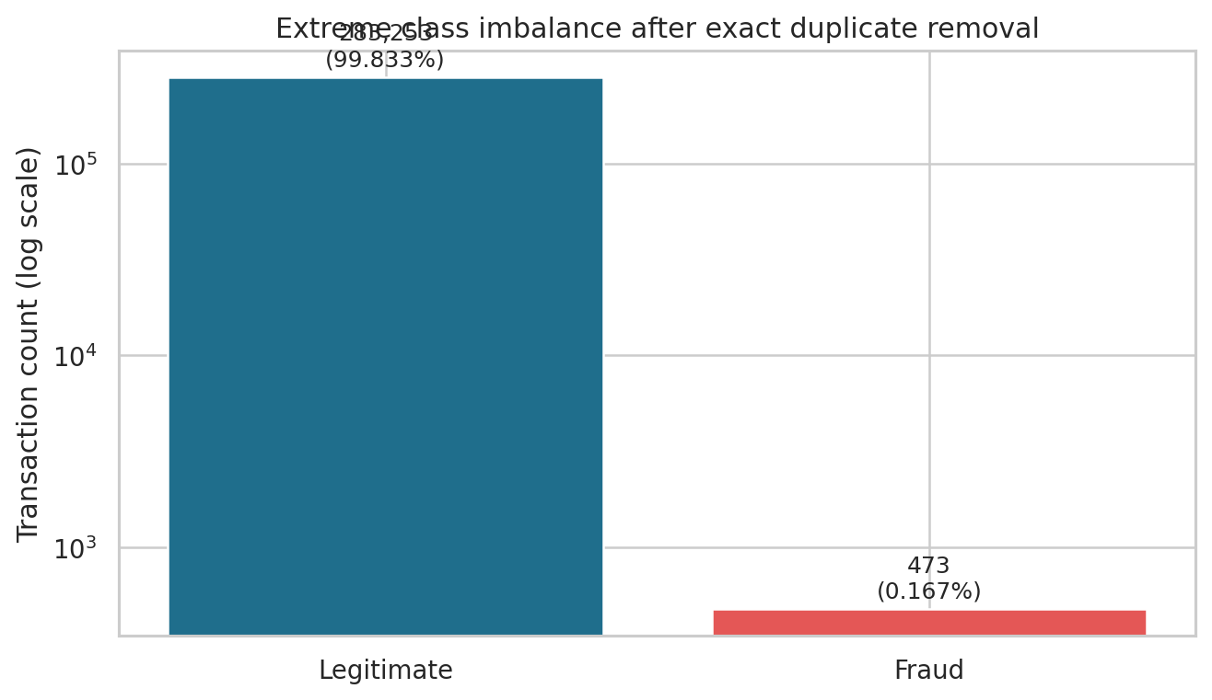
Figure 1. Class counts after exact duplicate removal; log scale makes the minority class visible.
After deduplication, 283,253 legitimate transactions and 473 fraud transactions remain. Fraud prevalence is 0.1667% (Wilson 95% CI 0.1524%–0.1824%). This is still an extreme imbalance: an all-legitimate classifier has about 99.870% test accuracy but zero fraud recall.
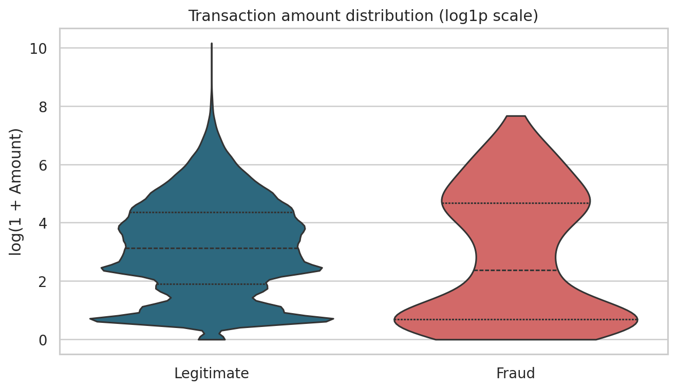
Figure 2. Distribution of log1p Amount by label.
The fraud amount median (9.82) is below the legitimate median (22.00), but the fraud mean (123.87) is higher than the legitimate mean (88.41). This divergence indicates a heavy right tail: a single mean or median cannot summarize both typical transactions and high-value extremes. The significant Mann–Whitney result supports a distributional difference, not the claim that amount alone identifies fraud.

4. Implementation & Results

Temporal cohort diagnostic
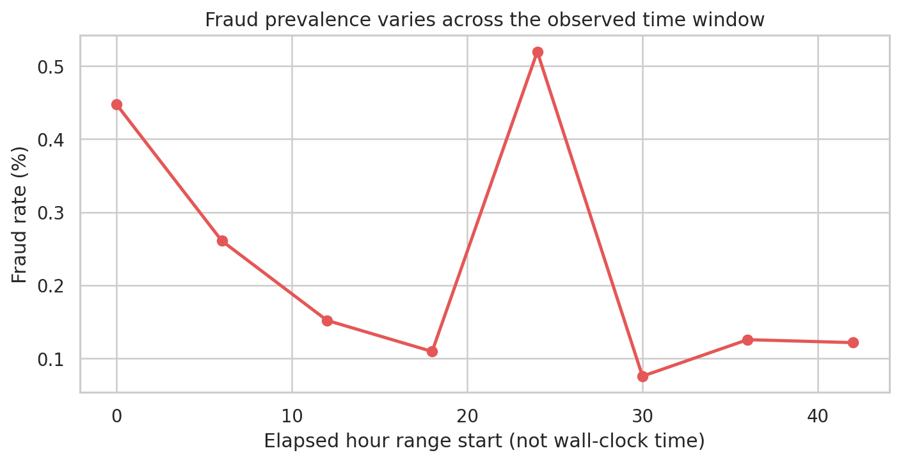
Figure 3. Fraud rate by six-hour elapsed-time blocks; elapsed time is relative to the first row.
The chronological cohort test found a difference in fraud prevalence between halves: 0.1847% vs 0.1487% (p=0.0189). The data span only about 48 hours; the pattern may reflect time drift, sampling, or sequence effects. This is an association, not causation, and should be rechecked on broader and more recent data.
Hypothesis | Test result | Interpretation
H1 — fraud and legitimate Amount distributions differ | Mann–Whitney U=59,517,130; p=2.69e-05 | Reject at 5%; medians 9.82 (fraud) vs 22.00 (legitimate). Distribution differs, but Amount alone is not a fraud rule.
H2 — fraud prevalence is equal in the two chronological halves | z=2.347; p=0.0189 | Reject at 5%; first half 0.1847% vs second 0.1487%. The direction may not persist.

Statistical significance does not establish operational value by itself. The test data contain few positive labels, observations are temporally ordered, and this benchmark covers only two days. Effect size, confidence intervals, alert volume and prospective validation must accompany any adoption decision.

4. Implementation & Results

Model comparison on the chronological test set
Model (threshold 0.50) | AP | ROC-AUC | Precision | Recall | F1 | TP / FP / FN
Always legitimate baseline | 0.001 | 0.500 | 0.000 | 0.000 | 0.000 | 0/0/74
Logistic Regression (class-weighted) | 0.750 | 0.982 | 0.024 | 0.905 | 0.047 | 67/2716/7
XGBoost (class-weighted) | 0.786 | 0.980 | 0.414 | 0.811 | 0.548 | 60/85/14

XGBoost reached average precision 0.786 and ROC-AUC 0.980. At 0.50 threshold it caught 60/74 fraud labels (recall 81.1%), with 85 false positives. The class-weighted Logistic Regression baseline reached AP 0.750; at the same 0.50 cutoff it produced many more positive predictions, showing that scores and thresholds are model-specific.
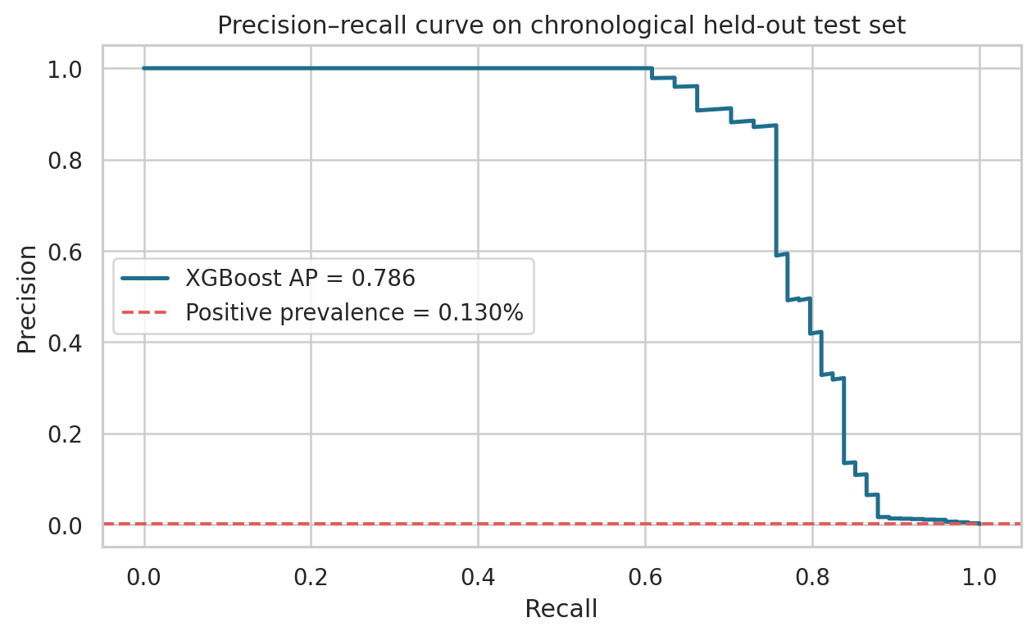
Figure 4. Precision–recall curve; dashed baseline equals test positive prevalence.
Average precision is the primary ranking metric because positive prevalence is only 0.130% in the test window. A model predicting all transactions as legitimate can achieve near-99.9% accuracy but has zero recall and no fraud-detection value. ROC-AUC is useful as a complementary ranking measure, not a substitute for PR analysis.

4. Implementation & Results

Error profile and explainability
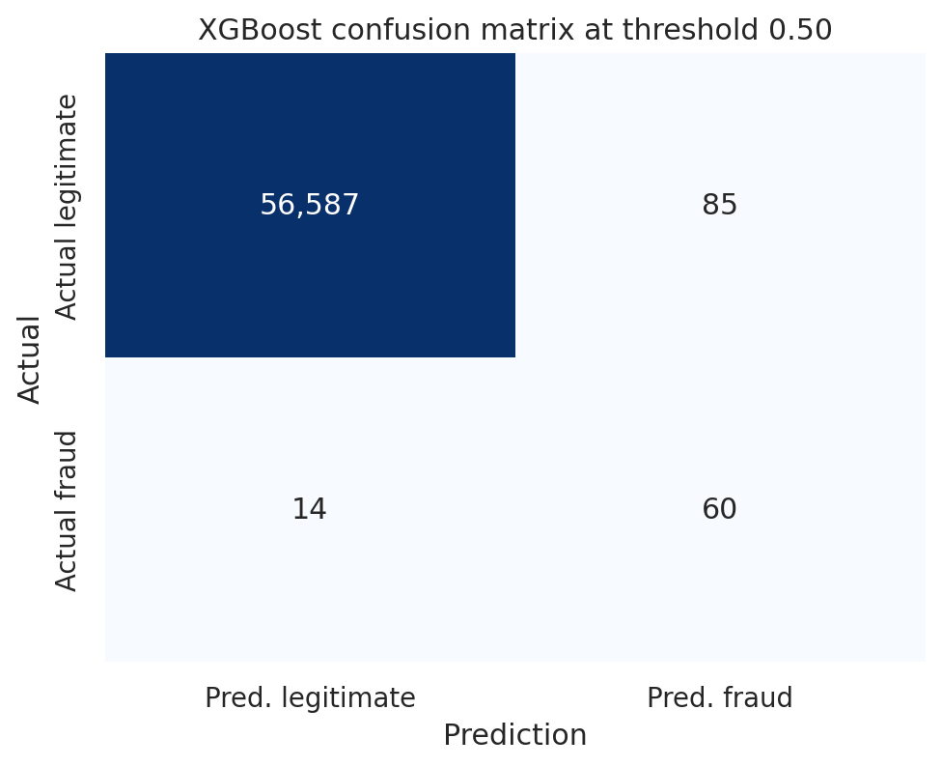  Figure 5. XGBoost confusion matrix at score threshold 0.50. | 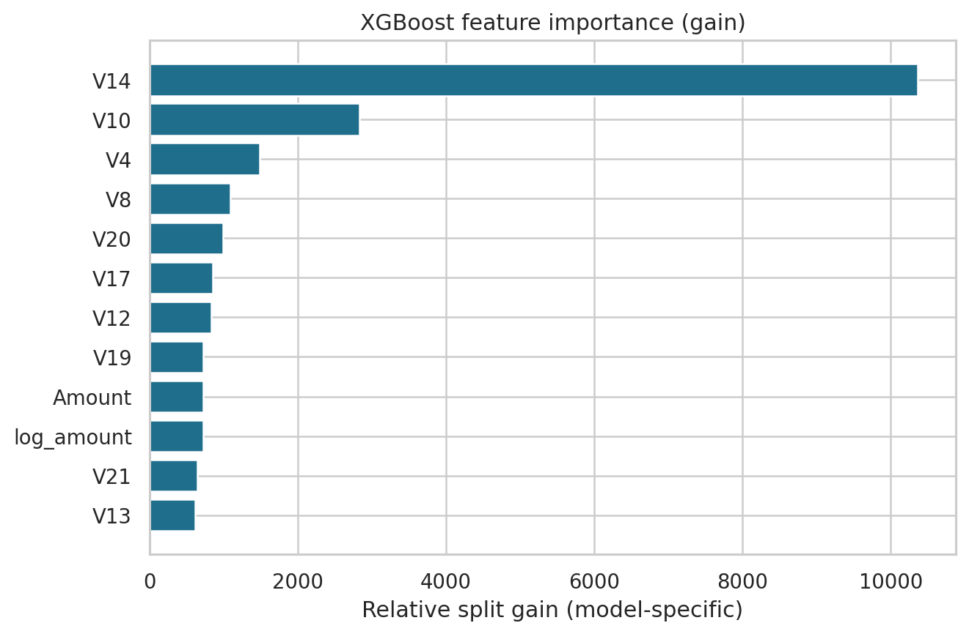  Figure 6. XGBoost gain importance; not causal effects.
At score threshold 0.50, the test confusion counts are TP=60, FP=85, FN=14, TN=56587. The 85 false alerts matter for review capacity and customer friction; the 14 missed fraud labels show that this model must not be treated as a complete control.

Local TreeSHAP and analyst workflow
The scorer exposes XGBoost prediction contributions (TreeSHAP values) for a selected transaction and reports the feature with the largest absolute contribution. V1–V28 are anonymous PCA components; the system deliberately avoids interpreting them as real-world concepts such as geography, device, merchant or customer behaviour. Feature attribution explains the model output, not causality.
The Streamlit application provides an overview, threshold filter, transaction investigation view, model-performance page and downloadable Power BI CSVs. The optional FastAPI `POST /predict` endpoint accepts all required source features and returns an uncalibrated score, risk tier and attribution metadata. Human review is required for flagged transactions.

Reproducibility status
Production logic is modular under `src/fraud_capstone/`; `requirements.txt` constrains versions; tests cover feature generation and model metadata; `.gitignore` excludes raw data and bulky generated files. The bundled compact sample is fraud-enriched for demonstration only and must not be used to estimate prevalence. The DuckDB SQL execution path is included but was not executed in the locked build runtime because DuckDB installation was unavailable; verify locally after installing dependencies.

4. Implementation & Results

Threshold and cost trade-off
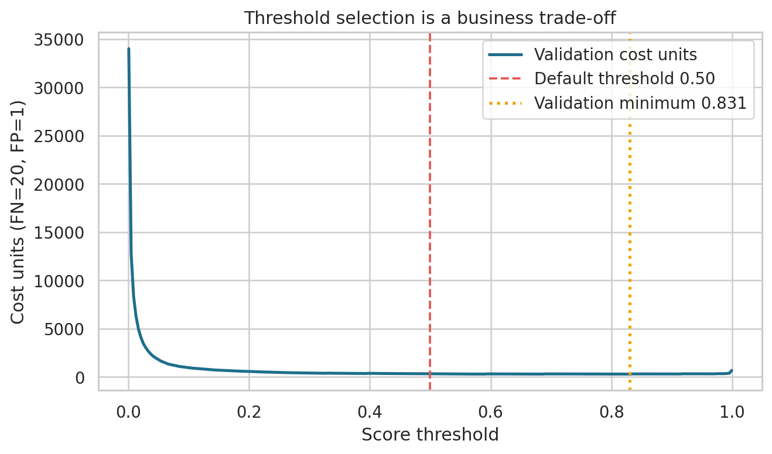  Figure 7. Validation cost across score thresholds; cost weights are assumptions. | 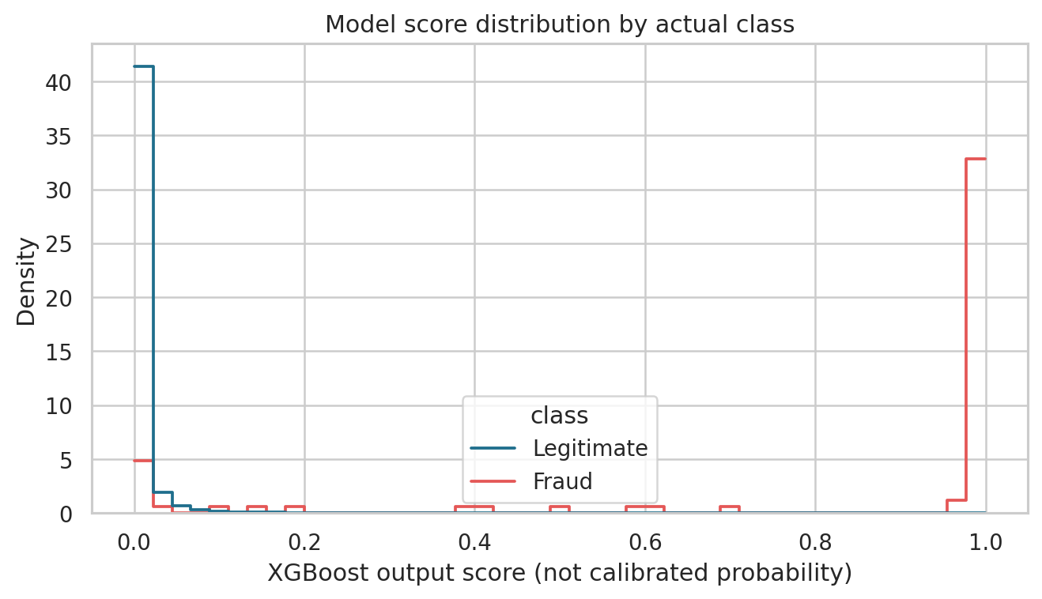  Figure 8. Model-score distribution by true label on test data.
Operating point | TP | FP | FN | Precision | Recall | Cost units
Test, threshold 0.50 | 60 | 85 | 14 | 0.414 | 0.811 | 365
Test, validation-selected 0.831 | 56 | 24 | 18 | 0.700 | 0.757 | 384

The validation minimum occurred near score threshold 0.831 with validation cost 278 units. When carried forward unchanged, test cost was 384, compared with 365 at 0.50. The threshold did not generalize. Validation contained only 57 fraud labels, so threshold estimates are noisy; production selection needs a larger rolling window and actual fraud-loss, review and false-positive costs.
The decision score is not a calibrated probability. The 20:1 false-negative to false-positive cost ratio is illustrative and unitless, not currency. Thresholds should be selected with operations and finance, tested prospectively, monitored by cohort, and used in a human-in-the-loop review queue before any automated payment action.

5. Strategic Deductions & Business Impact

What the metrics mean operationally
At the default 0.50 score threshold, the test window contains 56,746 rows. The model sends 145 transactions for review; 60 carry a fraud label and 85 are false alerts. Fourteen fraud-labelled transactions are missed. Relative to the held-out 74 fraud labels, the detector captures 81.1%, but only 41.4% of its alerts are fraud-labelled. This is a meaningful triage trade-off, not a claim of production savings.
Indicator | Measured result | Decision implication
Frauds captured | 60 of 74 (81.1% recall) | Shows recoverable fraud signal, but 14 miss events remain
False alerts | 85 at threshold 0.50 | Review capacity and customer friction matter; quantify with issuer costs
Review rate | 145 / 56,746 = 0.256% | Can be used to estimate analyst queue volume, not current portfolio impact
Illustrative test cost | 365 cost units at 0.50 vs 1,480 for no alerts | 75.3% lower than no-alert baseline under the stated scenario; not actual currency
Threshold transfer | Validation-selected threshold cost 384 vs 365 at 0.50 on test | Do not hard-code validation optimum without stability tests

Decision recommendations
- Use the model to rank a limited review queue rather than automate authorization. Keep a human reviewer in the loop and log both model score and final decision.
- Select an operating threshold with fraud operations and finance. Replace illustrative cost weights with estimates of fraud loss, customer friction, analyst effort and downstream recovery.
- Validate on temporally later, preferably more recent data. Report precision/recall and queue size by cohort, then run shadow mode before any live workflow.
- Build feedback loops for outcomes: confirmed fraud, false positive, chargeback recovery and review disposition. These labels enable calibration and reliable monitoring.

Expected value method
The next step is a scenario calculator: expected net value = avoided fraud loss − false-positive/customer-friction cost − review operating cost. The current dataset does not contain observed fraud loss, review time, cardholder lifetime value, merchant, or account features, so dollar savings cannot responsibly be estimated from this file. Instead, the prototype reports observable alert counts and transparent relative cost units to make the method auditable.

6. Limitations & Future Work

Limitations
- Age and representativeness: transactions are from September 2013 across roughly two days; performance may not generalize to modern fraud patterns, geographies, devices or payment products.
- Anonymization: V1–V28 are PCA components; model attribution explains mathematical contribution but not the underlying real-world variable.
- Duplicate ambiguity: 1,081 exact duplicates are excluded in the primary experiment, including 19 fraud-labelled rows. Without transaction IDs, true repeated events cannot be distinguished from duplicate records.
- Calibration / threshold instability: XGBoost was trained with class weighting; its scores are not calibrated probabilities. Validation-selected threshold had worse test cost than 0.50 under the chosen scenario.
- Cost assumptions: false-negative and false-positive costs are illustrative relative units; no actual monetary losses or review cost variables are in the data.
- Execution qualification: model/statistical outputs were calculated from the supplied CSV. DuckDB SQL ingestion code is included but was not executed in the locked generation runtime because the DuckDB package could not be installed; verify it locally with `pip install -r requirements.txt` before final submission.
- Operational controls: no real-time stream, identity/entity graph, online feature store, feedback-label pipeline or model monitor is deployed in this four-week prototype.

Future work
- Repeat evaluation with/without deduplication, rolling-origin backtests and confidence intervals for test metrics.
- Calibrate model scores on a dedicated chronological calibration window; use business-approved cost curves and queue capacity to select a threshold.
- Add drift monitoring for score distribution, feature distribution, fraud prevalence and label delay; track operational metrics over time.
- Extend features only when legally available and governed, such as merchant/device velocity and customer history. Add human-review feedback and audit trail.
- If adding a GenAI fraud analyst, ground every summary in actual model outputs and an approved policy corpus. The LLM should communicate evidence—not independently make the fraud decision. Apply the NIST AI RMF risk-management principles.

References and supporting sources
- Kaggle / ULB Machine Learning Group, Credit Card Fraud Detection: https://www.kaggle.com/datasets/mlg-ulb/creditcardfraud
- DuckDB documentation, Python data ingestion: https://duckdb.org/docs/current/clients/python/data_ingestion
- scikit-learn, Model evaluation: https://scikit-learn.org/stable/modules/model_evaluation.html
- Streamlit documentation: https://docs.streamlit.io/
- FastAPI tutorial: https://fastapi.tiangolo.com/tutorial/
- NIST AI Risk Management Framework: https://www.nist.gov/itl/ai-risk-management-framework
- upGrad BYOC Learner Handbook, Deliverable Templates, Data Analytics Scope Specification and Rubrics provided with this capstone.
Prepared for the upGrad Bring Your Own Capstone. Replace programme/track/author metadata before submitting if your cohort requires those details.

