Documentation for Transformation_SAP_Marco_Pack_for_Excel-26OCT15

# Introduction

This marco packs contains 5 VB exported file (.bas) each contains a function for automatizing the less technical and repetitive part in PMO transformation.

Combined, they can perform 3 tasks:

1. Copying operation-wise components from another Group Counter (Trans_Component_Copier.bas & Trans_Component_Paster.bas)
2. Copying operation-wise package list from another Group Counter (Trans_Package_Copier.bas & Trans_Component_Paster.bas)
3. Stripping unwanted PRT attachments (Trans_PRT_stripper.bas)

All these files are Excel-dependent for data storage and reference and thus cannot be executed without having a suitable host – MS Excel. Import is necessary for calling the functions, which the procedure of doing so will be detailed in the following section.

**Please note that the codes are still in a very crude state and will be subjected to change in the future.**

# Installation

The .bas files can be imported into the Excel Marco library in Visual Basic Editor.

To open the VB editor, go to the “Developer” tab and click the “Visual Basic” button:

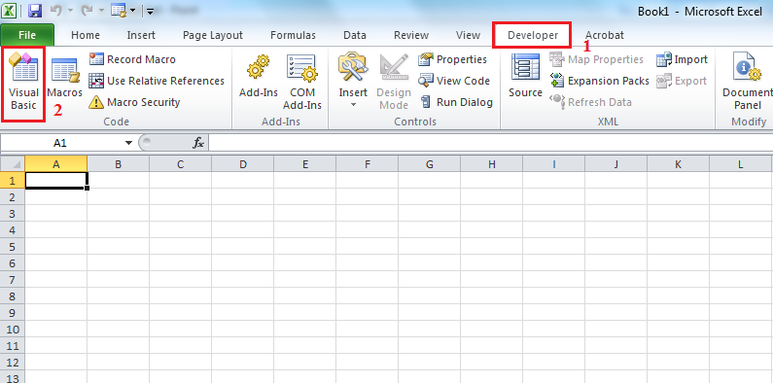  
Fig. 1

Once the editor is opened, please follow these steps to import the files:

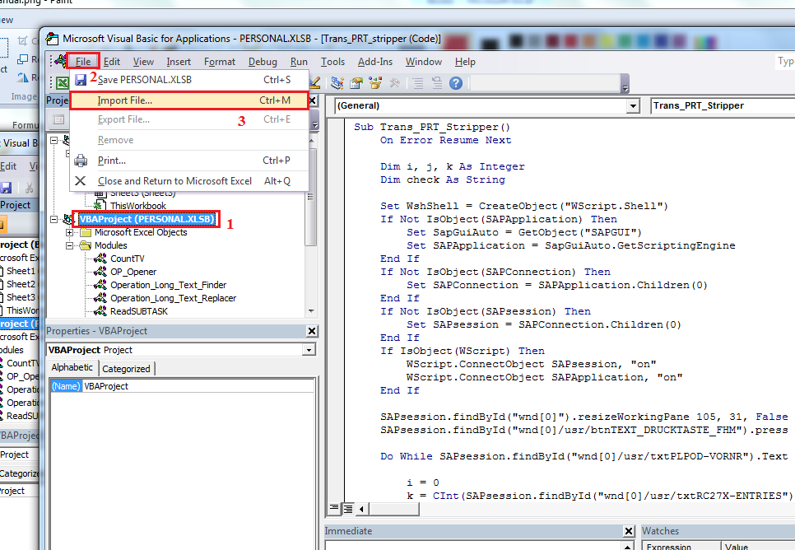  
Fig. 2

Notice that it is crucial to select PERSONAL.XLSB before importing the files, as this will instruct Excel to import the codes into your personal library instead of that of the current workbook.

In the dialogue box, select the files to import. When the import is finished, the codes should appear inside the “Modules” folder:

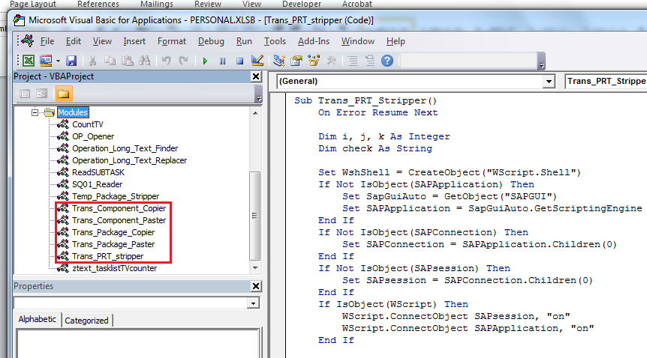  
Fig. 3

The codes are then ready to use and can been called via using shortcuts.

# How to use the Marco

It is very important to notice that the most of the codes are written in SAP GUI Scripting and thus it will only respond to a very specific set of conditions. Unpredicted outcomes may result should the conditions are not met.

Nevertheless, the codes are designed to be error tolerant, so that it should be able to run smoothly if minor deviances present.

Since enabling SAP GUI Scripting to control multiple windows (children) is still in development, the codes - at the present moment - can only control the **FIRST** window opened after login. If the script cannot find the elements referred in the codes in the first window, it will continue to run until it meets with a critical error or it runs to the end of code. Either way will not bring desired outcome and **should be avoided**. You can stop the codes anytime pressing the “Esc” key while the main Excel window is activated.

The codes can be called using the default Marco shortcut (Alt-F8). Select the Marco required and press “Run” to carry out the task. For example, selecting Trans_PFT_Stripper and press “Run” will result in SAP asking permission to run the script. Once allowed to do so, SAP will handle the rest of the work until the end of code:

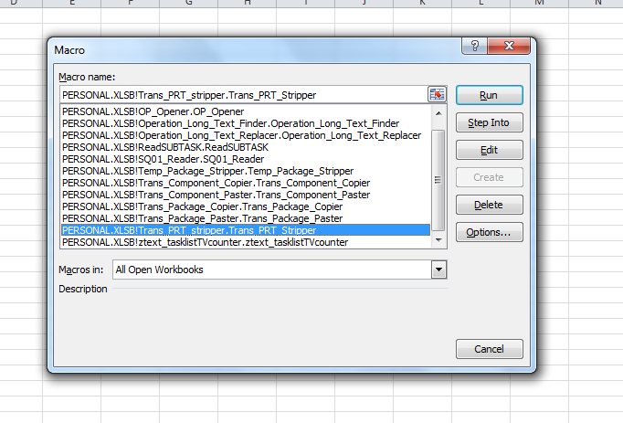  
Fig. 4

## Copying Components

The codes are divided into two parts: Trans_Component_Copier & Trans_Component_Paster.

The Trans_Component_Copier is designed to work in command “ia06” & “ia07”. It will copy all components from **only the** **selected operations**, to the current activated Excel Worksheet (table).

Make sure the activated Excel Worksheet (table) is empty, select the operations you want to copy their components in SAP and **remain on this screen**:

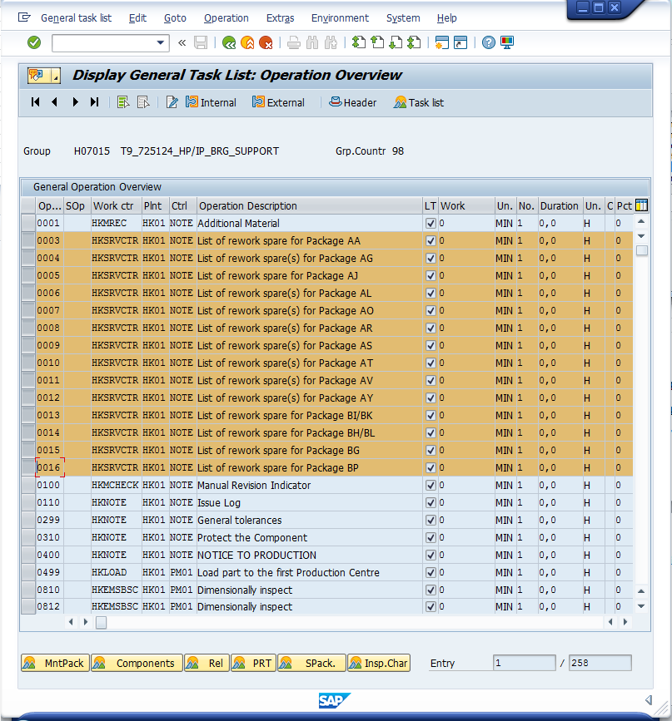  
Fig. 5

Run the codes in Excel, pressing Alt-F8 and select Trans_Component_Copier. Once completed, the Worksheet would be filled like this:

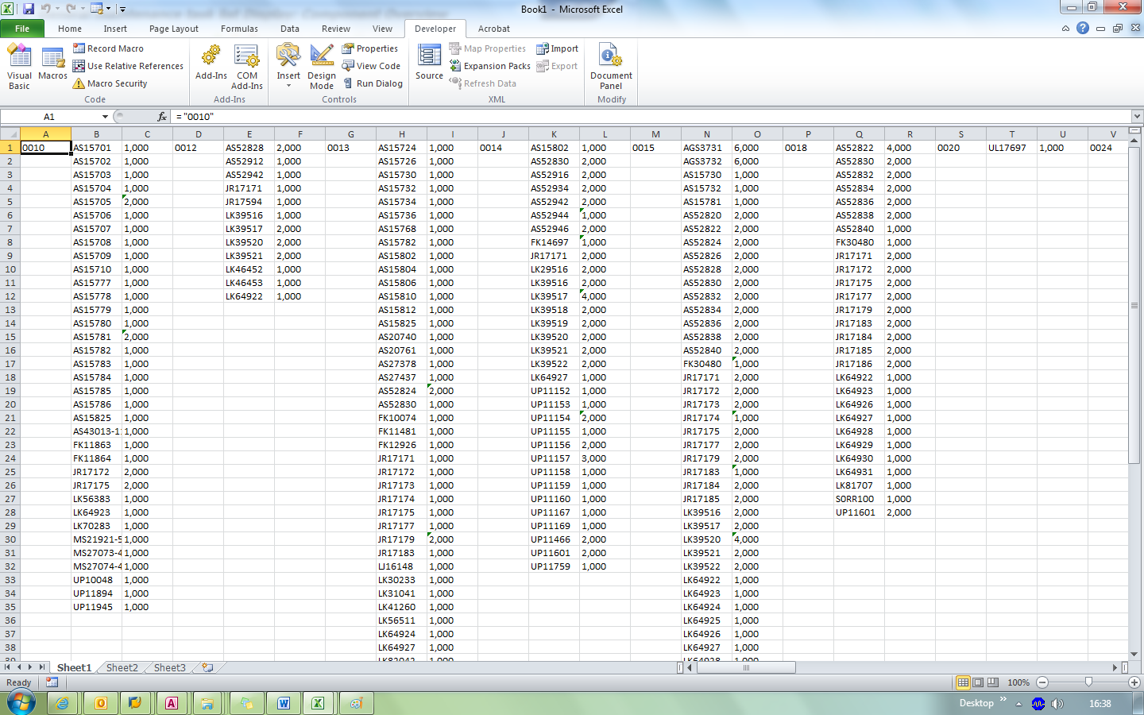  
Fig. 6

Now with the components data has been extracted, prepare to paste the data by opening the new Group Counter and select the **EXACT** operations you have just copied. Make sure the SAP screen remains in the “Operation Overview” screen as in Figure 4. Run the Trans_Component_Paster to paste the copied data to the selected operations.

## Copying Packages

Like its counterpart for copying components, the codes for copying packages also comes in two parts: Trans_Package_Copier and Trans_Package_Paster.

The procedure to utilize the codes is largely the same as in the Article 3.1:

1. Select the operations you want to copy;
2. Run the Trans_Package_Copier code;
3. Change SAP screen to the new Group counter;
4. Select the operations you want to paste in; and
5. Run Trans_Package_Paster to paste the data.

Alternatively, you can press “Select All” in the “Operation Overview” screen to copy from all operations.

## Stripping PRT Attachments

The codes only have one part: Trans_PRT_Stripper.

Select the operations you want to strip the attachments in PRT. The code will **NOT** strip any attachments other than entries that have DAT in the identifier. That means, entries with REC or MAT are unselected during the deletion.

**Alternatively, if you want to preserve certain DAT entries from deletion (i.e. labeling maps and part number lists), enter the IDs in Row A of the Excel table. The code will actively search for those numbers and deselect them during the run:**

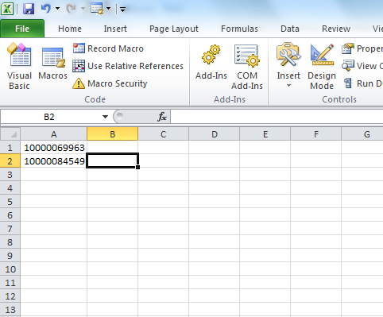  
Fig. 7

In the above example, if A1 and A2 are entered in prior of running the code, it will not delete any “10000069963” and “10000084549” it found in any operations.