Project Three: Data Validation Report
Olga Solodnikova
Southern New Hampshire University
DAT 325: Data Validation: Quality and Cleaning
Instructor: Valisa R. Brown
October 18, 2026

Validations of Data Sets
Provide counts of rows and columns in all data sets.
Data Set | Row Count | Column Count
Cleaned firm’s data set | 94 | 10
Your company’s data set | 105 | 17
Merged data set | 105 | 24
Report the minimum, maximum, and average values of the quantitative variables (after removing negative values and outliers).
Data Set | Minimum | Maximum | Average
Age | 26 | 67 | 38.99
Days Employed | 2 | 3,611 | 1,299.37
The following distributions show the quantitative variables after cleaning. The identified extreme outliers were removed.
Age
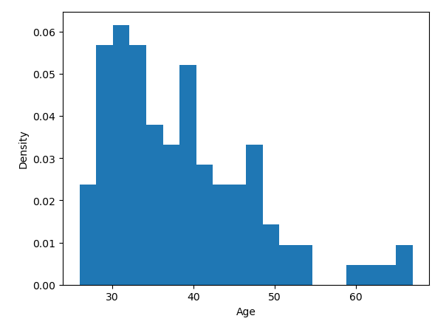
The age outlier of 139 years was identified and removed from the data set. After cleaning, employee ages range from 26 to 67 years, with an average of 38.99 years. The histogram shows that the extreme outlier is no longer present and the remaining ages are within a realistic range.

Days Employed
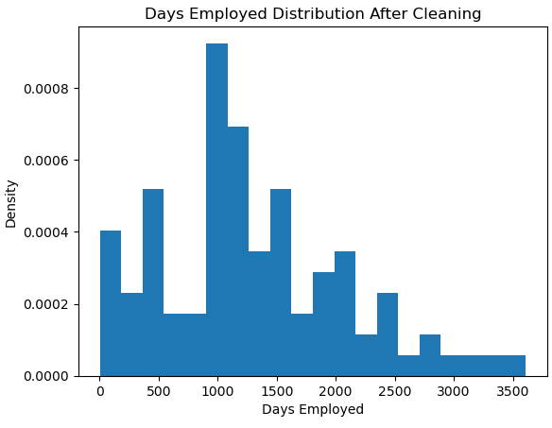
The outlier of 52,246 days employed was removed. After cleaning, the values range from 2 to 3,611 days, with an average of 1,299.37 days. The histogram confirms that the extreme value is no longer present.

Removing the extreme outliers improved the distribution of both quantitative variables. Before cleaning, the Age variable included an unrealistic value of 139 years, and Days Employed included an extreme value of 52,246 days. These values extended the ranges and could distort the averages and visualizations. After cleaning, Age ranged from 26 to 67 years, while Days Employed ranged from 2 to 3,611 days. The histograms now show the distribution of the remaining employee records without these extreme values, making the data easier to interpret and more suitable for analysis.

Summary
Following the DAT 325 Project Three lab procedures (Southern New Hampshire University, n.d.-b), I I cleaned and transformed the acquired firm's employee data using Python and the Pandas library. I used the data profiling results from Project Two to identify missing values, incorrect entries, and outliers. The goal was to improve data quality and prepare the firm's data for integration with our company's existing employee records.
As required by the Project Three validation guidelines (Southern New Hampshire University, n.d.-a), during data cleaning, I replaced missing values in Age and Days_Employed with their median values, which reduced the influence of extreme values on the replacements. I removed records containing negative ages and negative Days_Employed values. I also removed the extreme outliers of 139 years for Age and 52,246 days for Days_Employed. For categorical variables, I removed records with missing or invalid Marital_Status and Citizen_Desc values. After cleaning, the valid categories were Married and NotMarried for marital status, and US Citizen and Eligible NonCitizen for citizenship.
Next, I transformed the Employee_Name column into separate Last_Name and First_Name columns to match our company's data structure. I performed a left merge using Last_Name, First_Name, and DOB as the common variables. The cleaned firm's data contained 94 rows and 10 columns, our company's data contained 105 rows and 17 columns, and the merged data contained 105 rows and 24 columns. The merged data retained all 105 company records, and the column count was consistent with the three shared merge variables. These results support the expected structure of the merge, although the counts alone do not verify that every employee record matched correctly.
To validate the cleaned data, I reviewed the minimum, maximum, and average values and examined the distribution histograms. After cleaning, employee ages ranged from 26 to 67 years, with an average of 38.99 years. Days Employed ranged from 2 to 3,611 days, with an average of 1,299.37 days. The histograms showed that the identified extreme outliers were no longer present. These results confirmed that the cleaning steps removed the identified invalid and extreme numerical values.
Overall, the cleaning, transformation, and validation steps improved the accuracy, consistency, and usability of the acquired firm's data. Checking missing values, filtering invalid records, reviewing numerical distributions, and comparing dataset dimensions helped evaluate data quality and preserve the expected structure of the merged data. The resulting dataset is better prepared for reporting and data-driven decision-making, although additional record-level matching checks would provide further assurance of its integrity.

References
Southern New Hampshire University. (n.d.-a). DAT 325 Project Three guidelines and rubric [Course assignment instructions]. Brightspace.
Southern New Hampshire University. (n.d.-b). DAT 325: Data validation, quality and cleaning—Lab 12.2.2 [Jupyter Notebook lab]. uCertify.

