TASK 1 :
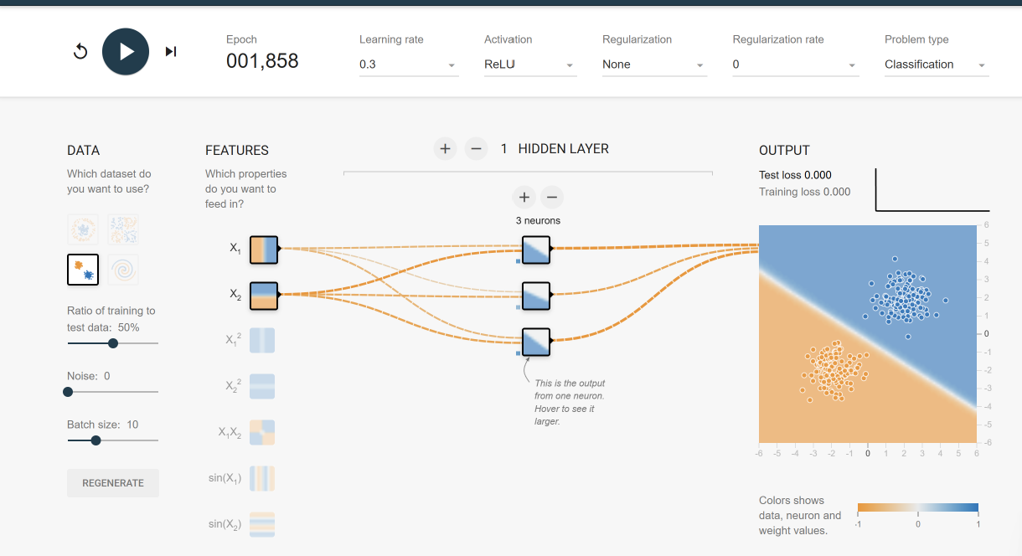
Learning rate 0.3
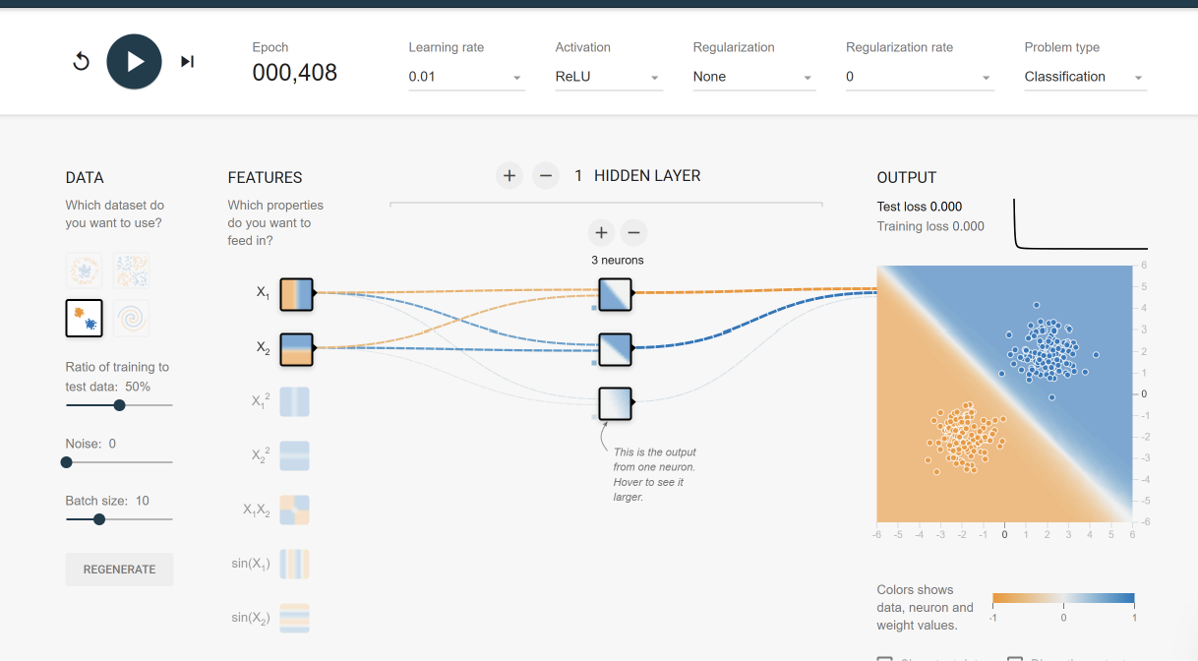
Learning rate 0.01

TASK 2:
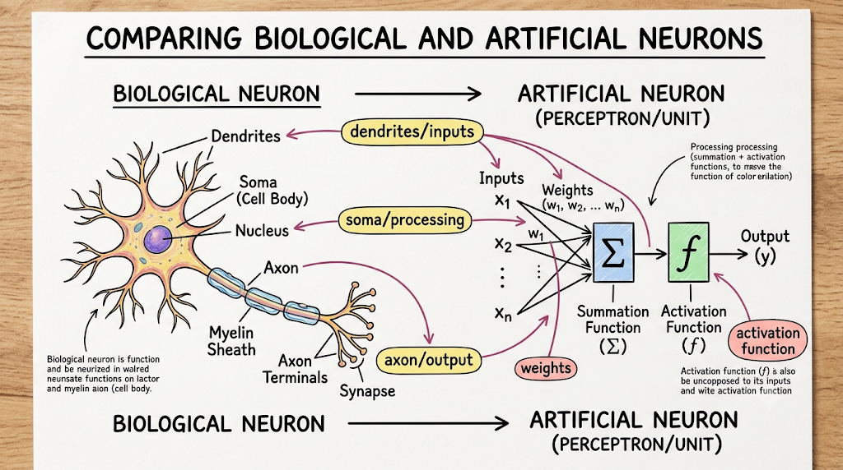
TASK 3 :
YouTube
- Feature using Deep Learning: The Recommendation Engine (Home Feed & Next Up)
- How it works: YouTube uses deep neural networks to filter through billions of videos in real time. The system analyzes watch sequences, search queries, video embeddings, and user interactions to predict which videos will maximize long-term satisfaction and engagement.
- How Deep Learning makes it better: Traditional algorithms struggle with the massive scale and continuous influx of new content. Deep learning models excel at capturing complex, non-linear relationships and temporal patterns (e.g., how interests evolve over a single day versus a month). This allows the feed to instantly adapt to a sudden shift in interest, ensuring the content stays highly relevant and fresh rather than trapping users in repetitive loops.
Notion
- Feature using Deep Learning: Notion AI (Content Transformation and Summary Generation)
- How it works: Notion utilizes Large Language Models (LLMs)—built on deep Transformer architectures—to process workspaces, databases, and long-form notes. The AI parses the text to instantly summarize information, change tones, or extract key action items.
- How Deep Learning makes it better: Unlike older, keyword-matching text processors, deep learning enables a profound semantic understanding of language. It recognizes context, implicit meaning, and long-range dependencies across complex dashboards. This allows the tool to accurately condense a chaotic wall of brainstormed text into a clean, structured set of daily milestones or summaries without losing the core intent.
Spotify
- Feature using Deep Learning: Discover Weekly & Acoustic Recommendation
- How it works: Spotify combines user behavior data with deep learning-driven audio analysis. It uses Convolutional Neural Networks (CNNs) to analyze raw audio signals—effectively turning songs into visual spectrograms—to understand acoustic characteristics like timber, rhythm, key, and intensity.
- How Deep Learning makes it better: Purely behavioral recommendation models suffer from a "cold start" problem, meaning they cannot recommend brand-new or niche tracks because no one has listened to them yet. Deep learning solves this by "listening" to the music itself. By analyzing the structural DNA of a track, the algorithm can accurately match an undiscovered song to a user's unique acoustic profile, greatly increasing the diversity and accuracy of the playlist.

TASK 4: WORKFLOW
1. Data: Collection & Preprocessing
The foundation of any recommendation model is high-quality data. In this stage, you gather and clean the information the model will learn from.
- Collect User Interactions: Gather explicit data (e.g., star ratings, thumbs up/down) and implicit data (e.g., watch time, clicks, search history).
- Collect Metadata: Gather context about the movies (genres, directors, cast, release year) and the users (demographics, location).
- Data Cleaning: Handle missing values, remove duplicates, and filter out bots or inactive users to reduce noise.
- Encoding: Convert categorical data (like User IDs and Movie IDs) into numerical formats that a neural network can process.
- Train/Test Split: Divide your dataset into training (e.g., 80%), validation (10%), and testing (10%) sets based on time (chronological split) to simulate real-world prediction.
2. Model: Architecture Selection
This stage involves designing the neural network architecture that will map user preferences to movie features.
- Choose an Architecture: Select a deep learning structure suitable for recommendations.
  - Neural Collaborative Filtering (NCF): Replaces traditional matrix factorization with a neural network to learn non-linear interactions between users and items.
  - Two-Tower Model: Uses one neural network to encode user features and another to encode movie features, computing the similarity (e.g., dot product) between their final outputs.
- Define Embedding Layers: Set up embedding layers to map sparse categorical variables (like a unique User ID) into dense, low-dimensional vectors.
- Construct Hidden Layers: Add fully connected dense layers with non-linear activation functions (like ReLU) to capture complex patterns in the data.
- Define the Output Layer: For rating prediction, use a single node with a linear activation. For predicting the probability of a user watching a movie, use a sigmoid activation.
3. Training: Optimization & Tuning
Here, you feed your training data into the model so it can learn the optimal weights to make accurate predictions.
- Select a Loss Function: Use Mean Squared Error (MSE) if you are predicting exact ratings, or Binary Cross-Entropy (BCE) if you are predicting clicks or watch probabilities.
- Choose an Optimizer: Use algorithms like Adam or SGD (Stochastic Gradient Descent) to update the model's weights and minimize the loss function.
- Batch Processing: Pass the data through the model in batches (e.g., 256 or 512 interactions at a time).
- Hyperparameter Tuning: Experiment with learning rates, batch sizes, and embedding dimensions.
- Regularization: Apply techniques like Dropout or Early Stopping (halting training when validation accuracy stops improving) to prevent the model from memorizing the training data (overfitting).
4. Evaluation: Metrics & Validation
Before trusting the model in a live environment, you must quantify how well it performs on unseen data.
- Predictive Accuracy Metrics: If predicting ratings, calculate Root Mean Squared Error (RMSE) or Mean Absolute Error (MAE) on your test set.
- Ranking Metrics: Since recommendation is ultimately about ordering items, evaluate the top-$K$ recommendations using:
  - Precision@K: What fraction of the top $K$ recommended movies were actually relevant?
  - Recall@K: What fraction of all relevant movies were found in the top $K$ recommendations?
  - NDCG (Normalized Discounted Cumulative Gain): Does the model put the most highly relevant movies at the very top of the list?
- Sanity Checks: Manually inspect recommendations for a few test users to ensure the model isn't just recommending the most popular movies to everyone.
5. Deployment: Serving & Monitoring
The final stage is taking the trained model and integrating it into the actual application architecture.
- Model Export: Export the trained weights and architecture into an optimized format (like TensorFlow SavedModel or ONNX).
- API Creation: Wrap the model in a lightweight web framework (like FastAPI or Flask) to create an endpoint that the app's backend can call.
- Serving Infrastructure: Deploy the API using containerization (Docker) and orchestration (Kubernetes) to handle multiple simultaneous requests.
- Caching Strategy: For faster load times, pre-compute recommendations for users during off-peak hours and store them in a fast cache (like Redis).
- Monitoring: Set up dashboards to track API latency and recommendation click-through rates. Monitor for "model drift" (when user preferences change over time, rendering the model outdated) and set up automated pipelines to retrain the model with fresh data weekly or daily.

