**Software Requirement Specification (SRS)**

**For**

**Crime Information Management System (CIMS)**

**1. Introduction**

Crime Information Management System (CIMS) is a web based application. This software provides facility for reporting crimes, complaints, missing persons, show most wanted person details online. Any Number of clients can connect to the server.

**Purpose:**

Crime Information Management System (CIMS) allows user to store police department’s case details, Complaint Details, FIR Details, etc. This Software Package allows Police Departments to store all the details related to the department and use them whenever necessary. This project will also be able to provide reports of various cases, FIR report, charge sheet report, Most Wanted Criminals record, payroll, attendance reports and also be able to upload and view criminal photos and scanned documents.

**Scope:**

1. The system should have a login.
2. System should support for Data Entry module for Nominal Roll, Case register for each prisoner entering in the prison.
3. Police officers should have a read only access to the information of prisoners.
4. Data managers must be able to add or update the data of prisoners.
5. Maintenance of Database about criminals and their details of crime
6. The user should be able to view all most wanted persons which can be given by the administrator.

**1.3 Definitions, Acronyms, and Abbreviations:**

**Acronyms and Abbreviations:**

SRS – Software Requirements Specification

CIMS – Crime Information Management System

Subjective satisfaction – The overall satisfaction of the system

End users – The people who will be actually using the system

**Definitions:**

1. HTML: Hypertext Mark-up Language is a mark-up language used to design static web pages.

2. J2EE: Java 2 Enterprise Edition is a programming platform² part of the Java Platform for developing and running distributed multi-tier architecture Java applications, based largely on modular software components running on an application server.

3. GUI: Graphical User interface with the system with mouse control and other easy to use control features like the menus etc.

4. SRS: A SRS is basically an organization's understanding (in writing) of a customer or potential client's system requirements and dependencies at a particular point of time (usually) prior to any actual design or development work. It's a two-way insurance policy that  
assures that both the client and the organization understand each other's requirements from every perspective at a given point of time.

5. Eclipse/Net Beans: Development tool (IDE) for Web applications.

6. JSP: Java server page is a standard part of the J2EE .It is used to create dynamic web pages.

7. Servlets: These are small programs which execute on the server side and dynamically extend the functionality of the web browser .It generally acts as a control in the server side.

8. HTTP: Hypertext Transfer Protocol is a transaction oriented client/server protocol between web browser & a Web Server.

9. HTTPS: Secure Hypertext Transfer Protocol is a HTTP over SSL (secure socket layer).

10. TCP/IP: Transmission Control Protocol/Internet Protocol, the suite of communication protocols used to connect hosts on the Internet. TCP/IP uses several protocols, the two main ones being TCP and IP.

**1.4 References:**

**1.5 Overview:**

The rest of this SRS is organized as follows: Section 2 gives an overall description of the software. It gives what level of proficiency is expected of the user, some general constraints while making the software and some assumptions and dependencies that are assumed. Section 3 gives specific requirements which the software is expected to deliver. Functional requirements are given by various use cases. Some performance requirements and design constraints are also given. Section 4 gives some possible future extensions of the system.

**2. Overall Description:**

**Product Perspective:**

1. The web pages (XHTML/JSP) are present to provide the user interface on customer client side.
2. Communication between customer and server is provided through HTTP/HTTPS protocols.
3. The Client Software is to provide the user interface on system user Client side and for this TCP/IP protocols are used.
4. On the server side web server is for EJB and database server is for storing the information.
5. It is a Window Based Platform.
6. It works on any operating system.
7. The project is user-friendly.
8. This system will reduce the manual operation required to maintain all the records of Police department.

**2.2 Product Functions:**

|  |  |  |
| --- | --- | --- |
| **Class of use cases** | **Use cases** | **Description of use cases** |
| Use case related to login | Login | Login into CRM |
| Use case related to Registration | Registration | Registration of criminal details |
| Use case related to view Registers | View Register | 1.view nominal role  2.view case register  3.view in-out register  4.view parole register  5.view duty register |
| Use case related to generate reports | Report generation | 1.prisoner wise report  2.case wise report  3.visitor wise report |
| Use case related to interview confirmation | Confirm interview request | All interview requests by relatives of  Prisoners |
| Use case related to release diary | View releasing dairy | Information of Release dates of criminal |
| Use case related to change of Password | To change password | Change CRMS password |

**USE CASE Diagram:**

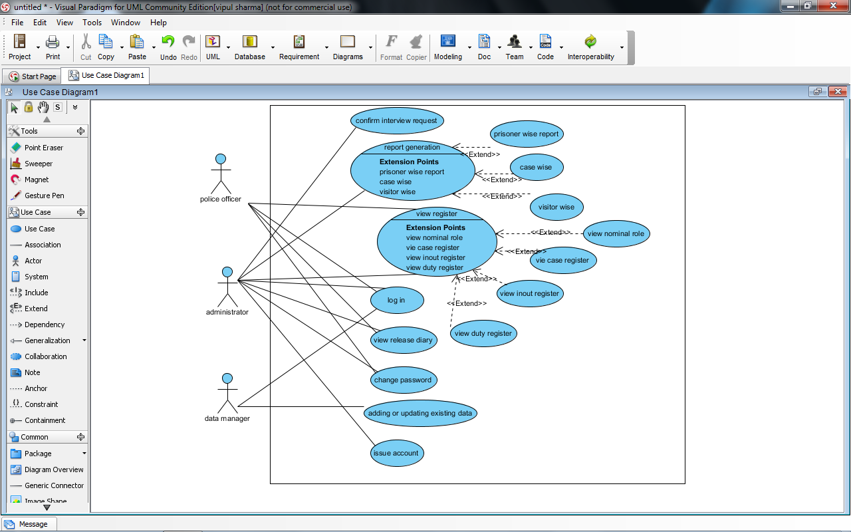

**2.3 User Characteristics:**

1. The user should be familiar with the Criminal Management related terminology.
2. The user should know the details of criminals
3. Operator should be computer literate
4. There will be a screen to display various information related to FIR
5. A login screen for entering username, password will be provided.
6. There will be a screen for taking and modifying the information of the related to FIR

**2.4 Principal Actors:**

The two principal actors in PIMS are “user” and “system”.

**2.5 General Constraints:**

1. For full working CRMS does not require Internet connection
2. CRMS is multi-user software.
3. It works on any Windows Operating system.

**2.6 Assumptions and Dependencies:**

1. Users are related of different branch of police Department

2. The information entered in Records should be correct.

3. User can fill the registration form.

**3 Specific Requirements:**

**1. USE CASE RELATED TO LOGIN:**

`

**Primary actor:**

All registered users having valid accounts  
1) Administrator  
2) Police Officer

3) Data Manager

**Precondition:** INTERNET connection is available and working at its optimal level

**Main scenario:**

1) Users Access the login Page

2) Provide User ID and Password.

3) Login Validity is checked

4) The user is shown their respective homepage.

**Alternate scenario:**

1) The entered User ID or Password is not valid

2) The user is shown the error page.

**2. USE CASE RELATED TO REGISTRATION:**

**Primary actor:** Unregistered Police Officers

**Main scenario:**

1. The visitor accesses the registration page for new ID.  
2. He/she fills up the form and submits.  
3. The completeness of data is checked on client side.  
4. The Database is updated

**Alternate scenario:**

1. The data completeness check fails and the user is prompted to provide all details.

2. The database update fails.

**3. USE CASE RELATED TOVIEW REGISTERS:**

**Primary actor:** Administrator, Police Officer

**Precondition:** Administrator or Police Officer should be logged in to his account

**Main scenario:**

1. Retrieved the nominal roll register, case register, parole register, in-out register from the data base.

2. Viewing of data.

**Alternate scenario:**

1. Data retrieval process failed.

**4. USE CASE RELATED TO GENERATE REPORTS:**

**Primary actor:** Administrator

**Precondition:** Administrator should be logged in to his account

**Main scenario:**

1. Retrieval of data prisoner-wise, case-wise or visitor-wise.

2. Form the retrieved data into printable format.  
3. Print out the retrieved data.

**Alternate scenario:**

1. Retrieval of data failed

2. Printing out of retrieved data failed

**5. USE CASE RELATED TO INTERVIEW CONFIRMATION:**

**Primary Actor:** Administrator

**Precondition:** Administrator should be logged in to his account to access this option

**Main scenario:**

1. Verification status is checked

2. If OK then it is approved.  
3. The database is updated.

**Alternate scenario:**

1. The interview request is not approved.

**6. USE CASE RELATED TO VIEWING OF RELEASE DIARY:**

**Primary actor:**

1) Administrator

2) Police Office

**Precondition:**

1. User must be logged in

2. He/she has to be at his home page

**Main scenario:**

1. Retrieved the release diary information from the data base.

2. Viewing of data.

**Alternate scenario:**

Retrieval of data failed.

**7. USE CASE RELATED TO CHANGE OF PASSWORD:**

**Primary actor:**

1. Administrator
2. Police Officer

**Precondition:**

1. The users should have registered an account with the system.

2. The users are logged into their account.

**Main scenario:**

1. The System asks for the old password.  
2. The User provides his/her old password.  
3. After successful match the system asks to enter the new password.  
4. The Database is updated.

5. The Success page is shown.

**Alternate scenario:**

1. The Old password doesn't match and the error page is shown.

2. The Database Update fails.