**INTERNSHIP CERTIFICATE**

**Date: 13 May 2025**

**TO WHOMSOEVER IT MAY CONCERN**

We are pleased to confirm that **Mr.Rahul Sarwa** has successfully undertaken their role as **Data Analyst**and completed their internship for a period of **2 month from 6 January 2025 to 3 March 2025**.

During their time at **CLUSTOR COMPUTING**, they were punctual, hardworking, and inquisitive. We would like to wish them best of luck for future endeavors and firmly believe that they would become an integral part of a future workplace.

 **Sincerely,**

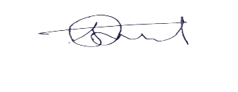

 **Shivam Tarale**

**HR Executive**

**Clustor Computing**