**INTERNSHIP CERTIFICATE**

**Date: {Issue date}**

**TO WHOMSOEVER IT MAY CONCERN**

We are pleased to confirm that **Mr.{Student Name}** has successfully undertaken their role as **{Domain Name}**and completed their internship for a period of **{No of months} from {Start date} to {End date}**.

During their time at **CLUSTOR COMPUTING**, they were punctual, hardworking, and inquisitive. We would like to wish them best of luck for future endeavors and firmly believe that they would become an integral part of a future workplace.

 **Sincerely,**

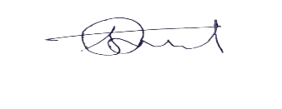

 **Shivam Tarale**

**HR Executive**

**Clustor Computing**