USING NMAP (ZENMAP) TO PERFORM
NETWORK RECONNAISSANCE
Project Documentation

1. Project Overview
This project documents a network reconnaissance exercise using Zenmap, the graphical interface for Nmap. The screenshots show the target field, selection of the Intense scan profile, scan results, the Ports/Hosts view, the Topology view, and Host Details.

2. Objective
To document the use of Zenmap to scan a specified website address and review the resulting port, network topology, and host details.

3. Tool Used
Nmap / Zenmap

4. Procedure

Step 1: Enter the target address
Type the website address into the Target field in Zenmap.
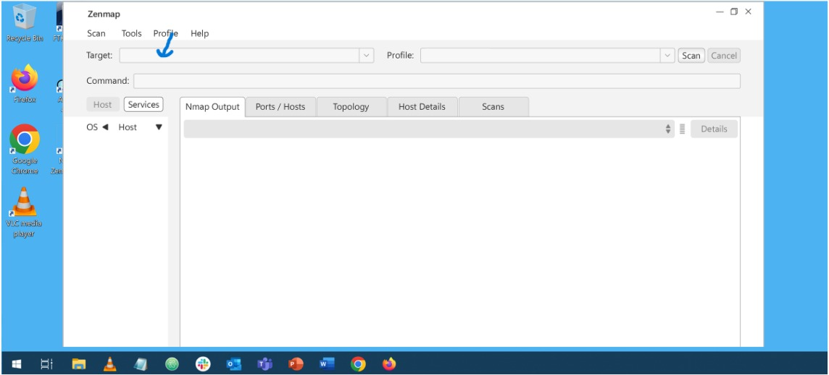

Step 2: Select the Intense scan profile
To perform the scan using the selected profile, choose Intense scan from the Profile drop-down menu.
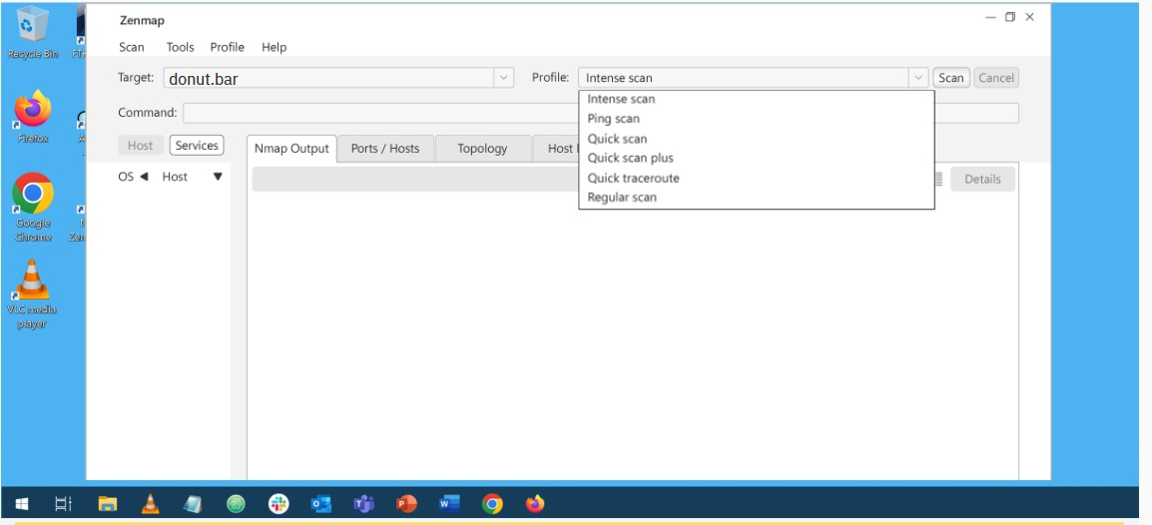

Step 3: Click Scan
Click Scan to run the scan. The screenshot shows the command nmap -T4 -A -v donut.bar and the resulting report for donut.bar at 45.33.32.156.
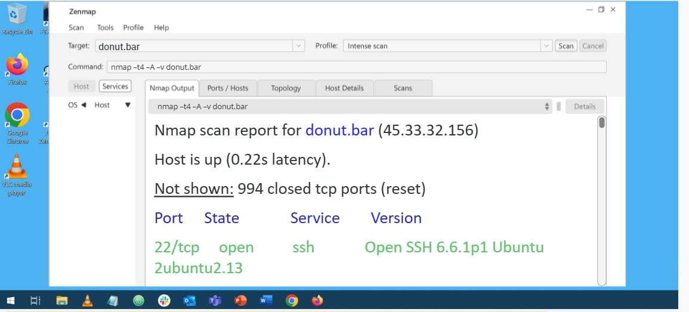

Step 4: Review the Ports/Hosts tab
Select Ports / Hosts to view the listed ports, states, services, and version information displayed by the scan.
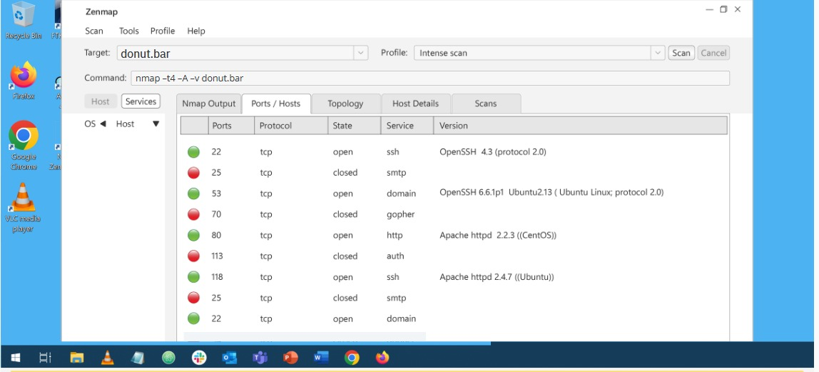

Step 5: Review the Topology tab
Select Topology to view the interactive network-path visualization shown in Zenmap.
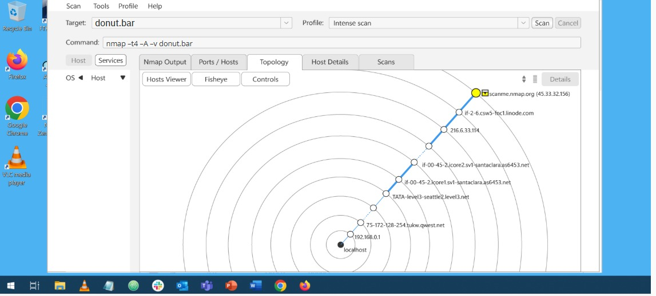

Step 6: Review Host Details
Select Host Details to view the host information, including the IPv4 address displayed in the screenshot.
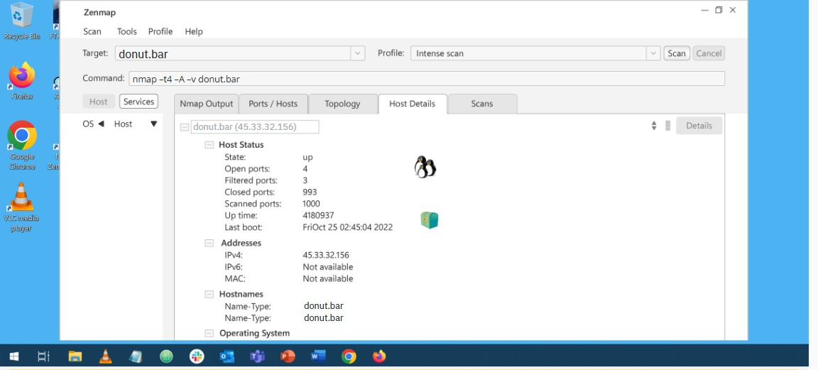

5. Observations From the Screenshots
- The target entered is donut.bar.
- The selected scan profile is Intense scan.
- The scan report identifies the target as donut.bar with IPv4 address 45.33.32.156.
- The scan output reports the host as up.
- The Nmap Output screenshot reports TCP port 22 as open for SSH and shows the OpenSSH version string Open SSH 6.6.1p1 Ubuntu 2ubuntu2.13.
- The Ports / Hosts screenshot lists open entries for ports 22, 53, 80, and 118, and closed entries for ports 25, 70, and 113, as displayed in the interface.
- The Topology tab displays a path visualization between the local system and the target.
- Host Details displays IPv4 address 45.33.32.156.

6. Conclusion
This exercise documents a basic network reconnaissance workflow in Zenmap: entering a target, selecting a scan profile, running the scan, and reviewing port/service output, topology, and host details.

7. Scope Note
Only the actions and results visible in the supplied screenshots are documented here. No additional vulnerabilities, exploitation, or security conclusions are claimed. Scan only systems you own or have explicit permission to assess.

