SPLUNK ENTERPRISE

Threat Investigation of
Multiple Failed Login Attempts
A hands-on log analysis project using the BetterBytes dataset

Project focus: ingest log data into Splunk, filter failed authentication events, investigate repeated attempts from a shared source IP, and preserve results as a table and CSV export.

Practical project documentation

1. Project Overview
This project demonstrates a basic security investigation workflow in Splunk Enterprise. The BetterBytes log archive is uploaded and indexed, then searched for failed login events. The search is narrowed to a source IP address observed in multiple failed SSH authentication events. The results are organized into a table and exported for use as investigation evidence.

Objective
Identify and review repeated failed login attempts, assess whether the pattern is consistent with a possible brute-force attempt, and preserve relevant event records for incident reporting.

Tools and data
- Splunk Enterprise — log ingestion, search, filtering, and table creation.
- BetterBytes Log Files.zip — the uploaded sample log archive.
- Splunk Search Processing Language (SPL) — used to filter matching events.
- CSV export — a portable copy of the investigation results.

Investigation scope and caution
The screenshots show failed SSH login events associated with source IP address 64.66.0.20, including attempts involving usernames such as “inet” and “mailman.” Repeated failures from one IP using different usernames can be consistent with password guessing or brute-force activity. The screenshots alone do not prove that an account was compromised or establish the source’s intent.
Evidence note: The narrowed query displays 655 events for the selected time range. This is the result count shown in Splunk for that query, not a count of confirmed malicious attempts.

2. Step-by-Step Methodology

Step 1 — Open Add Data
From the Splunk Enterprise home page, select Add Data. Choose the upload option and select BetterBytes Log Files.zip from the computer.
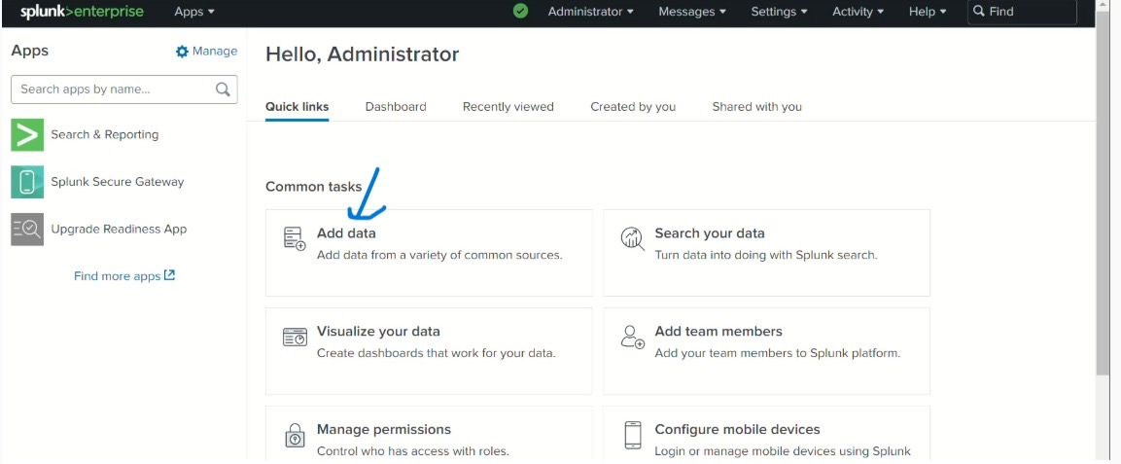
Figure 1. Splunk Enterprise home page with Add Data highlighted.

Step 2 — Configure input settings
Configure the input settings before ingesting the file. The recorded configuration uses Automatic for Source Type so Splunk can attempt to identify the event format. The review screen also shows a regular-expression option for the host/source path setting rather than assigning one constant host value to every event. This can be useful when the archive contains logs from different systems or paths.
Technical note: The screenshot does not show the full regular expression clearly enough to validate every character, so the exact expression is not reproduced here.

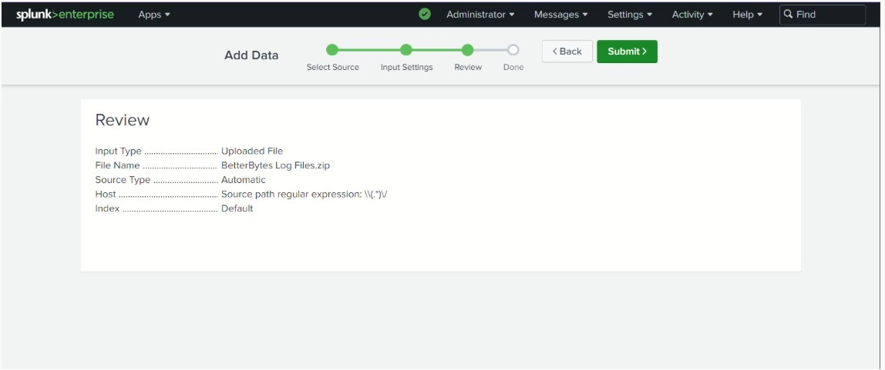
Figure 2. Upload review screen showing the archive, automatic source type, and host/source path setting.

Step 3 — Review the upload configuration
Review the input type, file name, source type, host setting, and index. Confirm that the settings match the intended dataset before submitting the upload.
Figure 3. Upload configuration reviewed before submission.

Step 4 — Submit and start searching
Submit the upload. Splunk displays a success message when the file has been uploaded. Select Start Searching to open Search & Reporting and begin examining the ingested events.
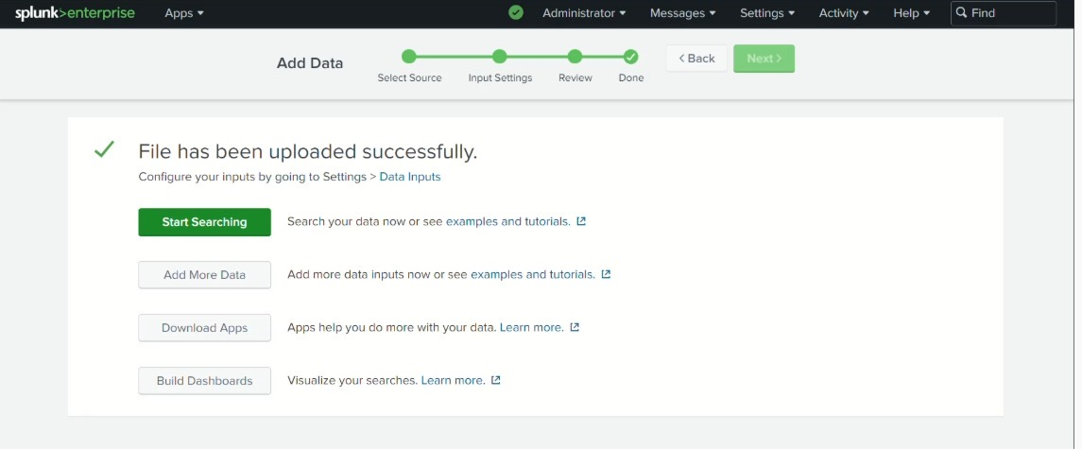
Figure 4. Splunk confirms that the file was uploaded successfully.

Step 5 — Review events and filter failures
The initial search returns many events. Append fail* to the search to narrow the results to events containing text that begins with “fail.” The asterisk is a wildcard that can match additional characters after that text.
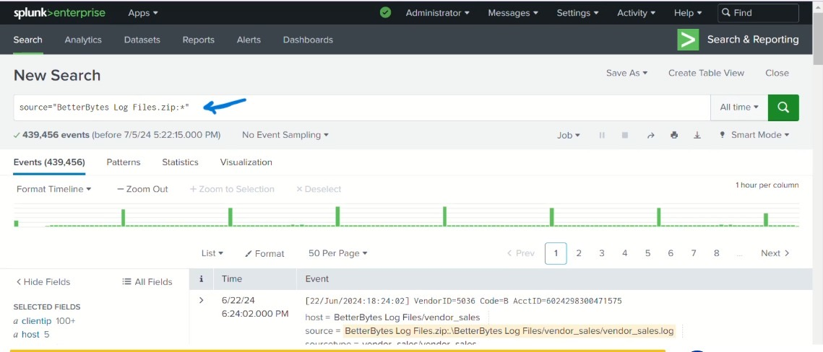
Figure 5. Initial search results from the uploaded BetterBytes log archive.
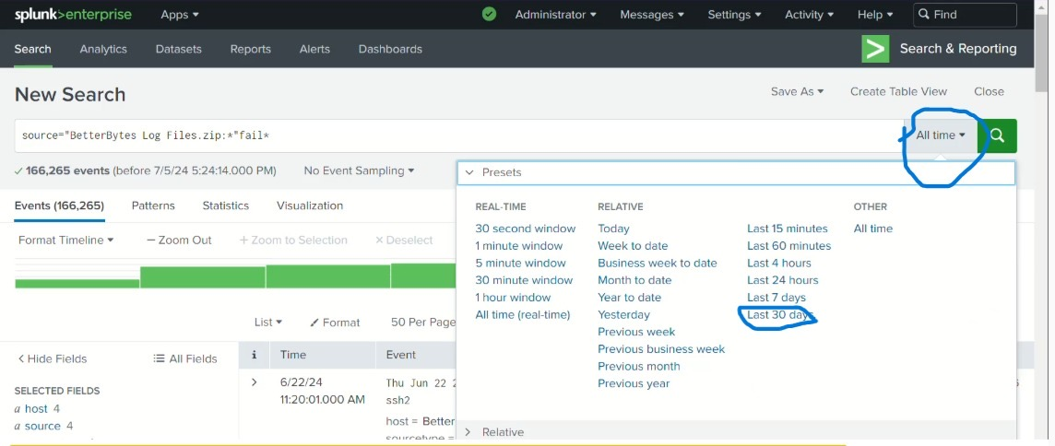
Figure 6. Search narrowed with fail*; the time-range menu is open.

Step 6 — Set the investigation time range
Choose Last 30 days from the time-range selector to focus the search on the relevant period. Confirm that the displayed range covers the events being investigated.
The screenshot shows a window from June 5 to July 5, 2024. Relative time ranges change over time; for repeatable reporting, record exact start and end dates.

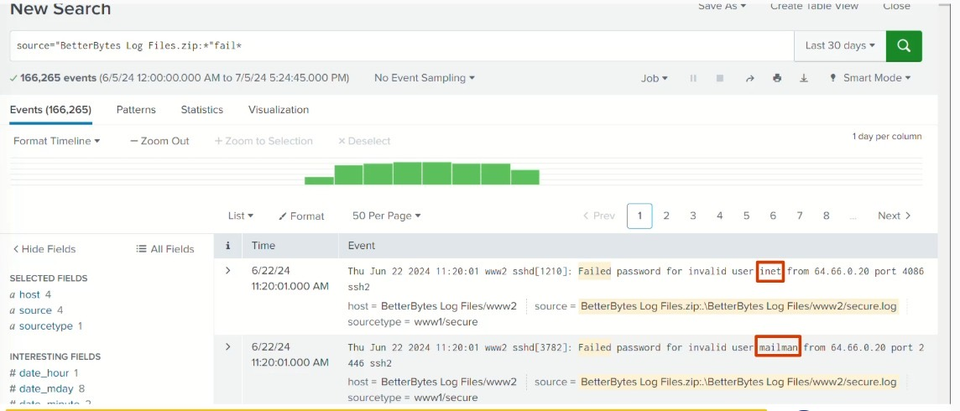
Figure 7. Failed-login results displayed with the Last 30 days time range.

Step 7 — Inspect the failed login events
Review event details for repeated authentication failures. The visible records show failed SSH password attempts for different usernames, including “inet” and “mailman,” from the same source IP address, 64.66.0.20. This pattern is suspicious and merits further investigation.
Figure 8. Example failed SSH password events showing different usernames and the same source IP.

Step 8 — Narrow the search to the source IP
Add 64.66.0.20 to the existing search after the fail* filter. This isolates matching failure events associated with that IP. The screenshot shows 655 matching events in the selected time range, with repeated SSH password failures visible.
Assessment: The pattern is consistent with a possible brute-force or password-guessing attempt. Check successful logins, affected accounts, surrounding activity, source reputation, and whether the activity was expected before reaching a conclusion.

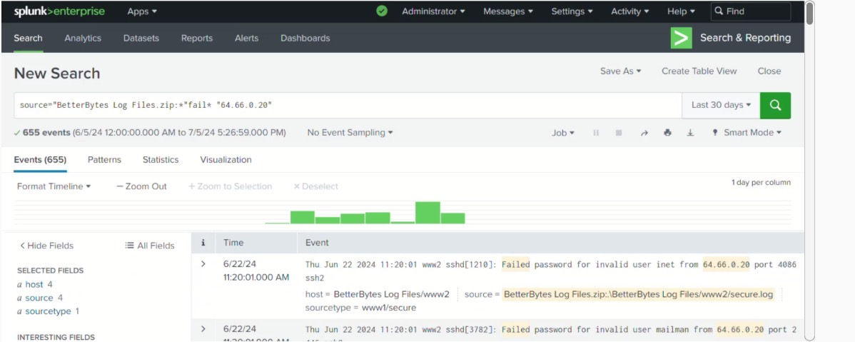
Figure 9. Search filtered by failure text and source IP address 64.66.0.20.

Step 9 — Create a table view
Select Create Table View to organize the search results into a structured view. This makes it easier to review fields such as event time, host, source, source type, and raw event content.
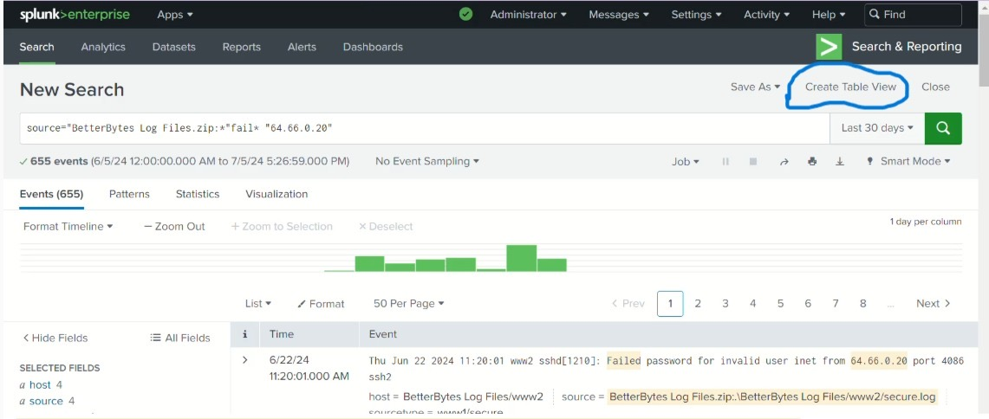
Figure 10. Create Table View option highlighted in the search results.

Step 10 — Save the table view
In the table-view editor, review the preview of selected fields and select Save. The saved investigation is titled “BetterBytes Investigation June 2024.”
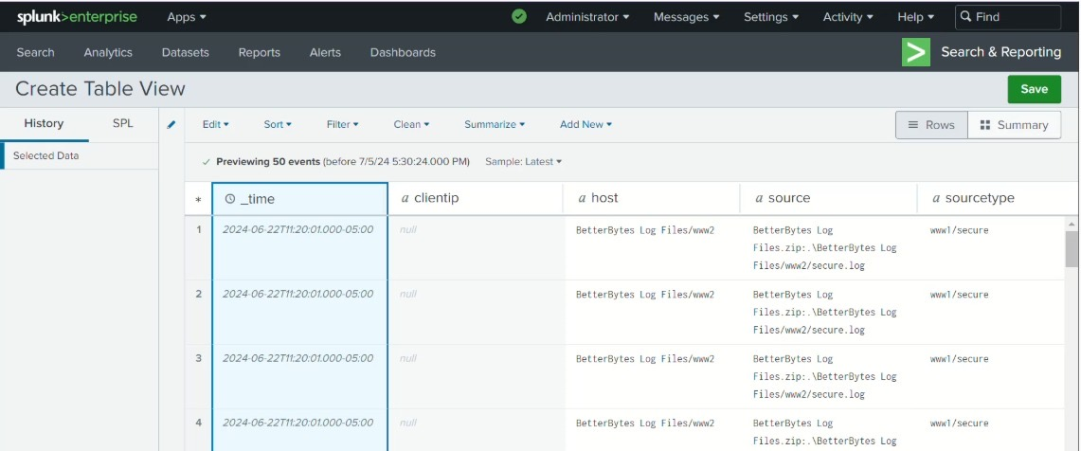
Figure 11. Table-view editor showing a preview of selected event fields.
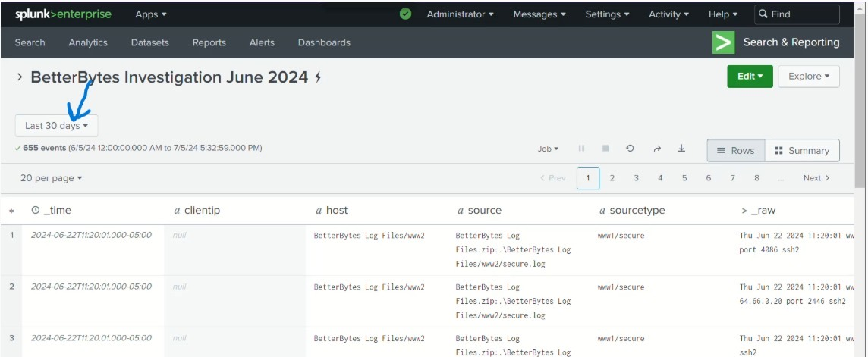
Figure 12. Saved table titled BetterBytes Investigation June 2024.

Step 11 — Review saved results and time range
Open the saved table and confirm that the time range matches the investigation period. In the captured example, the Last 30 days selector is visible and the result set shows 655 events.
For a formal incident report, preserve the exact search string, time zone, start/end timestamps, and result count alongside the exported data.

Figure 13. Saved investigation with the Last 30 days time-range selector visible.

Step 12 — Export the results
Use the export option for the saved results. Leave the format set to CSV, optionally enter a descriptive file name, and leave Number of Results blank if all results should be exported. Select Export to download the data.
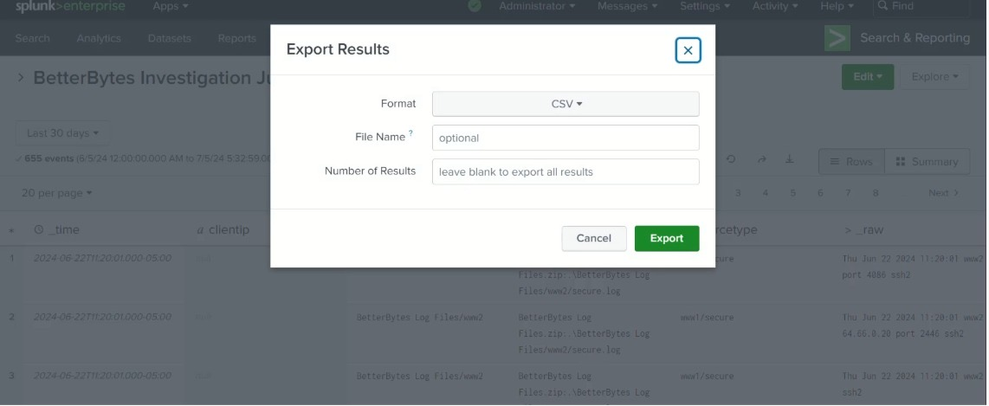
Figure 14. Export Results dialog with CSV selected and the result-count field left blank.

3. Findings
- The BetterBytes log archive was uploaded to Splunk Enterprise successfully.
- The search was narrowed from the broad event set to failure-related events and then to events matching source IP address 64.66.0.20.
- Visible event records show failed SSH password attempts against multiple usernames, including “inet” and “mailman.”
- The narrowed query displayed 655 events for the time range shown in the screenshots.
- The results were organized into a saved table view and prepared for CSV export.

4. Security Assessment
Repeated failed authentication attempts from one source IP against multiple usernames can indicate password guessing or brute-force behavior. Failed logins alone, however, do not confirm a successful compromise or conclusively establish malicious intent.

Recommended follow-up checks
- Search the same source IP for successful authentication events before, during, and after the failures.
- Identify which hosts and services received the attempts and whether any account was locked out.
- Review event frequency and timing to determine whether attempts were automated.
- Check whether the source IP is known or expected in the environment.
- If unauthorized activity is confirmed, follow the organization’s incident-response process and preserve original logs and exported evidence.

5. Conclusion
This project demonstrates a practical Splunk workflow for ingesting log data, filtering failed authentication events, investigating a repeated source IP, organizing results in a table, and exporting evidence to CSV. The visible events are consistent with a possible brute-force or password-guessing pattern and provide a starting point for deeper investigation. The next step is to correlate these failures with successful logins and other host or network activity before making a final incident determination.

Appendix — Search logic shown in the screenshots
Broad source search
source="BetterBytes Log Files.zip:*"
Failure-focused search
source="BetterBytes Log Files.zip:*" fail*
Narrowed search including source IP
source="BetterBytes Log Files.zip:*" fail* "64.66.0.20"
These queries transcribe the visible search logic and should be checked against the actual saved search in Splunk before reuse. Exact syntax may need adjustment to match the indexed source field and intended fields.

