**Computer Vision HW3 Report**

Student ID: R13921072

Name: 何家祥

**Part 1.**

**• Paste your warped canvas**

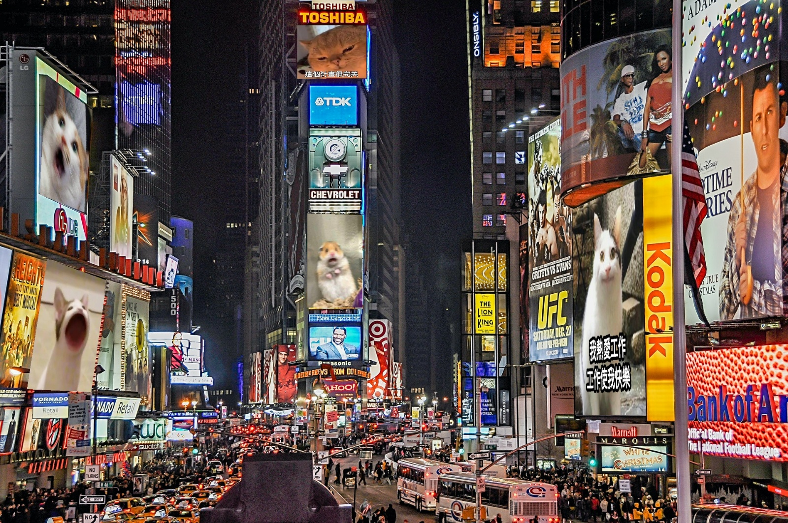

**Part 2.**

**• Paste the function code *solve_homography(u, v)* & *warping( )* (both forward & backward)**

**forward**

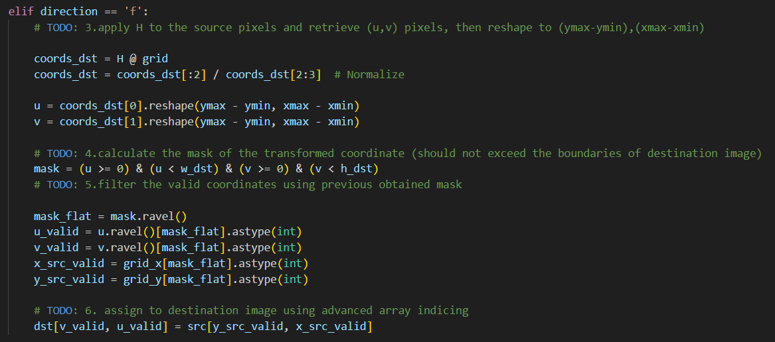

**backward**

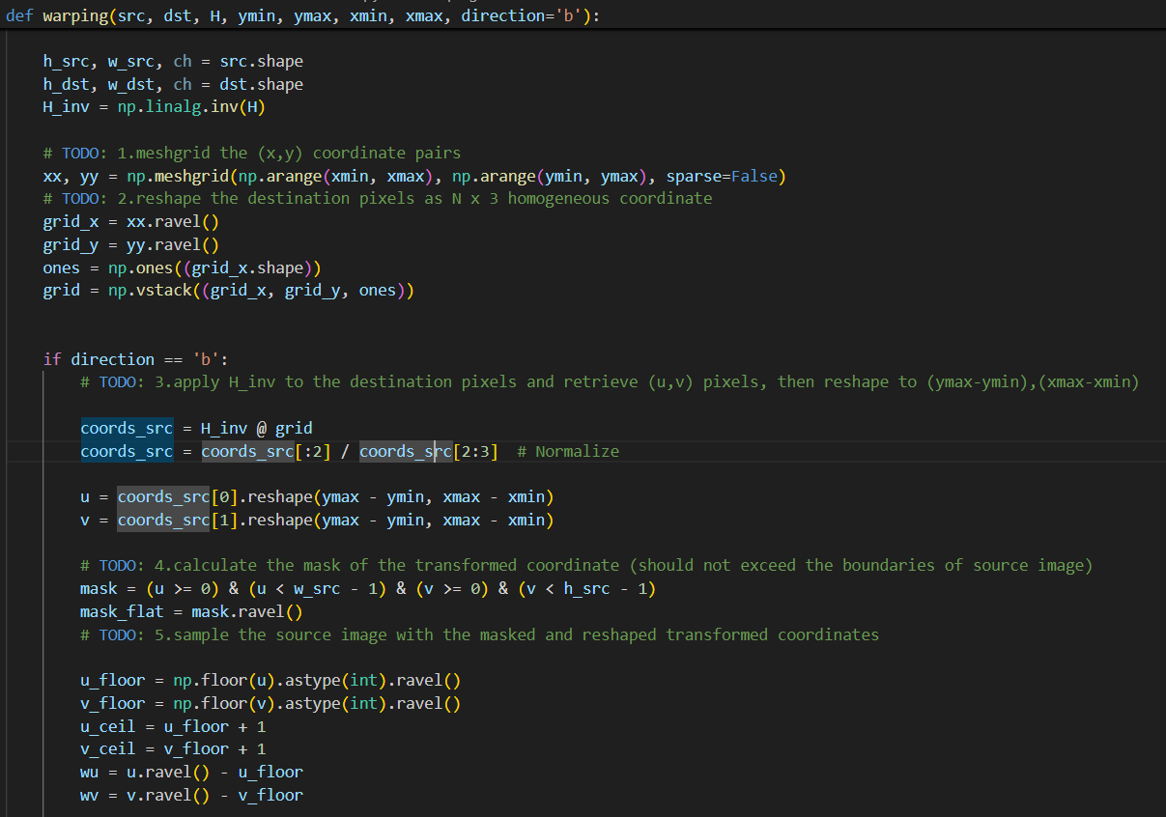

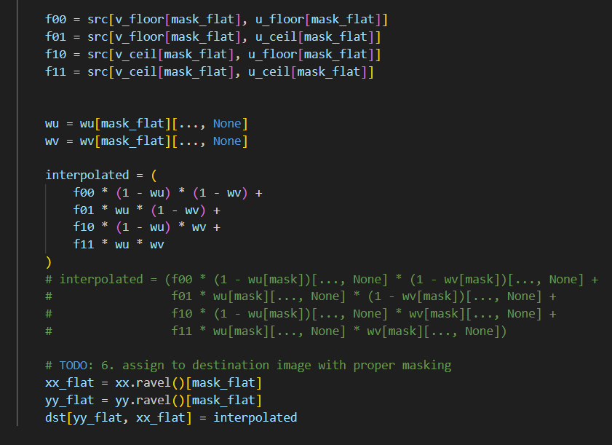

**• Briefly introduce the interpolation method you use**

In forward warping, I directly map each pixel in the source image to a position in the destination image using the homography. Since the mapped positions are usually not aligned to exact pixels, we use **nearest-neighbor assignment** without interpolation. So it will b*e* fast but may produce holes in the output.

In backward warping, processing each pixel in the destination image and map them back to source image coordinates. The result is typically non-integer, so we use **bilinear interpolation** to blend the values of the four surrounding pixels for smooth results.

**Part 3.**

**• Paste the 2 warped images and the link you find**

** **

[**http://media.ee.ntu.edu.tw/courses/cv/25S/**](http://media.ee.ntu.edu.tw/courses/cv/25S/)

**• Discuss the difference between 2 source images, are the warped results the same or different?**

Due to the difference in camera viewpoints, warping the two images using the same homography results in different levels of distortion. It can be observed that the second image appears slightly more blurred.

**• If the results are the same, explain why. If the results are different, explain why?**

Source image 1 preserves the original content better because its aspect ratio matches the original scene, allowing more visual information to be captured without distortion. In contrast, source image 2, although similar in size, appears more compressed and even looks rectangular, which reduces the visible area and lowers the clarity.

In short, maintaining the same aspect ratio between the original image and the warped result generally helps preserve information more accurately. Changing the aspect ratio or forcefully compressing the image often leads to distortion and loss of detail.

**Part 4.**

**• Paste your stitched panorama**

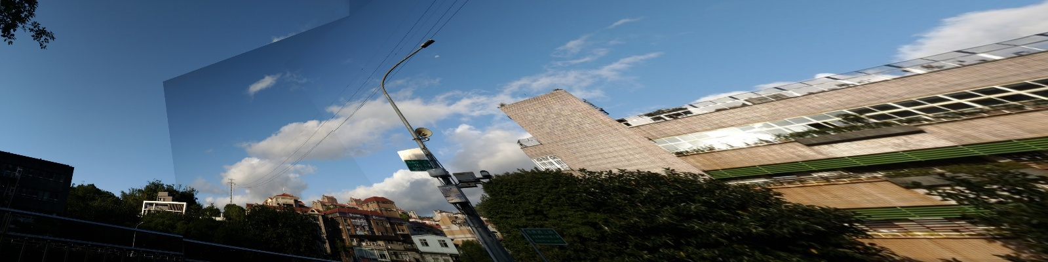

**• Can all consecutive images be stitched into a panorama?**

Stitching consecutive images isn’t always guaranteed to work.

**• If yes, explain your reason. If not, explain under what conditions will result in a failure?**

The images must share enough common ground. For the stitching algorithm to accurately match keypoints, adjacent images should overlap significantly, often by about 30% or more. Without this overlap, the software struggles to find corresponding features, making alignment difficult.

The way the camera moves between shots also matters. Ideally, the motion should be smooth, such as a steady horizontal pan or gentle rotation. If the camera jumps abruptly, produces blurry images, or introduces strong perspective changes, the stitching process can falter, leading to misaligned or distorted results.

Lighting plays a critical role as well. Sharp differences in exposure or illumination between images can disrupt the stitching process, causing visible seams or inconsistent color across the panorama.

The scene itself needs to remain consistent. If objects like cars or people move between frames, the resulting panorama might show ghosting effects or fail to align properly, as the algorithm tries to reconcile conflicting details.