I want to create an full stack web development project in the topic of smart waiter system using the qr code scanner using the html,css and javascript with mongodb
in That there will be an Qr code which directs them to the website
after going into the website by scanning the qr code it shows the login or register page .Add the registered users into the database with the role customer in the name of user category and display the message registered successfully then show the login page now they enter their details if it matches the database with the role as customer show the customers dashboard and also give another two roles chef and admin the chef and admin login details are stored manually inside the coding with specified role if the role is customer then go to customer dashboard if the details matches and the role is chef go to chef dashboard if the role is admin go to admin dashboard
LOGIN PAGE
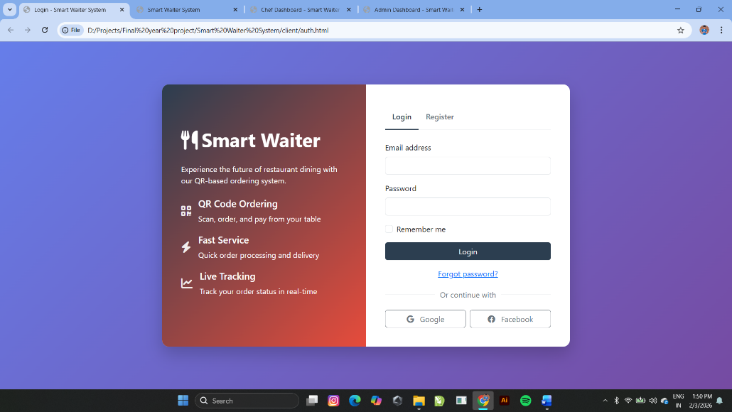

REGISTER PAGE
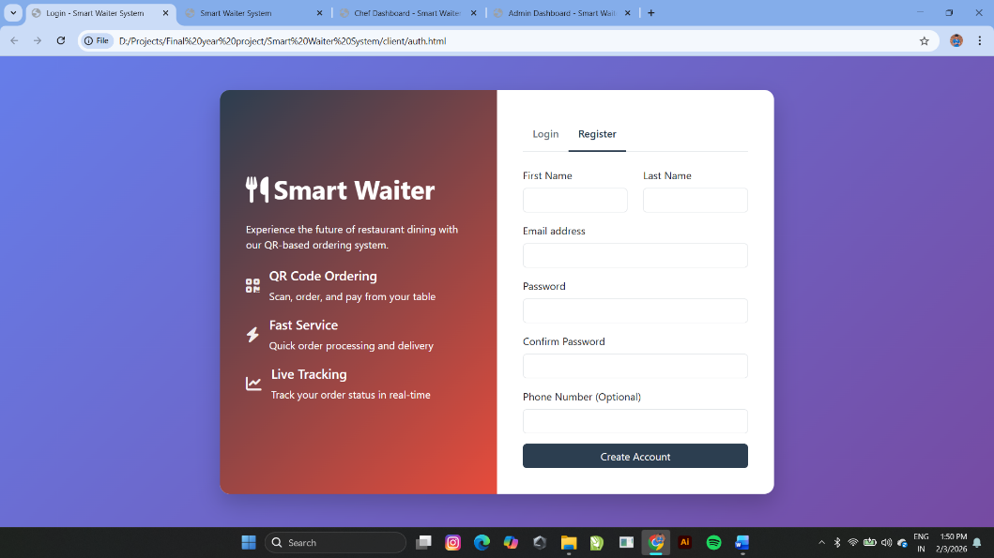
Demo Code for login and register page use this for my login and register page creation
<!DOCTYPE html>
<html lang="en">
<head>
<meta charset="UTF-8">
<meta name="viewport" content="width=device-width, initial-scale=1.0">
<title>Login - Smart Waiter System</title>
<link href="https://cdn.jsdelivr.net/npm/bootstrap@5.3.0/dist/css/bootstrap.min.css" rel="stylesheet">
<link rel="stylesheet" href="https://cdnjs.cloudflare.com/ajax/libs/font-awesome/6.4.0/css/all.min.css">
<style>
:root {
--primary: #2c3e50;
--secondary: #e74c3c;
--light: #ecf0f1;
}

body {
font-family: 'Segoe UI', Tahoma, Geneva, Verdana, sans-serif;
background: linear-gradient(135deg, #667eea 0%, #764ba2 100%);
height: 100vh;
display: flex;
align-items: center;
}

.auth-container {
background-color: white;
border-radius: 15px;
overflow: hidden;
box-shadow: 0 15px 35px rgba(0, 0, 0, 0.2);
}

.auth-left {
background: linear-gradient(135deg, var(--primary) 0%, var(--secondary) 100%);
color: white;
padding: 40px;
display: flex;
flex-direction: column;
justify-content: center;
}

.auth-right {
padding: 40px;
}

.auth-logo {
font-size: 2.5rem;
font-weight: bold;
margin-bottom: 20px;
}

.auth-feature {
display: flex;
align-items: center;
margin-bottom: 20px;
}

.auth-feature i {
font-size: 1.5rem;
margin-right: 15px;
color: rgba(255, 255, 255, 0.9);
}

.auth-tabs .nav-link {
border: none;
padding: 15px;
font-weight: 600;
color: #6c757d;
}

.auth-tabs .nav-link.active {
color: var(--primary);
border-bottom: 3px solid var(--primary);
}

.form-control:focus {
border-color: var(--primary);
box-shadow: 0 0 0 0.2rem rgba(44, 62, 80, 0.25);
}

.btn-primary {
background-color: var(--primary);
border-color: var(--primary);
}

.btn-primary:hover {
background-color: #1a252f;
border-color: #1a252f;
}

.auth-divider {
display: flex;
align-items: center;
margin: 20px 0;
}

.auth-divider::before,
.auth-divider::after {
content: "";
flex: 1;
border-bottom: 1px solid #dee2e6;
}

.auth-divider span {
padding: 0 10px;
color: #6c757d;
}
</style>
</head>
<body>
<div class="container">
<div class="row justify-content-center">
<div class="col-md-10 col-lg-8">
<div class="auth-container">
<div class="row g-0">
<div class="col-md-6 auth-left">
<div class="auth-logo">
<i class="fas fa-utensils me-2"></i>Smart Waiter
</div>
<p class="mb-4">Experience the future of restaurant dining with our QR-based ordering system.</p>

<div class="auth-feature">
<i class="fas fa-qrcode"></i>
<div>
<h5>QR Code Ordering</h5>
<p class="mb-0">Scan, order, and pay from your table</p>
</div>
</div>

<div class="auth-feature">
<i class="fas fa-bolt"></i>
<div>
<h5>Fast Service</h5>
<p class="mb-0">Quick order processing and delivery</p>
</div>
</div>

<div class="auth-feature">
<i class="fas fa-chart-line"></i>
<div>
<h5>Live Tracking</h5>
<p class="mb-0">Track your order status in real-time</p>
</div>
</div>
</div>

<div class="col-md-6 auth-right">
<ul class="nav nav-tabs auth-tabs mb-4" id="authTabs" role="tablist">
<li class="nav-item" role="presentation">
<button class="nav-link active" id="login-tab" data-bs-toggle="tab" data-bs-target="#login" type="button" role="tab">Login</button>
</li>
<li class="nav-item" role="presentation">
<button class="nav-link" id="register-tab" data-bs-toggle="tab" data-bs-target="#register" type="button" role="tab">Register</button>
</li>
</ul>

<div class="tab-content" id="authTabsContent">
<div class="tab-pane fade show active" id="login" role="tabpanel">
<form id="loginForm">
<div class="mb-3">
<label for="loginEmail" class="form-label">Email address</label>
<input type="email" class="form-control" id="loginEmail" required>
</div>
<div class="mb-3">
<label for="loginPassword" class="form-label">Password</label>
<input type="password" class="form-control" id="loginPassword" required>
</div>
<div class="mb-3 form-check">
<input type="checkbox" class="form-check-input" id="rememberMe">
<label class="form-check-label" for="rememberMe">Remember me</label>
</div>
<button type="submit" class="btn btn-primary w-100 mb-3">Login</button>
<div class="text-center">
<a href="#" id="forgotPassword">Forgot password?</a>
</div>
</form>

<div class="auth-divider">
<span>Or continue with</span>
</div>

<div class="row g-2">
<div class="col-6">
<button class="btn btn-outline-secondary w-100">
<i class="fab fa-google me-2"></i> Google
</button>
</div>
<div class="col-6">
<button class="btn btn-outline-secondary w-100">
<i class="fab fa-facebook me-2"></i> Facebook
</button>
</div>
</div>
</div>

<div class="tab-pane fade" id="register" role="tabpanel">
<form id="registerForm">
<div class="row">
<div class="col-md-6 mb-3">
<label for="firstName" class="form-label">First Name</label>
<input type="text" class="form-control" id="firstName" required>
</div>
<div class="col-md-6 mb-3">
<label for="lastName" class="form-label">Last Name</label>
<input type="text" class="form-control" id="lastName" required>
</div>
</div>
<div class="mb-3">
<label for="registerEmail" class="form-label">Email address</label>
<input type="email" class="form-control" id="registerEmail" required>
</div>
<div class="mb-3">
<label for="registerPassword" class="form-label">Password</label>
<input type="password" class="form-control" id="registerPassword" required>
</div>
<div class="mb-3">
<label for="confirmPassword" class="form-label">Confirm Password</label>
<input type="password" class="form-control" id="confirmPassword" required>
</div>
<div class="mb-3">
<label for="phone" class="form-label">Phone Number (Optional)</label>
<input type="tel" class="form-control" id="phone">
</div>
<button type="submit" class="btn btn-primary w-100">Create Account</button>
</form>
</div>
</div>
</div>
</div>
</div>
</div>
</div>
</div>

<script src="https://cdn.jsdelivr.net/npm/bootstrap@5.3.0/dist/js/bootstrap.bundle.min.js"></script>
<script>
document.addEventListener('DOMContentLoaded', function() {
const loginForm = document.getElementById('loginForm');
const registerForm = document.getElementById('registerForm');

loginForm.addEventListener('submit', function(e) {
e.preventDefault();
const email = document.getElementById('loginEmail').value;
const password = document.getElementById('loginPassword').value;

// Simulate login process
console.log('Login attempt:', email);
// In real implementation, you would call your authentication API

// Redirect to customer dashboard (for demo purposes)
window.location.href = 'customer.html';
});

registerForm.addEventListener('submit', function(e) {
e.preventDefault();
const firstName = document.getElementById('firstName').value;
const lastName = document.getElementById('lastName').value;
const email = document.getElementById('registerEmail').value;
const password = document.getElementById('registerPassword').value;
const confirmPassword = document.getElementById('confirmPassword').value;
const phone = document.getElementById('phone').value;

if (password !== confirmPassword) {
alert('Passwords do not match');
return;
}

// Simulate registration process
console.log('Registration attempt:', firstName, lastName, email);
// In real implementation, you would call your registration API

// Switch to login tab
const loginTab = new bootstrap.Tab(document.getElementById('login-tab'));
loginTab.show();

// Pre-fill login form
document.getElementById('loginEmail').value = email;
document.getElementById('loginPassword').value = password;

alert('Registration successful! Please login with your credentials.');
});

document.getElementById('forgotPassword').addEventListener('click', function(e) {
e.preventDefault();
const email = prompt('Please enter your email address:');
if (email) {
// Simulate password reset request
console.log('Password reset requested for:', email);
alert('If this email exists in our system, you will receive a password reset link.');
}
});
});
</script>
</body>
</html>
IN CUSTOMER DASHBOARD
in top it shows the hotel name with dashboard in that dashboard the order should be Home,About,Services,Menu,Contact and Logout buttons and below show the text welcome to hotel name and some greetings to the restaurant with hotel image as background
these all present in the home button category
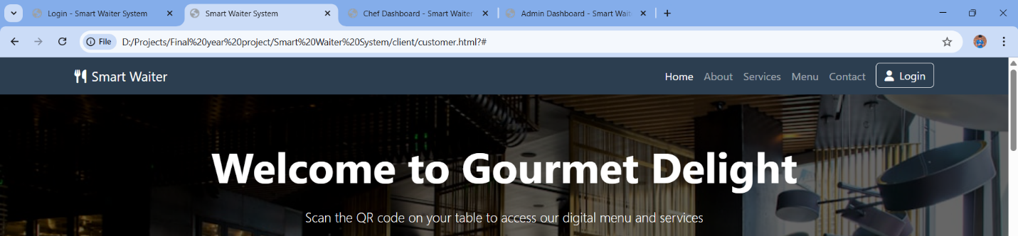
then pressing the about button it shows about the hotel take this as an example
Experience fine dining with our innovative Smart Waiter System
Founded in 2010, Gourmet Delight brings you the finest culinary experiences with a touch of technology. Our QR-based ordering system ensures a seamless dining experience from ordering to payment.
Our chefs craft each dish with passion, using only the freshest ingredients sourced from local providers. We take pride in our sustainable practices and commitment to excellence.
Award Winning Cuisine
Best Restaurant 2022 & 2023
Eco-Friendly
Sustainable sourcing and practices
Quick Service
Reduced waiting time with our technology
and create an about
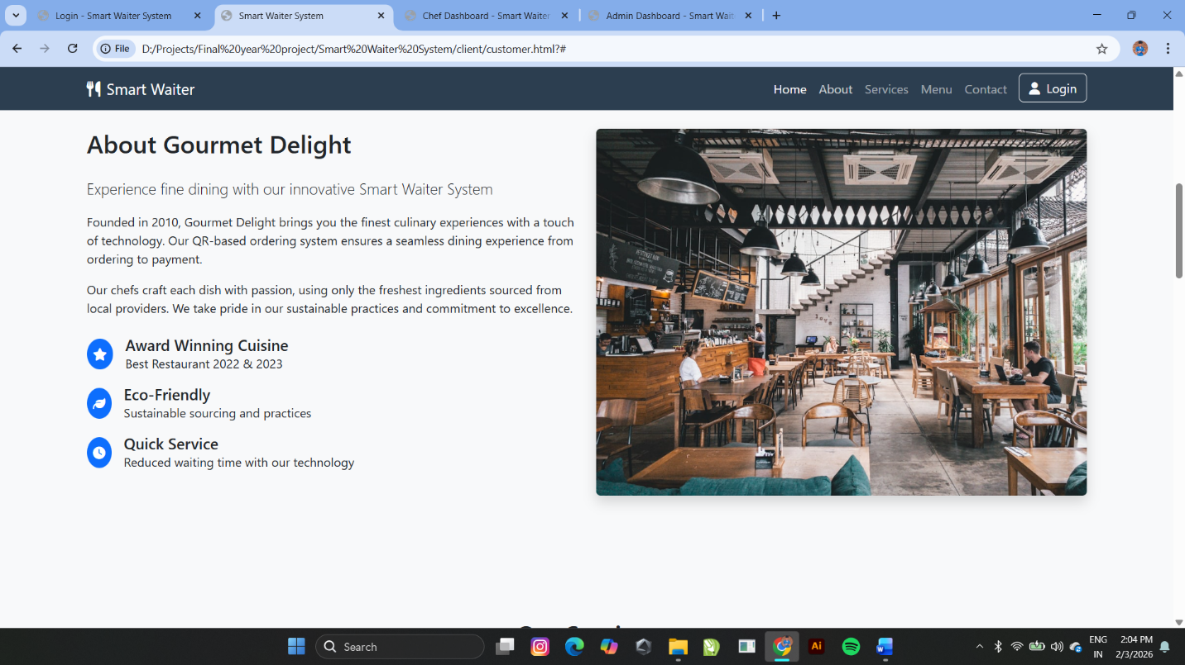
After pressing the services button it shows the page with Our services take this as an example
Our Services
How our Smart Waiter System enhances your dining experience
Request Water
Thirsty? Request water refill without waiting to catch a waiter's attention.
While pressing request water button it asks the table no after selecting the table number press the request button and it diplays in the chef dashboard
Table Cleaning
Request table cleaning service when needed for a pleasant dining experience.
While pressing table cleaning button it asks the table no after selecting the table number press the request button and it diplays in the chef dashboard

Pay Bill
Pay your bill digitally without waiting. Split bills with friends easily.
While pressing pay bill button it asks the table no after selecting the table number press the request button and it diplays in the chef dashboard

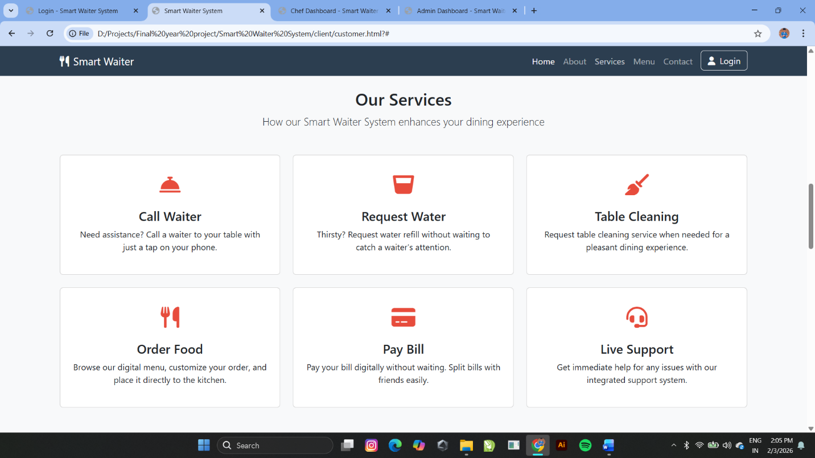
after pressing the Menu it asks the table no after selecting the table and pressing the submit button it shows all the available foods which was added by the admin and the chef as an menu
in that menu it shows the food name ,any description ,prize and add to cart button .
while pressing the add to cart button in the food menu an mini screen opens below the menu which displays all the added foods and the total prize it asks the no of quantity and add more food button after selecting all the foods needed press the submit button after it goes to the chef dashboard and then displays the food ordered in pending status for the customer screen if chef accept the order it displays the preparing status and then chef completes the order it display ready status after paying bill it displays the Thanks for coming message with the bill is send to your registered email message
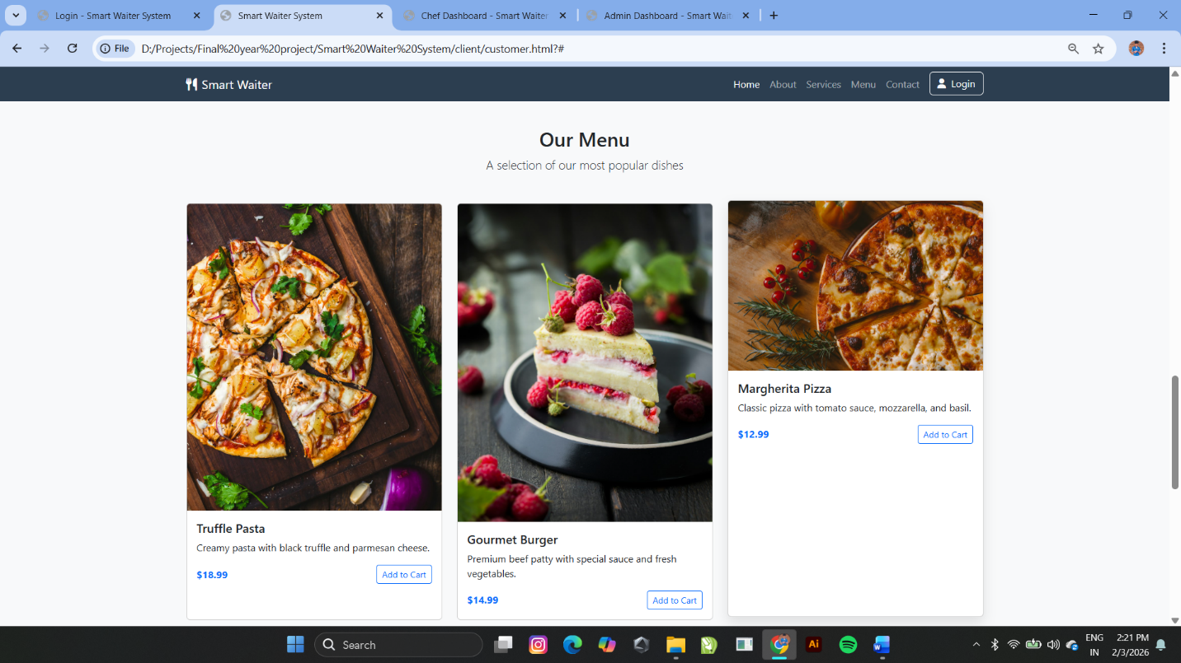
then pressing the contact button it shows the contact details of the hotel as example
Contact Us
We'd love to hear from you
Address
123 Gourmet Street, Foodville, FK 12345
Phone
(555) 123-4567
Email
info@gourmetdelight.com
Follow Us

Name
Email
Message
while pressing the send message the message is send to the admin email id it all stored in the datatbase
© 2023 Gourmet Delight. All rights reserved.
QR-based Smart Waiter System
and finally the logout button while pressing it that redirects to the login page
these are the customer dashboard
IN CHEF DASHBOARD
While login check the details are matched with the database and and check the role if it is chef role then show this dashboard
Here, in top it shows the notification button with symbol while pressing the button it shows all the notifications and the chef name also it has a dashboard ,in that dashboard the order should be Dashboard,Menu management, and Logout buttons
In the dashboard button in top it shows the kitchen dashboard text and Refresh button and New order button by pressing the refresh button it refresh the present page and updates the live orders and pressing the new order button it asks the table number and after pressing the submit it shows the menu same as the customer menu dashboard to order food for the phone not available users and it displays it the dashboard and order is placed
Below it shows the list as pending orders ,preparing now,and ready to serve details
And shows the current orders column in that give an filter button as all,pending and preparing to sort the food status order to view easily in that column it displays the ordered food lists from the customers which updates live it is sorted in the order of pending, preparing and ready status while in the all filter the orders the shown as the order no ,table no and working status and shows the ordered food list and some buttons
If the status in pending it shows the button as reject order and accept order if accept order button is pressed it is moved into the preparing status and also lively shows to the customer as preparing status and the accepted orders only shown to the chef who accepted it and the working status of that order is not shown to the other chef
If the status is preparing it shows the button as complete order while pressing it moves to the ready status and update customer as a ready status here after pressing it the ready status shows to all the chefs because to check the bills
In the ready status it shows the button as download and complete after pressing the download it downloads a bill in pdf and they can print if they wanted and pressing the complete it button it updates the thank you msg to the customer and the copy of the bill is send to the customers email id and to the chef dashboard it removes the order form the current orders list

And shows the service requests columns it displyas all the requested service from the customer to the chef like water refill,table cleaning and pay bill requests with assign button after pressing the assign button it removes the requests from that column
In menu management button it shows all the menus which is added by the admin .Chefs cant add more food but they can change the status as available and not available list of orders ,if chef select any food it shows the edit option while pressing it asks the available or not available option selecting any one and press submit and select the available category it listed in the available category if selected as a not available category it listed in the not available category,Only the available category foods are shown to the customers
And after pressing the logout button it logout and redirected to the login page
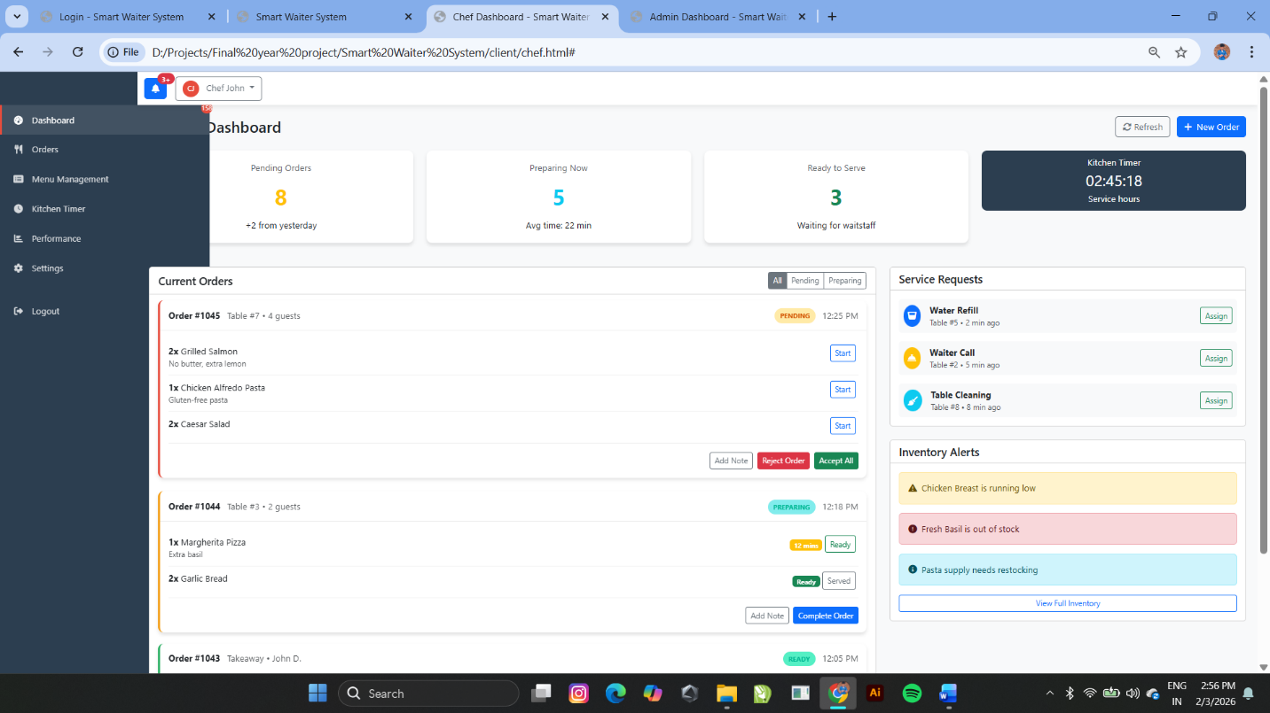
IN ADMIN DASHBOARD
While login check the details are matched with the database and and check the role if it is admin role then show this dashboard

Here, in top it shows the notification button with symbol while pressing the button it shows all the notifications and the admin name and also it has a dashboard ,in that dashboard the order should be Dashboard,Menu management,table management,Staff management,sales analytics and Logout buttons

In dashboard button ,in top it shows admin dashboard text below it shows the todays revenue ,todays customers ,orders today and table occupied list should be shown based on the datas of the ordered foods lists and their details
And show the overall daily revenue overview as an flow chart and the live recent order lists
In the menu management button ,show all the foods in the menu which was already added by the admin and also sort them in available and not available lists so that the admin can change that if he wanted and give add menu,edit menu and remove menu button while pressing the add menu button it asks the detail as name ,description,cover image , prize and the available or not available list option and submit button .after pressing submit it is added into the menu llist and stored in the database based on the available or not available listed options if its in available list then only it should be shown to the customers in the menu or else don’t show
while pressing the edit menu it shows all the added menu in the list with an edit button and we need to select the food which needed to be edited and press the edit button then it shows the name,description,cover image,prize and the available or not available option list here we can change what we wanted and press submit button to update the menu
while pressing the delete menu it shows all the added menu in the list with an delete button and we need to select the food which needed to be deleted and press the delete button then it deletes the food

In the table management button , show all the added tables as grids, one square grid is a one table and the total number of table and give add table,delete table button .while pressing the add table button it asks the number of tables to be added and press submit then it adds the table and updates the table in the screen as increased grids
while pressing the delete table button it asks the number of tables to be deleted and press submit then it deletes the table and updates the table in the screen as decreased grids

In the Staff management button ,show all the already added chef names in the page and give add and delete staff buttons.while pressing the add button it asks the first name , last name ,email address ,password,confirm password and phone number after entering this press the submit button then it is added into the user list in the database with the chef role because then only the chef can login with this role and specified password and email .and by pressing delete button it shows all the added chef lists with delete buttons by pressing it we can remove them from the list to have no ascess as an chef

In the Sales analytics ,there will be an list of dates with that day total revenue while pressing the date it displays the list of all the orders with order no,table no,total amount they paid and the customer details which is taken from the database automatically and displayed and finally logout button to redirect to login page

