Insider Threat Detection Program in AWS – Trusted access with behavioral accountability
Submitted By - Solomon Runzonza
Contact information: solomonrunzonza@outlook.com, 203 668 9742
Capstone Research Paper

Quinnipiac University
School of Computing and Engineering Sciences
Master of Science in Cybersecurity
Hamden, Connecticut, May 2026

Abstract
This capstone presents an AWS-native insider threat detection program that focuses on observable actions rather than assumptions about intent. The prototype monitors identity, storage, database, and infrastructure activity using AWS services such as CloudTrail, CloudWatch Logs, Lambda, DynamoDB, SNS, EventBridge, GuardDuty, IAM, S3, and EC2/VPC resources. The final framework uses four personas: Developer, Negligent-User, MaliciousInsider, and Compromised-User. This four-persona design allows the system to distinguish normal baseline behavior, careless employee mistakes, deliberate insider misuse, and stolen-credential activity. The detection model combines least-privilege violations, honey-resource interactions, time-series indicators, role-session context, event sequence tracking, and risk decay. Simulation results showed that the prototype generated alerts, updated user risk profiles, and produced explainable classifications for analyst review. The project demonstrates that an effective insider threat program can be built in AWS using explainable behavioral analytics without requiring a large-scale enterprise SIEM or complex machine learning model.

Acknowledgements
My first acknowledgements go to God Almighty, for strengthening me during the research period. The author gratefully acknowledges Professor F. Scholl and Professor H. Morrow Long for guidance, capstone oversight, and practical insight into cybersecurity operations and cloud security operations respectively. Thanks are also extended to those who reviewed interim project decisions and helped refine the simulated insider threat scenarios used throughout this study.
Table of Contents
Abstract 1
Acknowledgements 1
List of Figures ii
Executive Summary 1
Introduction 2
Risk, Threats, Vulnerabilities, and Impacts 2
Literature Review 3
Action-Centric Threat Model 4
System Architecture and Design Rationale 5
Setup and Configuration 6
Least-Privilege Configuration Summary 8
Detection Criteria Development 8
Weighted Detection Criteria 9
Risk Engine Design and Historical User Profiling 10
Simulation and Testing 11
Representative Test Matrix 13
GuardDuty Integration as Supplemental Insider-Threat Telemetry 14
Results and Discussion 15
Lambda-Based Detection Compared with GuardDuty 17
Recommendations and Future Work 18
Conclusion 18
References 20

List of Figures
Table 1: Risk, Threats, Vulnerabilities, and Impacts 2
Table 2: Action-Centric Threat Model 5
Table 3: Configuration Summary 8
Table 4: Detection criteria 10
Table 5: User profile fields 11
Table 6: Test Matrix 13
Table 7: GuardDuty risk scoring 15
Table 8: Operational noise reduction after introducing alert suppression and cooldown logic. 17
Table 9: Risk Scoring Function(Lambda vs GuardDuty 17

Executive Summary
Organizations often invest heavily in perimeter defenses, endpoint tools, and network controls, yet many modern breaches begin with trusted access. Attackers do not always need to break through a firewall when they can obtain a valid credential through phishing, poor password hygiene, credential stuffing, social engineering, or weak authentication controls. Once a valid identity is used, the security problem changes. The question is no longer only whether the user successfully logged in, but whether the user’s actions after authentication are consistent with legitimate business behavior.
This capstone developed an insider threat detection prototype in AWS that monitors trusted identities after access has been granted. The system does not attempt to judge a user’s motivation. Instead, it evaluates observable behavior: what resource was touched, whether the resource was allowed, whether the action occurred during normal hours, whether the source IP was expected, whether the user touched honey resources, and whether the behavior formed a suspicious sequence. This action-focused approach is useful because insider risk may come from multiple sources: careless employees, malicious insiders, compromised credentials, or even valid accounts behaving in abnormal ways.
The final project used four core personas. The Developer persona represented normal Engineering activity. The Negligent-User represented a legitimate employee who occasionally made low-volume accidental mistakes, such as touching a restricted HR or Executive resource. The MaliciousInsider represented deliberate misuse, including repeated attempts to access honey resources or escalation paths. The Compromised-User represented stolen credential activity, especially through command-line access and assumed-role sessions. This persona model helped the system classify behavior as Baseline, Negligent, Malicious, or Compromised.
The technical solution used CloudTrail and CloudWatch Logs to capture activity, Lambda to score events, DynamoDB to store user profiles and risk state, SNS to send alerts, EventBridge to schedule risk decay, and GuardDuty as an additional detection signal. S3, DynamoDB business tables, IAM roles, and EC2/VPC resources were used as monitored assets. The system assigned risk points based on denied access, cross-department access, honey-resource touches, IAM escalation attempts, security group modification attempts, new IP usage, and suspicious transitions.

Introduction
Insider threats are difficult to detect because they often involve identities that already have some level of trust. A successful login does not automatically mean the activity that follows is safe. In cloud environments, a valid identity can quickly access files, query databases, inspect infrastructure, create access keys, or attempt privilege escalation. This makes identity behavior one of the most important areas of cloud security monitoring.
A simple way to describe the problem is this: most breaches do not begin by breaking the door; they begin when someone uses a valid key (Verizon, 2024). A locked house is only secure until someone with a key becomes careless, malicious, or compromised. In cybersecurity, the “key” is often a password, access key, session token, assumed role, or privileged identity. For this reason, an insider threat program must monitor what trusted identities do after they gain access.
This capstone project was designed around that principle. Instead of focusing only on whether access was allowed or denied, the project analyzed user actions in context. It considered whether an action matched the user’s department, role, normal working hours, usual resources, source IP pattern, and historical activity. The project also included honey resources, which are files, tables, or infrastructure targets that ordinary users should have no reason to touch.
The final prototype was built in AWS using services that are realistic for a small organization. The environment included S3 folders for departmental files, DynamoDB tables for department-specific business data, IAM users and roles for access control, EC2/VPC resources for infrastructure simulations, CloudTrail for logging, Lambda for scoring, DynamoDB for user profiles, SNS for notifications, EventBridge for scheduling, and GuardDuty for additional threat signals.

Risk, Threats, Vulnerabilities, and Impacts
Element | Project-specific interpretation
Risk | A legitimate or stolen identity could use AWS capabilities in ways that compromise data, identity controls, or network exposure.
Threats | Malicious insider misuse, negligent insider mistakes, compromised credentials, and misuse of privileged cloud actions.
Vulnerabilities | Over-permissioned access, weak monitoring correlation, limited object-level visibility, exposed network controls, and delayed alert triage.
Impacts | Data loss, unauthorized disclosure, weakened identity governance, infrastructure exposure, compliance consequences, and slower incident response.
Table 1: Risk, Threats, Vulnerabilities, and Impacts

Literature Review
The literature reviewed for this project consistently showed that insider threats are difficult to detect because the actor already possesses, or appears to possess, legitimate access. CISA guidance, NIST publications, and industry reporting all emphasized that insider risk is not limited to intentionally malicious employees; it also includes negligent behavior, compromised accounts, and—in modern cloud environments—non-human identities such as service roles and automation workflows (Cybersecurity and Infrastructure Security Agency [CISA], n.d.; National Institute of Standards and Technology [NIST], 2012; Verizon, 2024). This broader framing was important because AWS environments are heavily API-driven. In practice, an insider threat may emerge through the misuse of a person’s console session, a long-lived access key, or a cloud service credential that appears legitimate in logs (Amazon Web Services [AWS], n.d.-a; AWS, n.d.-b).
Academic and practitioner literature also showed that insider detection benefits from a shift away from static rule matching toward behavioral analytics. User and entity behavior analytics (UEBA) literature argues that context matters: one file download or one policy read is often insufficient evidence of malicious activity, but a sequence of unusual actions by the same identity can produce a much stronger signal (Proofpoint & Ponemon Institute, 2023; Verizon, 2024). This principle informed the capstone’s emphasis on cumulative scoring and historical user profiling. Rather than label users as malicious, the implemented model observed the accumulation of abnormal actions over time.
AWS-specific security literature highlighted the shared responsibility model as a central consideration. AWS secures the infrastructure of the cloud, but customers remain responsible for the security of their identities, data, and configurations in the cloud (AWS, n.d.-c). That distinction makes insider-threat monitoring particularly relevant in AWS. Services such as S3, IAM, VPC, CloudTrail, CloudWatch, and GuardDuty provide rich telemetry and enforcement options, but they do not automatically resolve the insider problem (AWS, n.d.-a; AWS, n.d.-b; AWS, n.d.-d; AWS, n.d.-e). Security teams still need to define normal access patterns, translate business sensitivity into technical controls, and correlate actions into meaningful detections.
Case studies and incident discussions reviewed during the project reinforced the importance of action-based monitoring. Breaches involving cloud storage exposure, misused permissions, and stolen credentials frequently followed recognizable action patterns: credential validation, reconnaissance, policy probing, unauthorized data access, persistence attempts, and infrastructure change (Microsoft Security Response Center, 2024; Snowflake, 2024; Verizon, 2024). These patterns aligned directly with the simulation scenarios used later in the capstone. The literature therefore supported the decision to focus the solution on observable actions and sequence analysis rather than on assumptions about personal intent.
Finally, the literature revealed a tension between sensitivity and noise. Systems that alert on every unusual event create alert fatigue; systems that ignore too much detail miss meaningful insider behavior. The capstone’s design addressed this tension by combining least-privilege boundaries, weighted scoring, historical profiling, cooldown-based alert suppression, and risk decay. This combination reflected the core insight of the literature review: insider threat monitoring is most effective when it is contextual, cumulative, and operationally sustainable (Proofpoint & Ponemon Institute, 2023; Verizon, 2024).
Industry guidance also increasingly recognized that the same outcome can arise from different actor categories. A malicious employee, a negligent user, and a compromised account may all produce the same log evidence: a sensitive read, a policy change, or a widened security group. That observation reinforced the research decision to prioritize action evidence in the detection layer while leaving motive analysis as a later analytical question (CISA, n.d.; NIST, 2012). In practical SOC operations, reliable action evidence generally arrives before reliable motive evidence.
This review therefore framed the project around four ideas that remained consistent throughout the build: first, insider threat detection should begin from observable cloud actions; second, baseline context is required to judge whether an action is abnormal; third, accumulated risk over time is more informative than isolated events; and fourth, a useful insider program must be technically effective and operationally manageable (AWS, n.d.-a; NIST, 2012; Proofpoint & Ponemon Institute, 2023; Verizon, 2024).

Action-Centric Threat Model
A major design choice in this project was to model insider risk around actions rather than around actor labels. This choice matters because many cloud detections fail when they begin from assumptions about intent. In contrast, cloud actions are directly observable and can be mapped to security outcomes. An action-centric threat model asks several simple questions: what did the identity do; which resource was affected; was the action inside or outside expected scope; did the action weaken controls; and did the action appear in a suspicious sequence?
For S3, the action-centric model concentrated on object-level reads, denied reads, and targeting of high-value folders such as Executive and IT. For IAM, it concentrated on actions that could increase persistence or privilege, especially CreateAccessKey and AttachUserPolicy. For VPC, it concentrated on actions that could weaken segmentation or expose workloads, including security-group changes, route changes, and network ACL updates. GuardDuty findings were treated as corroborating signals that a suspicious pattern had already been recognized in AWS-managed telemetry.
This framing had two benefits. First, it made the program explainable. Analysts could easily understand why an event was scored because the score was attached to a concrete action. Second, it prevented the program from overreaching. The detection layer did not attempt to know the actor’s personal intent, which would have required information unavailable in cloud logs. Instead, it evaluated whether the action itself represented elevated security risk. In practice, that is enough to justify triage and investigation.
The action-centric model also made the simulated personas reusable. The same Engine could score a compromised key, a malicious employee, or a negligent actor if those identities performed the same risky action sequence. This gave the capstone a more durable methodology than a motive-specific approach would have allowed.

Action class | Observable evidence | Example interpretation
Boundary crossing | Denied or out-of-scope access | Identity probed beyond approved data boundary
Control weakening | Policy or network change | Identity attempted to weaken preventive security controls
Persistence creation | Access-key or policy expansion | Identity attempted to preserve or enlarge future access
Reconnaissance | Repeated reads, describe actions, folder targeting | Identity gathered context before higher-value actions
Action sequence escalation | Low-risk actions followed by higher-risk actions | Pattern indicated progression rather than isolated error
Table 2: Action-Centric Threat Model

System Architecture and Design Rationale
The implemented architecture was intentionally simple, explainable, and AWS-native. CloudTrail served as the primary source of authoritative action telemetry. It recorded management events and S3 data events needed for S3, IAM, and VPC monitoring. CloudWatch Logs received the CloudTrail (Amazon Web Services, n.d.) stream and provided near real-time event delivery to the scoring function. EventBridge supported both scheduled risk decay and GuardDuty-finding ingestion. DynamoDB acted as the persistent risk and profile store. SNS delivered tiered notifications. Lambda linked the entire design together by evaluating the event, scoring the action, consulting the user’s prior profile, updating the persistent record, and generating alerts when required.
The design rationale favored explainability over algorithmic opacity. In many insider-threat programs, explainability is critical because analysts need to justify why an alert occurred and whether it should trigger a response. The scoring engine therefore used explicit action categories, explicit points, and explicit thresholds. This enabled analysts to see whether a risk score was driven by denied S3 access, a privilege escalation attempt, a VPC security change, or a managed GuardDuty finding. It also aligned well with capstone objectives because it demonstrated how detection logic could be built from cloud telemetry in a transparent and teachable way.
The architecture also reflected a deliberate separation between action collection and action interpretation. CloudTrail and GuardDuty collected or generated signals. Lambda interpreted those signals in the context of the project’s insider personas, least-privilege boundaries, and historical baselines. This separation mattered because it allowed the program to evolve over time. The telemetry sources could be expanded, but the central scoring model remained the place where organizational context was applied.
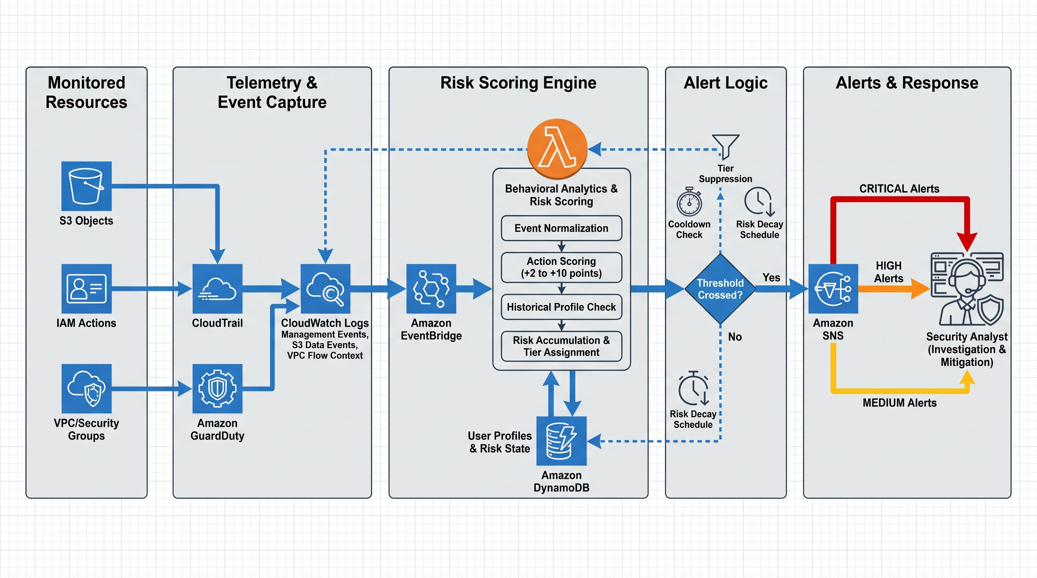
Figure 1: Action-based insider threat detection architecture used in the capstone implementation.

Setup and Configuration
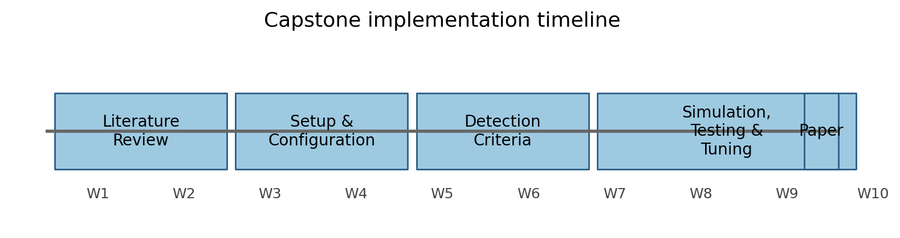
Figure 2: Capstone implementation timeline across the principal build phases.

During Weeks 3 and 4, a dedicated AWS account was configured to support the insider threat program. This phase established the technical environment and ensured that subsequent testing could occur in an isolated space with sufficient permissions to configure CloudTrail, CloudWatch, IAM, SNS, EventBridge, DynamoDB, GuardDuty, S3, VPC, and EC2 resources. A dedicated account was preferable to a restrictive classroom sandbox because the latter limited IAM and logging actions required for realistic insider-threat simulation.
The first major task was trail and log configuration. A multi-region CloudTrail was created so that management events, global IAM events, and relevant object-level S3 data events could be captured consistently. CloudTrail was then integrated with a CloudWatch log group so that events could be processed near real time by the Lambda scoring engine. S3 data-event logging was enabled specifically for the project bucket to ensure object access attempts produced telemetry suitable for behavioral scoring. GuardDuty was later enabled as a supplementary detection source and connected through EventBridge.
The S3 bucket used for the simulations was named insider-threat-sensitive-cloudtrail-logs. It was structured into department-based folders, including Engineering, Finance, Executive, IT, HR, and Strategy. This structure reflected a simplified enterprise data landscape and supported least-privilege enforcement at the prefix level. The project then applied tailored IAM policies to the simulated personas so that baseline behavior could be differentiated from suspicious behavior. For example, the Developer persona was limited to Engineering, the MaliciousInsider persona was allowed Finance but denied Executive and IT object access, and the Compromised-User persona was given a narrower engineering and reconnaissance-oriented capability aligned to the stolen-key scenario.
A dedicated VPC named InsiderThreatVPC with the 10.0.0.0/16 address range was created to support network-abuse simulations. Subnets, route tables, an internet gateway, security groups, and a lightweight EC2 instance were used to make infrastructure actions meaningful. The EC2 instance acted as a protected internal workload so that a security-group modification attempt represented an actual attempt to broaden exposure rather than an abstract API call. Because the project focus was action detection, the insider users were generally allowed to view VPC and security-group resources but denied actual destructive or risky configuration changes where appropriate. This enabled the program to log and score attempts while preserving environment safety.
Finally, DynamoDB, SNS, and EventBridge were configured to support persistence, notifications, and automated decay. DynamoDB stored per-user risk scores and historical profile attributes. SNS supported Medium, High, and Critical notification topics. EventBridge scheduled a daily risk-decay function and later routed GuardDuty findings to the scoring engine. By the end of the setup phase, the environment was fully instrumented and ready for criteria development and simulation.

Least-Privilege Configuration Summary
Persona | Authorized scope | Restricted scope | Monitoring value
Developer | Engineering data access; normal reads | Sensitive data outside Engineering; IAM/VPC changes | Clean baseline for expected user behavior
MaliciousInsider | Finance data; selected folder visibility; self IAM recon | Executive/IT object access; privileged IAM changes; risky VPC changes | Malicious employee action simulation
Compromised-User | Engineering API access; limited VPC describe actions | Non-Engineering object access; VPC changes; IAM escalation | Stolen credential simulation
Security-Analyst | Alert and log review | No operational misuse path | Monitoring and response role
Table 3: Configuration Summary

Detection Criteria Development
During Weeks 5 and 6, the project translated the available AWS telemetry into concrete detection criteria. This phase focused on defining suspicious actions, assigning risk values, and implementing the logic needed to turn CloudTrail and GuardDuty events into cumulative insider-risk records. The key design principle was that the program would evaluate actions and action sequences rather than attempt to infer motive directly. If a user opened an unauthorized object, attempted to create an access key, or tried to widen a security-group rule, the system would score those actions because of their security implications, regardless of the user’s self-reported reason.
The first step in criteria development was establishing behavioral baselines. Baseline expectations were seeded according to least-privilege role design and later reinforced through historical user profiling. The Developer was expected to access Engineering resources. The MaliciousInsider was expected to access Finance resources. The Compromised-User was expected to use API access against Engineering resources and limited infrastructure describe calls. The Security-Analyst and administrative users were excluded from scoring to reduce noise. Baseline activity consistent with assigned permissions produced no risk points.
The second step was defining weighted scoring (National Institute of Standards and Technology, 2012) rules for suspicious action categories. The project assigned lower scores to denied unauthorized object access and higher scores to actions associated with meaningful escalation or infrastructure exposure. IAM privilege escalation attempts such as CreateAccessKey and AttachUserPolicy were scored at the high end because they represented attempts to increase persistence or privilege. VPC configuration changes such as AuthorizeSecurityGroupIngress, CreateSecurityGroup, or CreateRoute were scored as high-value infrastructure-abuse indicators. S3 access to Executive and IT areas was treated as more sensitive than ordinary denied access because those areas represented high-value targets and honeyfile locations.
Historical user profiling was then added to improve context. DynamoDB stored prior folders accessed, prior event types, prior source IPs, and activity counts for each monitored user. However, the project found through testing that broad historical anomaly scoring created noise if applied to benign events. The detection engine was therefore refined so that historical anomaly points only amplified already suspicious base events. This prevented harmless Describe-style console activity from receiving risk simply because it was new. That refinement significantly improved the fidelity of the program and aligned historical profiling with insider-threat goals.
A third design feature was alert discipline. Because cumulative scoring can generate many events once a user reaches a higher tier, the Lambda function introduced alert cooldown logic and tier-aware suppression. The system sent alerts only when a user first entered Medium, High, or Critical, or when a cooldown period elapsed. This prevented alert storms while preserving escalation visibility. A daily risk-decay process then reduced stale risk scores over time to prevent isolated events from permanently biasing the profile.

Weighted Detection Criteria
Action category | Representative events | Risk points | Why the action mattered
Unauthorized S3 access | GetObject with AccessDenied | +2 | Suggested targeting beyond the user's approved data boundary
Sensitive folder targeting | Executive/* or IT/* access attempts | +5 | Represented an attempt to reach higher-value data and honeyfiles
VPC/security group abuse | AuthorizeSecurityGroupIngress; CreateSecurityGroup | +7 | Could expose internal workloads or establish a backdoor path
High-risk infrastructure change | DeleteSecurityGroup; CreateRoute; CreateNetworkAclEntry | +10 | Could materially weaken network protections or availability
IAM privilege escalation | CreateAccessKey; AttachUserPolicy | +10 | Could create persistence or elevated privileges
GuardDuty managed finding | Recon / UnauthorizedAccess / PrivilegeEscalation | +5 to +10 | Added AWS-managed anomaly context to the user-specific score
Table 4: Detection criteria
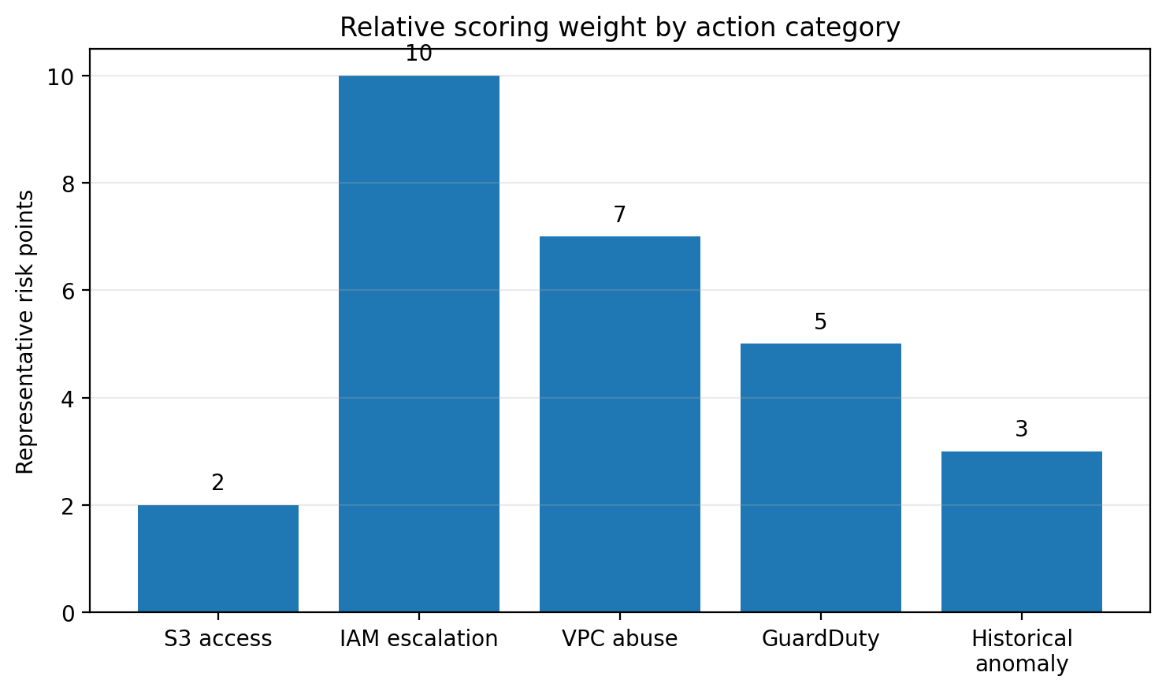
Figure 3: Representative scoring weights by suspicious action category.

Risk Engine Design and Historical User Profiling
The Lambda scoring function became the core of the program because it transformed raw telemetry into operational risk state. The function accepted CloudWatch-delivered CloudTrail events and EventBridge-delivered GuardDuty findings, normalized them into a consistent structure, and applied scoring logic. For each monitored user, the function updated a DynamoDB record containing risk_score, last_activity, usual_prefixes, usual_event_types, usual_source_ips, access_count, and alert metadata such as last_alert_tier and last_alert_time.
Historical user profiling was implemented to answer a specific question: was this already risky action also unusual for this user? The profile attributes therefore did not seek to model personality or intent. They modeled prior resource access, common event types, and common source IPs. During testing, seeded baseline profiles were created for Developer, MaliciousInsider, and Compromised-User so that the first simulation actions would be evaluated against a known state rather than against an empty record.
The engineering lesson from this phase was that anomaly scoring must be constrained. When the first historical-profile version awarded points for any new event type or any new IP address, even benign administrative reads created inflated scores and operational noise. The final design corrected this by requiring a suspicious base event before historical anomaly points could be added. This preserved the value of historical context without creating false positives from normal console navigation.
The risk engine also included explicit noise filtering. Only the three monitored simulation identities were scored. AWS service-generated traffic, CloudTrail log-delivery paths, and noisy Describe/List-style actions were ignored in the scoring path. This decision aligned the implementation with the capstone’s action-centric premise: not every logged action should be treated as evidence of insider risk. The program should focus on actions that have security significance.
Profile field | Purpose in the model | Example
usual_prefixes | Stores normal department/resource paths | Engineering/ for Developer
usual_event_types | Stores common action types for the user | GetObject for Developer; GetCallerIdentity for Compromised-User
usual_source_ips | Stores normal source addresses | Known workstation or test host IP
access_count | Tracks observed activity volume | Used for general profile maturity, not direct risk in final version
last_alert_tier / time | Controls alert suppression | Prevents repeated Critical emails for the same burst
Table 5: User profile fields

Simulation and Testing
The testing phase validated whether the implemented program could distinguish baseline activity from suspicious action sequences across S3, IAM, VPC, and GuardDuty signals. Three principal monitored personas were used: Developer, MaliciousInsider, and Compromised-User. The scenarios were intentionally structured around concrete actions rather than around assumptions about psychology. The underlying logic was that if specific actions were unsafe, out of scope, or cumulative in a suspicious sequence, they should be detected regardless of whether the actor believed them to be justified.
The Developer scenario served as the baseline control. The Developer account accessed Engineering content and performed expected low-risk actions. The absence of a DynamoDB risk record for truly zero-risk baseline behavior was treated as successful design rather than as a failure. This result confirmed that the system could preserve expected activity without forcing every user into the watchlist.
The MaliciousInsider scenario focused on an authorized employee who intentionally pushed beyond role boundaries. The sequence included access to permitted Finance data, attempts to access Executive and IT honeyfiles, a VPC security-group modification attempt, and an IAM CreateAccessKey attempt. These actions were chosen because they mirrored the path from curiosity to reconnaissance, then to infrastructure abuse and privilege escalation. The resulting score escalated through the defined alert tiers, and SNS alerts were generated when thresholds were crossed. Early testing exposed two important engineering lessons: IAM management events required careful CloudTrail-to-CloudWatch routing, and requestParameters could be null for certain IAM events, which required defensive Lambda parsing. Once corrected, the scenario behaved as expected.
The Compromised-User scenario used a stolen access key to simulate misuse of legitimate API credentials. This scenario was particularly important because it tested the difference between identity validation and suspicious use. The stolen-key simulation first executed low-risk AWS calls such as GetCallerIdentity and allowed Engineering reads to establish that the credentials were valid. It then attempted unauthorized reads in Executive and IT, infrastructure reconnaissance such as DescribeSecurityGroups, and denied VPC configuration changes. This produced a realistic cloud-attack sequence in which the actor began with stealthier actions before probing beyond the approved scope.
The project also tested operational refinements. Historical profile seeding was introduced for the four monitored personas so that the scoring model had a known baseline from the outset. Alert suppression and cooldown logic were then validated after one iteration of the scoring engine generated excessive email noise. That refinement reduced the email volume dramatically while preserving meaningful Medium, High, and Critical notifications. Finally, the project tested GuardDuty integration via EventBridge and confirmed that managed GuardDuty findings could invoke the same Lambda function and be translated into additional risk points when the finding mapped to a monitored user.
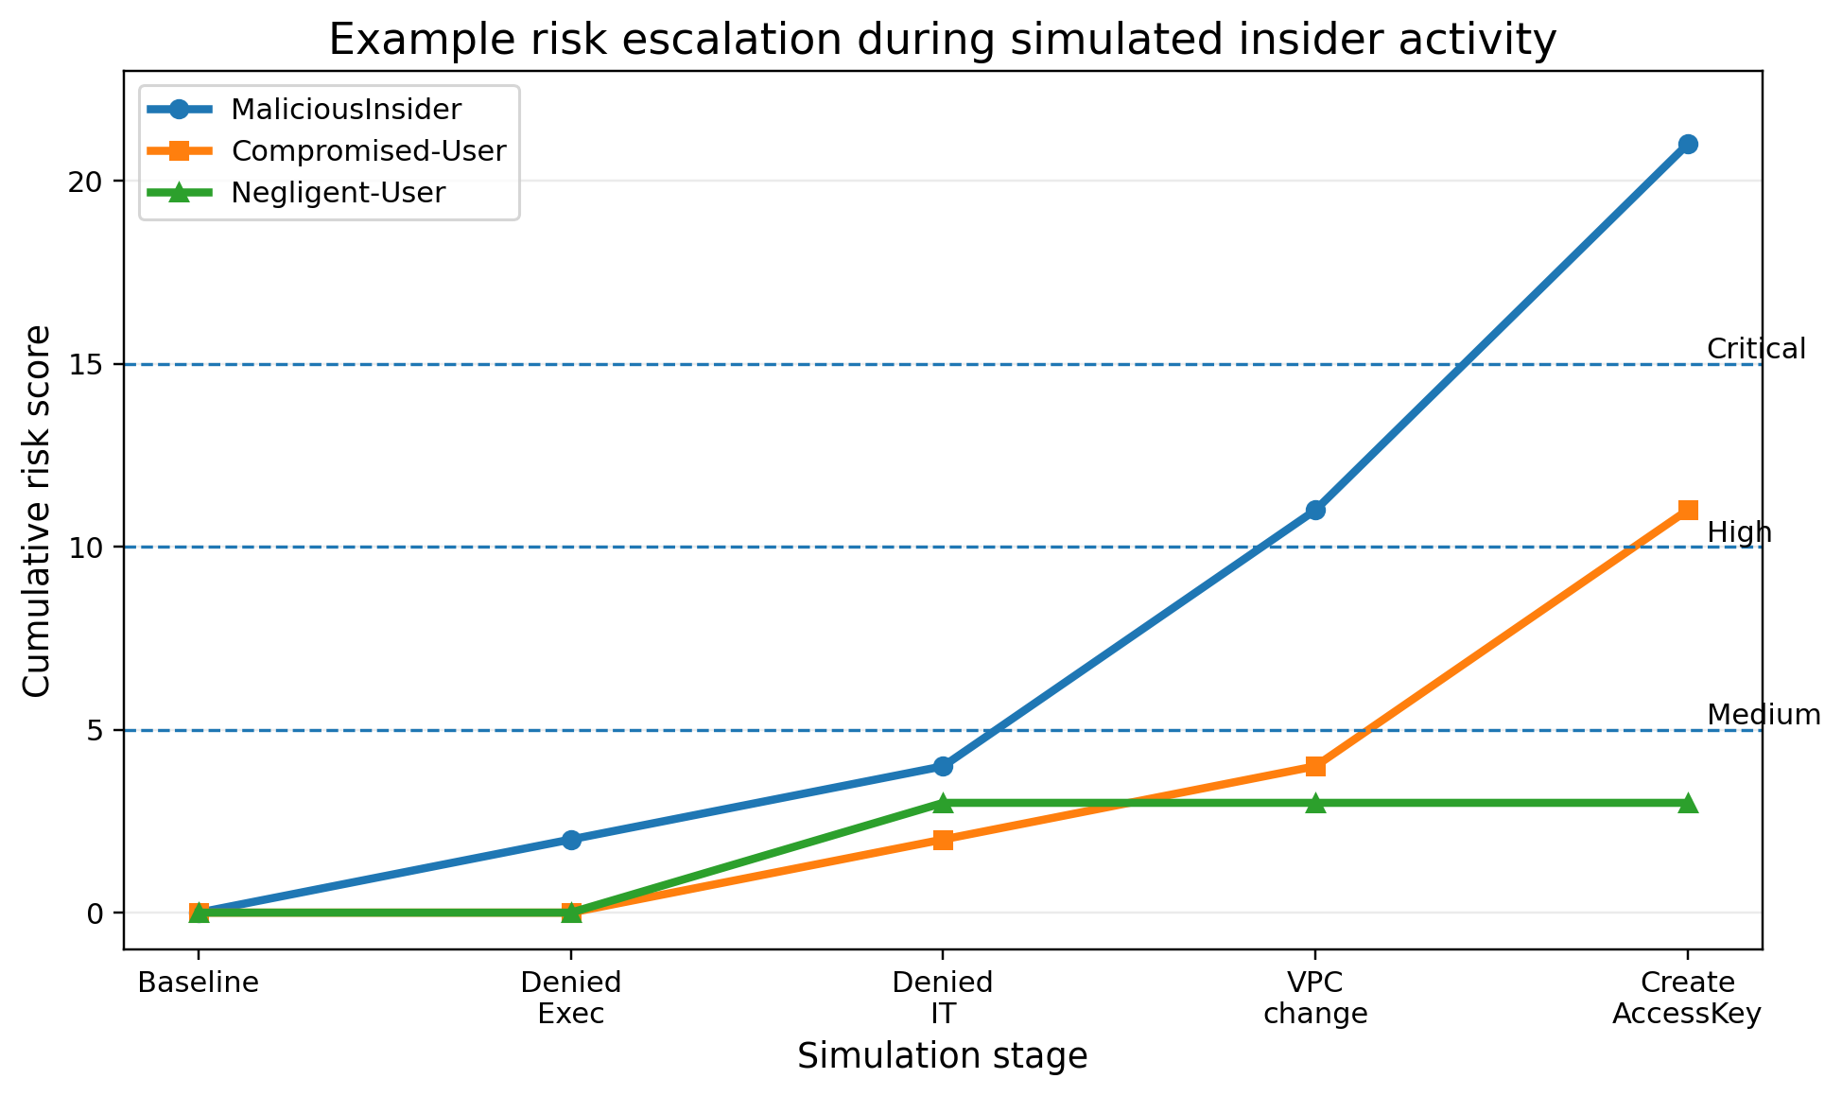
Figure 4: Example cumulative risk escalation during insider and compromised-user simulations.

Representative Test Matrix
Scenario | Action sequence | Expected outcome | Observed result
Developer baseline | Allowed Engineering read only | No risk record; no alert | Observed as expected after filtering and profile seeding
MaliciousInsider | Denied Executive + denied IT + VPC change + CreateAccessKey | Escalation from Low to High/Critical | Observed after Lambda parsing and alert controls were corrected
Compromised-User | GetCallerIdentity + allowed Engineering + denied Executive/IT + VPC attempt | Escalation to Medium/High with API-driven evidence | Observed with stolen access key simulation
GuardDuty integration | Sample finding routed through EventBridge | Lambda invocation and optional additive scoring | EventBridge-to-Lambda path verified; mapped scoring retained
Table 6: Test Matrix

GuardDuty Integration as Supplemental Insider-Threat Telemetry
GuardDuty was integrated not as a replacement for the custom scoring engine, but as a complementary AWS-managed detection source. This distinction was important to the capstone’s research design. GuardDuty can detect suspicious AWS behaviors such as reconnaissance, unauthorized access, privilege escalation, and workload exposure using managed analytics across CloudTrail, VPC Flow Logs, and DNS telemetry. However, GuardDuty does not inherently understand the role-specific S3 prefix boundaries, historical user baselines, or custom insider personas configured in this project.
The integration design therefore routed GuardDuty findings through EventBridge into the same Lambda scoring function already used for CloudTrail-derived events. The function parsed the finding type, attempted to identify the affected principal, and then translated the finding into additive risk points. In this model, GuardDuty contributed a managed signal while the Lambda engine remained the source of user-specific context. A Recon finding could add moderate points, while a PrivilegeEscalation finding could add higher points. This preserved architectural simplicity because all risk-state updates still occurred in one DynamoDB table.
The conceptual value of this integration was significant. It demonstrated how an enterprise insider-threat program could combine organization-specific logic with cloud-provider-managed threat intelligence. It also clarified the division of labor between the two systems. GuardDuty asked whether AWS had observed suspicious behavior in the telemetry. The custom engine asked whether that behavior was suspicious for a specific monitored identity within this environment and within the role boundaries defined by the project.
Testing of the GuardDuty path focused first on the EventBridge-to-Lambda invocation chain before requiring user mapping. This was a practical engineering step: sample GuardDuty findings do not always correspond to the simulated personas, so the program initially validated transport, logging, and safe parsing. Once that path worked, the project could treat GuardDuty as a useful but subordinate enhancement layer in the insider-risk model.

GuardDuty finding family | Role in the capstone | Suggested additive score
Recon:* | Supplemented custom recon and probing detections | +5
UnauthorizedAccess:* | Strengthened suspicion around credential misuse | +7
PrivilegeEscalation:* | Corroborated high-risk IAM abuse | +10
Policy:* | Suggested attempts to weaken controls | +10
Exfiltration:* | Would indicate attempted or ongoing data theft | +15
Table 7: GuardDuty risk scoring

Results and Discussion
The completed implementation demonstrated that an insider threat program in AWS can be built effectively around actions rather than motives. The strongest result was not that the system 'understood intent,' but that it consistently separated expected behavior from sequences of unsafe or out-of-scope actions. This was important because in operational security environments, analysts rarely know why an actor took a given action at the moment of detection. What they do know is whether the action crossed a data boundary, altered identity controls, weakened network exposure, or escalated in a pattern that demanded response.
The results also showed that explainable, weighted scoring was useful. S3, IAM, and VPC actions could be scored in a way that made sense to an analyst and could be defended to a stakeholder. A denied read against a sensitive folder did not automatically create a critical alert, but a denied read followed by a VPC abuse attempt and an IAM access-key attempt did. This cumulative model better reflected operational reality than flat one-event alerting. It also aligned with the research objective of reducing false positives while still flagging meaningful insider actions early enough for investigation.
A second major result was the value of historical context—but only when tightly constrained. Historical profiling improved fidelity when it amplified already suspicious events, such as a new source IP on top of an unauthorized object-access event. However, it created significant noise when it was allowed to score benign events such as Describe-style console activity. The refinement to apply historical anomaly points only to suspicious base events was therefore a crucial design correction. That adjustment turned historical profiling from a noise source into a genuine strength of the program.
The project further showed that cloud-native alerting requires discipline. Once a user reached a higher risk tier, each new event could have produced repeated alerts. The initial version of the scoring engine generated excessive notification volume, which would have made the program unsustainable in a real SOC. Alert cooldown and tier-aware suppression solved that problem and are therefore as important to the final design as the scoring rules themselves. This finding reflects a broader lesson from security operations: detection quality is not defined only by sensitivity, but also by the usability of the alert stream it creates.
Another important result was that VPC monitoring materially improved the insider-threat model. If the program had monitored only S3 and IAM, it would have missed a class of insider actions involving infrastructure exposure. By adding security-group and route-related monitoring, the capstone captured a more complete representation of how insiders and compromised identities can behave in AWS. The inclusion of an EC2-backed workload in the VPC made those actions concrete and easier to explain. A security-group change was no longer an abstract API call; it was an attempt to expose a protected internal server.
GuardDuty integration also added value, but it did not replace the custom scoring engine. GuardDuty contributed AWS-managed detections for reconnaissance, unauthorized access, and privilege escalation patterns. The Lambda engine remained the component that applied role-aware insider logic, historical baselines, cumulative scoring, and custom escalation. This distinction mattered for the final evaluation. GuardDuty answered whether AWS had identified suspicious behavior in managed telemetry. The custom engine answered whether that behavior was suspicious for a specific monitored identity in the context of this environment.
The principal limitations of the work should also be acknowledged. The scoring model remained rule-based and therefore depended on carefully chosen thresholds and event mappings. The simulation set, while realistic enough for a capstone, did not represent enterprise-scale volumes or years of historical telemetry. Some parts of the testing environment required deliberate IAM policy design so that actions could be attempted, denied, and logged without creating unsafe side effects. In a larger production environment, additional context such as longer behavioral baselines, geolocation analysis, device or session profiling, and external SIEM correlation would further improve detection quality.
Even with those limitations, the overall result was strong. The final system succeeded in detecting meaningful deviations across S3, IAM, VPC, and GuardDuty inputs, maintained user-specific risk state over time, reduced noise through suppression and decay, and produced a credible prototype for an AWS-native insider threat program. Most importantly, it demonstrated that action-based analytics can provide operationally useful insider-threat detections without requiring speculative assumptions about why a user acted.
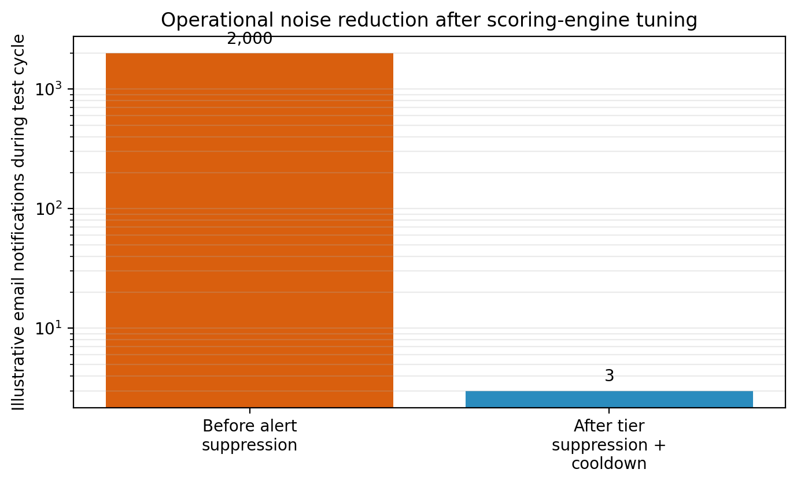
Table 8: Operational noise reduction after introducing alert suppression and cooldown logic.

Lambda-Based Detection Compared with GuardDuty
Capability | Custom Lambda risk engine | GuardDuty
Role-aware baselining | Yes; seeded and role-specific | No; managed anomaly detection is not role-seeded
Prefix-level S3 sensitivity model | Yes; Engineering/Finance/Executive/IT logic | No custom folder semantics
Cumulative per-user risk score | Yes; persisted in DynamoDB | No equivalent custom per-user score
Historical user profiling | Yes; prefixes, event types, source IPs | Indirect managed baselining only
Action explainability | High; explicit points and thresholds | Moderate; findings are categorized but not custom-scored
Managed anomaly findings | No; depends on custom rules | Yes; AWS-managed recon and privilege findings
Table 9: Risk Scoring Function(Lambda vs GuardDuty

Recommendations and Future Work
Several extensions would strengthen the prototype if it were transitioned toward production use. The first is richer historical user profiling over longer periods. The current design used seeded baselines and short testing windows. In an operational environment, weeks or months of prior behavior would allow stronger judgments about normal access time, service usage, API sequence patterns, and device or network origin.
A second improvement would be geolocation and session-context analytics. CloudTrail already records source IP information, and the project demonstrated how source IP can be incorporated into user profiles. A future version could combine IP enrichment, approved-network lists, and session-pattern analysis to raise confidence when access originates from unusual geographies or inconsistent infrastructure.
A third area is broader workload telemetry. The capstone included VPC monitoring and an EC2 workload to make infrastructure actions meaningful, but a production insider-threat program would benefit from deeper integration with VPC Flow Logs, host telemetry, container logs, and endpoint or EDR sources where available. This would improve visibility into lateral movement and post-exposure activity after a security-group or route change.
Finally, enterprise integration with SIEM, ticketing, and response orchestration would make the program operationally complete. The current design intentionally demonstrated that a strong insider-threat prototype can be built natively in AWS. The next step would be to integrate those detections into broader case management and incident-response workflows while preserving the clear, action-based scoring logic developed in this project.

Conclusion
This capstone project developed, implemented, and evaluated an AWS-native insider threat detection program that focused on observable actions rather than on presumed personal motives. The completed system showed that suspicious insider behavior could be detected effectively by combining least-privilege controls, CloudTrail and GuardDuty telemetry, cumulative scoring, historical user profiling, alert suppression, and risk decay. It successfully monitored actions across S3, IAM, and VPC resources and differentiated baseline behavior from suspicious sequences involving unauthorized data access, privilege escalation attempts, and network configuration abuse.
The major elements of the paper were closely connected. The literature review established that insider threats are best understood as a behavioral and contextual problem. The architecture and setup sections translated that understanding into an AWS-native monitoring pipeline. Detection criteria converted cloud actions into risk values. Simulation and testing validated those choices under malicious-insider negligent user and compromised-user conditions. Results and discussion then showed that the program’s greatest strength lay in its ability to connect action sequences over time while keeping the resulting alert stream operationally manageable.
The paper concludes that a practical insider threat program in AWS does not need to infer motive to be useful. By concentrating on risky actions, deviations from role-consistent behavior, and cumulative changes in security posture, organizations can improve visibility into insider abuse and compromised identities. Future work should extend the prototype with richer geolocation analytics, larger-scale historical profiling, broader workload telemetry, and integration with enterprise SIEM and case-management platforms. Even in its current form, however, the project demonstrates that explainable, action-based analytics can provide a strong foundation for insider-threat detection in cloud environments.

References
Amazon Web Services. (n.d.). AWS CloudTrail user guide. https://docs.aws.amazon.com/awscloudtrail/latest/userguide/cloudtrail-user-guide.html
Amazon Web Services. (n.d.). Amazon CloudWatch user guide. https://docs.aws.amazon.com/AmazonCloudWatch/latest/monitoring/WhatIsCloudWatch.html
Amazon Web Services. (n.d.). Amazon DynamoDB developer guide. https://docs.aws.amazon.com/amazondynamodb/latest/developerguide/Introduction.html
Amazon Web Services. (n.d.). Amazon GuardDuty user guide. https://docs.aws.amazon.com/guardduty/latest/ug/what-is-guardduty.html
Amazon Web Services. (n.d.). AWS Identity and Access Management user guide. https://docs.aws.amazon.com/IAM/latest/UserGuide/introduction.html
Block, Inc. (2022, April 4). Block, Inc. reports unauthorized access of Cash App Investing customer information. U.S. Securities and Exchange Commission.
Caesars Entertainment, Inc. (2023, September 14). Form 8-K current report. U.S. Securities and Exchange Commission.
Code42. (2024). Data Exposure Report.
Costa, D. (2017). Insider threat indicators and behavioral detection considerations.
Cybersecurity Ventures. (2024). Insider Threat Statistics and Trends.
Microsoft Security Response Center. (2024, January 19). Microsoft actions following attack by nation state actor Midnight Blizzard. https://msrc.microsoft.com/blog/2024/01/microsoft-actions-following-attack-by-nation-state-actor-midnight-blizzard/
National Institute of Standards and Technology. (2012). Guide for conducting risk assessments (NIST Special Publication 800-30 Rev. 1). https://doi.org/10.6028/NIST.SP.800-30r1
Okta. (2023, November 29). Unauthorized access to Okta’s support case management system: Root cause and remediation.
Ponemon Institute. (2023). 2023 cost of insider risks global report. Proofpoint. https://www.proofpoint.com/us/resources/threat-reports/cost-of-insider-threats
Snowflake. (2024, June 2). Snowflake statement on customer cybersecurity investigations.
TechTarget Editorial. (2024, June 21). Change Healthcare cyberattack: Timeline and what happened. TechTarget.
UnitedHealth Group. (2024, April 22). UnitedHealth Group update on Change Healthcare cyberattack. https://www.unitedhealthgroup.com/newsroom/2024/2024-04-22-uhg-updates-on-change-healthcare-cyberattack.html
Verizon. (2024). 2024 Data Breach Investigations Report. https://www.verizon.com/business/resources/reports/dbir/
23andMe. (2023, December 4). 23andMe provides additional information about credential stuffing incident. https://blog.23andme.com/articles/addressing-data-security-concerns

