@title@

A Basic Fantasy Role-Playing Game Adventure

Copyright © @year@ Chris Gonnerman
All Rights Reserved. See next page for license information.
www.basicfantasy.org

@title@
Copyright © @year@ Chris Gonnerman – All Rights Reserved

All textual materials in this document, as well as all maps, floorplans, diagrams, charts, and forms included herein, are distributed under the terms of the Creative Commons Attribution-ShareAlike 4.0 International License. Most other artwork presented is property of the original artist and is used with permission. Note that you may not publish or otherwise distribute this work as is without permission of the original artists; you must remove all non-licensed artwork before doing so.
The full license text can be viewed at:
https://creativecommons.org/licenses/by-sa/4.0/
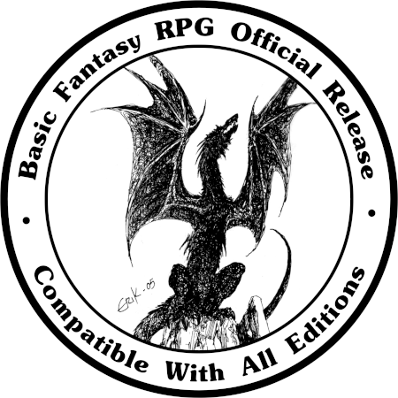

Introduction
This adventure was created by the Basic Fantasy RPG Dungeoneer suite, an online dungeon generation system. It is NOT based in any way on artificial intelligence, whether generative or otherwise; instead, dungeon contents are generated by rolling on random tables built into the software. Because the software was created by Chris Gonnerman, the copyright attached is his, and the license is of course the Creative Commons Attribution-ShareAlike license used for all new Basic Fantasy Project books. This document was constructed using release 26 of the Adventure Template document, available from the relevant thread in the Workshop forum on the main website.

If you might be a player in this adventure, stop reading now! Beyond this point lies information meant only for the Game Master's eyes!

Adventure Key

SubHeading
Use the MainHeading style for main section headings (as in the Adventure Key heading above). Use the SubHeading style for subheadings (again as above) and the Text Body style for all running text paragraphs (like this one).
Text meant to be read to players is usually boxed; use the BoxedText style for that purpose. Be sure to write things out as they would be spoken; use "foot" or "feet" rather than the ' symbol, etc. A “3' ladder” should be written as "3-foot ladder." Likewise, we recommend writing abbreviations out in words as they would be spoken, i.e. "Doctor Castor" instead of "Dr. Castor." These changes are helpful for those who may read English just fine but are not completely familiar with our abbreviations and symbols.
7 Wild Boars: AC 13, HD 3, #At 1, Dam 2d4, Mv 50', Sv F3, ML 9, XP 145 ea.
HP 15 ☐☐☐☐☐ ☐☐☐☐☐ ☐☐☐☐☐
15 ☐☐☐☐☐ ☐☐☐☐☐ ☐☐☐☐☐
10 ☐☐☐☐☐ ☐☐☐☐☐
12 ☐☐☐☐☐ ☐☐☐☐☐ ☐☐
16 ☐☐☐☐☐ ☐☐☐☐☐ ☐☐☐☐☐ ☐
12 ☐☐☐☐☐ ☐☐☐☐☐ ☐☐
19 ☐☐☐☐☐ ☐☐☐☐☐ ☐☐☐☐☐ ☐☐☐☐

Wandering Monsters
1. 1d6 Frogmen (8 total): AC 17, HD 3, #At 2 swordspear or 1 stonebow, Dam 1d8+1/1d8+1 or 1d8, Mv 40', Sv F3, ML 10, XP 145 ea.
HP 14 ☐☐☐☐☐ ☐☐☐☐☐ ☐☐☐☐
10 ☐☐☐☐☐ ☐☐☐☐☐
17 ☐☐☐☐☐ ☐☐☐☐☐ ☐☐☐☐☐ ☐☐
8 ☐☐☐☐☐ ☐☐☐
12 ☐☐☐☐☐ ☐☐☐☐☐ ☐☐
14 ☐☐☐☐☐ ☐☐☐☐☐ ☐☐☐☐ 18 ☐☐☐☐☐ ☐☐☐☐☐ ☐☐☐☐☐
☐☐☐
11 ☐☐☐☐☐ ☐☐☐☐☐ ☐

Dungeon Level 1

1. GRAND FOYER:

