|  |  |
| --- | --- |
|  |  |

**COMPUTER NETWORKS - CSA07**

**M.THIRUMALA MANOHAR**

**192211851**

**List of Experiments**

|  |  |  |
| --- | --- | --- |
| **Sl.NO** | **Experiment** |  |
|  | Configuration of Network Devices using Packet Tracer tools (Hub, Switch, Ethernet, Broadcast) |  |
|  | Design and Configuration of Star Topologies using Packet Tracer |  |
|  | Design and Configuration of BUS Topologies using Packet Tracer |  |
|  | Design and Configuration of RING Topologies using Packet Tracer |  |
|  | Design and Configuration of Mesh Topologies using Packet Tracer |  |
|  | Design and Configuration of Tree Topologies using Packet Tracer |  |
|  | Design and Configuration of Hybrid Topologies using Packet Tracer |  |
|  | Data Link Layer Traffic Simulation using Packet Tracer Analysis of ARP |  |
|  | Data Link Layer Traffic Simulation using Packet Tracer Analysis of LLDP |  |
|  | Data Link Layer Traffic Simulation using Packet Tracer Analysis of CSMA/CD & CSMA/CA |  |
|  | Implementation of Bit stuffing mechanism using C |  |
|  | To design the two different networks with Static Routing techniques using Packet Tracer |  |
|  | To design the Network with Dynamic Routing using Packet Tracer (Distance vector & OSPF) |  |
|  | Design the Functionalities and Exploration of TCP using Packet Tracer |  |
|  | Design the Functionalities of Exploration UDP using Packet Tracer |  |
|  | Design the network model for Subnetting – Class C Addressing using packet tracer |  |
|  | Implementation of server – client using TCP socket programming | **NOT** |
|  | Implementation of server – client using UDP socket programming | **NOT** |
|  | Simulating X, Y, Z Company Network Design and simulate using Packet Tracer |  |
|  | Configuration of DHCP (dynamic host configuration protocol) in packet tracer |  |
|  | Configuration of firewall in packet tracer. |  |
|  | Make a Computer Lab to transfer a message from one node to another to design and simulate using Cisco Packet Tracer |  |
|  | Transport layer protocol header analysis using Wireshark- TCP |  |
|  | Network layer protocol header analysis using Wireshark - SMTP |  |
|  | Network layer protocol header analysis using Wireshark - ICMP |  |
|  | Transport layer protocol header analysis using Wireshark - UDP |  |
|  | Network layer protocol header analysis using Wireshark - ARP |  |
|  | Network layer protocol header analysis using Wireshark - HTTP |  |
|  | Identify and monitor the IP, network address, Trace the router  information, how to take remote system and check the node connection  in network. | **NOT** |
|  | Demonstration of PING operation using ICMP in Wireshark | **NOT** |

**EXPERIMENT-1**

**NETWORK DEVICES**

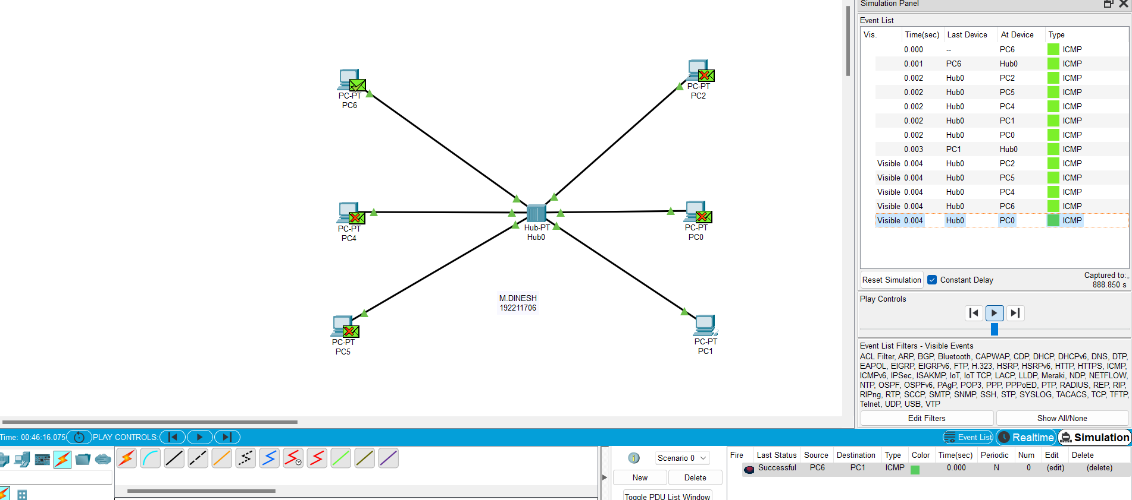

M.THIRUMALA MANOHAR

192211851

**EXPERIMENT-2**

**STAR TOPOLOGY:**

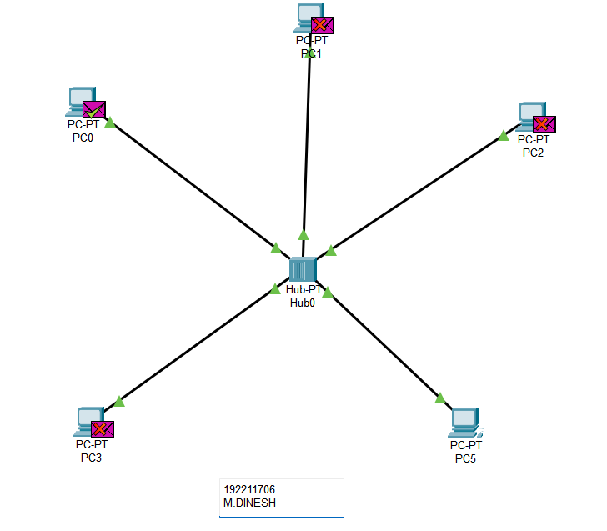

M.THIRUMALA MANOHAR

192211851

**EXPERIMENT-3**

**BUS TOPOLOGY**

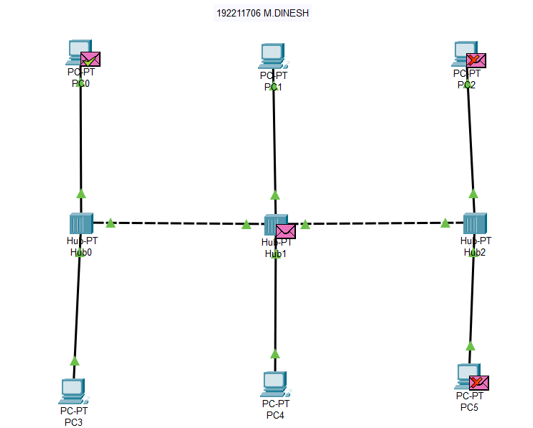

M.THIRUMALA MANOHAR

192211851

**EXPERIMENT-4**

**RING TOPOLOGY**

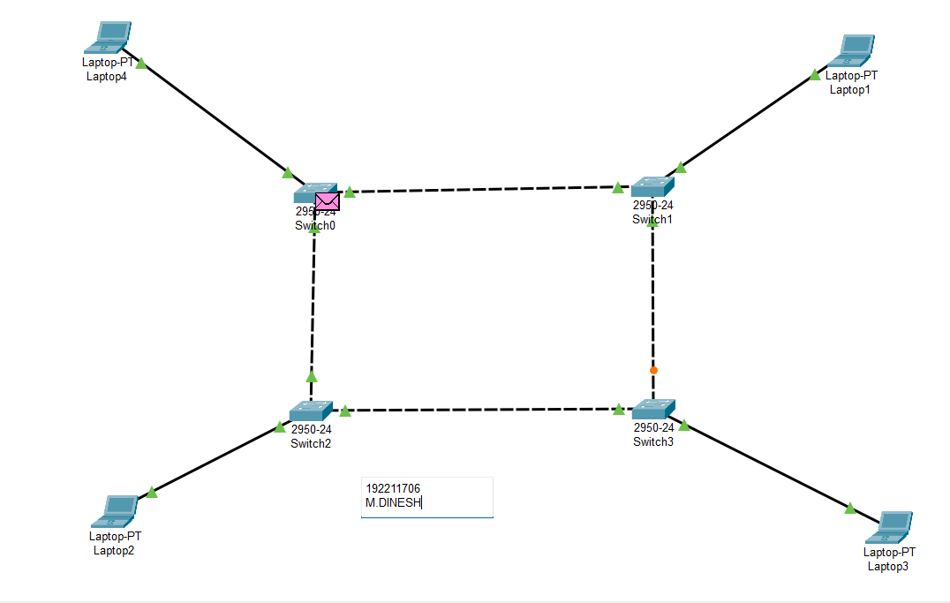

M.THIRUMALA MANOHAR

192211851

**EXPERIMENT-5**

**MESH TOPOLOGY**

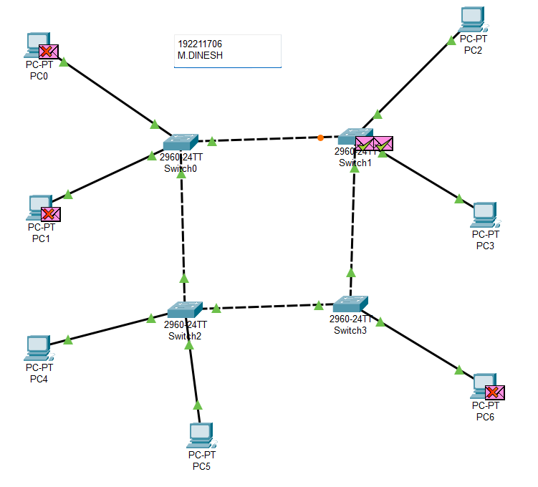

M.THIRUMALA MANOHAR

192211851

**EXPRIMENT-6**

**TREE TOPOOGY**

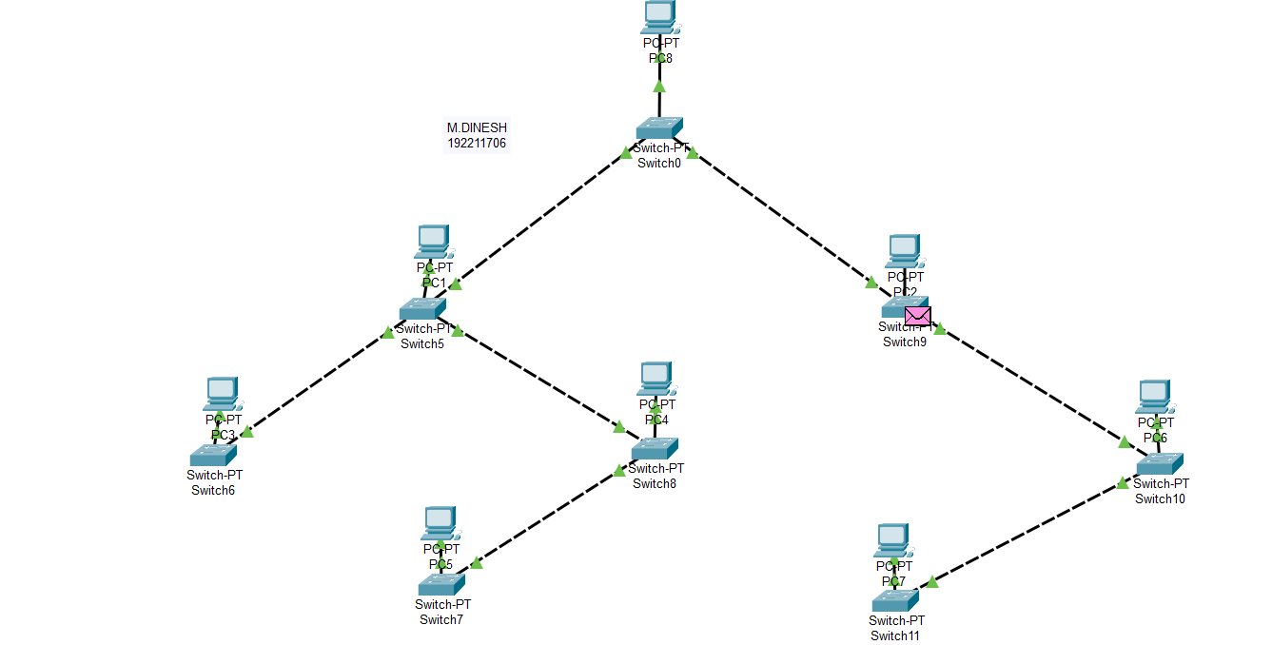

M.THIRUMALA MANOHAR

192211851

**EXPERIMENT-7**

**HYBRID TOPOLOGY**

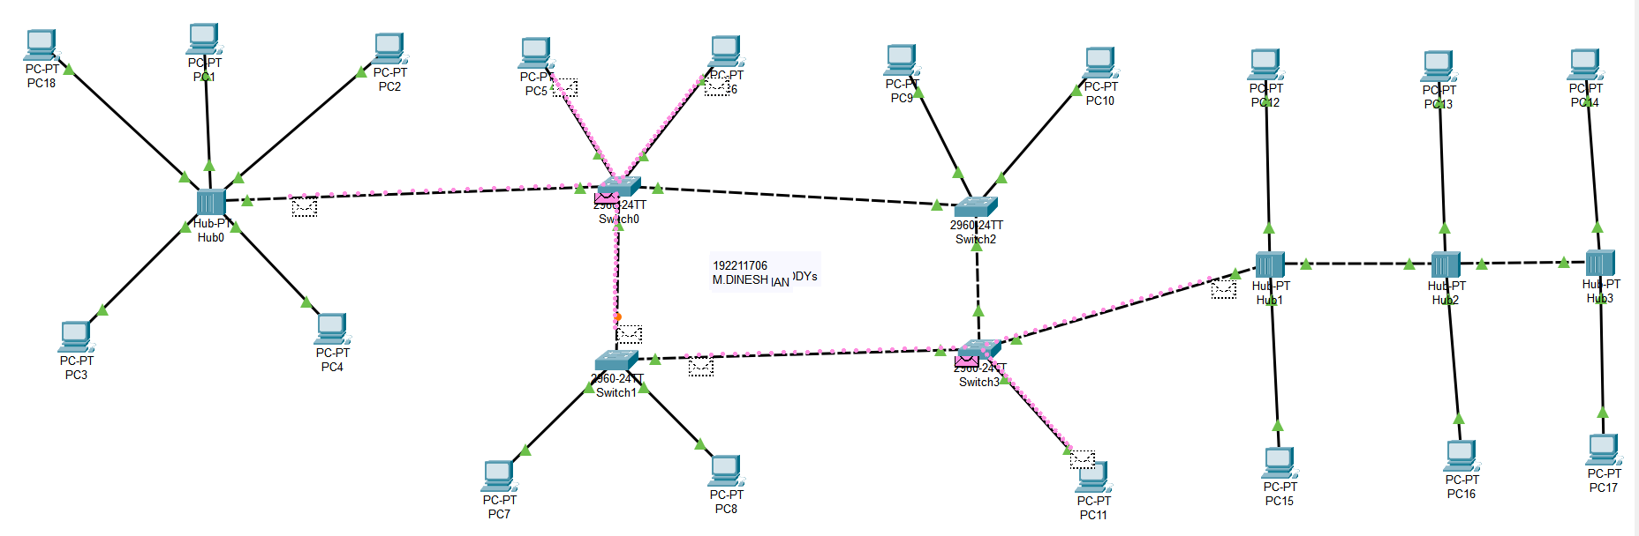

M.THIRUMALA MANOHAR

192211851

**EXPERIMENT-8**

**DATA LINK ARP**

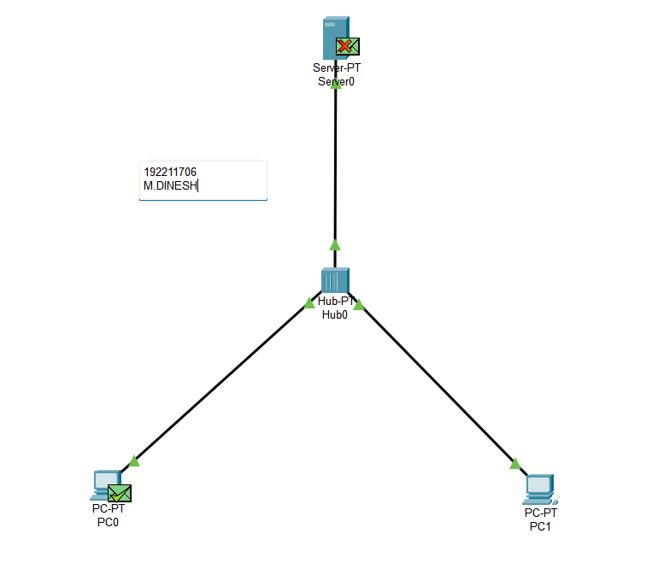

M.THIRUMALA MANOHAR

192211851

**EXPERIMENT-9: DATA LINK LLDP**

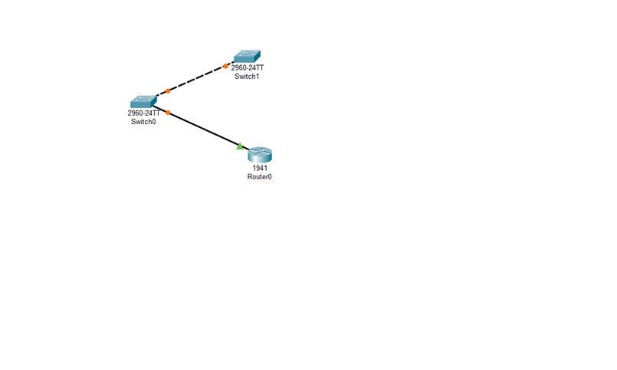**EXPERIMENT-10 DATA CSMA**

M.THIRUMALA MANOHAR

192211851

M.DINESH

192211706

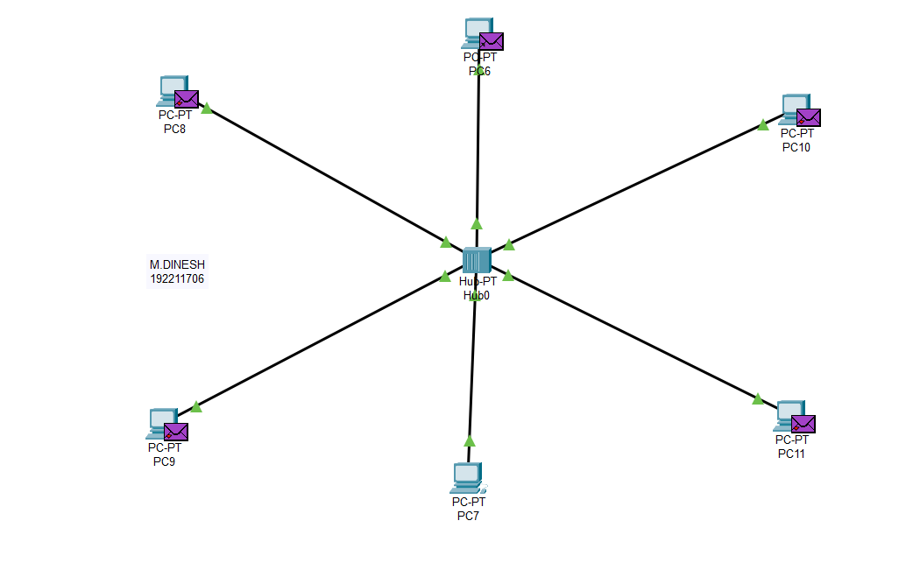

M.THIRUMALA MANOHAR

192211851

**EXPERIMENT-11: C PROGRAMME FOR BIT STUFFING**

**M.THIRUMALA MANOHAR**

**192211851**

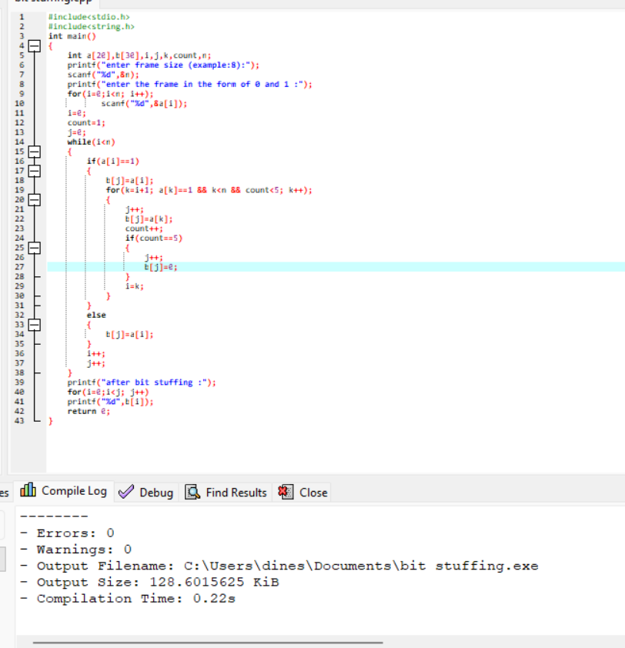

**EXPERIMENT-12: STATIC ROUTING**

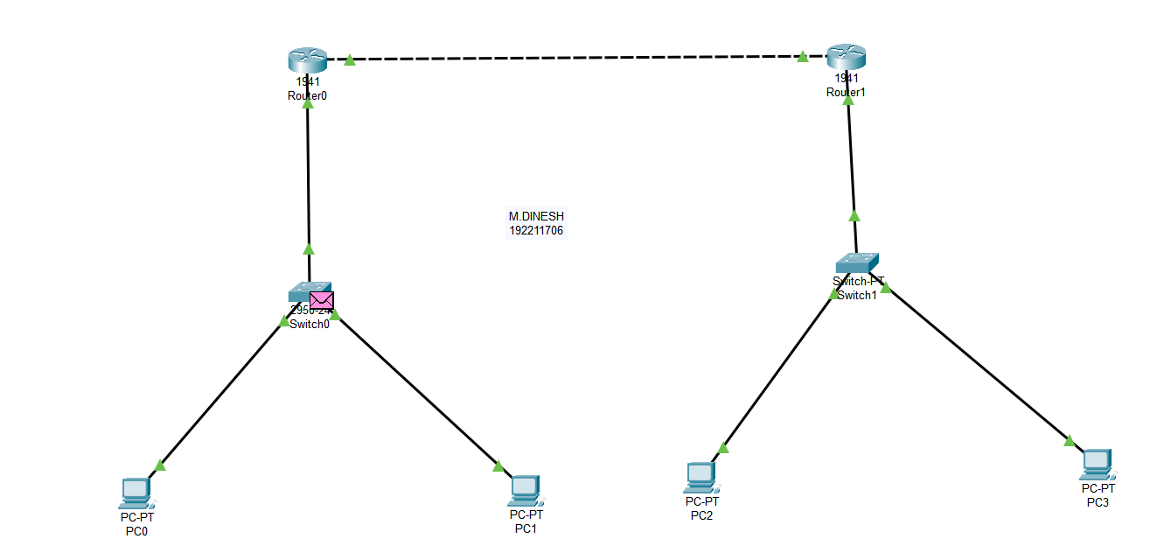

M.THIRUMALA MANOHAR

192211851

**EXPERIMENT-13: DYNAMIC ROUTING (OSPF)**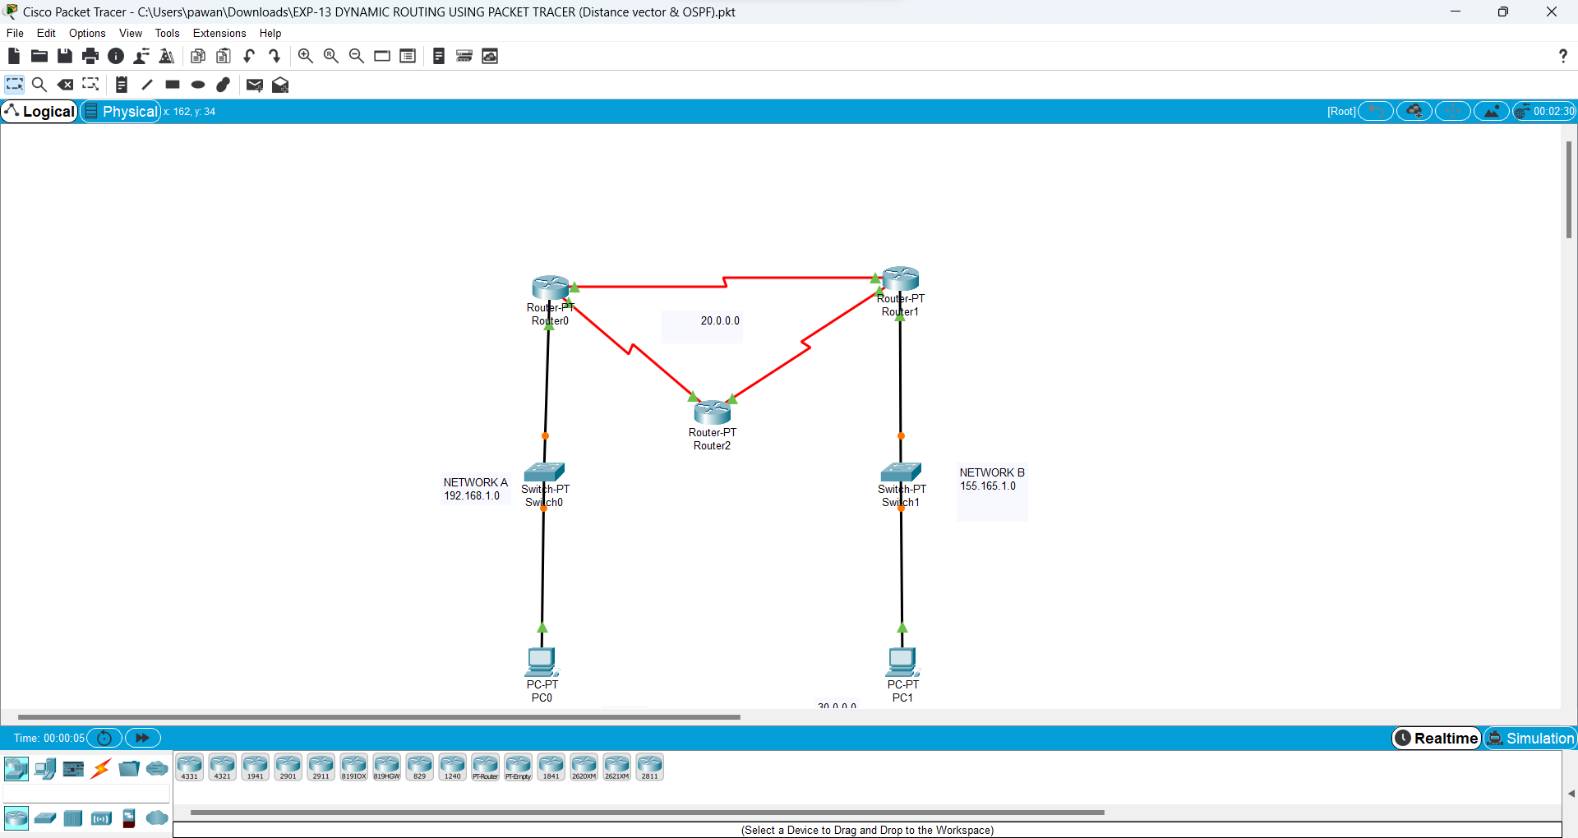

M.THIRUMALA MANOHAR

192211851

M.DINESH

192211706

**EXPERIMENT-14: FUNCTIONALITIES OF TCP**

M.THIRUMALA MANOHAR

192211851

M.DINESH

192211706

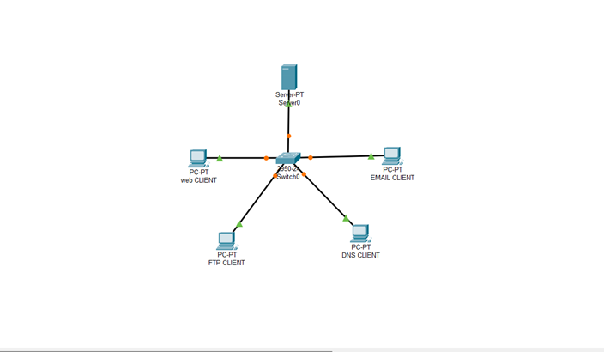

**EXPERIMENT-15: FUNCTIONALITIES OF UDP**

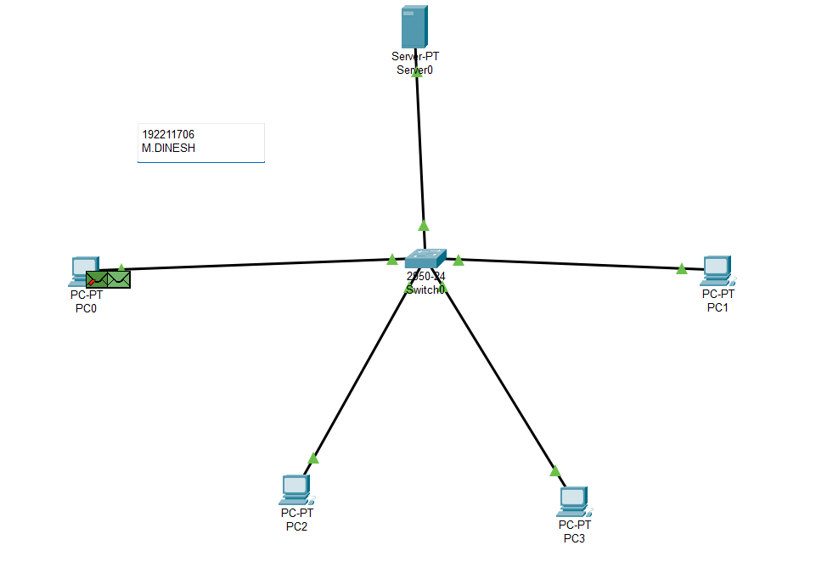

M.THIRUMALA MANOHAR

192211851

**SMART HOME**

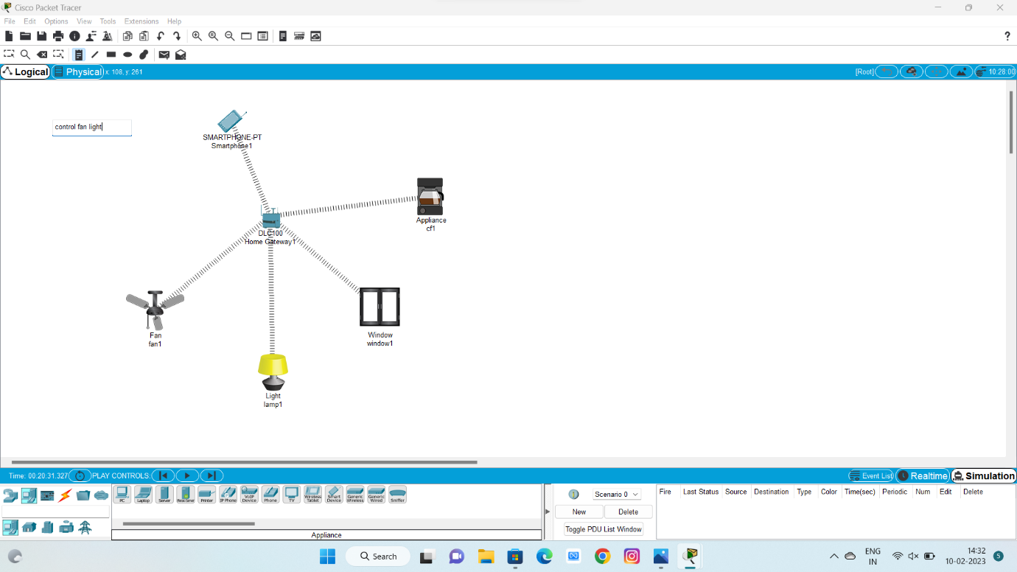

M.THIRUMALA MANOHAR

192211851

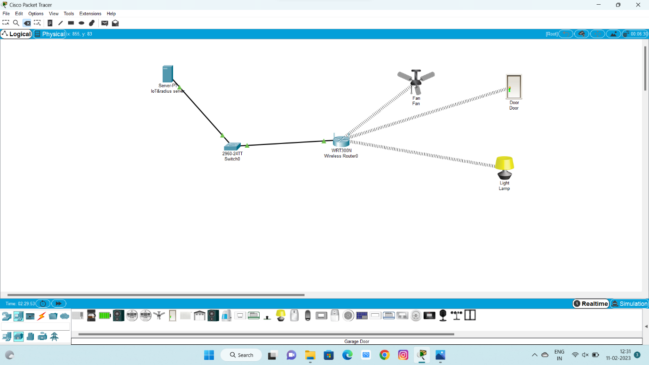

M.THIRUMALA MANOHAR

192211851

**EXPERIMENT-16: CLASS C ADRESSING**

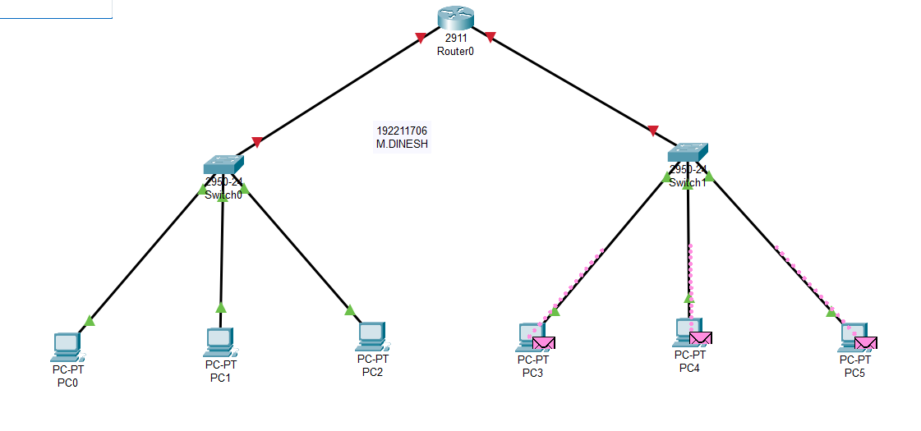

M.THIRUMALA MANOHAR

192211851

**EXPERIMENT-19: XYZ NETWORKS**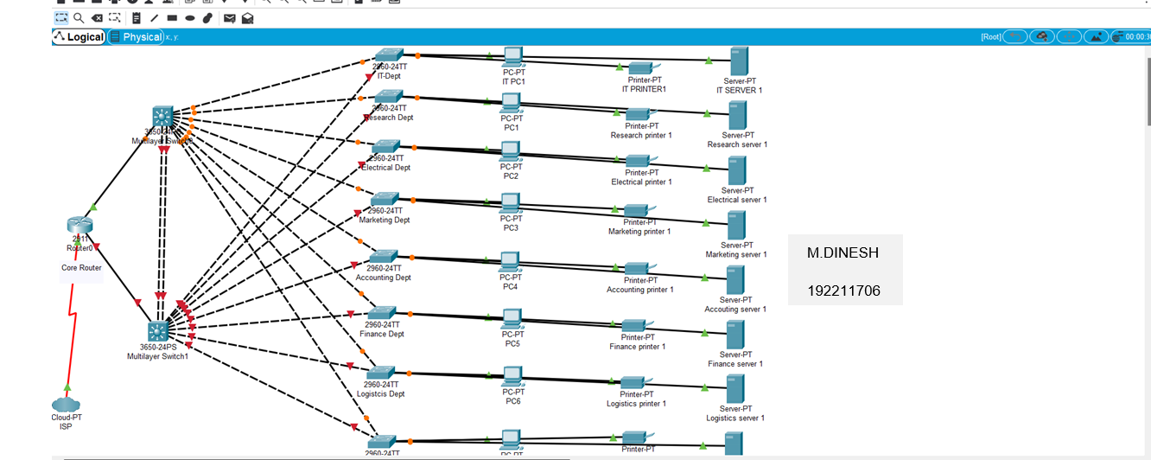

M.THIRUMALA MANOHAR

192211851

**EXPERIMENT-20: DHCP**

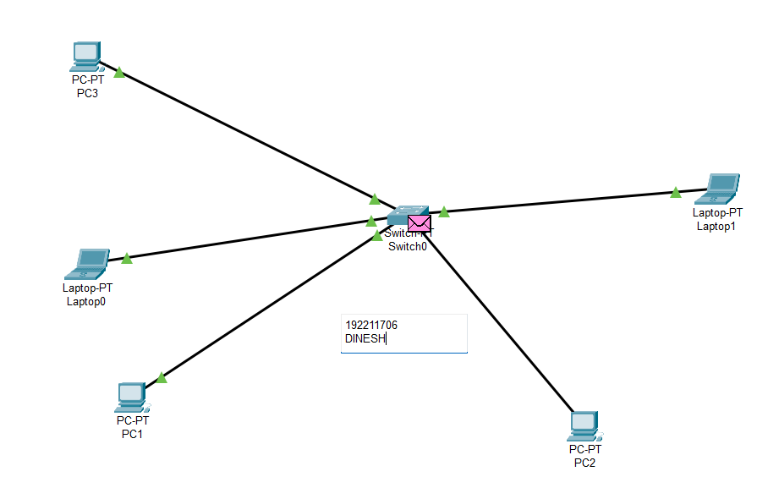

M.THIRUMALA MANOHAR

192211851

**EXPERIMENT-21: FIRE WALL**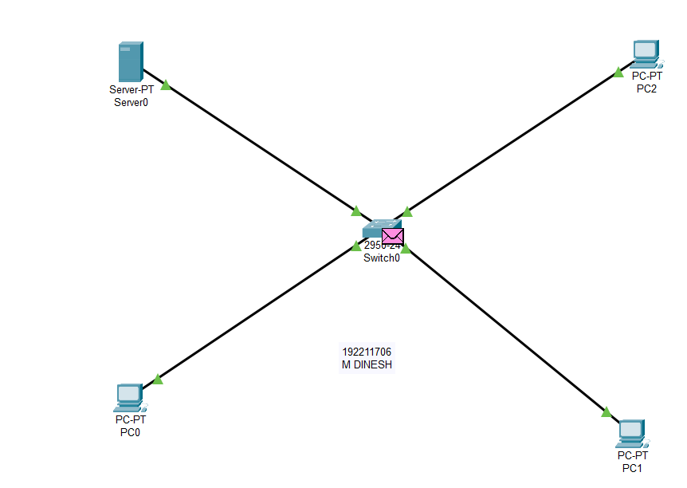

M.THIRUMALA MANOHAR

192211851

**EXPERIMENT-22: C LAB**

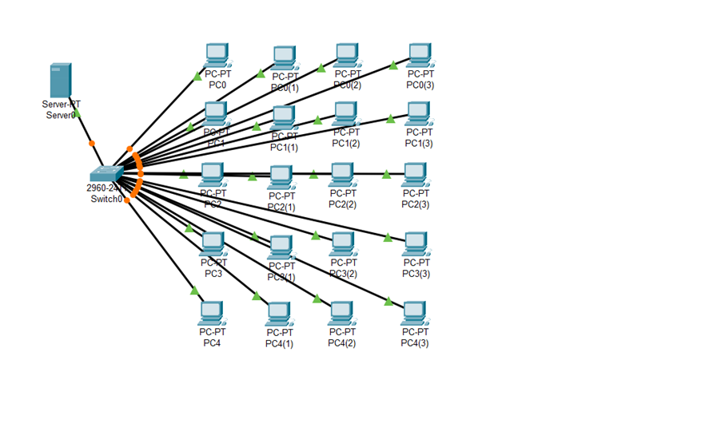

M.THIRUMALA MANOHAR

192211851

M.DINESH

19221106

M.DINESH

192211706

**EXPERIMENT-23: TCP WIRE SHARK**

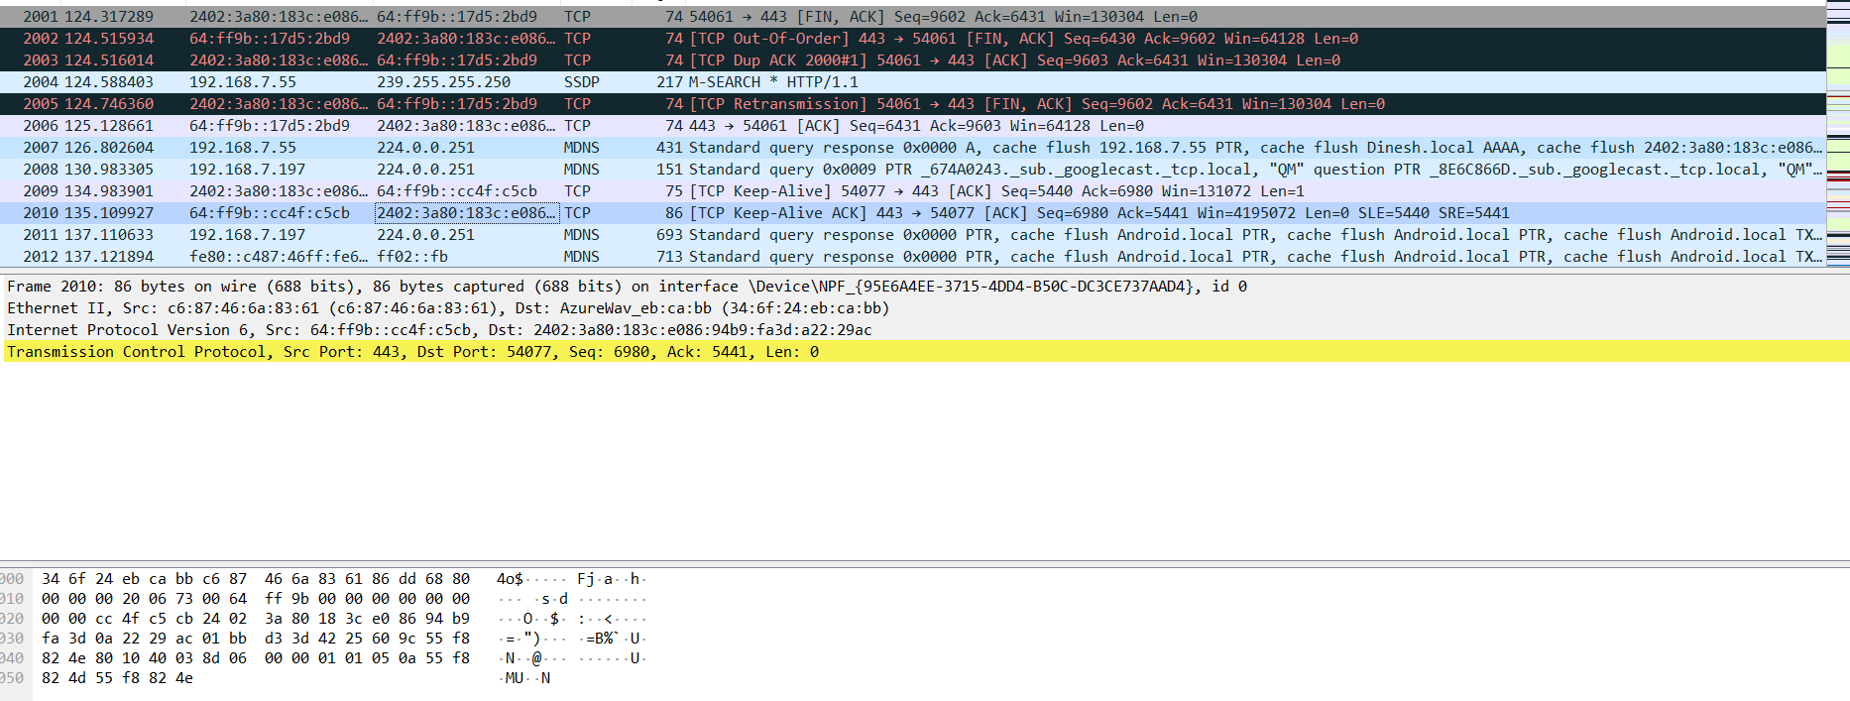

**EXPERIMENT-24: SMDP WIRE SHARK**

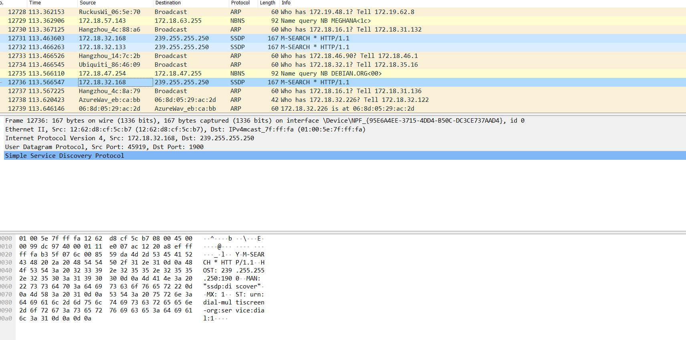

**EXPERIMENT-25: TCP**

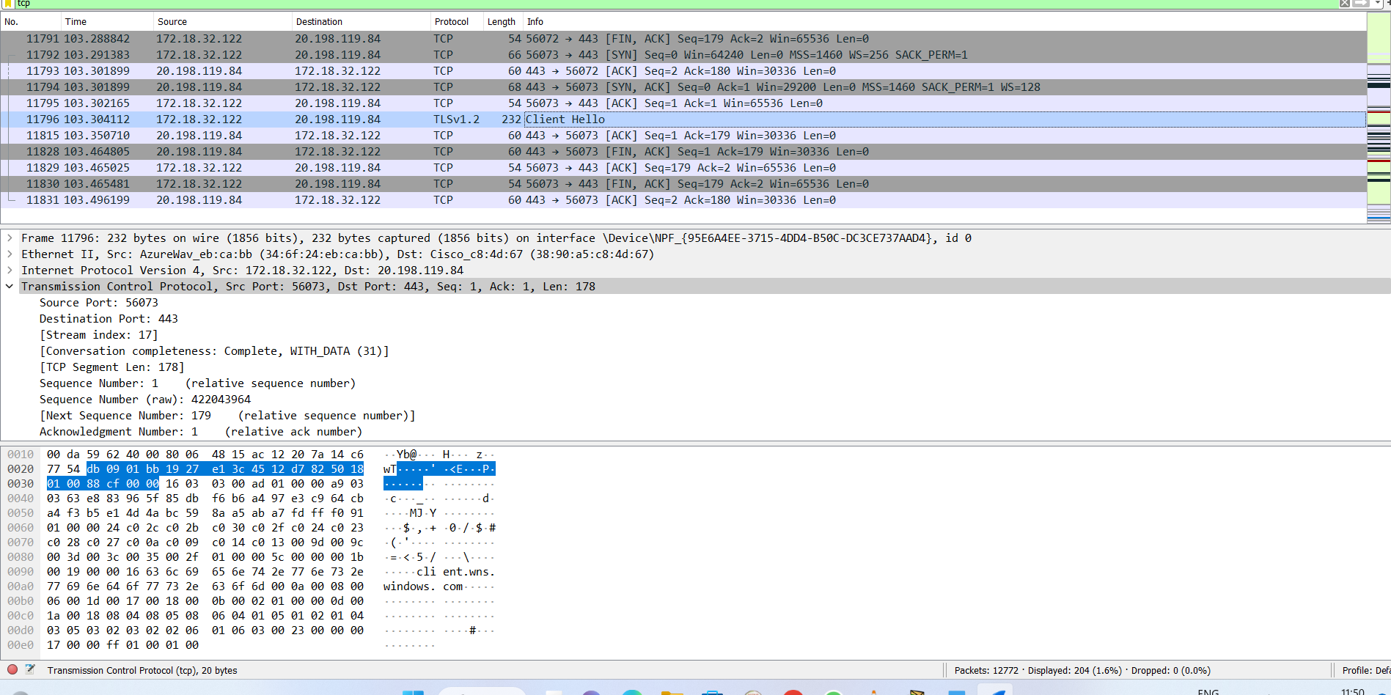

**EXPERIMENT-26: UDP**

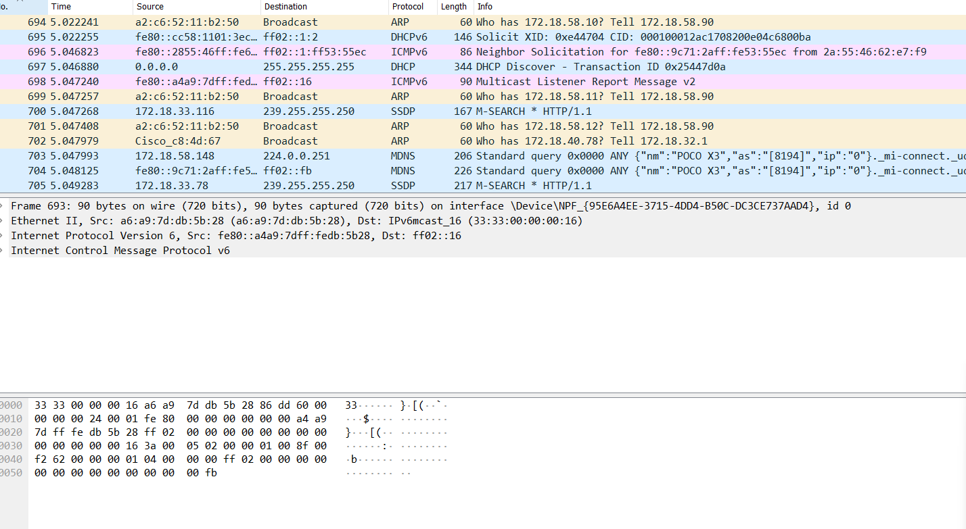

**EXPERIMENT-27: ADP**

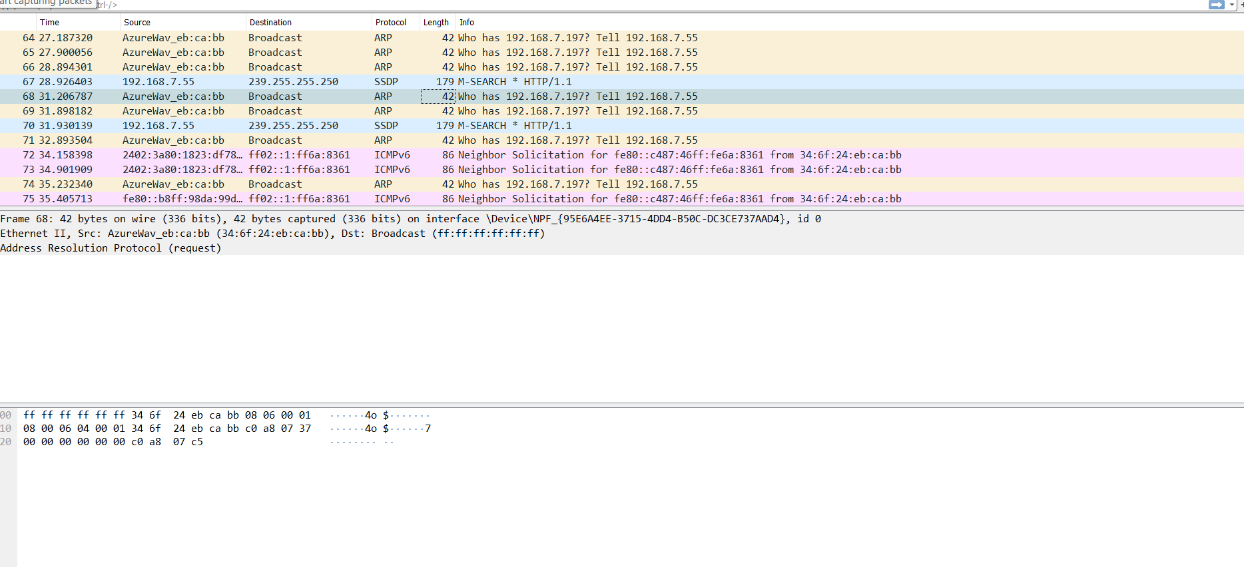

**EXPERIMENT-28: HTTP**

