**Use Case: Authentication**

Click on the “*Sign Up*” button on the right hand side of the navigation bar.

Complete all the required information.

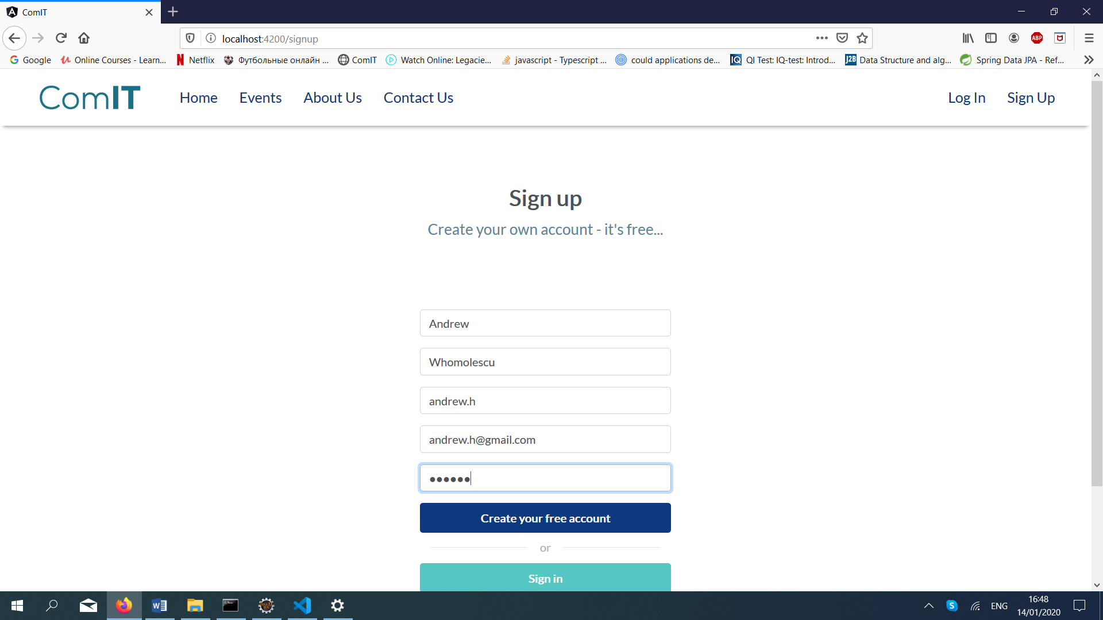

After clicking the “*Create your free account*” button, you will be redirectioned to the “*Login page*”.

Insert your username and password and click the “*Login*” button.

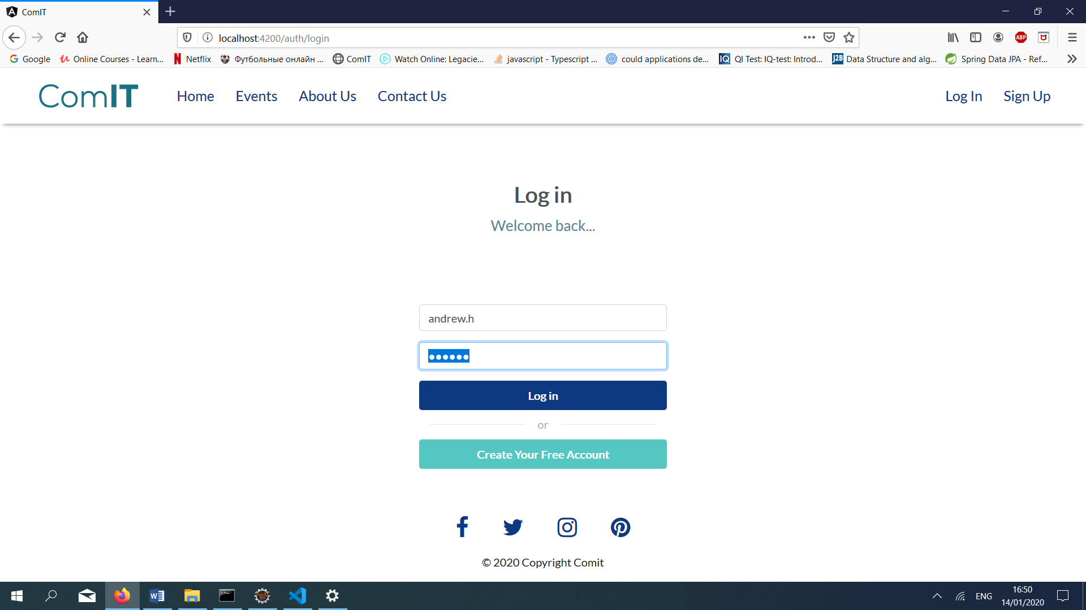

**Use Case: Create and event and add a challenge to the event**

Login with an admin account and from the navigation bar access the “*Dashboard*”.

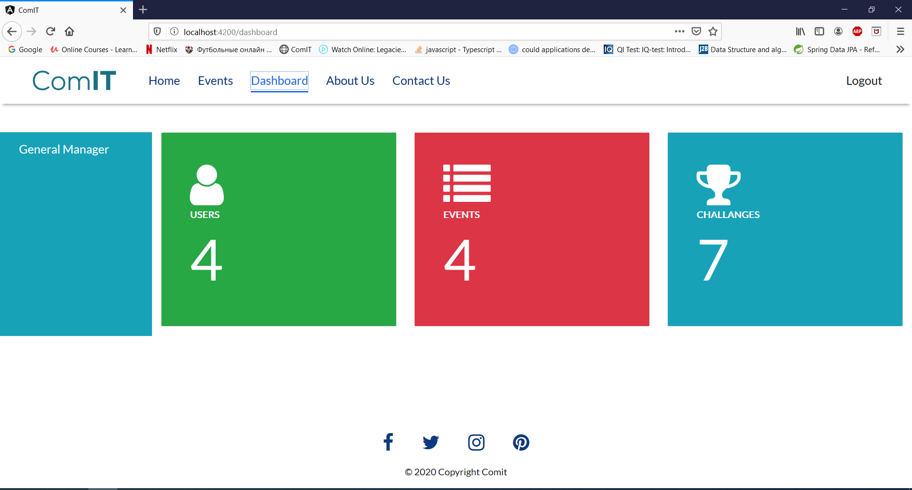

From the left menu select “*General Manager*”. From there we have two options:

* Manage events;
* Manage challenges.

First of all, create a challenge click the “*Add*” button and complete all the required informations:

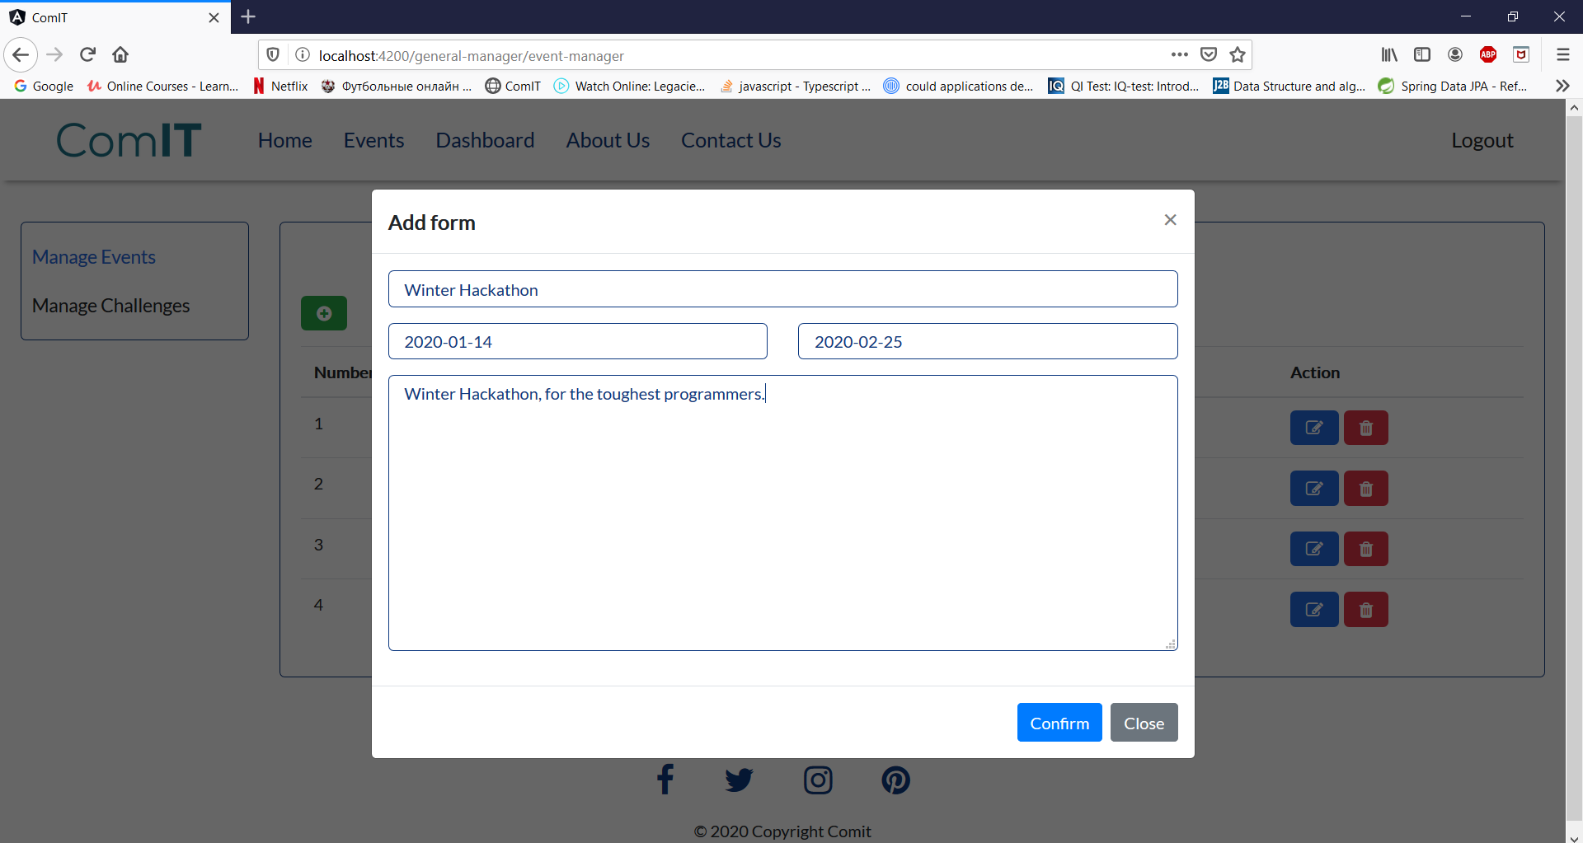

After completing all the informations, click the confirm button to complete the operation.

From the “*Manage Challenges*” page add a challenge to the event:

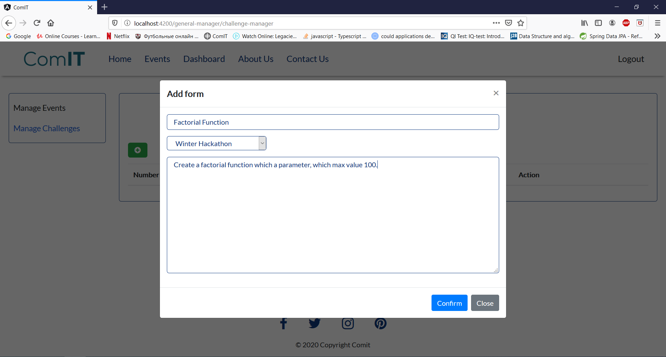

Click the “*Confirm*” button to complete the operation.

**Use Case: Create and event and add a challenge to the event**

Login with a user account. Access the events page:

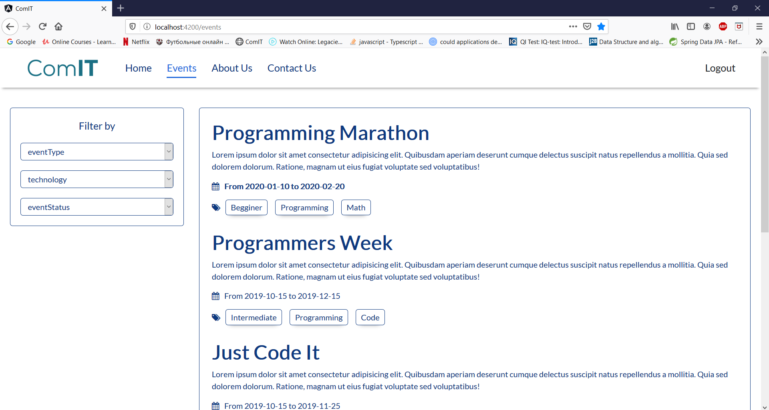

Choose an event. Once an event is selected, all the available challenges:

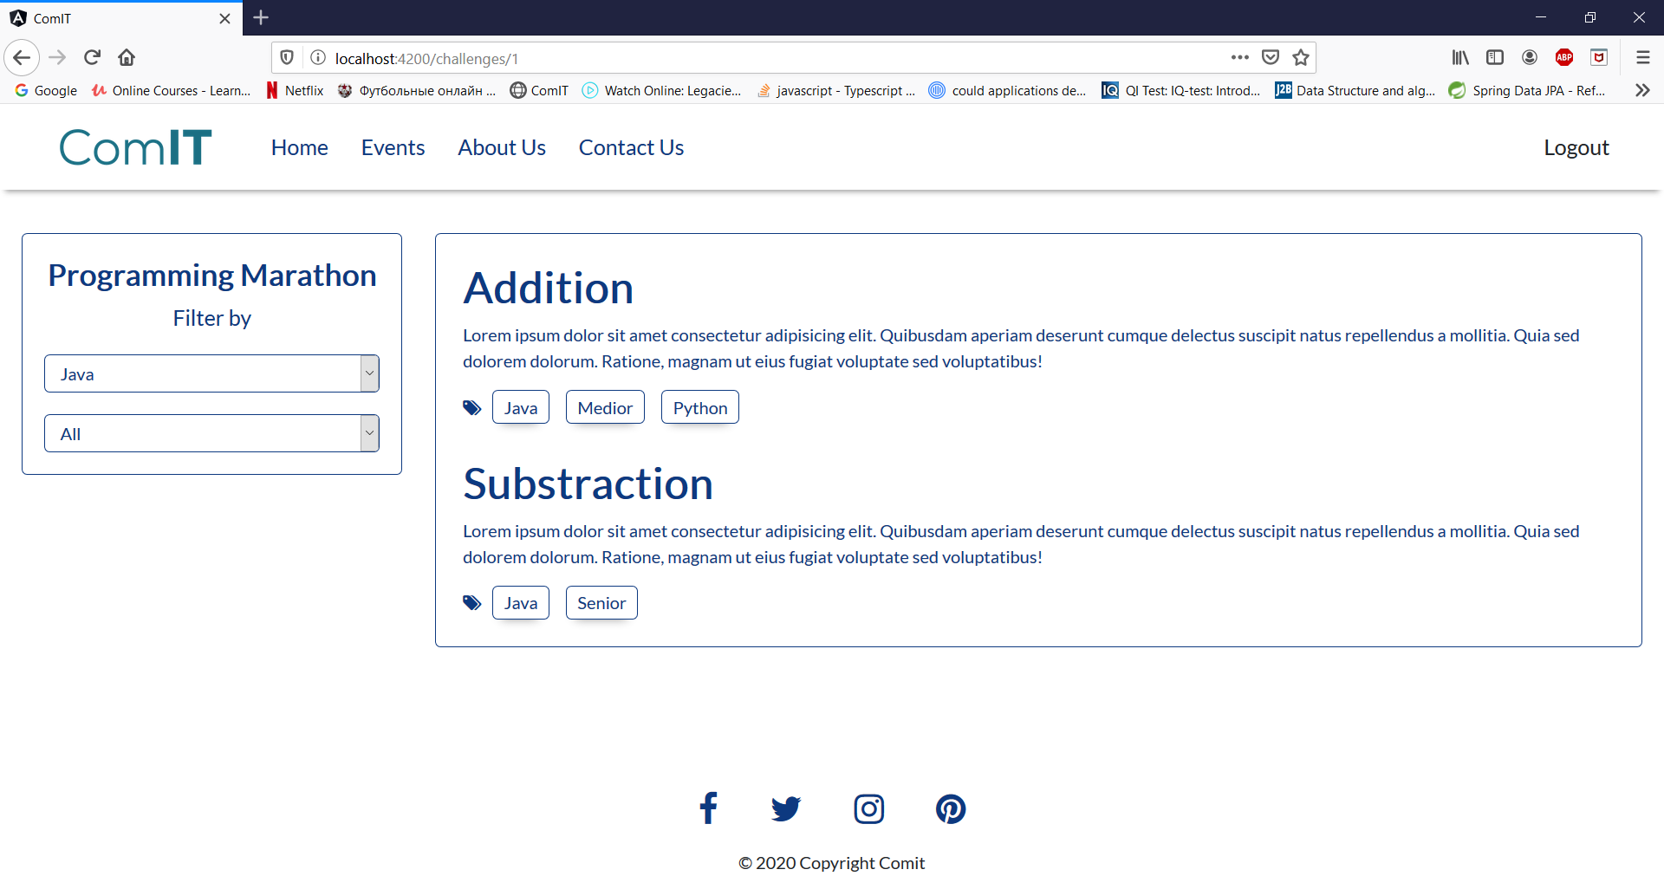

Select a challenge and from the “Code” section submit your solution:

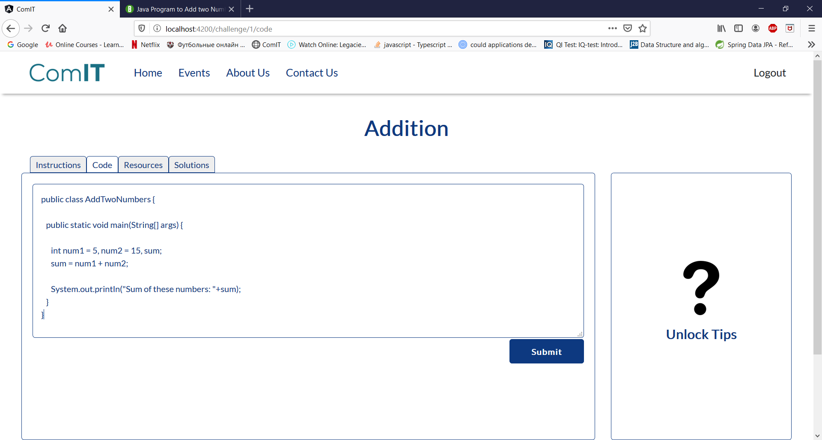

Click the “*Submit*” button to send your solution.