JDBC

Java Data Base Connectivity.

BY:

* Omar Mohamed Emam 44
* Islam Yousry 14
* Islam Mohamed 12
* Bahaa Khalaf 21

Report

JDBC

Report

**Report Content:**

1. Program Specifications
2. User Guide
3. UML Diagrams
4. Program Description
5. Design Patterns
6. Sample Runs

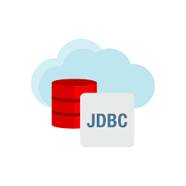

Program Specifications:

- Program creates the driver , connection , statement which are ready to accept your sql query , check it and then transfer it to DBMS to execute it and send the result back (if there is a result ) or just edit or create your databases and your tables

- Program deals with URL as database path in your local machine, so there is no existence for servers and its functions

- Program will keep running even if you entered in wrong syntax, you will be able to retry till you want to stop

- Program runs through self-runnable Cmd app

User Guide:

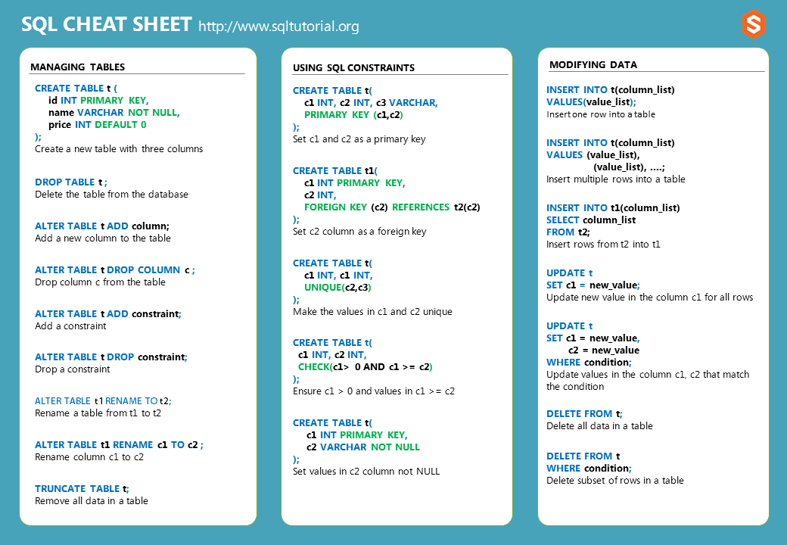Run “excucation.bat”, wait creation of connection then enter your SQL query in right syntax and then you can do more queries or exit by typing “end”.

UML Diagrams:

* 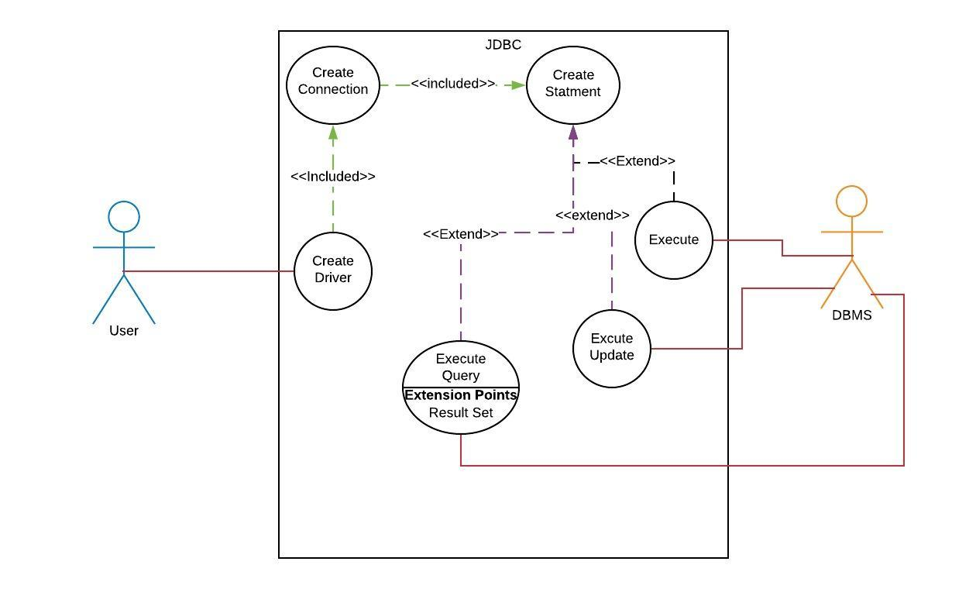Use Case Diagram :
* State Diagram For 3 Scenarios :

** General Scenario:

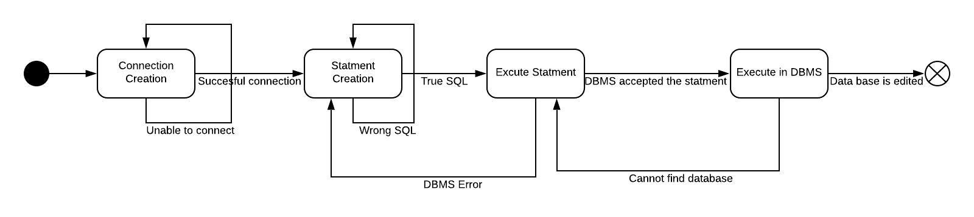

** Scenario #1 (create table):

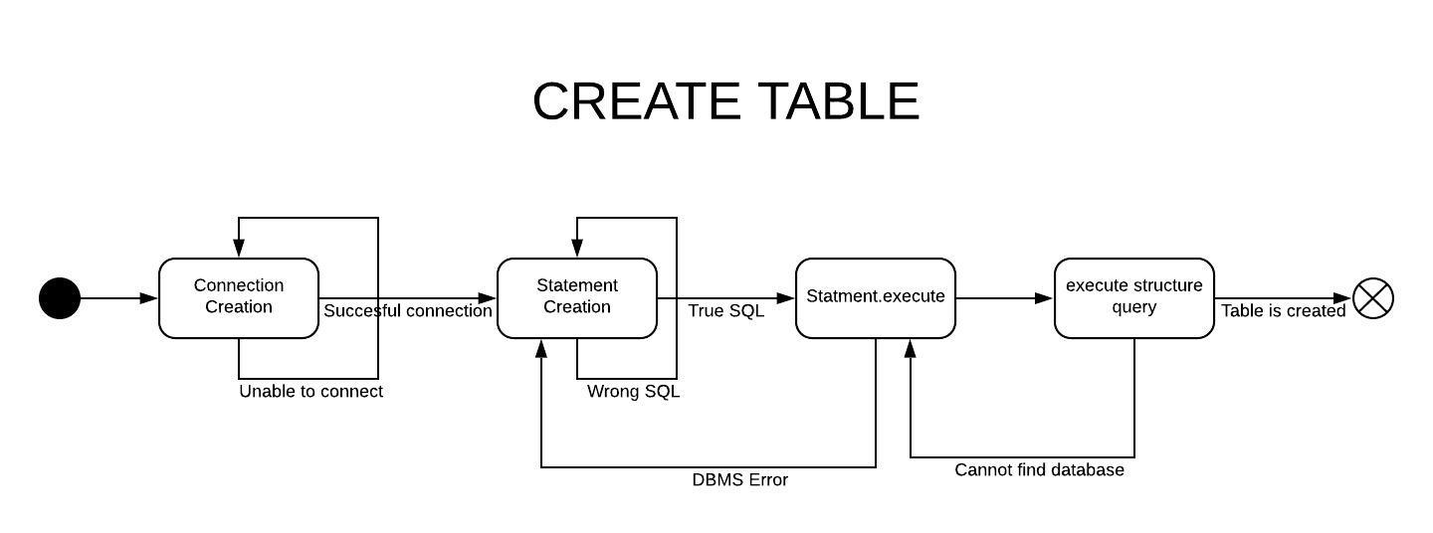** Scenario #2 (insert into table):

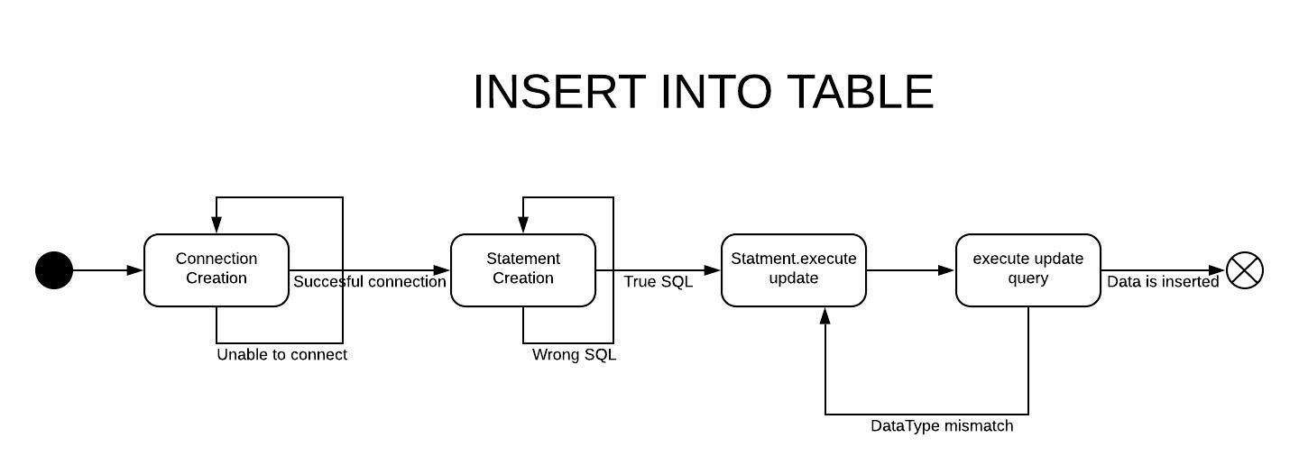** Scenario #3 (select from table):

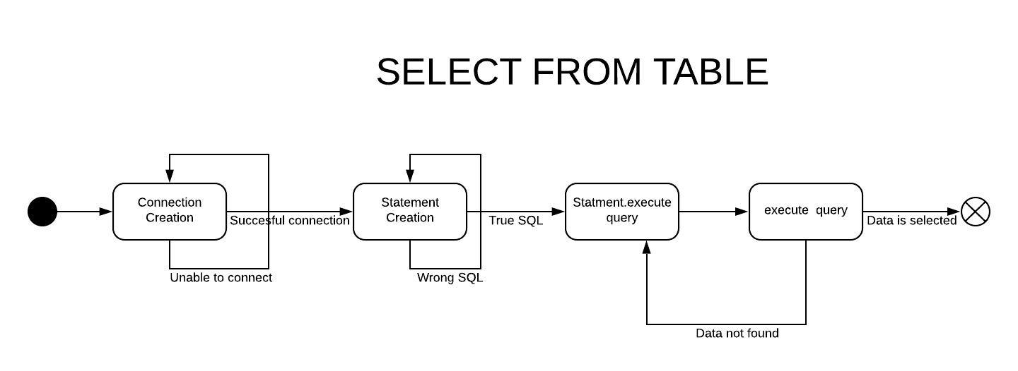

* Class Diagram :

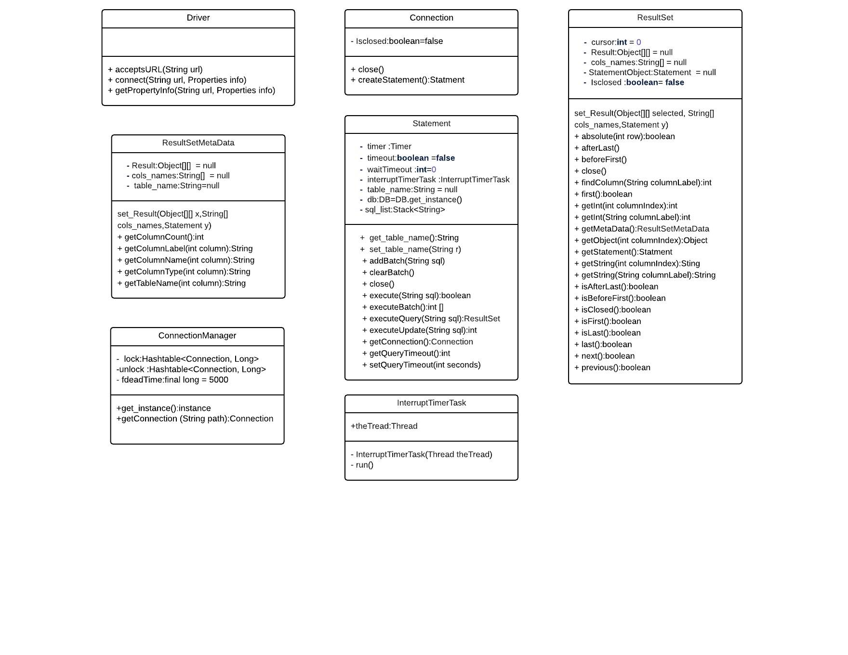

* 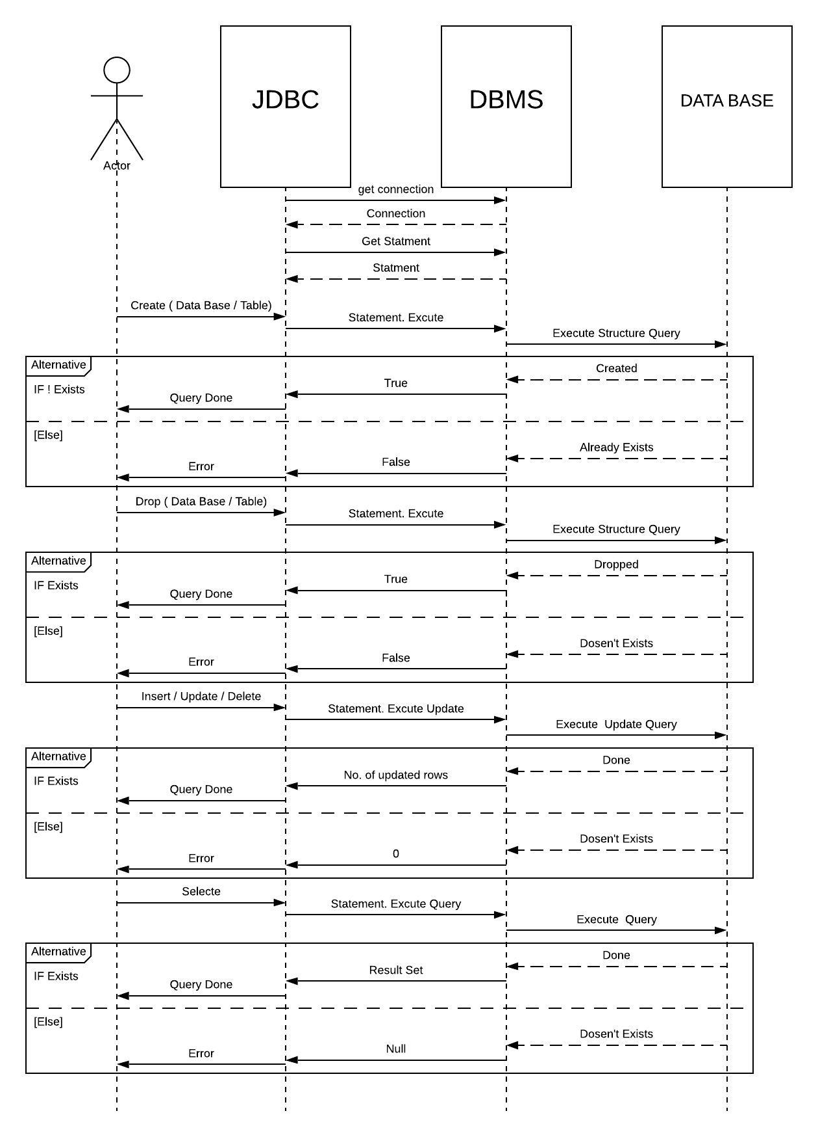Sequence Diagram :

Program Description:

We implemented some function in JDBC interfaces as following:

In java.sql.Driver:

* Accept URL: takes the url which must be path of data base and check if it’s correct or not
* Connect: Create a new connection between the driver and the database
* Get property Info: Gets information about the possible properties for this driver.

In java.sql.Connection:

* Crete Statement: Creates a Statement object that will generate ResultSet objects with the given type and concurrency.
* Close: Releases this Connection object's database and JDBC resources immediately instead of waiting for them to be automatically released.

In java.sql.Statement:

* Add Batch: check if sql query is right in syntax or not and add it to stack
* Clear Batch: Remove all queries from the stack
* Execute: Send Sql query to execute structure query function in DBMS
* Execute Update: Send Sql query to execute update query function in DBMS
* Execute Query: Send Sql query to execute query function in DBMS
* Set timeout: makes sure that execute function won’t pass the required run time
* Get timeout: get execution time for execute functions

In java.sql.ResultSet:

* Absolute : Moves the cursor to the given row number in this ResultSet object
* After Last: Moves the cursor to the end of this ResultSet object, just after the last row.
* Before First: Moves the cursor to the front of this ResultSet object, just before the first row.
* Close: Releases this ResultSet object's database and JDBC resources immediately instead of waiting for this to happen when it is automatically closed.
* Find Column: Maps the given ResultSet column label to its ResultSet column index.
* First: Moves the cursor to the first row in this ResultSet object.
* Get Int: Retrieves the value of the designated column in the current row of this ResultSet object as an Int in the Java programming language.
* Get Meta Data: Retrieves the number, types and properties of this ResultSet object's columns.
* Get Object: Gets the value of the designated column in the current row of this ResultSet object as an Object in the Java programming language
* Get Statement: Retrieves the Statement object that produced this ResultSet object.
* Get String(Int column Index) : Retrieves the value of the designated column in the current row of this ResultSet object as a String in the Java programming language.
* Get String (String column Label): Retrieves the value of the designated column in the current row of this ResultSet object as a String in the Java programming language.
* Is After Last: Retrieves whether the cursor is after the last row in this ResultSet object.
* Is Before First: Retrieves whether the cursor is before the first row in this ResultSet object.
* Is Closed: Retrieves whether this ResultSet object has been closed.
* Is First: Retrieves whether the cursor is on the first row of this ResultSet object.
* Is Last: Retrieves whether the cursor is on the last row of this ResultSet object.
* Last: Moves the cursor to the last row in this ResultSet object.
* Next: Moves the cursor forward one row from its current position.
* Previous: Moves the cursor to the previous row in this ResultSet object.

Design Patterns:

**Object Pool design pattern**:

Object pool pattern is a software creational design pattern which is used in situations where the cost of initializing a class instance is very high.  
Basically, an Object pool is a container which contains some amount of objects. So, when an object is taken from the pool, it is not available in the pool until it is put back.

**Singleton design pattern**:

The singleton pattern is a design pattern that restricts the instantiation of a class to one object.

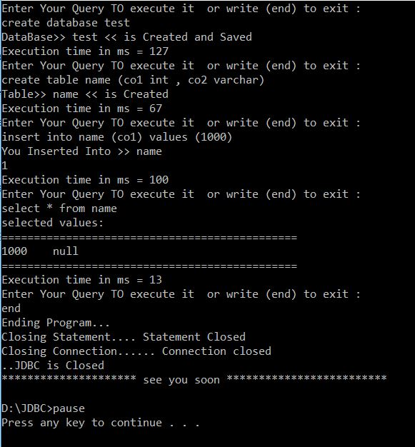Sample Runs:

