Uncertainty-guided referral for pneumonia screening improves in-domain triage but fails to transfer across institutions: internal and external validation of an MC Dropout chest radiograph classifier

Abstract
Background. Pneumonia is a leading cause of morbidity and mortality worldwide [1], and chest radiography is the first-line imaging modality in many settings. Deep learning models for pneumonia detection report high internal accuracy, but most are evaluated on single-institution data without uncertainty-aware referral, and their behavior across institutions is not well characterized. Whether predictive uncertainty can guide referral of low-confidence cases to human review, and whether this signal survives domain shift, is unclear.
Methods. We trained a ResNet-18 classifier on 5,856 frontal chest radiographs using patient-level splitting, with three random seeds. Uncertainty was estimated by Monte Carlo Dropout (MC Dropout; 30 samples), and a referral strategy routing high-uncertainty predictions to human review was compared against random referral at matched referral rates and against a plain-confidence baseline. The model was externally validated on 26,684 images from the RSNA cohort and on 9,103 images from a second independent external cohort (NIH ChestXray-14).
Results. Internal test AUC was 0.992 (95% CI 0.986–0.997). The uncertainty-based referral strategy reduced retained-case error from 4.0% to 1.4% at a 10% referral rate and to 0.3% with no missed cases at 25%, whereas random referral was ineffective. External AUC was 0.807 on RSNA (ECE 0.369 vs 0.034 internally) and 0.658 (95% CI 0.585–0.735) on the second NIH cohort. Referral no longer improved retained-case accuracy in either external cohort (e.g., 0.393 to 0.381 at 50% referral on RSNA). Internally, the referral signal performed comparably to plain model confidence (error-prediction AUC ≈ 0.93 for both) and was uninformative on both external cohorts. Low RSNA specificity (51.9%) was driven by classification of other pulmonary abnormalities as pneumonia (70%).
Conclusions. Uncertainty-guided referral is effective within the deployment institution but does not transfer across domain shift. Models meant for cross-institutional use should be trained or adapted on multi-institutional data and combined with clinical features rather than relied on as image-only classifiers.
Key points
1. An uncertainty-guided referral strategy eliminated missed pneumonia among retained predictions at a 25% referral rate (internal AUC 0.992), but failed on two independent external cohorts (RSNA AUC 0.807; NIH AUC 0.658).
2. The failure is not specific to MC Dropout: a plain-confidence referral signal behaves identically — effective within domain, uninformative under domain shift.
3. Both discrimination and calibration deteriorated sharply under domain shift, delimiting where confidence-based triage can be trusted.
Keywords Pneumonia; Chest radiograph; Deep learning; Uncertainty quantification; Monte Carlo dropout; Referral; External validation; Domain shift

Introduction
Pneumonia is a leading cause of hospitalization and death worldwide [1]. Chest radiography is the first-line imaging modality for its evaluation because it is widely available, inexpensive, and radiation-sparing relative to computed tomography. In high-volume and low-resource settings, the demand for interpretation frequently exceeds the supply of radiologists, which has motivated interest in deep learning systems that can triage chest radiographs [2].
Recent deep learning models for pneumonia detection on chest radiographs report high internal accuracy [3, 4, 5]. The availability of large public chest radiograph datasets, including CheXpert [4] and MIMIC-CXR [6], has accelerated this work. Most such studies, however, are conducted on data from a single site or dataset, report only internal validation, and do not characterize calibration or predictive uncertainty. Prior work has shown that pneumonia classifiers can vary substantially across institutions [7], and that performance measured on images from the training distribution overestimates performance under real-world acquisition differences.
For a system intended to assist rather than replace clinicians, an automated classifier must know when not to act autonomously [8]. Predictive uncertainty has been proposed as the basis for referring low-confidence predictions to human review [9, 10]: rather than emitting a confident label for every image, the system estimates how much it does not know and routes the least certain cases to a human reader. In this report we use the terms referral and triage interchangeably for this workflow — routing uncertain predictions to a human reader rather than accepting them automatically. In principle this turns a fixed threshold on accuracy into a tunable safety valve — the institution chooses how many cases to refer, and the remaining set is the part the model is most confident about. Uncertainty can be estimated in several ways — with ensembles [11], test-time augmentation, or Monte Carlo (MC) Dropout [12, 13]. MC Dropout stands out for clinical use: it needs no architectural change, only a trained model sampled stochastically at inference, and the spread of those samples becomes the uncertainty estimate at modest computational cost. Yet the evidence for uncertainty-guided referral in diagnostic imaging is thin, and its behavior under domain shift — images acquired outside the training distribution — is essentially untested. A deploying institution needs a specific answer: does a referral signal that works at the training site survive transfer to a different acquisition environment? That question is the one our study was designed to answer.
We therefore evaluated an MC Dropout uncertainty-based referral strategy for pneumonia detection on two fronts: whether it improves the accuracy of retained cases within an institution relative to random referral at matched rates, and whether the improvement survives across independent external cohorts. Our expectation was that referral would help internally but weaken under domain shift, and the analysis below tests exactly that.

Methods

Study design
This is a retrospective evaluation of a deep learning classifier for pneumonia detection on frontal chest radiographs. The aim was twofold: to test whether MC Dropout predictive uncertainty can drive a referral strategy that flags low-confidence predictions for human review, and to see whether that strategy generalizes across institutions. We developed and internally validated the classifier on a public single-site dataset, splitting at the patient level, and externally validated it on an independent multi-institution dataset from the National Institutes of Health (NIH).
Throughout, the image is the unit of analysis. The internal dataset is a set of individual chest radiographs; the model produces one prediction per image; and all metrics are reported at the image level. The patient-level split guarantees that no patient appears in both training and test partitions, but patients are otherwise not aggregated — the implications of within-patient image correlation for the bootstrap confidence intervals are taken up in the Discussion. The study follows the Standards for Reporting of Diagnostic Accuracy Studies (STARD) [14], the Checklist for Artificial Intelligence in Medical Imaging (CLAIM) [15], and the Transparent Reporting of a multivariable prediction model for Individual Prognosis Or Diagnosis (TRIPOD) statement [16].

Internal dataset
The internal dataset was the publicly available Chest X-Ray Images dataset described by Kermany et al. [3], comprising 5,856 frontal chest radiographs labeled as pneumonia or normal. Images were originally partitioned by the dataset authors at the image level, which permits the same patient to appear in both training and test partitions and inflates performance estimates. To eliminate patient-level leakage, we regrouped all images by patient identifier (derived from the filename prefix) and re-split the full cohort into training, validation, and test sets at the patient level (70/15/15), with the random split seeded at 42. The resulting partitions contained 4,076 images (2,222 patients), 884 images (476 patients), and 896 images (476 patients), respectively. The test set had a pneumonia prevalence of 75.6% (677 pneumonia versus 219 normal images), reflecting the original dataset's imbalance, which is preserved rather than resampled. The dataset derives from a single institution's retrospective archive centered on a pediatric population, as described in the original report [3]; the images span the normal and pneumonia appearances that form the core contrast of the collection, and no finer-grained subclassification of pneumonia patterns is available in the labels.

External dataset
The external validation cohort was the RSNA Pneumonia Detection Challenge dataset [17], comprising 26,684 frontal chest radiographs contributed by the NIH Clinical Center and the Society of Thoracic Radiology. Each image carried an expert-annotated image-level class derived from the competition's detailed classification: Lung Opacity (evidence of pneumonia), No Lung Opacity / Not Normal, or Normal. The annotations reflect the consensus of a panel of radiologists assembled for the challenge, rather than a single reader, and the dataset was designed to capture the diagnostic ambiguity between pneumonia and other opacity-producing conditions that a binary label set obscures. We defined pneumonia positivity as a Lung Opacity annotation, yielding 6,012 positive images (22.5%); the remaining images were split between 11,821 No Lung Opacity / Not Normal and 8,851 Normal. This cohort is drawn from a broader, more demographically diverse patient population than the internal dataset and was acquired in a different hospital network, providing a genuine domain shift for validation purposes. The external cohort was used exclusively for evaluation; no external data were used for model development, validation-set tuning, or threshold selection.
As a second, independent external cohort, we used a binary two-class subset of the NIH ChestXray-14 dataset [18] in which images are labeled as either Pneumonia or No Finding. We used the preprocessed test partition of this dataset (9,103 images: 49 pneumonia and 9,054 normal; pneumonia prevalence 0.5%), resized to 224 × 224 pixels. This cohort differs from the internal data in population (adults versus a predominantly pediatric internal cohort), acquisition, and label provenance (NLP-derived from radiology reports rather than expert re-adjudication); it therefore provides a distinct domain-shift test. As with the RSNA cohort, it was used exclusively for evaluation without threshold tuning.

Reference standard
For the internal dataset, the reference standard was the binary pneumonia/normal label provided by the dataset authors [3]. For the external dataset, the reference standard was the expert consensus annotation of Lung Opacity [17]. No images were excluded from either cohort.

Model development
We used a ResNet-18 convolutional network pretrained on ImageNet. ResNet-18 was selected because it is lightweight, well suited to the available compute (single RTX 3060, 6 GB), and among the most widely used backbones in chest radiograph classification [2]; in a preliminary comparison on the original (image-level) split it matched or exceeded alternative backbones in validation accuracy, and it was retained as the primary model for the patient-level analysis reported here. We did not undertake a systematic patient-level architecture comparison; the choice trades off the possibility that a stronger backbone would improve absolute accuracy against the transparency of a standard, widely used architecture, and this trade-off is addressed as a limitation.
The convolutional backbone was frozen, and the classification head was replaced with a dropout layer followed by a two-unit linear layer; the head and the final residual block were fine-tuned. This design keeps the number of trainable parameters small and reduces overfitting on a training set of 4,076 images, while still allowing the deepest convolutional features to adapt to the chest-radiograph domain. Images were resized to 224 × 224 pixels, normalized using ImageNet statistics, and augmented during training with random rotation (±10°), color jitter (brightness 0.2, contrast 0.1), and random affine translation (5% of image dimensions). The model was trained with the AdamW optimizer (learning rate 1 × 10⁻⁴, weight decay 1 × 10⁻⁵), a batch size of 16, and early stopping on validation loss with a patience of five epochs; the validation loss was monitored on the patient-level validation split throughout. To characterize run-to-run variability, we trained three models from different random seeds (42, 2024, 2026) under the fixed patient-level split, and two additional models with an unfrozen backbone (seeds 42, 2024) to test the sensitivity of the results to the backbone-freezing choice. Training was performed in PyTorch 2.5 with automatic mixed precision on a single NVIDIA RTX 3060 GPU.

Uncertainty quantification
Predictive uncertainty was estimated using MC Dropout [12, 19]. At inference, dropout was enabled and 30 stochastic forward passes were performed; the mean of the pneumonia probability across passes served as the final prediction, and its standard deviation (std) served as the uncertainty estimate. The number of passes was fixed at 30 to balance computational cost against estimator stability. The estimator was implemented with batch normalization kept in evaluation mode so that only the dropout-induced stochasticity contributed to the variance, rather than the data-dependent scaling that batch normalization in training mode would introduce. We used the standard deviation rather than the variance as the referral statistic because it is expressed in probability units and is therefore interpretable as a confidence band around the mean prediction; the two statistics produce identical rankings of uncertainty and hence identical referral curves.

Referral strategy
The referral rule is simple: pick a standard-deviation threshold; any case whose uncertainty exceeds it is sent to a human reader instead of being accepted as the automated answer. Sweeping that threshold across the observed range of uncertainties traces a referral-error trade-off — at each step we record the referral rate (the fraction of cases sent for review) and, among the cases retained for automation, the error rate and the missed-case rate. Because the shape of the uncertainty distribution determines how a threshold translates into a referral rate, we present results at fixed referral rates (0%, 5%, 10%, …, 50%) rather than at fixed standard-deviation values; that makes the curves comparable across cohorts whose uncertainty scales differ. As a control, we also ran a random referral policy at the same rates — referring a random subset of equal size — and recomputed the retained-set error. Comparing the uncertainty-based and random curves at matched rates isolates whether the uncertainty signal itself carries information about correctness, rather than merely reflecting the effect of dropping cases. As a further reference, we also constructed a referral rule from the model's plain confidence rather than its MC Dropout variability: cases closest to the 0.5 decision boundary (lowest MC-mean probability confidence) were referred first. This plain-confidence curve indicates whether the referral signal derives specifically from dropout-induced variability or is already present in the model's own predictive confidence; we refer to this rule as plain-confidence referral throughout.
Referral decisions and the classification of retained cases were made on the MC Dropout mean probability (temperature-scaled at T = 1.67) thresholded at 0.5; consequently the baseline (0% referral) error rate in the referral analysis reflects this MC-mean protocol and differs slightly from the single-pass classification error rate reported above. All referral metrics — for both the uncertainty-based and the random policy — were computed within this single protocol, so internal comparisons across referral rates and against random referral are internally consistent.

Statistical analysis
Discrimination was quantified with the area under the receiver operating characteristic curve (AUC), with 95% confidence intervals (CIs) obtained by 2,000 bootstrap resamples of the test images (resampling with replacement at the image level), and with the area under the precision-recall curve (AUPRC). Calibration was quantified with the expected calibration error (ECE) [13, 20], computed over 15 probability bins as the sample-size-weighted mean of the absolute difference between the predicted probability and the observed frequency within each bin, and with the Brier score, the mean squared difference between predicted probabilities and binary labels. Both calibration measures were computed on the raw (unscaled) class probabilities so that internal and external values are directly comparable; a temperature-scaled variant of the external ECE is reported in the Discussion to quantify what a post-hoc recalibration could and could not recover. We reported sensitivity, specificity, and accuracy at the default operating point of 0.5. The three seed models were summarized as mean ± standard deviation (SD; sample SD, n − 1 degrees of freedom) for all metrics. Differences between uncertainty-based and random referral in the retained-case error counts at the 10% and 25% referral rates were tested with two-sided chi-square tests of proportions on the 2 × 2 tables of correct versus incorrect retained predictions. The information content of each referral signal was quantified with the error-prediction AUC, defined as the area under the receiver operating characteristic curve when the signal (MC Dropout standard deviation or plain confidence) is used to predict whether a retained prediction is incorrect. For the external cohorts, no formal test of the referral effect was performed: the uncertainty-based and random curves overlapped at every referral rate and no directional alternative was prespecified, so the external comparisons are reported descriptively. Analyses were performed in Python 3.11 using scikit-learn and SciPy, with model inference in PyTorch 2.5 on an NVIDIA RTX 3060.

Results

Dataset characteristics
The internal cohort contained 5,856 chest radiographs, regrouped by patient and split into training (4,076 images from 2,222 patients), validation (884 images from 476 patients), and test (896 images from 476 patients) sets (Table 1). The internal test set had a pneumonia prevalence of 75.6%. The external RSNA cohort contained 26,684 images, of which 6,012 (22.5%) were annotated as Lung Opacity (pneumonia), 11,821 as No Lung Opacity / Not Normal, and 8,851 as Normal (Table 1, Fig 1).

Internal test performance
On the internal test set, the classifier achieved an AUC of 0.992 (95% CI 0.986–0.997) and an AUPRC of 0.997 (Table 2, Fig 2). At the default 0.5 threshold, accuracy was 96.1%, sensitivity 96.4%, and specificity 95.0%, with 24 false negatives and 11 false positives among 896 images. The ECE before temperature scaling was 0.034, with a Brier score of 0.032 (Fig 3).

Run-to-run stability
Across three training seeds (42, 2024, 2026) under the fixed patient-level split, the internal test AUC was 0.9925 ± 0.0007, AUPRC 0.9974 ± 0.0002, accuracy 0.965 ± 0.008, ECE 0.029 ± 0.007, and Brier score 0.028 ± 0.005 (Table 3). The dominant source of variability was not the training procedure but the operating threshold and the small number of errors: across the three seeds the test sets contained between 23 and 37 errors, and the accuracy difference between the best and worst seed (0.9743 vs 0.9587) corresponded to roughly 14 images out of 896. Training models with an unfrozen backbone produced AUC values (0.9962 and 0.9946 for seeds 42 and 2024) that were slightly higher than the frozen-backbone counterparts but within the range one would expect from unregularizing a small dataset; we retained the frozen-backbone setting as primary because it is more conservative and better aligned with the compute constraints of a typical deployment site. The internal referral results were likewise stable across seeds: at a 10% referral rate, retained-case error ranged from 0.7% to 1.4% across the three seeds (2.6–3.9% for random referral at matched rates), and at a 25% referral rate it ranged from 0.1% to 0.3%, with a retained-case missed-pneumonia rate of at most 0.2% (one case for seed 2026 and zero for seeds 42 and 2024; Table S1).

Internal referral strategy
In the internal test set, the MC Dropout uncertainty-based referral rule reduced the error rate of retained cases from 4.0% at a 0% referral rate to 1.4% at a 10% referral rate and to 0.3% at a 25% referral rate, at which point the missed-case rate among retained cases was zero (Fig 4). Random referral at identical referral rates left the retained error rate essentially unchanged (3.9% at 10% and 3.4% at 25%). The difference between uncertainty-based and random referral was statistically significant at both rates (χ² = 9.56, P = 0.002 at 10%; χ² = 16.30, P < 0.001 at 25%). Two properties of the curve are worth making explicit. First, the benefit is concentrated in the first quarter of referrals: the retained error rate drops by two thirds by the 10% point and is already near zero at 25%, so a referral rate materially higher than 25% adds little. Second, the referred cases were not merely the hard-but-answerable ones — because the missed-case rate in the retained set reached zero, the referral channel captured every pneumonia case that would otherwise have been missed, which is precisely the property a safety-oriented triage tool requires.

External validation
On the external RSNA cohort, the classifier achieved an AUC of 0.807 (95% CI 0.801–0.812) and an AUPRC of 0.514 (Table 2, Fig 2). At the 0.5 threshold, accuracy was 60.7%, sensitivity 90.7%, and specificity 51.9%. Calibration degraded substantially, with an ECE of 0.369 (vs 0.034 internally) and a Brier score of 0.355 (Fig 3). The operating point deserves comment: the 0.5 threshold was carried over unchanged from the internal analysis, and the external specificity of 51.9% is a property of that fixed threshold under a different prevalence and label distribution, not of the model's ranking ability, which the AUC of 0.807 reflects. Applying a threshold tuned to the external distribution would trade sensitivity for specificity and change the reported accuracy substantially; we report the fixed-threshold results to reflect the realistic scenario of deploying a model without local threshold re-optimization, and we return to this point in the Discussion.

External subgroup analysis
In the external cohort, the mean predicted probability of pneumonia was 0.901 among the 6,012 Lung Opacity images (90.7% classified as pneumonia), 0.203 among the 8,851 Normal images (18.7% classified as pneumonia), and 0.700 among the 11,821 No Lung Opacity / Not Normal images (70.0% classified as pneumonia) (Fig 5). Decomposing the 9,936 false positives by subgroup confirms where the specificity loss comes from: images annotated No Lung Opacity / Not Normal contributed 8,280 of them (83.3%), whereas genuinely Normal images contributed 1,656 (16.7%). In other words, the classifier is not generally trigger-happy — it is specifically confusing pneumonia with other opacities that share its radiographic appearance — and a binary Normal-versus-pneumonia framing hides this entirely. This also explains why the external specificity does not recover with any threshold that preserves sensitivity: the No Lung Opacity subgroup sits at a mean predicted probability of 0.70, squarely on the pneumonia side of the decision boundary, so no single scalar threshold cleanly separates it from true pneumonia.

External referral strategy
In the external cohort, the uncertainty-based referral rule reduced the retained error rate from 0.393 at a 0% referral rate to 0.381 at a 50% referral rate, comparable to the random referral control (0.387 at 50%) (Fig 4). The contrast with the internal curve is stark: internally, referring one quarter of cases cut the retained error rate by more than 90%; externally, referring half the cohort reduced it by only three percentage points, and random referral performed just as well. The MC Dropout standard deviation, which separated correct from incorrect internal predictions, carried almost no such signal on the external images. This is expected in hindsight: dropout uncertainty reflects the model's sensitivity to its own stochasticity, which is informative about decision confidence only insofar as the model's operating regime is the one it was trained in. Under domain shift the model is confident — uniformly so — about inputs it has never seen in the right distribution, and the uncertainty estimate no longer tracks correctness.

Second external cohort (NIH ChestXray-14)
On the second, independent external cohort (9,103 images; pneumonia prevalence 0.5%), AUC was 0.658 (95% CI 0.585–0.735) and AUPRC 0.010 (Table 2, Fig 2); at the fixed 0.5 threshold, sensitivity was 61.2% and specificity 62.3%. Calibration was again markedly degraded (raw ECE 0.265, Brier 0.315; Table 2, Fig 3). The uncertainty-based referral rule again failed to improve the retained error rate beyond random referral (e.g., 0.354 at 25% referral versus 0.378 for random referral; Fig 4). This second, label-distinct external cohort (NLP-derived Pneumonia versus No Finding labels, adult population) thus replicates the RSNA finding: the uncertainty ranking that separates correct from incorrect internal predictions carries no such information under domain shift.

Referral-signal baseline: MC Dropout versus plain confidence
To test whether the referral signal derives specifically from MC Dropout variability, we compared it with a rule that refers cases by the model's plain confidence (cases with the lowest MC-mean probability confidence, i.e., closest to the decision boundary). Internally, the two signals were near-equivalent: the error-prediction AUC — the AUC of the signal as a predictor of a wrong prediction — was 0.931 for the MC Dropout standard deviation and 0.933 for plain confidence, and the referral curves were similar, with MC Dropout modestly better at intermediate referral rates (retained error 0.0112 versus 0.0136 at 10% referral; 0.0015 versus 0.0030 at 25%). On the NIH external cohort, neither signal was informative (error-prediction AUC ≈ 0.5, referral curves flat and overlapping random referral); on RSNA, both the uncertainty-based and plain-confidence curves were flat and comparable to random referral. The referral benefit is therefore not an artifact of the MC Dropout estimator: a plain-confidence referral rule behaves the same — effective within domain, uninformative under domain shift — and the failure is a property of using model confidence as a signal of correctness in a foreign distribution, not of the specific uncertainty estimator.

Tables

Table 1. Dataset characteristics
 | Internal (Kaggle) | External (RSNA) | External (NIH)
Images, total | 5,856 | 26,684 | 9,103 (test)
Split (patients) | train 2,222 / val 476 / test 476 | — | —
Test images (prevalence) | 896 (75.6%) | 26,684 (22.5% Lung Opacity) | 9,103 (0.5% Pneumonia)
Positive class | Pneumonia | Lung Opacity | Pneumonia
Source | Kermany et al. 2018 | NIH Clinical Center | NIH (NLP-derived labels)

Table 2. Model performance
Metric | Internal test | External (RSNA) | External (NIH)
AUC (95% CI) | 0.992 (0.986–0.997) | 0.807 (0.801–0.812) | 0.658 (0.585–0.735)
AUPRC | 0.997 | 0.514 | 0.010
Accuracy | 96.1% | 60.7% | 62.3%
Sensitivity | 96.4% | 90.7% | 61.2%
Specificity | 95.0% | 51.9% | 62.3%
ECE (raw) | 0.034 | 0.369 | 0.265
Brier (raw) | 0.032 | 0.355 | 0.315
Brier score (raw) | 0.032 | 0.355

Table 3. Run-to-run stability (3 seeds, internal test)
Metric | Seed 42 | Seed 2024 | Seed 2026 | Mean ± SD
AUC | 0.9919 | 0.9924 | 0.9933 | 0.9925 ± 0.0007
AUPRC | 0.9971 | 0.9973 | 0.9977 | 0.9974 ± 0.0002
Accuracy | 0.9609 | 0.9743 | 0.9587 | 0.9646 ± 0.0084
ECE (raw) | 0.0335 | 0.0213 | 0.0334 | 0.0294 ± 0.0070
Brier (raw) | 0.0316 | 0.0225 | 0.0291 | 0.0277 ± 0.0047

Discussion
This study asked whether MC Dropout uncertainty can drive a referral strategy for pneumonia detection, and how that strategy holds up across institutions. Within a single institution the answer was clearly yes: referring the 25% most uncertain cases eliminated missed cases among the retained predictions, while random referral at the same rate did nothing. Across two independent external cohorts the answer was just as clearly no: discrimination and calibration deteriorated sharply, and the uncertainty signal stopped separating correct from incorrect predictions. The pattern that emerges is that uncertainty-aware referral is a genuine human-AI collaboration mechanism within the deployment institution, yet its value does not transfer across domain shift, and image-only models remain vulnerable to confusing pneumonia with other pulmonary abnormalities.
The framing of uncertainty as a trigger for human review has been articulated previously. Kompa et al. proposed that machine learning systems should communicate predictive uncertainty to support clinical decision-making, and argued that high-uncertainty predictions warrant referral rather than autonomous action [9]. Our internal results provide direct empirical support for this proposal in a diagnostic imaging task, and quantify the improvement: at a 10% referral rate, the retained-case error rate fell from 4.0% to 1.4%, and at 25% it fell to 0.3% with zero missed cases; both improvements over random referral were statistically significant. Prior work on referral has compared an uncertainty-based rule against random referral largely within a single domain and through summary statistics — e.g., Zhang et al. introduced the AR statistic, the area under the referral curve relative to that of random referral, in the setting of diabetic retinopathy screening [21]. To our knowledge, the full error-rate referral curves at matched rates for an uncertainty-based versus random-referral comparison have not been evaluated across an independent external cohort; it is that matched-rate comparison that establishes that the uncertainty signal, rather than simply removing cases, is responsible for the improvement. The design detail that makes this evidence clean is the control: a naive reading of the referral curve could attribute the improvement to having removed a fraction of the data, but the random-referral curve at matched rates shows that removing data without regard to uncertainty does nothing. It is the pairing of the two curves, not the referral curve alone, that demonstrates the uncertainty signal carries information about prediction correctness.
A second, less commonly reported contribution of our study is that the same controlled comparison fails out-of-domain. The referral framework is typically evaluated within a single dataset, and the question of whether the signal survives transfer is rarely asked with a matched random control. Our external results — replicated across two independent external cohorts (RSNA and NIH ChestXray-14) — show that it does not: the uncertainty ranking that cleanly separated correct from incorrect internal predictions was essentially uninformative on both [22]. This is a null result, but it is a useful one for a deploying institution, because it delimits where the mechanism can be trusted. We would argue that reporting the failure mode explicitly is as important as reporting the success, since a literature that contains only positive referral results provides no calibration of expectations for readers building on it.
Since the initial analyses for this study, several groups have reported uncertainty-aware screening frameworks for pneumonia that pair MC Dropout with interpretability (Ayub et al., 2026 [23]) or that compare MC Dropout against ensemble alternatives on chest radiograph classification (Whata et al., 2024 [24]). These reports share our motivation — using predictive uncertainty to flag cases for expert review — but primarily evaluate within single datasets. Our contribution relative to this emerging literature is the controlled comparison itself: establishing both that the referral signal improves in-domain triage and that it fails to transfer across institutions, rather than any novelty in the uncertainty estimator or classifier architecture.
The degradation of discrimination on external data is consistent with prior reports of variable generalization in chest radiograph classifiers. Zech et al. demonstrated that a deep learning model for pneumonia detection showed substantial differences in performance across institutions, and attributed the variation to acquisition-specific and population-specific confounders [7, 25]. Our results extend this pattern in two ways. First, the AUC fell from 0.992 internally to 0.807 on RSNA and 0.658 on NIH ChestXray-14, confirming that even a well-optimized internal model loses substantial discrimination under acquisition shift. Second — and more strikingly — calibration collapsed from an ECE of 0.034 to 0.369. This calibration failure is the more consequential of the two for deployment: it indicates that a model that is well calibrated within its training distribution can become markedly overconfident under domain shift, a property that is not captured by discrimination metrics alone and that matters for any deployment in which the predicted probability is used to drive a decision or threshold. The result also qualifies the standard remedy. Temperature scaling, the post-hoc calibration method we applied internally [13], fits a single scalar to the in-distribution validation set and, by construction, has no way to recover calibration once the input distribution shifts. In our data the internally fitted temperature (T = 1.67) left the external ECE essentially unchanged (0.3605 with temperature scaling vs 0.3692 raw), confirming that the external overconfidence is not a miscalibrated probability scale that a scalar transform could fix but a systematic distributional mismatch. This is consistent with the broader observation that calibration is a property of a model on a specific population rather than a property of the model alone. View position has recently been implicated as a major driver of cross-dataset performance variance in chest radiograph AI; we could not stratify by view because view metadata were not retained when the RSNA images were converted from DICOM and because the NIH external subset contained too few pneumonia-positive cases per view, but view-type confounding remains a plausible contributor to the external degradation we observed.
Our findings also sit alongside the large-scale chest radiograph datasets that have shaped this field. CheXpert [4] and MIMIC-CXR [6] were designed precisely because single-dataset training generalizes poorly, and they enable multi-institution development at a scale the internal cohort used here cannot match. We do not claim that the referral framework is competitive with models trained on such corpora; rather, the contribution is methodological. A small, publicly available training set — the kind a resource-limited center can realistically assemble — combined with an explicit referral mechanism and honest external validation, is sufficient to establish both the internal value of uncertainty-guided referral and its fragility under domain shift. The quantitative lesson (referral works in-domain, fails out-of-domain) is the transferable finding, and it is exactly what large-cohort studies that report only in-distribution accuracy cannot reveal.
The low external specificity (51.9%) arose largely from the subgroup of images annotated as No Lung Opacity / Not Normal, 70% of which were classified as pneumonia, whereas Normal images were classified correctly in 81.3% of cases. This pattern reflects a fundamental limitation of image-only classification: on chest radiographs, pneumonia overlaps morphologically with other pulmonary abnormalities such as consolidation, atelectasis, and lung opacity of other etiologies, and without clinical or laboratory information the model cannot resolve this ambiguity. The finding argues for multimodal approaches that combine imaging with clinical features, and for external validation that reports performance separately across such subgroups rather than collapsing them into a binary negative class.
Returning to the operating threshold: our external accuracy figures were computed at the internal 0.5 threshold, and a reader might reasonably ask what the model achieves after local threshold re-optimization. Because the AUC of 0.807 summarizes ranking performance independently of threshold, re-optimizing the threshold on external data would move the reported operating point along the ROC curve but would not change the model's fundamental inability to separate No Lung Opacity from true pneumonia — the subgroup mean probabilities (0.70 vs 0.90) are simply too close. Threshold selection also has a cost that internal-only analyses typically ignore: choosing a threshold on external data uses the external labels, which in a genuine deployment scenario are exactly the information a new institution would need a reference standard to obtain. We therefore regard the fixed-threshold result, not the re-optimized one, as the honest description of out-of-the-box deployment, and we emphasize that any deployment decision should be grounded in the full ROC and referral curves rather than in a single threshold-specific point.
Taken together, the two halves of our results describe what an institution should and should not assume about an uncertainty-aware classifier before deploying it. Within the institution where the model was developed, the referral mechanism is a workable triage tool: at a 10% referral rate, only one in seventy retained predictions was wrong, and at 25% the retained set contained no missed pneumonia. In practice, this means a radiologist reviewing roughly one in four cases could in principle clear the remaining cases to a lower-intervention pathway with confidence. But the external result is the cautionary half. Deploying the same model unchanged to a new institution would reproduce the failure we measured: the referral signal becomes no better than random, the low-specificity subgroup floods the positive channel with non-pneumonia opacities, and the predicted probabilities — which the internal evaluation had calibrated to within 3.4 percentage points — mislead by nearly 37 percentage points. For a deployment team, our results therefore recommend three concrete steps before any go-live decision: re-estimate the operating threshold on local data, re-validate the uncertainty signal on a local hold-out set, and, wherever feasible, recalibrate or retrain on locally sourced images. None of these steps can be skipped on the strength of internal validation alone [26].
Several limitations should be considered. First, the three datasets are the entire evidentiary base: a single, publicly available internal dataset drawn predominantly from a pediatric population, and two external sources (RSNA and NIH ChestXray-14). The second external cohort contains few pneumonia-positive cases (49 of 9,103 images), is extremely imbalanced (0.5% prevalence), and carries NLP-derived labels, which are known to be noisier than expert re-adjudication; its AUC estimate therefore has a wide confidence interval, and the magnitude of its performance drop should be interpreted cautiously. All three sources are among the most widely used resources in the field, which aids comparability, but conclusions about generalizability are bounded by these distributions, and a third acquisition environment could behave differently. Second, the referral threshold was selected heuristically rather than calibrated to a target referral rate on a validation set. The practical operating point would require prospective specification: an institution would choose a referral rate on the basis of its own workload and acceptable residual risk, and the standard-deviation threshold would then be derived from local data. We report the full curve precisely so that such a choice can be made, but we have not made it here. Third, the study evaluated a single architecture (ResNet-18) without a patient-level comparison against alternative backbones. The architecture was chosen for its lightweight and widely validated profile, but stronger backbones might alter the magnitude of the reported effects, and our results should not be read as a claim that the specific numeric gains are architecture-independent. Fourth, the bootstrap confidence intervals were computed by resampling images rather than patients. Because the internal test set contains multiple images per patient, these intervals do not fully account for within-patient correlation; images from the same patient are not independent, and patient-level resampling would widen the intervals. The point estimates are unaffected, but the reported CIs should be treated as optimistic. Fifth, the study did not include a comparison with radiologist performance, and the reference standards are expert labels rather than pathological confirmation. A head-to-head comparison against human readers would be needed to establish the clinical value proposition of the referral mechanism relative to existing practice [27]; our data speak to the mechanism's internal consistency, not to its superiority over radiologists. Sixth, the external reference standard treats No Lung Opacity as negative, whereas these images may contain other clinically significant abnormalities; this label semantics contributes to the observed specificity and should be interpreted accordingly. The severity of this issue is partially mitigated by our subgroup analysis, which separates Normal from No Lung Opacity rather than collapsing both into a single negative class, but the two-class labeling remains a simplification of clinical reality.

Conclusions
An MC Dropout-based referral strategy can reliably route low-confidence pneumonia predictions to human review within a deployment institution, eliminating missed cases among retained predictions at a referral rate of 25% — but the uncertainty signal, like discrimination and calibration, does not transfer across domain shift. The message is therefore conditional: within the training institution, uncertainty-guided referral is a workable safety mechanism whose effect is large and statistically robust; elsewhere, it must be re-validated, re-thresholded, and likely recalibrated or retrained before it can be trusted. Models intended for cross-institutional deployment should be trained or adapted on multi-institutional data and combined with clinical features rather than relied on as image-only classifiers.

Abbreviations
AUC: area under the receiver operating characteristic curve; AUPRC: area under the precision–recall curve; CI: confidence interval; ECE: expected calibration error; FNR: false-negative rate; MC: Monte Carlo; NLP: natural language processing; ROC: receiver operating characteristic; RSNA: Radiological Society of North America.

Declarations
Ethics approval and consent to participate
Not applicable. Both datasets are publicly available research resources that were used exclusively in de-identified form; the study therefore required no institutional review board approval under applicable regulations.
Consent for publication
Not applicable.
Availability of data and materials
The internal dataset (Chest X-Ray Images, 5,856 frontal chest radiographs) is the public resource described by Kermany et al. [3], distributed on Kaggle (https://www.kaggle.com/paultimothymooney/chest-xray-pneumonia) under its original license. The external RSNA cohort (26,684 frontal chest radiographs) is described by Shih et al. [17] and was obtained in accordance with the RSNA competition terms of use (https://www.kaggle.com/c/rsna-pneumonia-detection-challenge). The second external cohort is a two-class subset of the NIH ChestXray-14 dataset [18]. Analysis code, the patient-level split definitions, and model weights are available from the corresponding author on reasonable request; a public code repository will be made available on acceptance.
Competing interests
The authors declare no competing interests.
Funding
This research received no specific grant from any funding agency in the public, commercial, or not-for-profit sectors.
Authors' contributions
[To be completed by the authors.]
Acknowledgements
Not applicable.
Use of artificial intelligence
An artificial intelligence language model (Claude, Anthropic) was used to assist with drafting and refining the manuscript text and with organizing the analysis pipeline. All generated content was critically reviewed and verified against the source data by the authors, who take full responsibility for the final content. The model was not involved in study design, data collection, or the interpretation of results.

References
[1] World Health Organization. Pneumonia: Fact sheet. https://www.who.int/news-room/fact-sheets/detail/pneumonia (accessed 2024).
[2] Rajpurkar P, Irvin J, Zhu K. CheXNet: Radiologist-Level Pneumonia Detection on Chest X-Rays with Deep Learning. arXiv preprint. 2017. arXiv:1711.05225.
[3] Kermany DS, Goldbaum M, Cai W. Identifying Medical Diagnoses and Treatable Diseases by Image-Based Deep Learning. Cell. 2018;172(5):1122–1131. https://doi.org/10.1016/j.cell.2018.02.010.
[4] Irvin J, Rajpurkar P, Ko M, Yu Y, Ciurea-Ilcus S, Chute C, et al. CheXpert: A Large Chest Radiograph Dataset with Uncertainty Labels and Expert Comparison. Proceedings of the AAAI Conference on Artificial Intelligence. 2019:590–597. https://doi.org/10.1609/aaai.v33i01.3301590.
[5] Rajpurkar P, Lungren MP. The Current and Future State of AI Interpretation of Medical Images. New England Journal of Medicine. 2023;388(21):1981–1990. https://doi.org/10.1056/nejmra2301725.
[6] Johnson AEW, Pollard TJ, Berkowitz SJ, Greenbaum NR, Lungren MP, Deng C, et al. MIMIC-CXR, a de-identified publicly available database of chest radiographs with free-text reports. Scientific Data. 2019;6:317. https://doi.org/10.1038/s41597-019-0322-0.
[7] Zech JR, Badgeley MA, Liu M, Costa AB, Titano JJ, Karlsson EK. Variable generalization performance of a deep learning model to detect pneumonia in chest radiographs: A cross-sectional study. PLOS Medicine. 2018;15(11):e1002683. https://doi.org/10.1371/journal.pmed.1002683.
[8] Kelly CJ, Karthikesalingam A, Suleyman M, Corrado G, King D. Key challenges for delivering clinical impact with artificial intelligence. BMC Medicine. 2019;17(1):195. https://doi.org/10.1186/s12916-019-1426-2.
[9] Kompa B, Snoek J, Beam AL. Second opinion needed: communicating uncertainty in medical machine learning. npj Digital Medicine. 2021;4:4. https://doi.org/10.1038/s41746-020-00367-3.
[10] Begoli E, Bhattacharya T, Kusnezov D. The need for uncertainty quantification in machine-assisted medical decision making. Nature Machine Intelligence. 2019;1(1):20–23. https://doi.org/10.1038/s42256-018-0004-1.
[11] Lakshminarayanan B, Pritzel A, Blundell C. Simple and Scalable Predictive Uncertainty Estimation using Deep Ensembles. Advances in Neural Information Processing Systems (NeurIPS). 2017:6402–6413. arXiv:1612.01474.
[12] Gal Y, Ghahramani Z. Dropout as a Bayesian Approximation: Representing Model Uncertainty in Deep Learning. Proceedings of the 33rd International Conference on Machine Learning. 2016:1050–1059. arXiv:1506.02142.
[13] Guo C, Pleiss G, Sun Y, Weinberger KQ. On Calibration of Modern Neural Networks. Proceedings of the 34th International Conference on Machine Learning. 2017:1321–1330. arXiv:1706.04599.
[14] Bossuyt PM, Reitsma JB, Bruns DE, Gatsonis CA, Glasziou PP, Irwig L, et al. STARD 2015: an updated list of essential items for reporting diagnostic accuracy studies. BMJ. 2015;351:h5527. https://doi.org/10.1136/bmj.h5527.
[15] Mongan J, Moy L, Kahn CE. Checklist for Artificial Intelligence in Medical Imaging (CLAIM): A Guide for Authors and Reviewers. Radiology: Artificial Intelligence. 2020;2(2):e200029. https://doi.org/10.1148/ryai.2020200029.
[16] Collins GS, Reitsma JB, Altman DG, Moons KGM. Transparent Reporting of a multivariable prediction model for Individual Prognosis Or Diagnosis (TRIPOD): The TRIPOD Statement. Annals of Internal Medicine. 2015;162(1):55–63. https://doi.org/10.7326/M14-0697.
[17] Shih G, Wu CC, Halabi SS. Augmenting the National Institutes of Health Chest Radiograph Dataset with Expert Annotations of Possible Pneumonia. Radiology: Artificial Intelligence. 2019;1(1):e180041. https://doi.org/10.1148/ryai.2019180041.
[18] Wang X, Peng Y, Lu L, Lu Z, Bagheri M, Summers RM. ChestX-Ray8: Hospital-Scale Chest X-Ray Database and Benchmarks on Weakly-Supervised Classification and Localization of Common Thorax Diseases. 2017 IEEE Conference on Computer Vision and Pattern Recognition (CVPR). 2017:3462–3471. https://doi.org/10.1109/cvpr.2017.369.
[19] Kendall A, Gal Y. What Uncertainties Do We Need in Bayesian Deep Learning for Computer Vision?. Advances in Neural Information Processing Systems (NeurIPS). 2017:5580–5590. arXiv:1703.04977.
[20] Nixon J, Dusenberry MW, Zhang L, Jerfel G, Tran D. Measuring Calibration in Deep Learning. Proceedings of the IEEE/CVF Conference on Computer Vision and Pattern Recognition (CVPR) Workshops. 2019:38–41. arXiv:1904.01685.
[21] Zhang R, Gatsonis C, Steingrimsson JA. Role of calibration in uncertainty-based referral for deep learning. Statistical Methods in Medical Research. 2023;32(5):927–943. https://doi.org/10.1177/09622802231158811.
[22] Ovadia Y, Fertig E, Ren J, Nado Z, Sculley D, Nowozin S, et al. Can You Trust Your Model's Uncertainty? Evaluating Predictive Uncertainty Under Dataset Shift. Advances in Neural Information Processing Systems (NeurIPS). 2019:13991–14002. arXiv:1906.02530.
[23] Ayub F, Javid I, Khattak MK, Hayyat A. Beyond accuracy: a clinically safe, uncertainty-aware EfficientNetB3 framework for interpretable pneumonia screening. Biomedical Signal Processing and Control. 2026. https://doi.org/10.1016/j.bspc.2026.110852.
[24] Whata A, Dibeco K, Madzima K, Obagbuwa I. Uncertainty quantification in multi-class image classification using chest X-ray images of COVID-19 and pneumonia. Frontiers in Artificial Intelligence. 2024;7. https://doi.org/10.3389/frai.2024.1410841.
[25] Pooch EHP, Ballester P, Barros RC. Can We Trust Deep Learning Based Diagnosis? The Impact of Domain Shift in Chest Radiograph Classification. Progress in Pattern Recognition, Image Analysis, Computer Vision, and Applications (CIARP 2020). 2020:74–83. https://doi.org/10.1007/978-3-030-62469-9_7.
[26] Abràmoff MD, Lavin PT, Birch M, Shah N, Folk JC. Pivotal trial of an autonomous AI-based diagnostic system for detection of diabetic retinopathy in primary care offices. npj Digital Medicine. 2018;1(1):39. https://doi.org/10.1038/s41746-018-0040-6.
[27] Liu X, Faes L, Kale AU, Wagner SK, Fu DJ. A comparison of deep learning performance against health-care professionals in detecting diseases from medical imaging: a systematic review and meta-analysis. The Lancet Digital Health. 2019;1(6):e271–e297. https://doi.org/10.1016/s2589-7500(19)30123-2.

Figure Legends
Figure 1. Study flow. The internal Chest X-Ray Images (Kermany) dataset was regrouped by patient and split at the patient level (70/15/15, seed 42); a ResNet-18 classifier was trained with three random seeds and internally evaluated on the held-out test partition. The model was then applied without retraining or threshold optimization to two independent external cohorts (RSNA and NIH ChestXray-14) for discrimination, calibration, subgroup, and referral analysis.
Figure 2. Receiver operating characteristic curves on the internal test set (AUC 0.992, 95% CI 0.986–0.997), the external RSNA cohort (AUC 0.807, 95% CI 0.801–0.812), and the second external NIH cohort (AUC 0.658, 95% CI 0.585–0.735). The dashed diagonal line indicates chance performance.
Figure 3. Reliability diagrams for the internal test set (left), the external RSNA cohort (center), and the external NIH cohort (right), computed on raw class probabilities with 15 bins. Points above the identity line indicate overconfidence. Expected calibration error (ECE) and Brier score are shown for each cohort; shaded areas at the bottom of each panel show the distribution of predicted probabilities. Left: ECE 0.034, Brier 0.032; center: ECE 0.369, Brier 0.355; right: ECE 0.265, Brier 0.315.
Figure 4. Referral-error trade-off curves for the internal test set (left), the external RSNA cohort (center), and the external NIH cohort (right). Solid lines show MC Dropout-based referral; square markers show referral by plain model confidence; dashed lines show random referral at matched referral rates. The error rate is computed among retained, automatically classified cases. In the internal panel, asterisked points mark the 10% and 25% referral rates, where uncertainty-based referral significantly outperformed random referral (χ² = 9.56, P = 0.002; χ² = 16.30, P < 0.001). In both external panels all three curves overlap at every referral rate. In the internal panel, the MC Dropout signal retained fewer errors than plain confidence at the 10% and 25% referral rates (retained-case error 0.0112 vs 0.0136 and 0.0015 vs 0.0030, respectively).
Figure 5. External subgroup performance on the RSNA cohort. Bars show the mean predicted pneumonia probability for images annotated as Lung Opacity (n = 6,012), No Lung Opacity / Not Normal (n = 11,821), and Normal (n = 8,851), with values printed above each bar; the horizontal dashed line marks the 0.5 classification threshold.

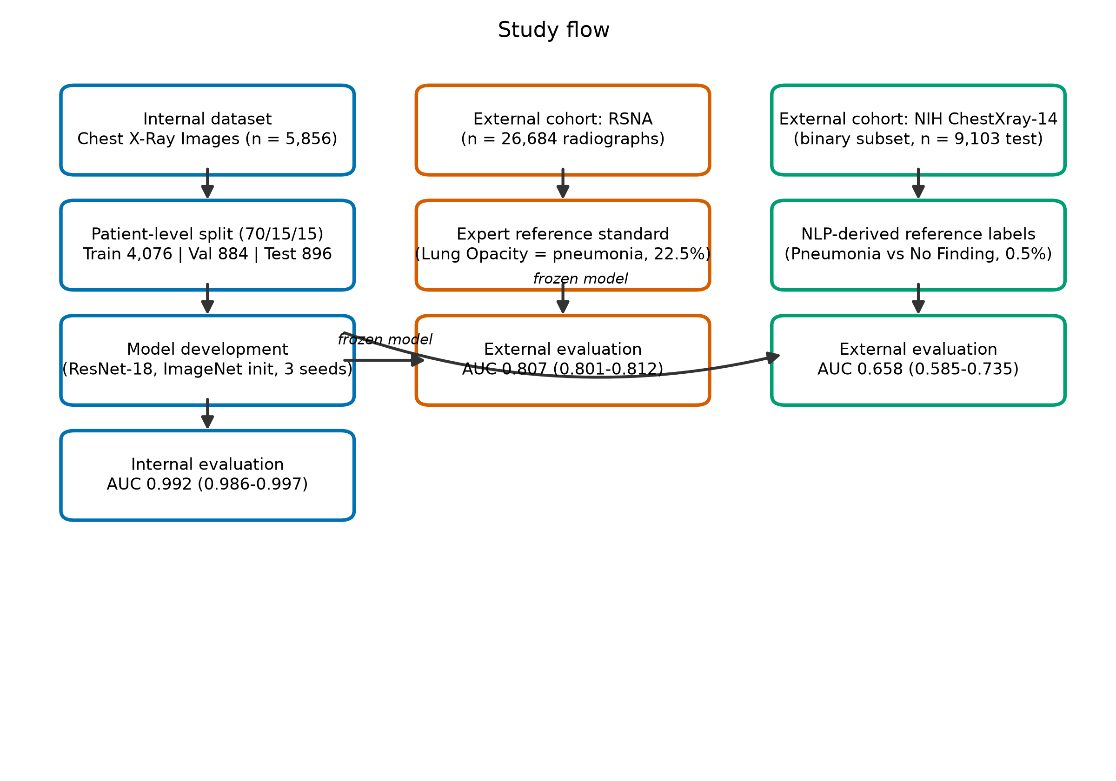
Figure 1

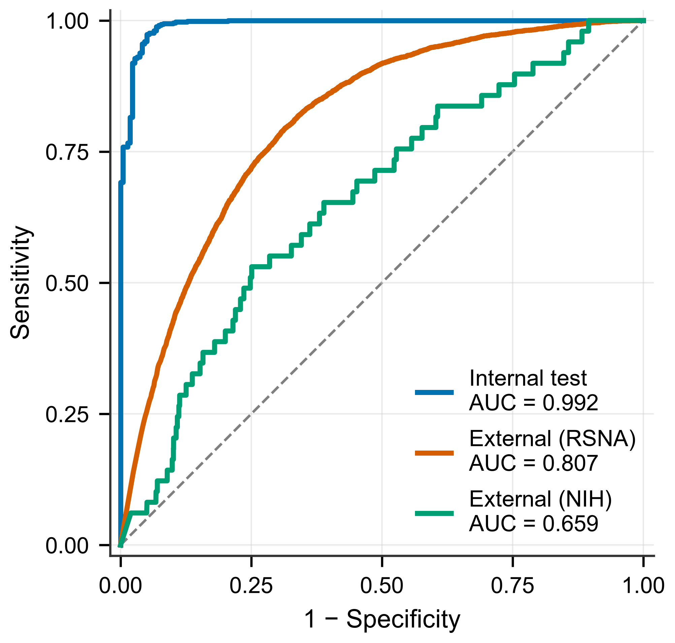
Figure 2

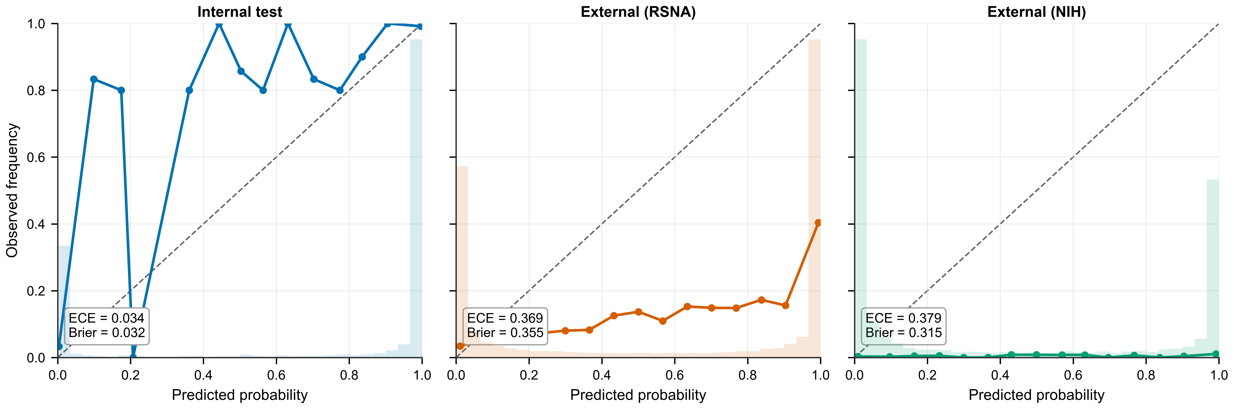
Figure 3

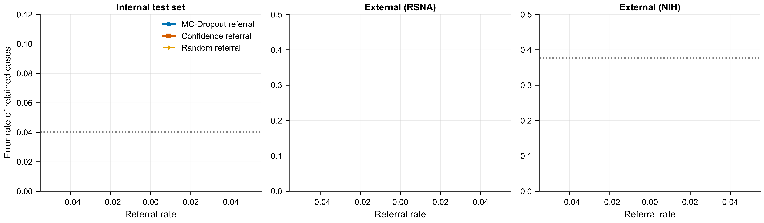
Figure 4

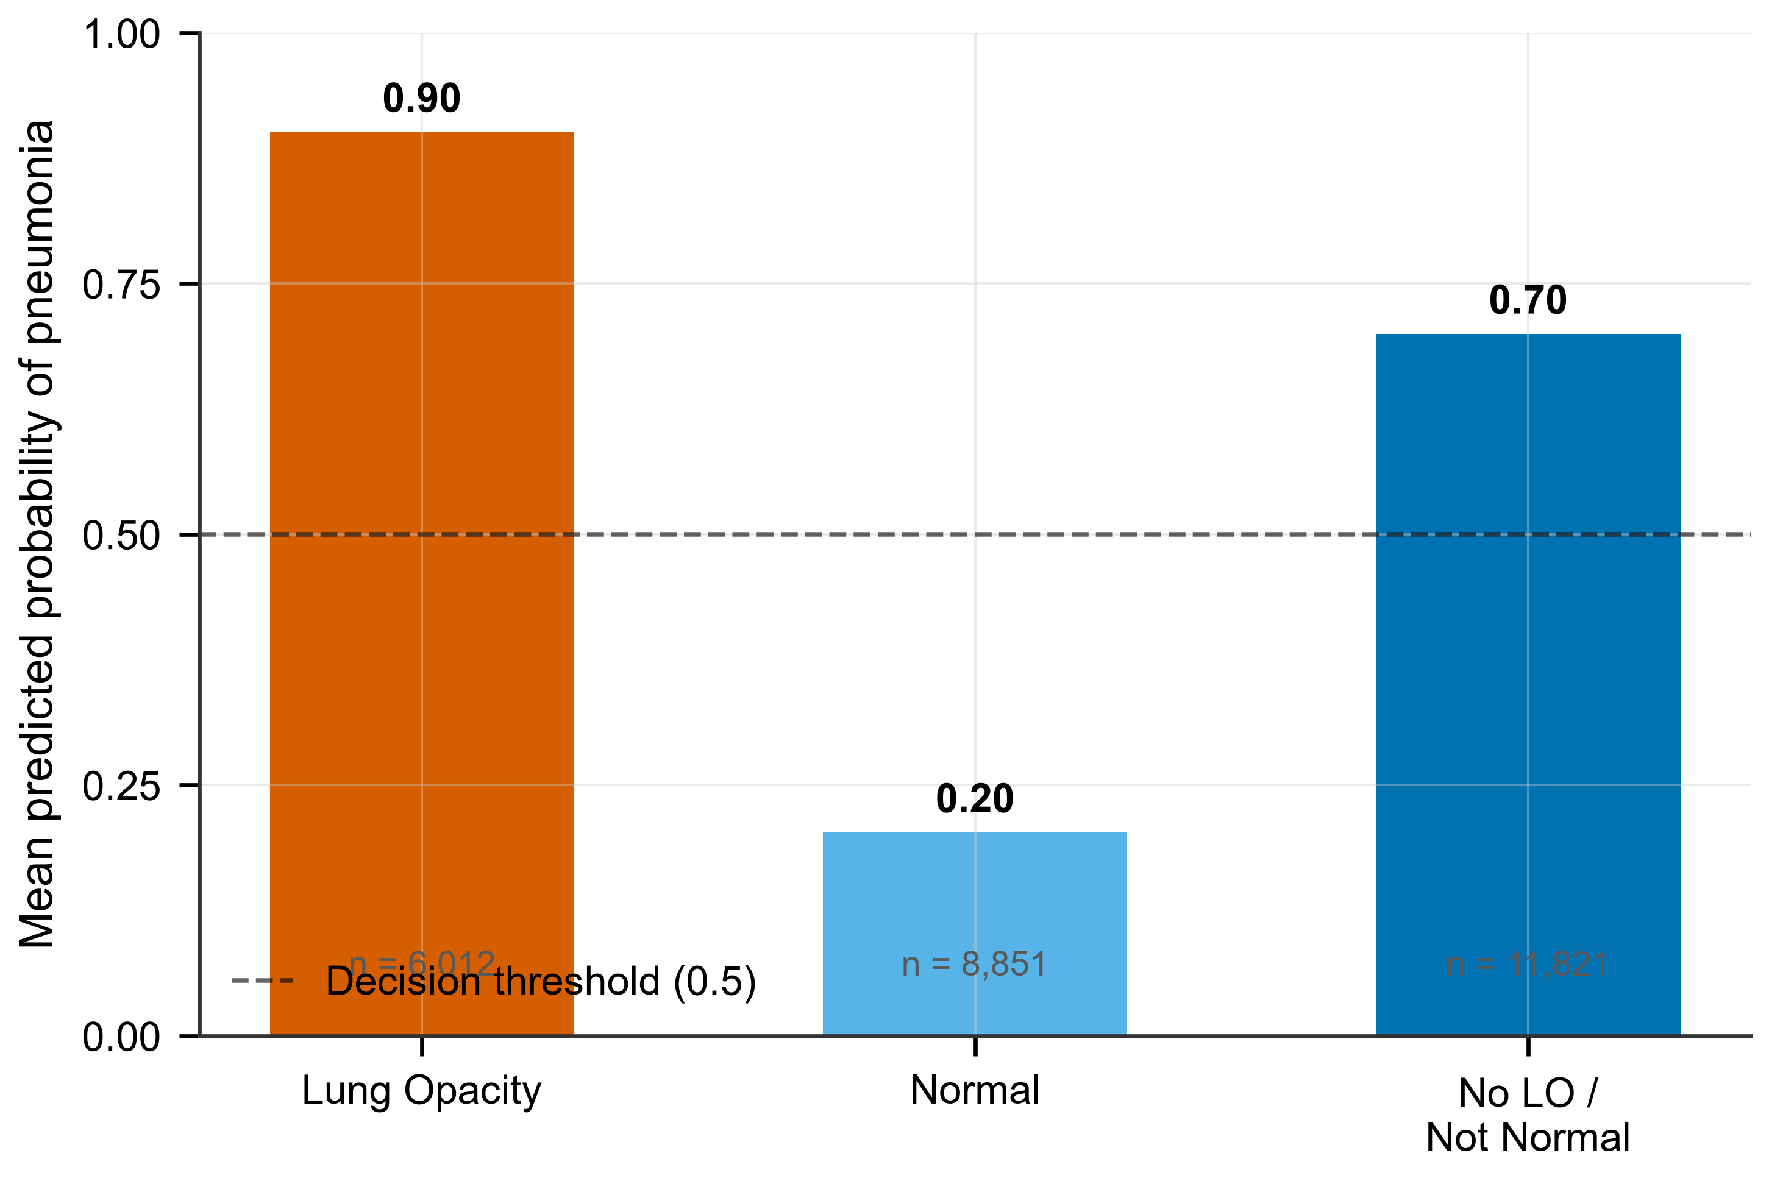
Figure 5

