Retail One Addon

introduction

Soluone

The Retail One addon is an interface for create and configure the Retail One point of sales, this addon run into SAP interface and use UI API for build the screens.

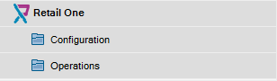

In Retail One we have two folders, Configuration and Operations.

In configuration folder are located all the screen like Store, Workstations, Restaurant, etc.

In operation folder are two screen, one for create a global invoice from deliveries, and another for apply the payment to these global invoices.

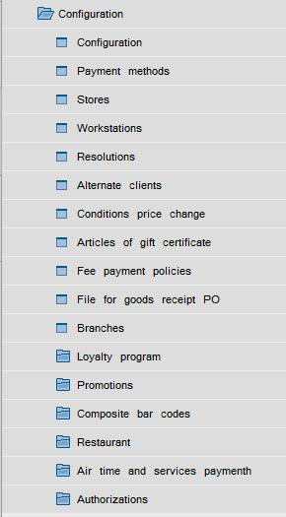

Configurations options

* Configuration

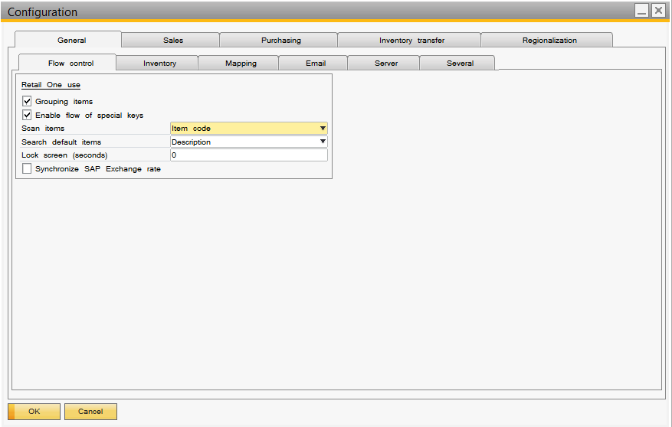

This screen I for set general parameters like transit warehouse, Email server, Electronic invoice, customer data, region special configuration, etc.

* Payment methods

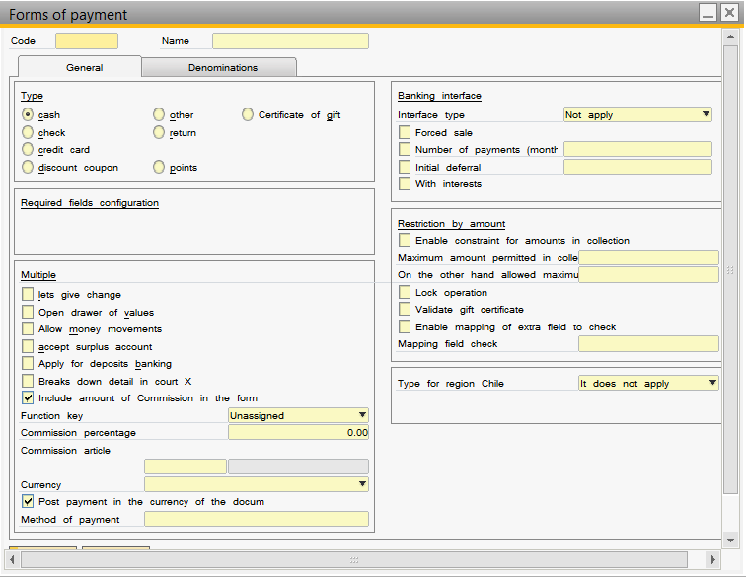

This screen is for create the payment methods used in points of sales.

* Store

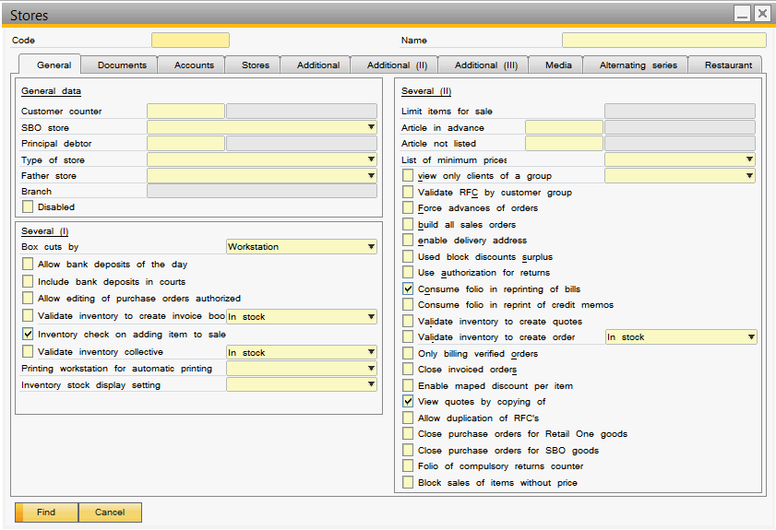

This screen is for create the stores, configurated the payment methods account, counter customer for public sales, warehouse, etc.

Illustration for store and workstation:

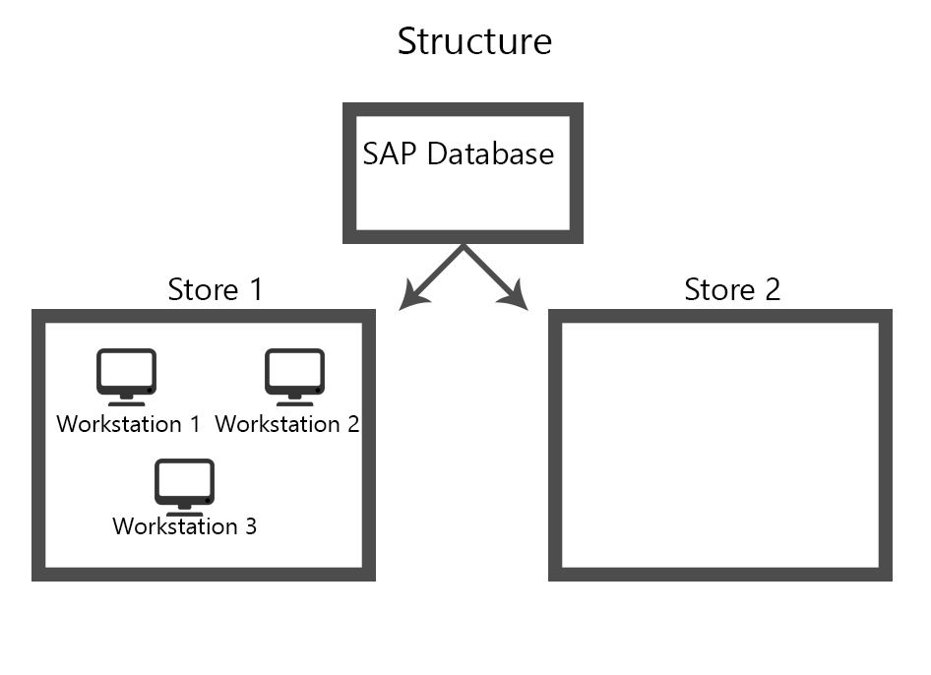

* Workstation

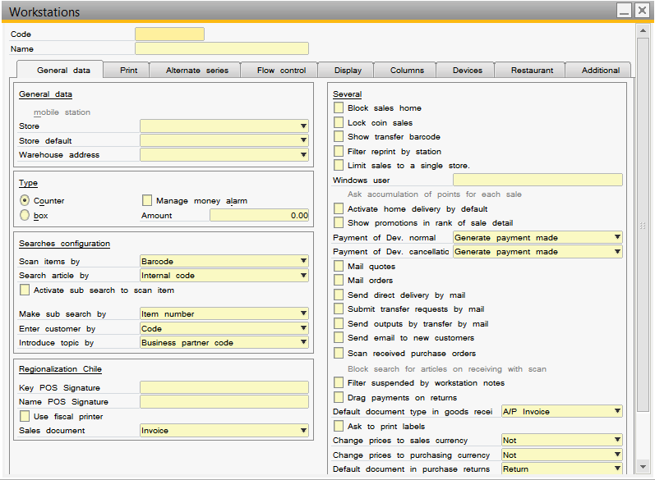

This screen Is for create the workstation for the different stores created previously, scan option, printers for tickets, etc.

* Restaurant folder

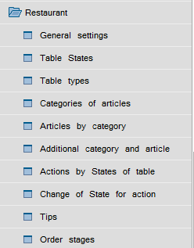

In this folder is located options for this specific schema like menu builder, tables templates, additional for items, etc.

* General settings

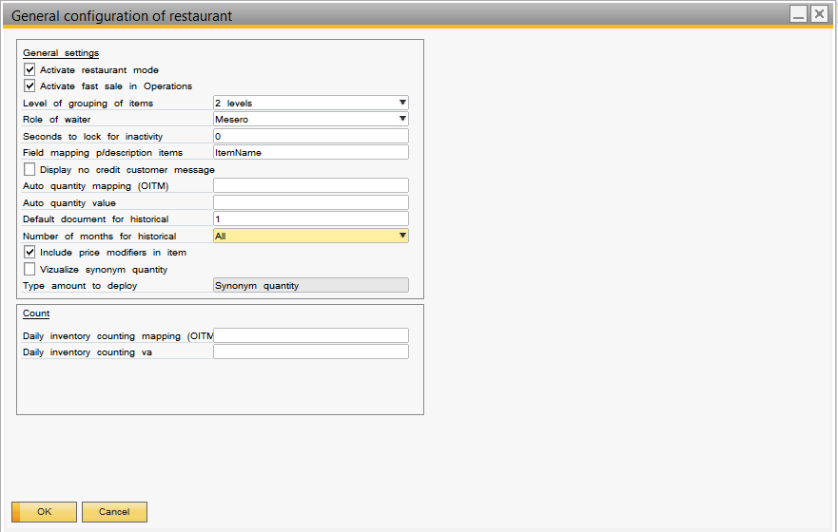

* Catalog menu

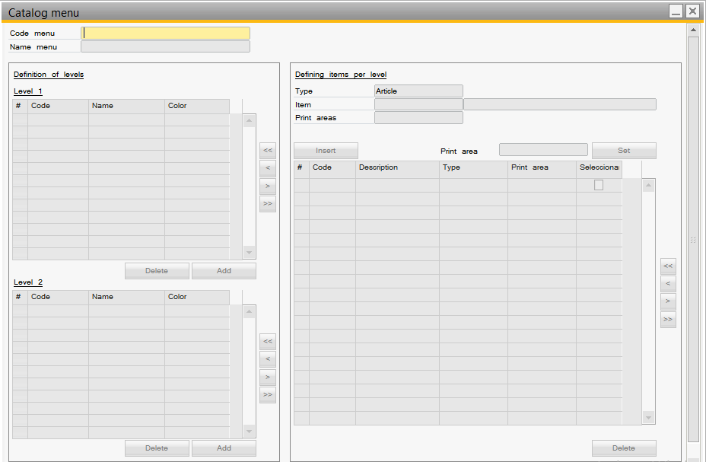

* Modifiers by category and item

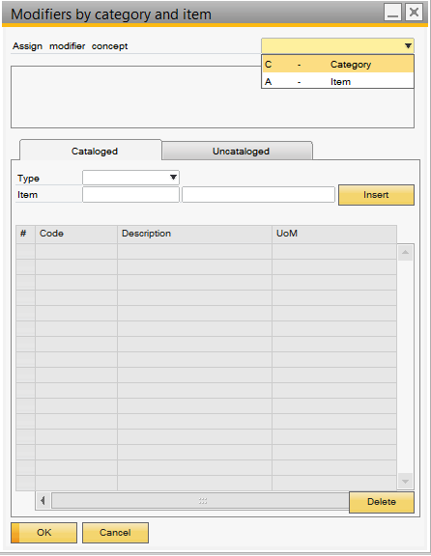

* Print Areas

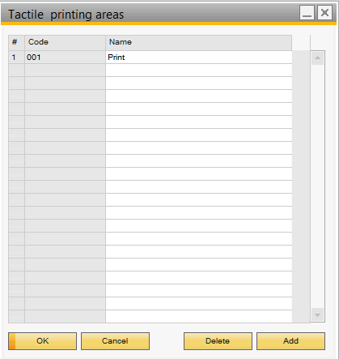

* Areas codes

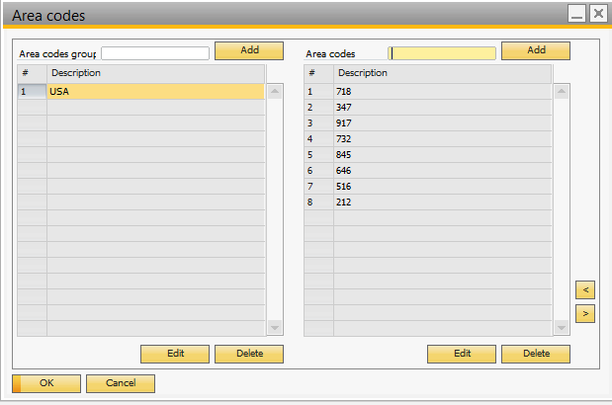

* Authorizations folder

This folder is located the options for assign password for Retail One user and profiles for permission.