CMS Provider Enrollment Screening - DMF PECOS and NETStudy Module Architecture Application Design Specification
Author | Revision Number | Date
architect | 1.0

CMS Provider Enrollment Screening - DMF PECOS and NETStudy Module Architecture Application Design Specification 1
1. Design 3
1.1 Work Flow Description 3
1.2 Component Requirements 5
1.2.1 New TopCoder Software Components 5
1.2.2 Existing TopCoder Software Components 5
1.2.3 Third Party Components 5
1.2.4 Existing or To Be Built Applications 5
1.2.5 Assemblies 5
1.3 Application Management 5
1.3.1 Configuration 5
1.3.2 Concurrency and Transaction Management 5
1.3.3 Threading 6
1.3.4 Logging 6
1.3.5 Exception Handling Overview 6
1.3.6 Validation 7
1.3.7 Audit 7
1.3.8 Internationalization 7
1.3.9 Persistence 7
1.3.10 Performance 7
1.3.11 Authentication and Authorization 7
1.3.12 Risks 7
1.3.13 Scalability 7
1.4 Deployment Constraints 7
1.4.1 Logical Deployment 7
1.4.2 Technology overview 7
1.4.3 Operation System(s) 8
1.5 Interfaces Classes Overview 8
1.6 Changes to Existing System 8
2. User Interface 8
3. Included Documentation 8
3.1 Architecture Documentation 8

Design
The United States Center for Medicaid Services ("CMS") is running a Challenge (a series of TopCoder contests) through the NASA Center of Excellence for Collaborative Innovation (CoECI) and TopCoder to develop a web-based portal to support provider enrollment and screening. Medicaid is a healthcare program that is funded by the US federal government and by individual states. It is operated by individual states. The portal developed in this Challenge will allow medical service providers to register themselves in their individual state for compensation from the Medicaid program. While this alone will provide a very welcome new procedure for providers, who must often fill out many paper forms today, the true goal of the portal will be to automatically screen potential providers for fraud risk before they are approved for Medicaid payments. The portal will assign a potential level of risk to each registrant, and will do this by applying a suite of dynamic business rules. Once a level of risk has been assigned, the registrant's application will be sent to the appropriate sub-system for additional screening and processing.
To a give a sense of the scope of the overall project, the Community will need to accomplish the following in this series of contests:
- Integrate existing business rules for provider screening, and generate new ones. This will require feedback from client subject matter experts (in a later contest, not this one).
- Design and develop the web based portal
- Design and develop the data validation and provider screening verification tiers
- Ensure the design is compliant with the MITA 3.0 Architecture (will require an ESB based architecture)
- Ensure the application complies with Section 508 requirements
In this contest, we will design the required services and their implementation classes to store and retrieve the following external sources:
- Social Security Death Master File (DMF)
- Provider Enrollment, Chain and Ownership System (PECOS)
Also we will design the service and implementation classes for NETStudy verification based on the provided WSDL.

Work Flow Description
Below is the assembly diagram:
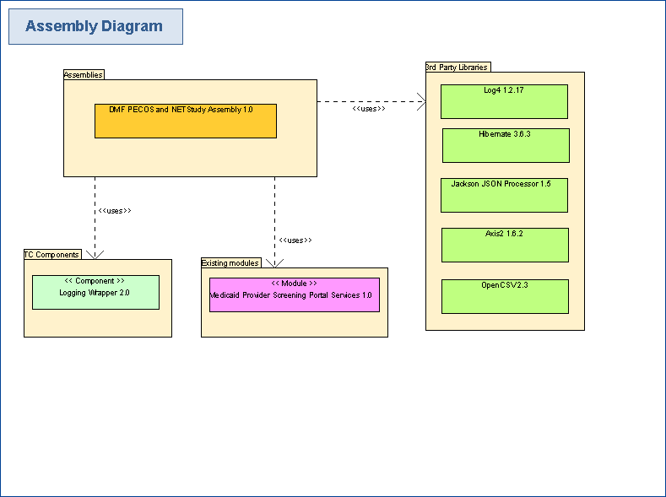

This module provides EJB 3.1 based web services, these services will delegate to local DAO EJBs, and then the DAO EJBs will use JPA (backed by Hibernate) to access database, or access external web service using Axis2.
The DeathMasterSchedulerBean and PECOSSchedulerBean will be scheduled by EJB container to run periodically to load death master files and PECOS files into database.

Workflow of scheduler beans:
  - EJB container triggers scheduler bean (DeathMasterSchedulerBean or PECOSSchedulerBean).
  - Scheduler bean’s run method is executed.
  - It scans files in inputDirectory, parse each file and persist data into database using DAO (DeathMasterDAO or PECOSDAO).
  - DAO uses JPA backed by Hibernate to persist data in database.

Workflow of querying web service of death master and PECOS:
- User makes query to web service.
- The service delegates to DAO.
- DAO use JPA backed by Hibernate to get data.
- Data is returned from DAO to service.
- Data is returned from service to user.

Workflow of querying NETStudy web service:
- User makes query to NETStudy web service.
- The service delegates to NETStudyDAO.
- NETStudyDAO uses stub code to access external NETStudy service.
- Result XML is returned from stub code to DAO.
- DAO constructs NETStudyResponse from result XML.
- NETStudyResponse is returned from DAO to service.
- NETStudyResponse is returned from service to user.

This module is not complicated, so there is only one assembly to implement the whole module.

Component Requirements

New TopCoder Software Components
None

Existing TopCoder Software Components
- TopCoder Logging Wrapper 2.0

Third Party Components
- J2EE - The application framework
- EJB 3.1 based WS - The EJB Based WebServices
- Log4 1.2.17: http://logging.apache.org/log4j/1.2/ - used for logging
- Hibernate 3.6.3 http://planet.jboss.org/post/hibernate_core_3_6_3_release - used for JPA persistence
- Jackson JSON Processor 1.5 http://jackson.codehaus.org/ - used for entities serialization
- Axis2 1.6.2 http://axis.apache.org/axis2/java/core/ - used to access web service
- OpenCSV 2.3 http://sourceforge.net/projects/opencsv/ - used to read CSV file

Existing or To Be Built Applications
- Medicaid Provider Screening Portal Application

Assemblies
DMF PECOS and NETStudy Assembly 1.0 – This assembly will be responsible for the whole module.

Application Management

Configuration
The configuration is done via EJB deployment descriptor. The EJB fields annotated with @Resource, @EJB, @PersistenceContext, etc. will be injected by EJB container.

Concurrency and Transaction Management
Any database operations must be transactional safe. Transaction will be managed using EJB declarative transactional control by the container. Each service class requiring transactions can be annotated like the following to manage transactions:

@TransactionManagement(value = TransactionManagementType.CONTAINER)

Each service method that performs any modifying actions can be annotated like the following to require a transaction:

@TransactionAttribute(value = TransactionAttributeType.REQUIRED)

Threading
All the implementations classes should be thread-safe. The models, which are not thread-safe, are not supposed to be managed by more than one thread at a time. They should be used in thread-safe manner by the EJB container, and they are to be used in a single lifecycle of the request to ensure thread safety.

Logging
The application will log activity and exceptions using the Logging Wrapper that will wrap a log4j Logger.

It will log errors at Error level, and method entry/exit information at DEBUG level.

Specifically, logging will be performed as follows:

- Method entrance and exit will be logged with DEBUG level.
  - Entrance format: [Entering method {className.methodName}]
  - Exit format: [Exiting method {className.methodName}]. Only do this if there are no exceptions.
- Method request and response parameters will be logged with INFO level
  - Format for request parameters: [Input parameters[{request_parameter_name_1}:{ request_parameter_value_1}, {request_parameter_name_2}:{ request_parameter_value_2}, etc.)]]
  - Format for the response: [Output parameter {response_value}] . Only do this if there are no exceptions and the return value is not void.
  - If a request or response parameter is complex, use its toString() method. If that is not implemented, then print its value using the same kind of name:value notation as above. If a child parameter is also complex, repeat this process recursively.
- All exceptions will be logged at ERROR level, and automatically log inner exceptions as well.
  - Format: Simply log the text of exception: [Error in method {className.methodName}: Details {error details}]
  - The stack trace of the error and a meaningful message.

In general, the order of the logging in a method should be as follows:

    - Method entry
    - Log method entry
    - Log method input parameters
    - If error occurs, log it and skip to step7
    - Log method exit
    - If not void, log method output value
    - Method exit

Logging functionality will require to format and output strings with input/output information about data entities. All data entities provide a JSON version of their data supplied in a toJSONString():String method.

Note the application should not log sensitive data like user password, medical data etc...

Exception Handling Overview
The services will only throw following types of exceptions:

The ServiceException is the parent exception for all non-runtime custom exceptions in this module.

The ParsingException will be thrown if any error occurs while parsing input file.

The PersistenceException will be thrown is any persistence related error occurs.

The ConfigurationException is the parent exception for any configuration related error occurs.

Validation
The only validation that takes place is for invalid parameters, which is done in the API with the use of IllegalArgumentException.

Audit
None.

Internationalization
Not handled in this module.

Persistence
JPA backed by Hibernate will be used for managing data against Oracle 11g data store.

Performance
There are no performance requirements in general.
The files loading is not done very frequently, they have no performance issue.
The web services use simple database queries, they have no performance issue too.

Authentication and Authorization
The application will not manage user authentication or authorization. It is managed by base screening portal application. All the needed user credentials to authenticate users against external resources will be provided by base screening portal application.

Risks
There are no risks and the application doesn’t use new, exotic software.

Scalability
There is no scalability requirement.

Deployment Constraints

Logical Deployment
The application consists of some EJB based web services to be deployed in JBOSS J2EE container. This application will be packaged as a single jar file. The services will be deployed on a JBoss Application Server, and use JPA backed by Hibernate to access the database.

Technology overview
- J2SE 1.6
- J2EE 1.6
- Log4 1.2.17: http://logging.apache.org/log4j/1.2/
- Oracle 11g http://www.oracle.com/technetwork/database/enterprise-edition/overview/index.html
- JBoss 5.1.0.GA http://www.jboss.org/jbossas/downloads/
- JBoss ESB 4.10 http://www.jboss.org/jbossesb/downloads/
- Hibernate 3.6.3 http://planet.jboss.org/post/hibernate_core_3_6_3_release
- Jackson JSON Processor 1.5 http://jackson.codehaus.org/
- Axis2 1.6.2 http://axis.apache.org/axis2/java/core/
- OpenCSV 2.3 http://sourceforge.net/projects/opencsv/
- EJB 3.1

Operation System(s)
- RHEL 6(Linux)

Interfaces Classes Overview
See TCUML

Changes to Existing System
This is a new system.

User Interface
None.

Included Documentation

Architecture Documentation
- Class Diagrams
- Sequence Diagrams
- Application Design Specification
- Assembly Requirement Specification
- Entity Relationship Diagram

