You need the following information
- MQ server connection details
- Queue Manager Name
- Queue Name where to POST messages
- Queue Name where to RECEIVE messages

STEP 1 - Setup Connection To MQ
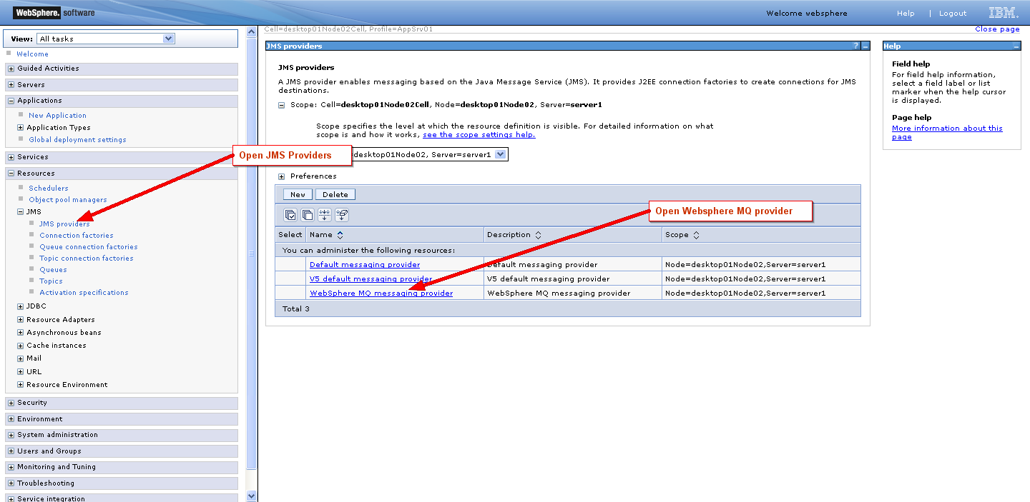

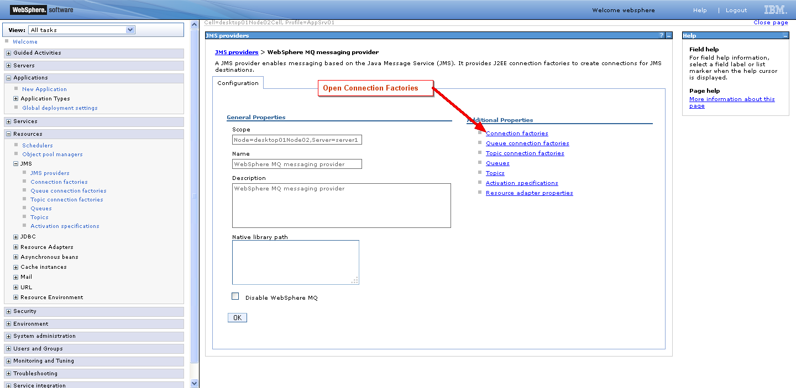

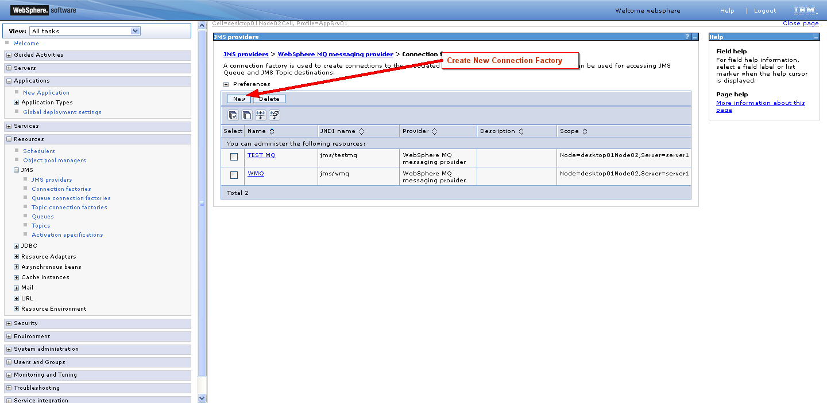
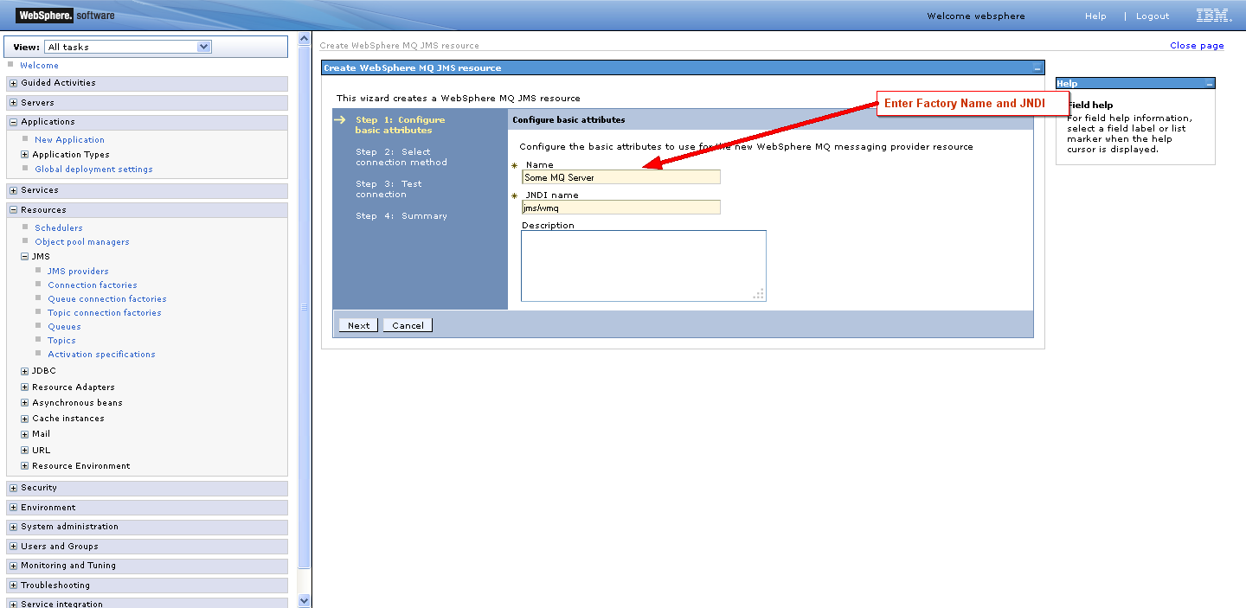
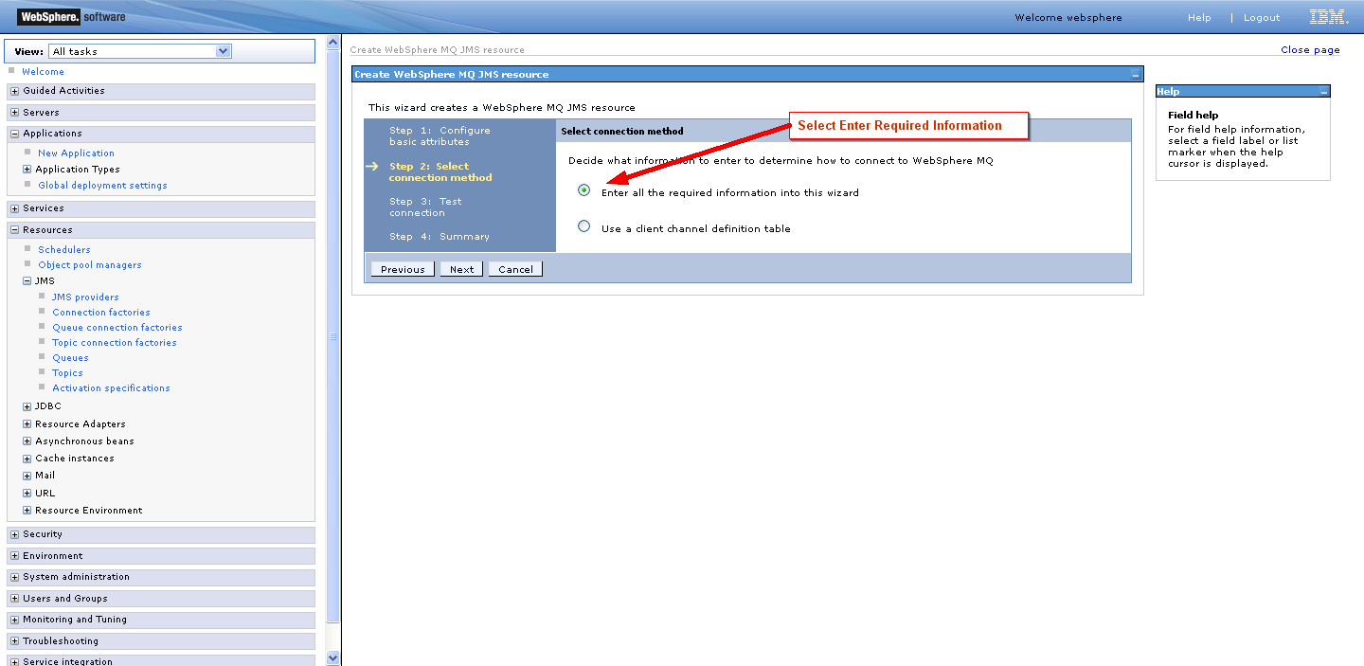
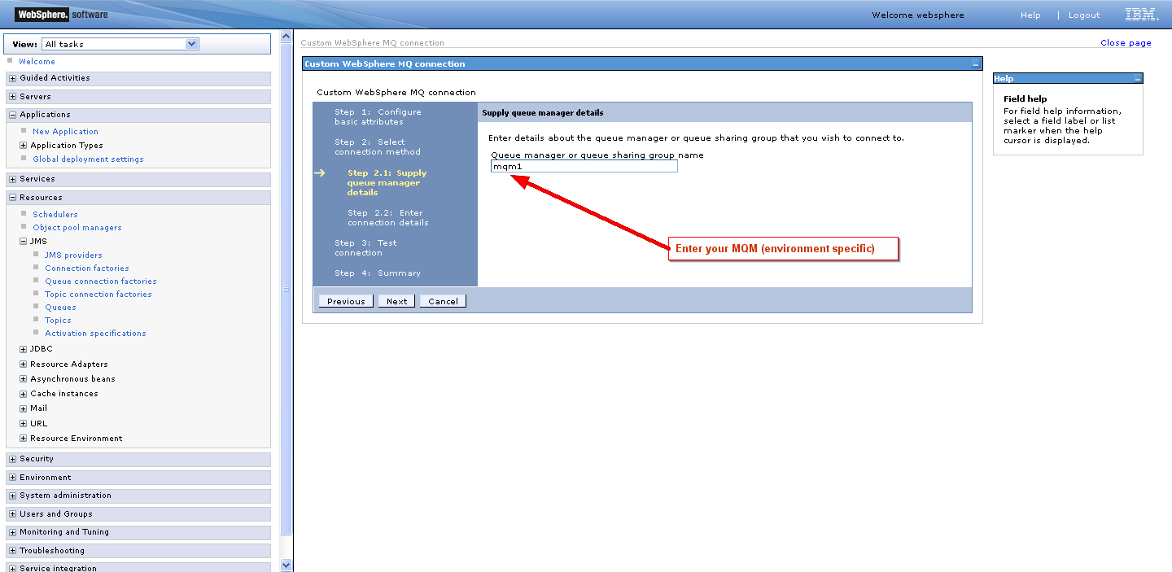
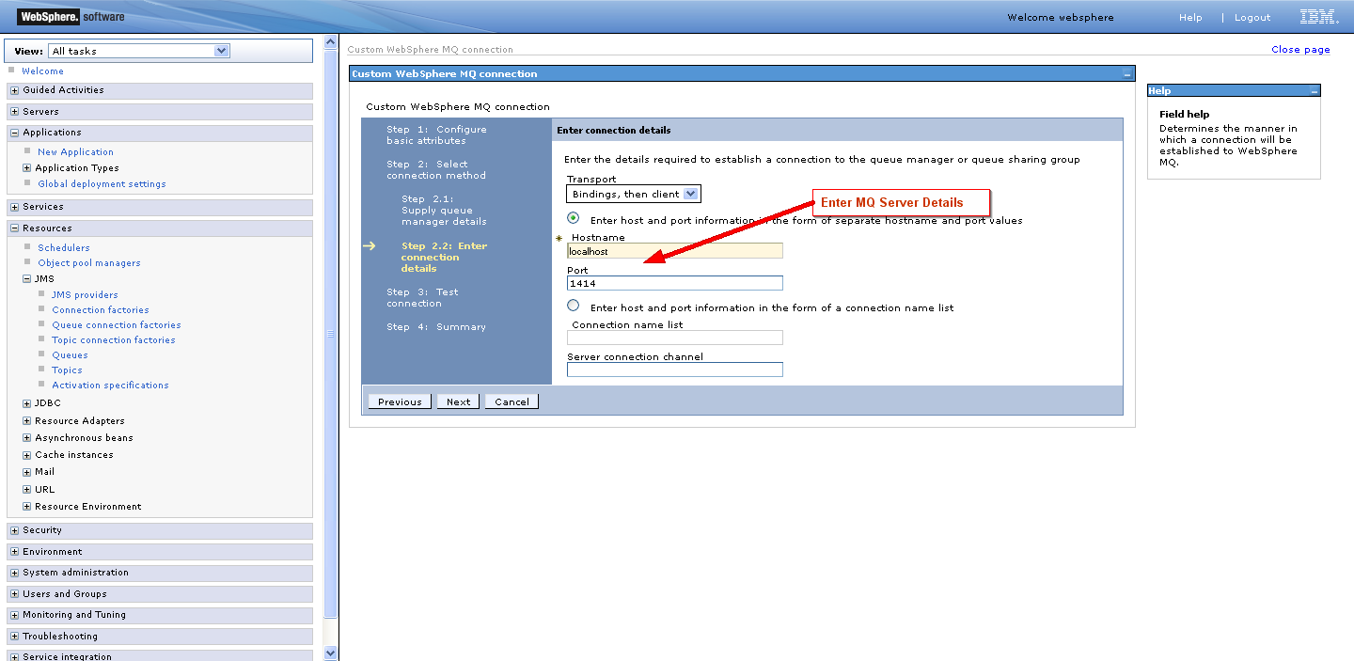
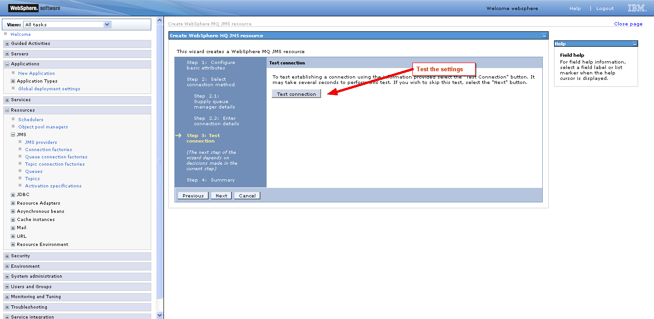
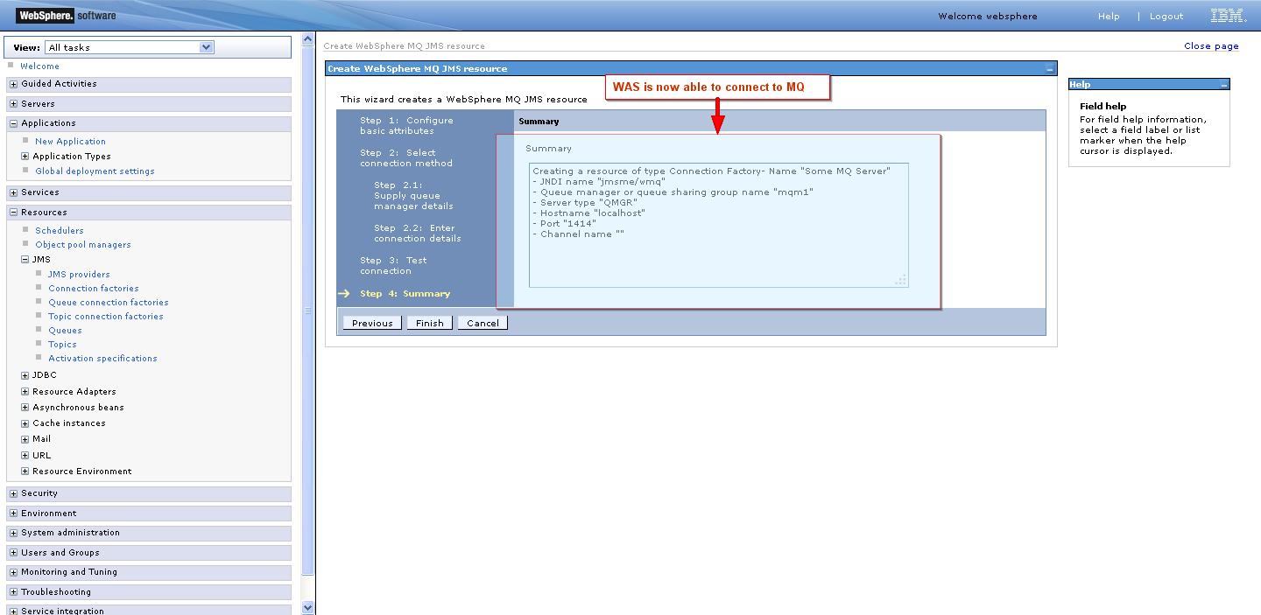

STEP 2 - SETUP A SEND QUEUE AND A RECEIVE QUEUE

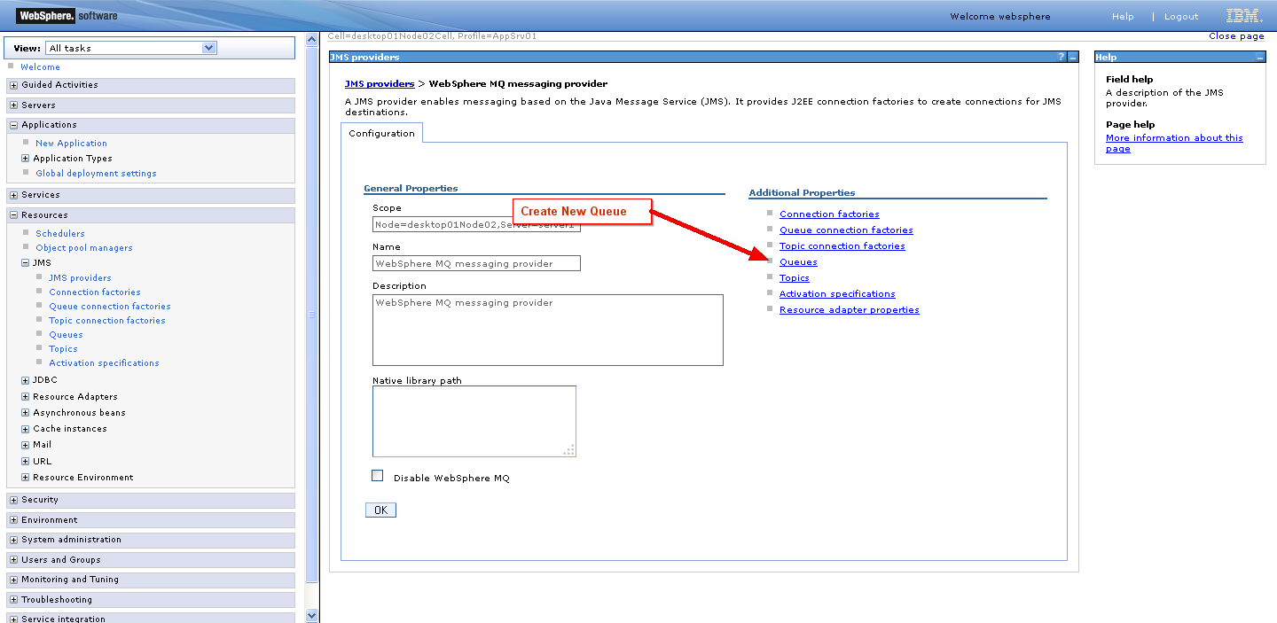

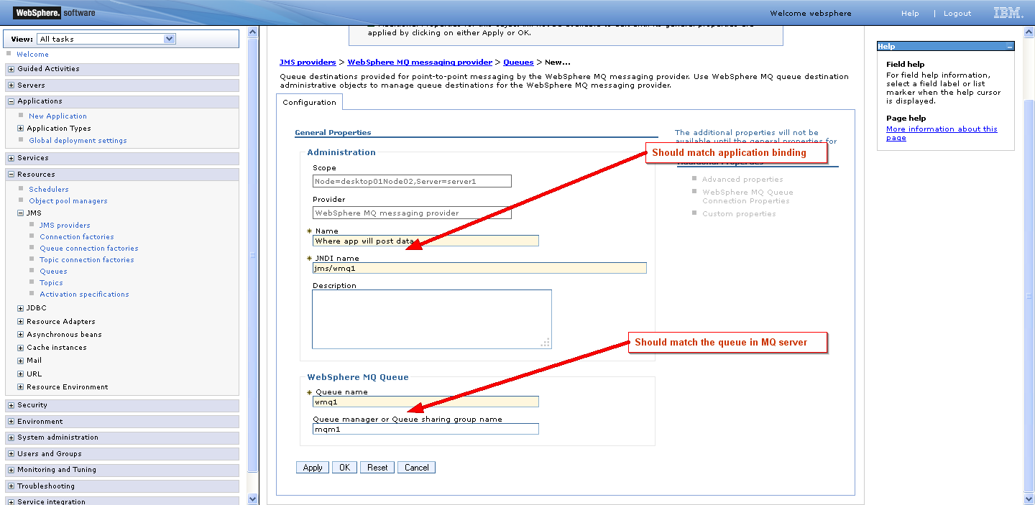
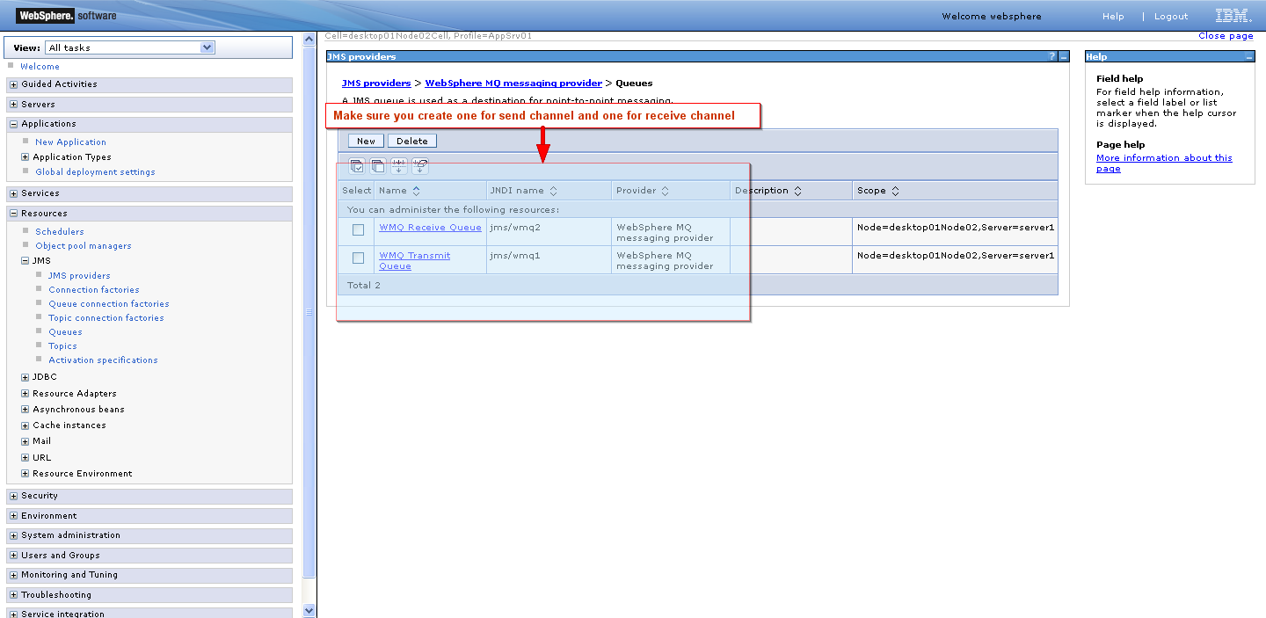

STEP 3 - Create an activation spec for the response (where the bean will listen for responses)
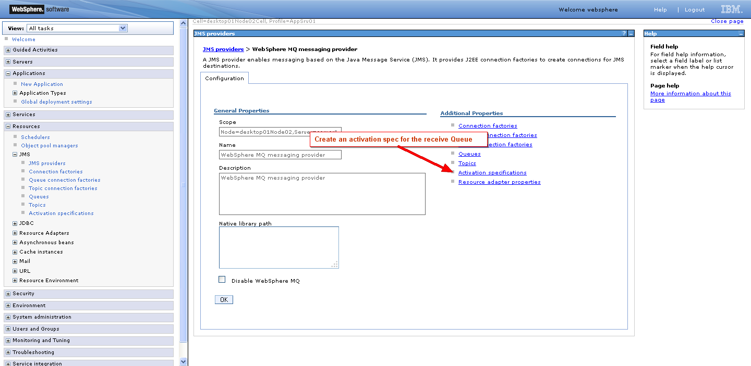

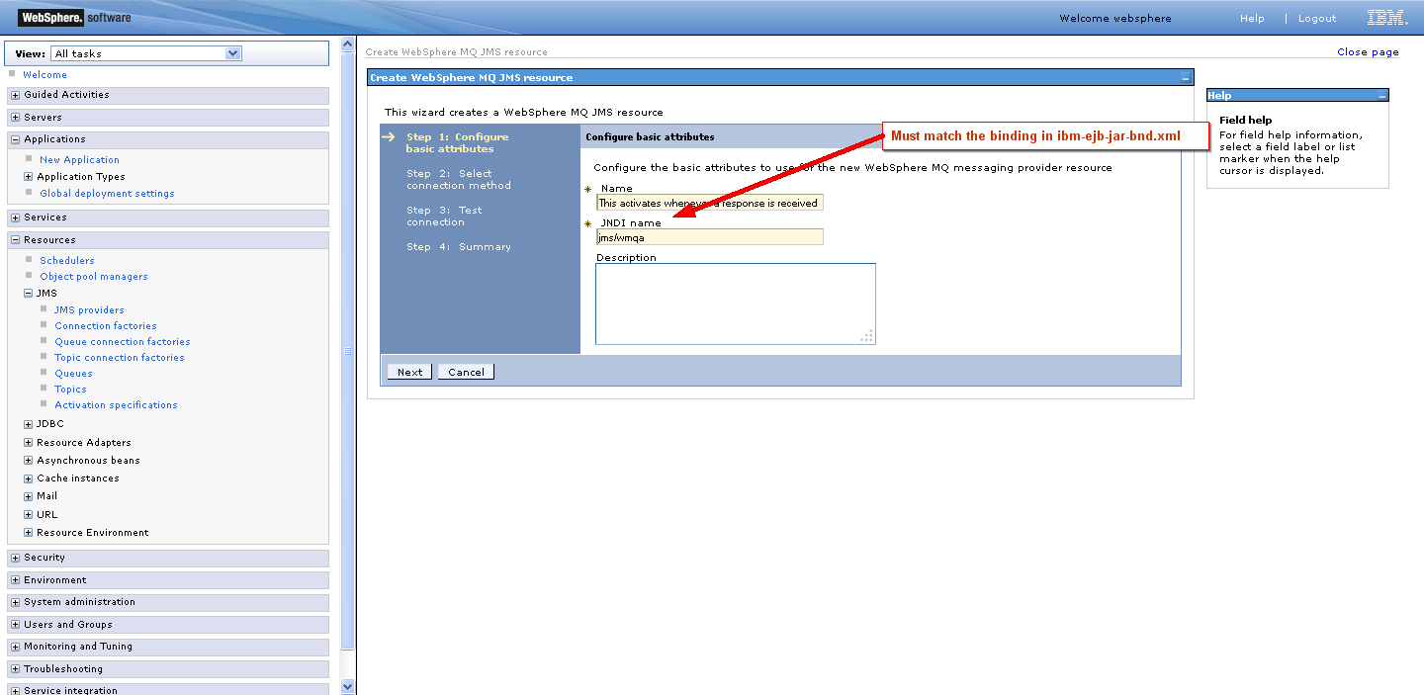
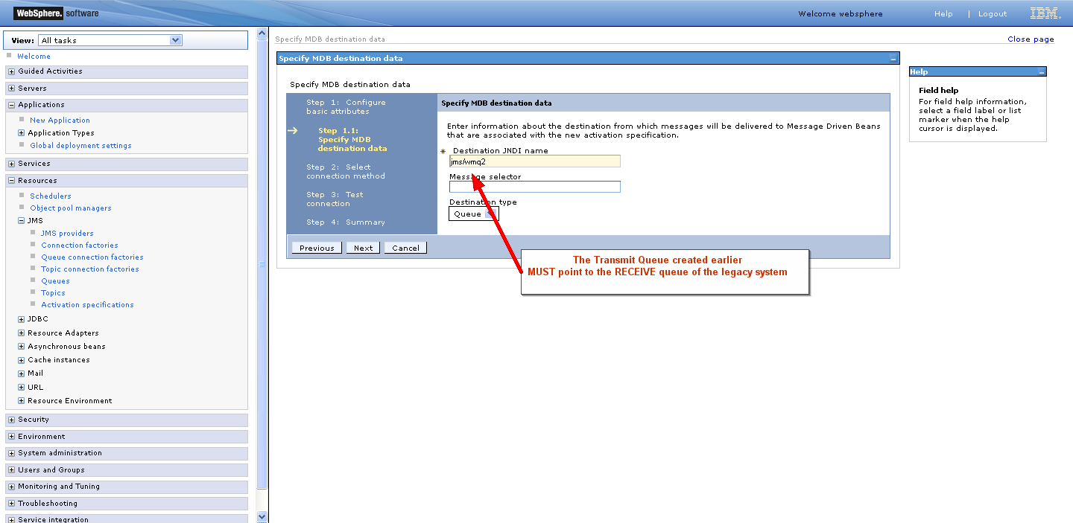
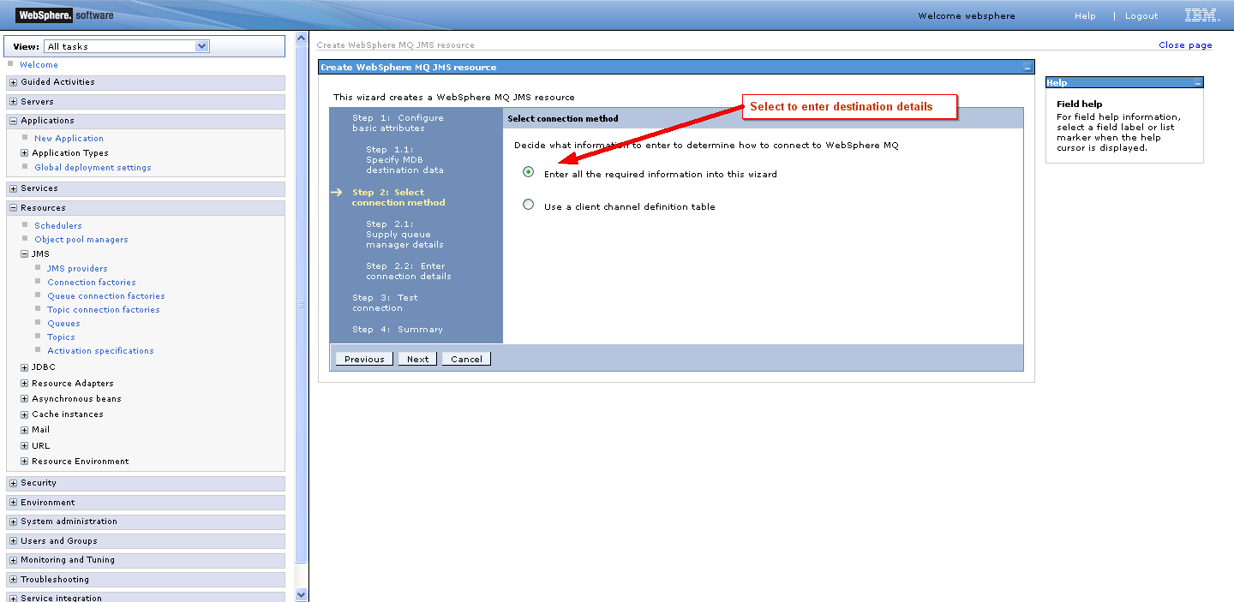
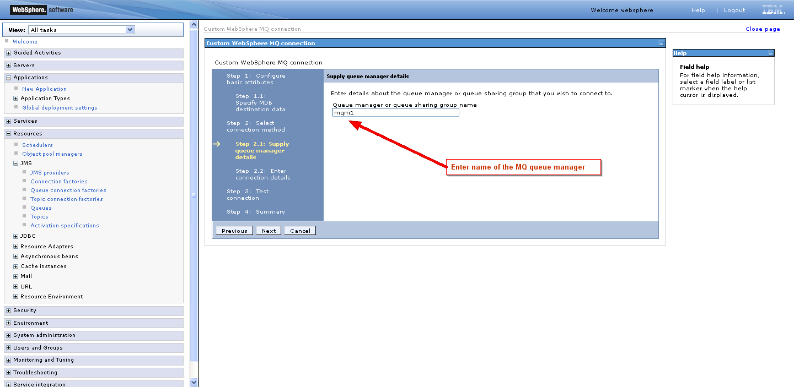
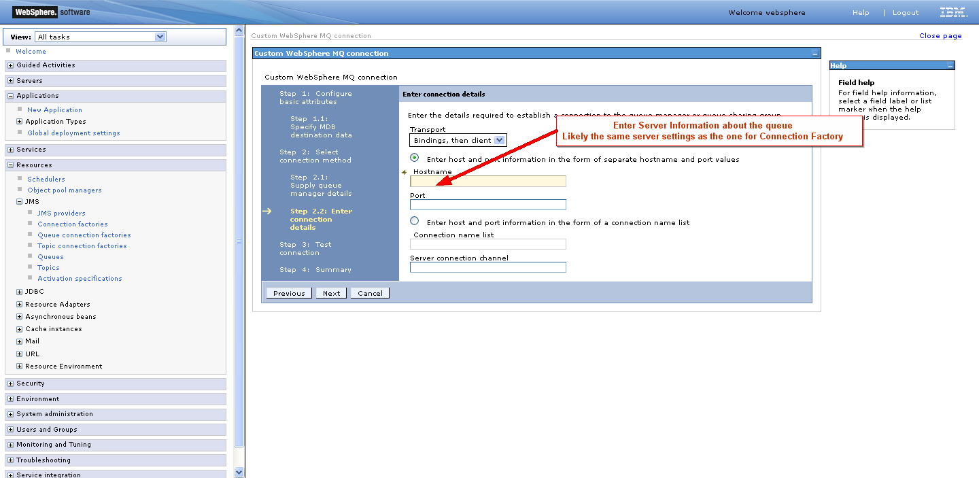
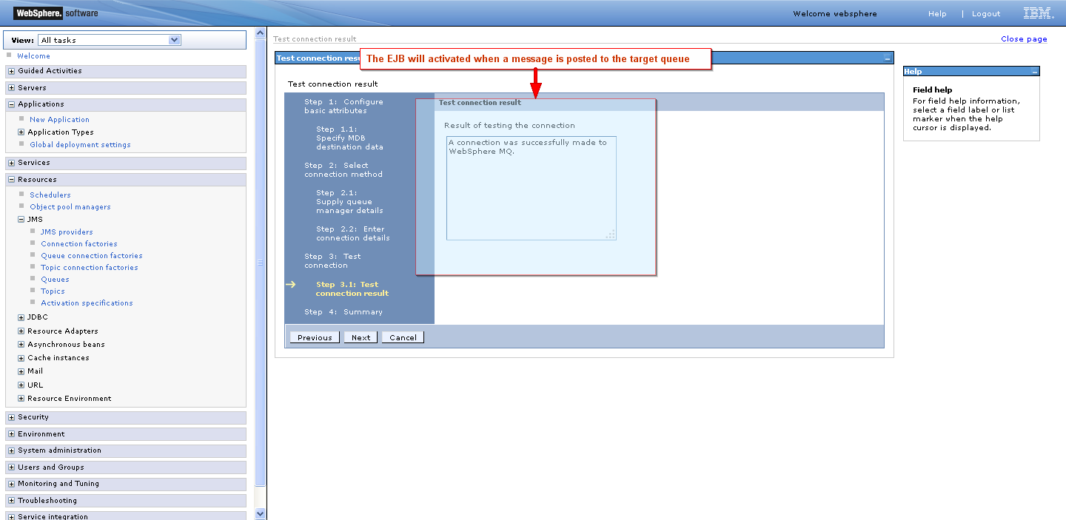

Please take note of whatever JNDI names you enter. They should match the values you put in
/cms-portal/cms-business-process/src/main/resources/META-INF/ibm-ejb-jar-bnd.xml
Specifically:
This is the config for our RECEIVE queue (where MN will post the response) – it should match the JNDI names for the activation spec and the receive queue created, it triggers the bean when a message is posted on the queue mapped to jms/wmq2 (one of the queues in step 2), connection is established using the settings of jms/wmqa(created in step 3)
<message-driven name="DataSynchronizationMessageBean">
<jca-adapter activation-spec-binding-name="jms/wmqa" destination-binding-name="jms/wmq2" />
</message-driven>

This is the config for or TRANSMIT queue (where MN is waiting for messages). JBPM will send approved requests to the queue mapped to jms/wmq1 (one of the queues in step 2) the connection is established through the connection factory mapped to jms/wmq1 (created in step 1)
<session name="ProviderEnrollmentServiceBean" simple-binding-name="cms-portal-services/ProviderEnrollmentServiceBean/local">
<message-destination-ref
name="gov.medicaid.services.impl.ProviderEnrollmentServiceBean/dataSyncQueue"
binding-name="jms/wmq1" />
<resource-ref
name="gov.medicaid.services.impl.ProviderEnrollmentServiceBean/mqConnectionFactory"
binding-name="jms/wmq" />
</session>

