Aflac × Channel Strategies
Broker Bonus Agreement - Problem, Success Criteria & Implementation Timeline
Prepared for: Jon | Prepared by: Chris Heinsen & Joe | Date: May 19, 2026

Problem Statement
Aflac field leaders in our pilot markets (Indiana, Ohio, Kentucky) face three converging pressures: leader-departure premium disruption of 15%-40% lasting 6-18 months across DSC, RSC, and MKD roles; dormant accounts with no structured reactivation engine; and producers leaving meaningful commission on the table by selling Aflac-only. On a single 25-employee case, an associate earns roughly $3K with Aflac alone versus roughly $25K with a full ancillary portfolio.
Channel is uniquely positioned to deliver ICHRA and Enrollment solutions together. That combination does two things at once: (a) it upskills the field by giving reps real-time exposure to ICHRA alongside enrollment best practices, and (b) it brings headcount and enrollment resources to cases the field would otherwise miss - keeping that business inside the Aflac market rather than handing it to a competing broker or carrier.

Agreement Summary
- Bonus rate: Channel Strategies receives 5% of attributable premium production.
- Cadence: Bonus paid quarterly, following validation and approval.
- Attribution: Captured via a manual tracking log maintained by Aflac.
- Approvals: Managing Market Director, Division Vice President, and Head of Sales Strategy.

Pros
- Performance-based: Aflac pays only on validated, attributable production - no fixed-cost exposure.
- Dormant account activation: Reaches accounts, ZIPs, and brokers the Aflac field is not currently working.
- Retention play: Gives RSCs and MKDs structure and ancillary income that reduce leader flight risk and the 15%-40% premium disruption it causes.
- Leads with ICHRA: Anchors on the product employers are asking for today, so the partnership produces visible wins early.
- ICHRA + Enrollment as a unique combination: Channel brings both the product and the enrollment headcount, which upskills the field in real time and keeps missed-enrollment business inside the Aflac market rather than walking to a competitor.
- Complementary product set: Channel One sells through Aflac, not around it - producers gain ICHRA, Life, and STD/LTD without abandoning the Aflac core.
- Replicable playbook: A successful pilot becomes the leadership-endorsed template for how Aflac scales future GA partnerships.
- Upfront investment absorbed by Channel One: Channel One funds activation; Aflac avoids fixed-cost exposure during the pilot.

Risks & Mitigations
Risk | Mitigation
Manual attribution accuracy | Written attribution methodology, quarterly reconciliation, and a documented dispute process owned jointly.
Attributable-premium scope creep | The multi-step approval process (Managing Market Director, Division Vice President, and Head of Sales Strategy) reviews and confirms attribution before each quarterly payment.
Field distraction | Minimize the audience and the message. Avoid overloading the field with solutions. Ensure each Channel One offering is introduced organically to an Aflac sale rather than competing for the rep's attention.
Field leadership buy-in | Secure named MKD and RSC champions in each pilot territory before launch.
AEP timing window | Hard pre-launch milestones with named owners; protect the window so AEP positioning is in market on time.

How We Define Success
Tracked at the quarterly attribution log and reviewed formally at each QBR:
- ICHRA cases placed and premium written in pilot territories (the leading indicator in Year 1).
- Premium lift in pilot territories vs. comparable control markets (Cancer and core Aflac products).
- Count and recovered premium from reactivated dormant accounts.
- FAME achievement by designated RSCs and DSCs.
- Field retention: leader and producer attrition in pilot vs. control.
- New producers onboarded and cases placed with Channel One support.
- Net ROI: incremental Aflac premium divided by bonus paid.

Implementation Timeline
Six-month pilot followed by a formal Go/Hold/No-Go gate at Month 7. Quarterly bonus payments align with QBR cadence.
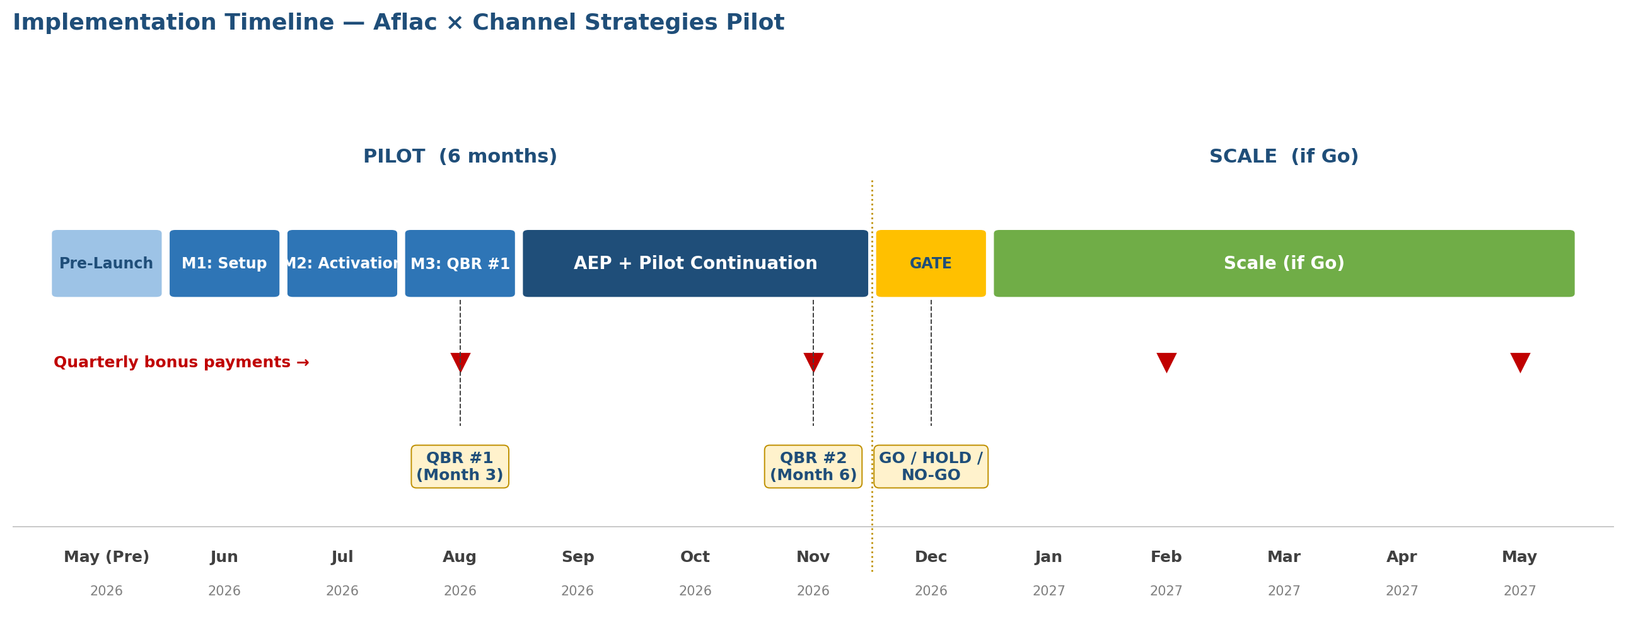

Expansion Gate (Month 7)
At Month 7 we evaluate the pilot against the success metrics above and choose one of three paths:
GO - Expand | HOLD - Extend Pilot | NO-GO - Wind Down
Premium lift in pilot vs. control meets target; dormant-account reactivation hits goal; field retention improves; leadership endorses expansion. | Directional signal positive but one or two KPIs short; clear corrective actions identified; leadership willing to extend one quarter. | No measurable premium lift; attribution disputes unresolved; field resistance; better alternative use of investment identified.

Recommended Next Steps
- Finalize the written attribution methodology and manual log template before pre-launch.
- Confirm pilot territories (Indiana, Ohio, Kentucky) and secure named MKD/RSC champions.
- Schedule the brief alignment discussion Jon requested this week.
- Once aligned, Chad and Joe formalize the custom arrangement language.

