Categis Software Pvt. Ltd. www.softwaretogo.de

softwaretogo | a beta systems company

OTTOPro

functional documentation

Change Log:

|  |  |  |  |
| --- | --- | --- | --- |
| **S. No.** | **Author** | **Changes** | **Date** |
| 1 | Narendar Reddy | Initial Draft | 17-Apr-20 |

Contents

1 Overview 4

1.1 Current System 4

1.2 Existing system 5

2 Meta data 6

2.1 Organization 6

2.1.1 Organization Meta Data 6

2.1.2 Organization Contact 7

2.2 Customer 7

2.2.1 Customer Meta Data 7

2.2.2 Customer Contacts& Addresses 7

2.3 Supplier 8

2.3.1 Supplier Meta Data 8

2.3.2 Supplier Contacts& Addresses 8

2.3.3 Supplier Articles 9

2.4 Article Master 9

2.4.1 Article Meta Data 9

2.4.2 Dimensions 10

2.4.3 Typ 10

2.4.4 Rabatt 11

2.4.5 Accessories 11

2.4.6 Validity Date 12

2.5 User, Role and access 12

2.5.1 User, Role and features Meta Data 12

2.5.2 Password Change 13

2.6 Text Modules 14

2.7 Proposal Settings 14

3 Project 15

3.1 New Project 15

3.2 Load Existing Project 15

3.3 Import Project 15

3.4 Export Project 16

3.5 Refresh Project 16

3.6 Copy & Delete Project 16

3.7 Functional Modules 17

3.7.1 Project Meta Data 17

3.7.2 LV Details 17

3.7.3 Cost Details 19

3.7.4 Tabular View 21

3.7.5 Bulk Processing 22

3.7.6 Multi5 23

3.7.7 Multi6 23

3.7.8 Special Costs 23

3.7.9 Supplier Proposals/Price Enquiry 23

3.7.10 Price Entry/Price Comparison 24

3.7.11 Copy Positions from another project 25

3.7.12 Price Comparison of Articles 25

3.7.13 Field Definitions/Settings of Article Values 26

3.7.14 Articles Mapping with Cost Types for Form Blatt Reports 26

3.7.15 Project Specific and Position Specific Articles 27

3.8 Reports 27

3.8.1 Angebot Report 27

3.8.2 QuerCalculation 27

3.8.3 Form Blatt 221& 223 28

3.8.4 Einzelaufgliederung Beispiel (Breakdown Report) 28

3.8.5 Title Blatt 28

4 Title Blatt Templates 28

4.1.1 Path Configuration for Title Blatts and Templates 28

4.1.2 Templates 28

5 Shortcuts 28

6 Log File 29

7 Version matching implementation 29

8 Word Add-in 29

8.1 Merge Fields 29

8.2 Text Modules 30

# Overview

## Current System

OTTOPro is a calculation tool for construction industries. It also includes information of organization, customer, supplier, articles along with dimensions along with prices.

Project will have many sub modules like Project meta data, LV Positions, Bulk or Batch processing and few additional cost. We can also send proposals to customers and send price enquiry to suppliers.

There are other modules like GAEB import and Export, DATANORM import, Submitting prices from suppliers to positions, delivery and invoicing.

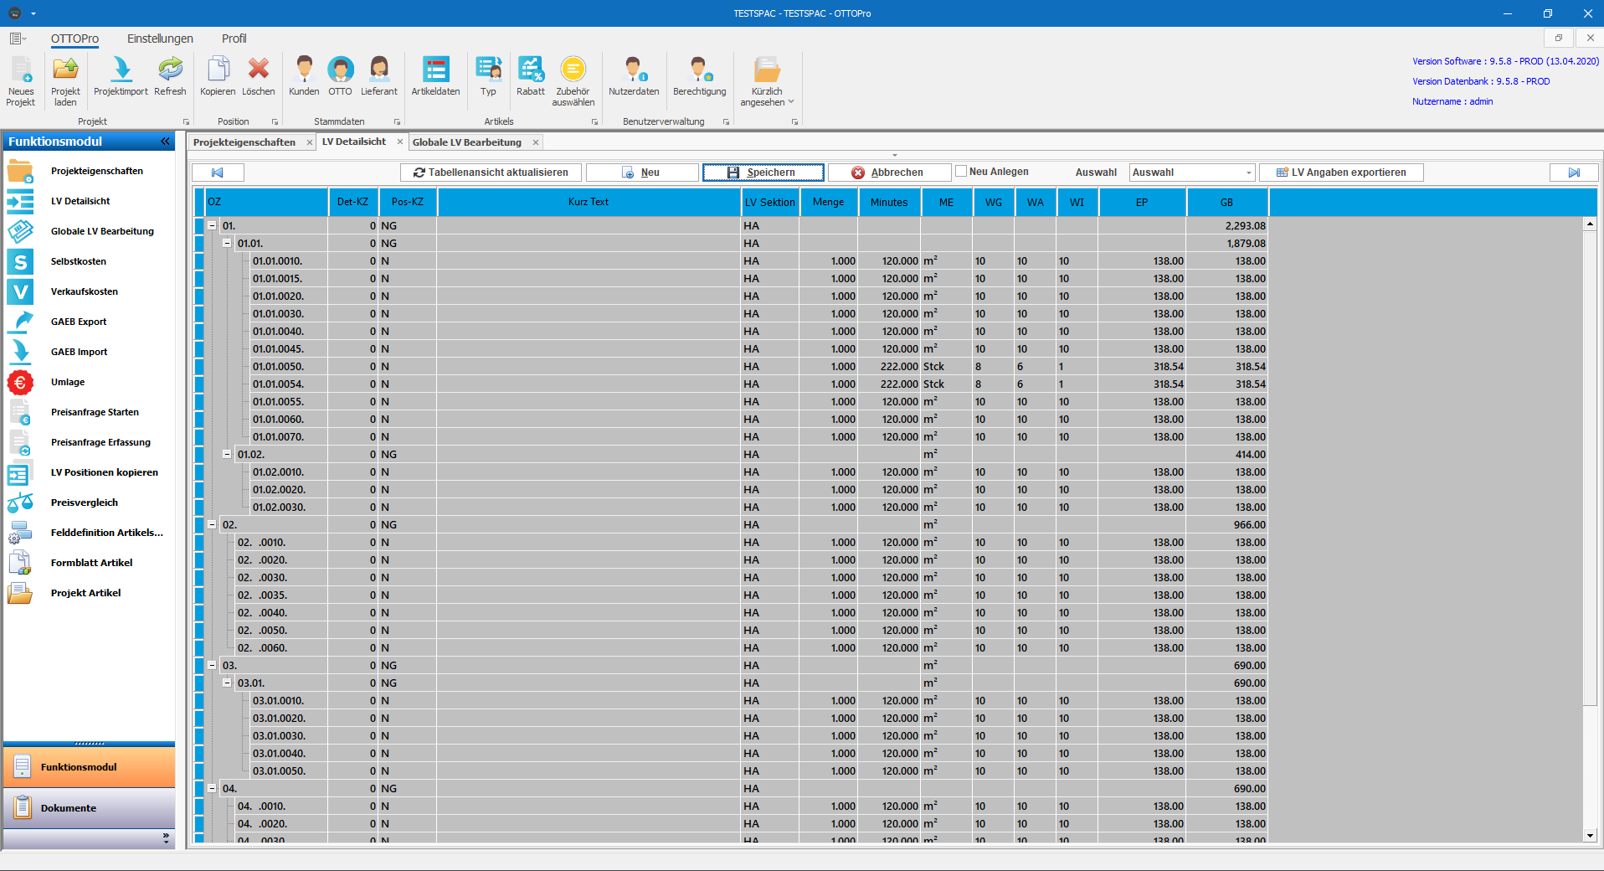

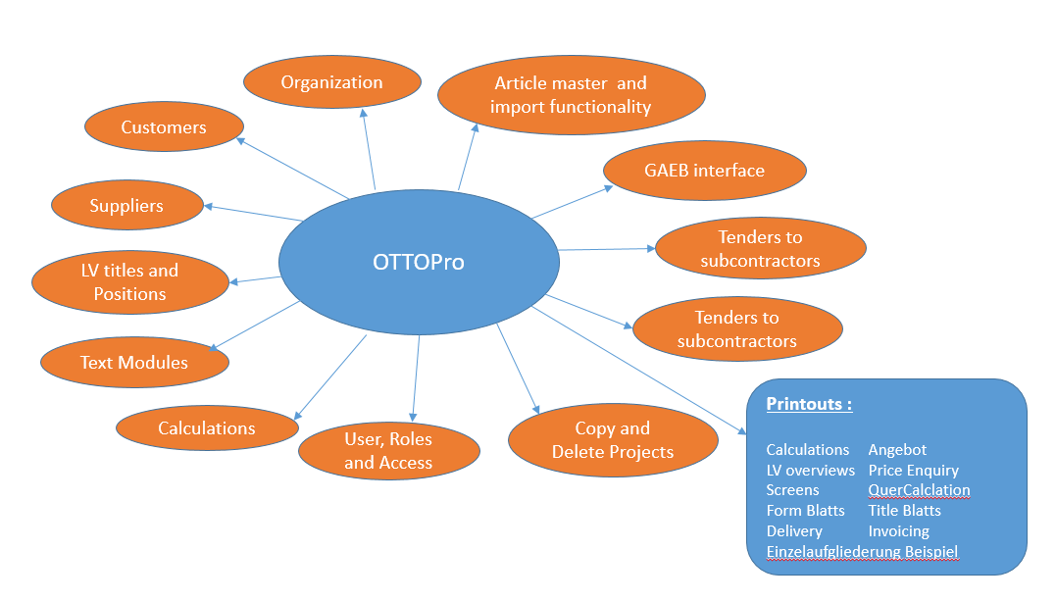

## Existing system

IGEL was developed using VB 5.0 with basic features. It is not so user friendly with current usage of application.

Here few major features not exist in IGEL

* Import and Export of XML version of GAEB files.
* Lang text with Images, media and links.
* View of LV details, Cost Details and tabular view in single form.
* View Position hierarchy.
* Grid printing and exporting.

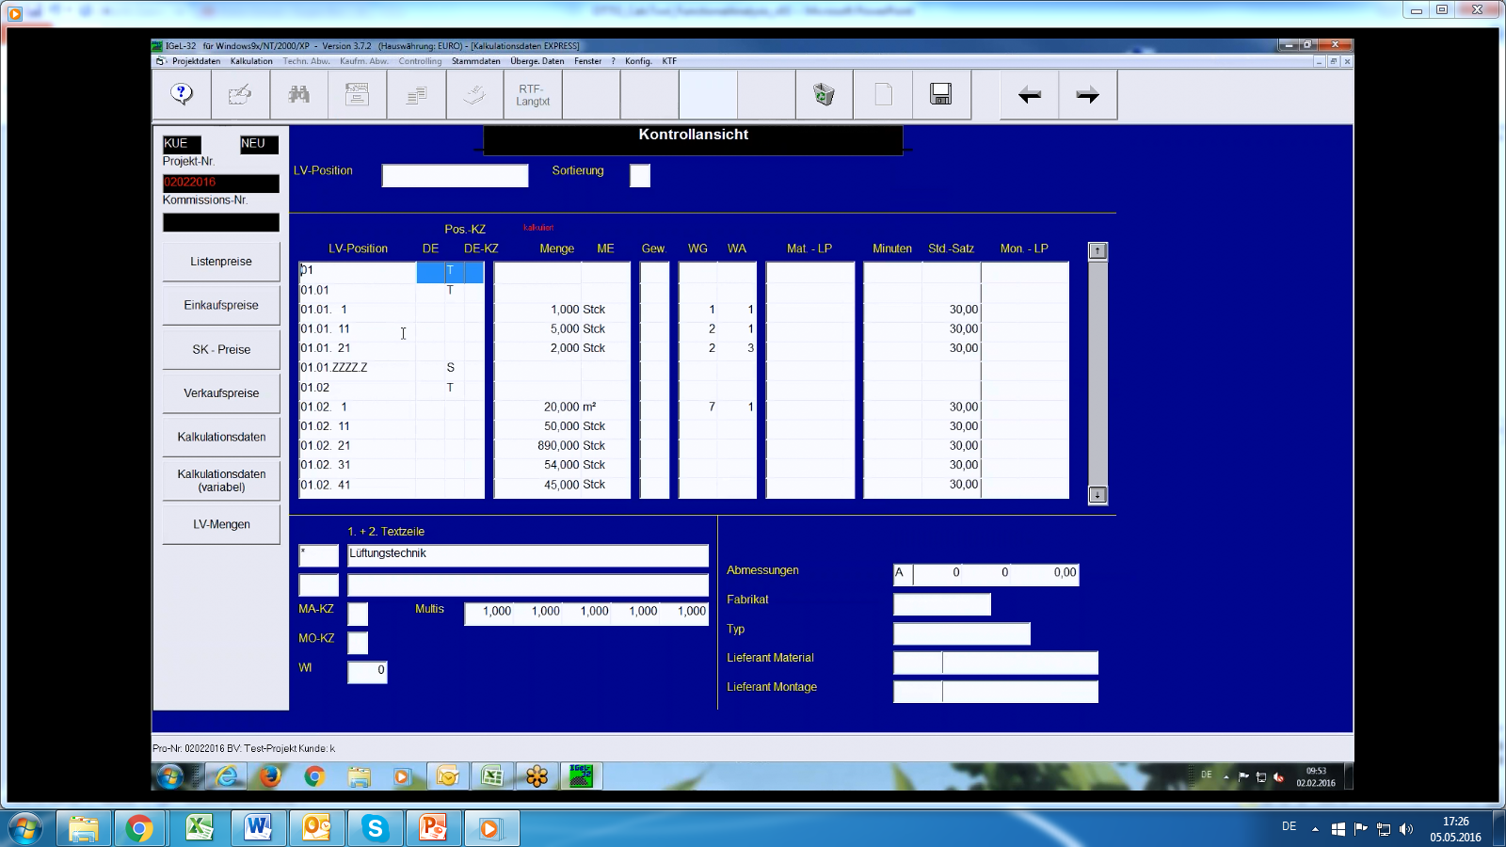

# Meta data

## Organization

### Organization Meta Data

Organization meta data describes about company and its details like address, contact numbers, Fax Numbers and the bank account related information. We can use this module for saving new organization and editing existing organization.

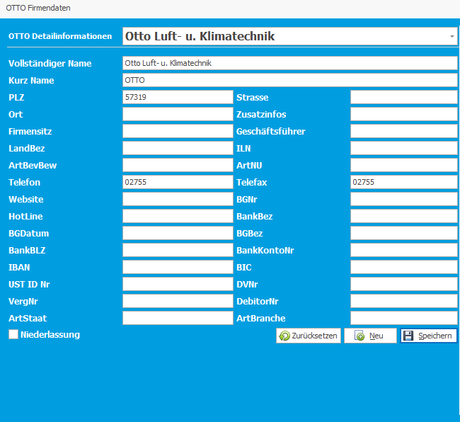

### Organization Contact

This section will have the info about the Organization’s point of contacts. We can also identify a contact and save it as default contact. We can add new contacts and edit existing contacts.

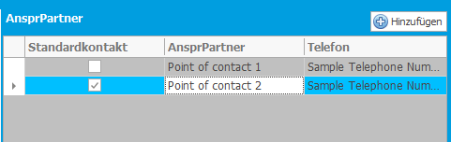

## Customer

### Customer Meta Data

This section will have information of organization’s Customer/ Customer’s Organization information like Name, Short Name, Address, Contact Numbers and Fax Numbers. It will also have the bank account information. Using this module, we can add new customers and edit existing customer’s information.

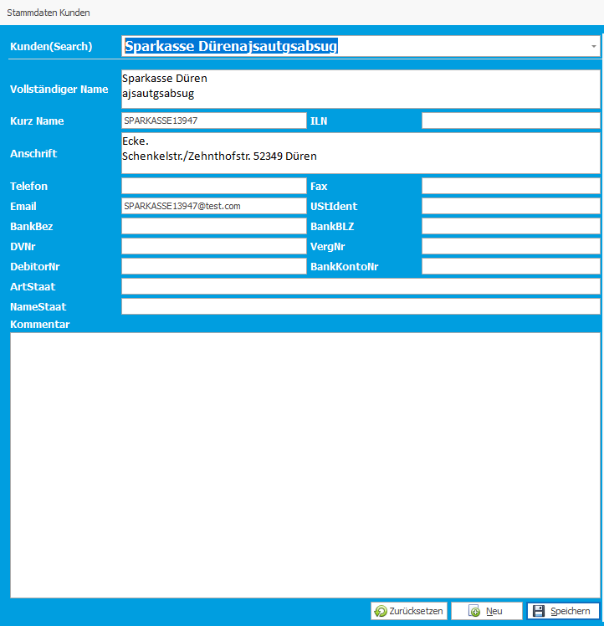

### Customer Contacts& Addresses

This section will have point of contacts of Customer or Customer’s organization. User can add multiple contacts to each customer and each customer will have a default contact from one of them.

This section will also have the Addresses of multiple braches or offices of a customer or its organization. User can also set default address and the same will get picked when user sending proposals to customer.

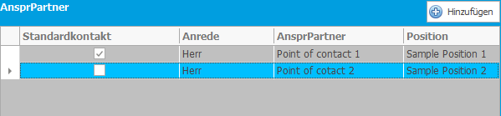

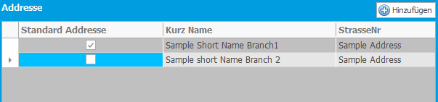

## Supplier

### Supplier Meta Data

This section will have the information about the suppliers related to organization like Name, Short name, contact numbers, Fax Numbers and etc… It will also have commentary field to write description of supplier and another filed for a payment conditions. User can add new suppliers and edit existing suppliers.

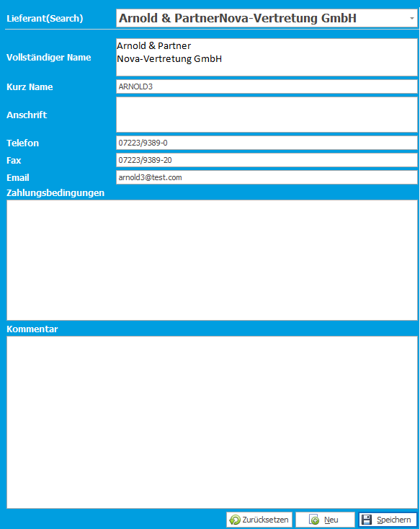

### Supplier Contacts& Addresses

This section will have the information about supplier’s multiple point of contacts and addresses. User can add new contact or address and edit existing contacts and addresses. There is option to make a contact or address as default so that we can use them in price enquiries.

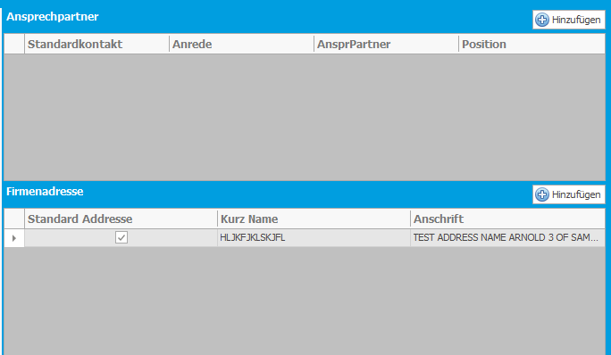

### Supplier Articles

In this section user can map the articles available in article meta data and project or position specific articles to suppliers. Using this mapping user will select the positions and sends the price enquiry to suppliers.

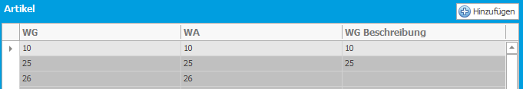

## Article Master

### Article Meta Data

In this section, we will have global article’s meta data. Below are the details:

* WG (Group) , WA(Variant) and WI are the article numbers.
* Fabricate, Massenheit, Mengenheit, DataNorm Number, Dimension, text-KZ and description are the properties.

Here is the articlesrepresentation:

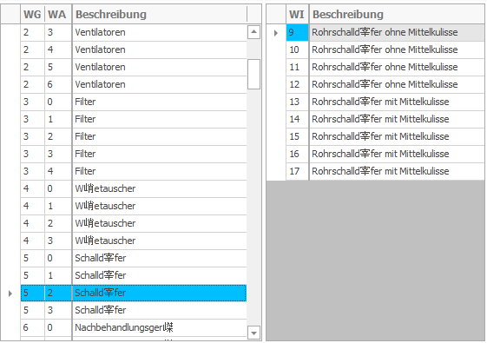

We can also see the Typ and Rabatt mapping with article in the same screen. We will discuss about Typ and Rabatt in coming sections.

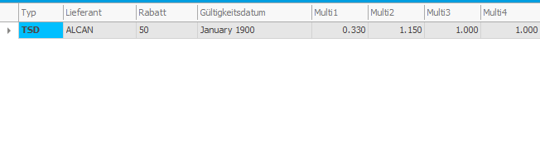

### Dimensions

Each article will have its own set of multiple dimensions with list price and minutes. List price is the material price and we can calculate montage price with minutes along with hourly rate which is mentioned in the project meta data. Hourly rate will be different for each project. There is also an option for saving the dimensions with different validity dates because there may be price changes year to year.

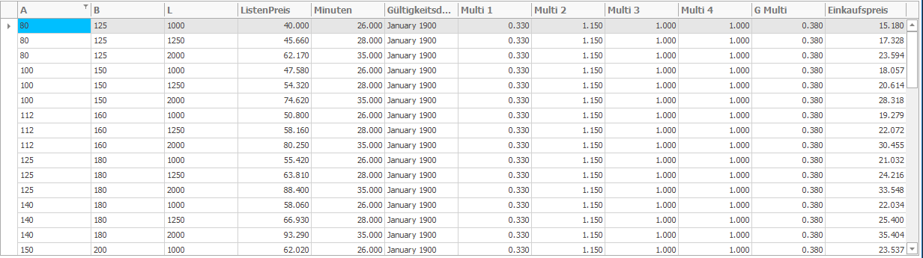

### Typ

Typ is combination of Article and Supplier. When user wanted to update an article along with a supplier to position, Typ will come into the picture. Also user can assign Rabatt to Article using Typ.

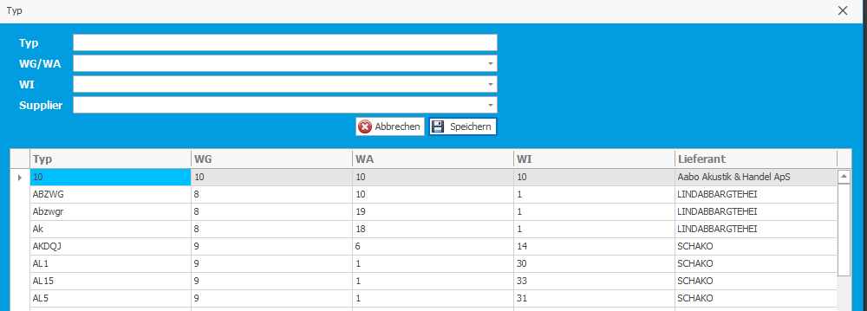

### Rabatt

Rabatt is a combination of Multi on material and montage prices. Rabatt will also have the validity date based price changes Month to Month. This will get mapped with article, when user assigning an article to positon, based on its submission date Rabatt values will get assigned to position along with material prices.

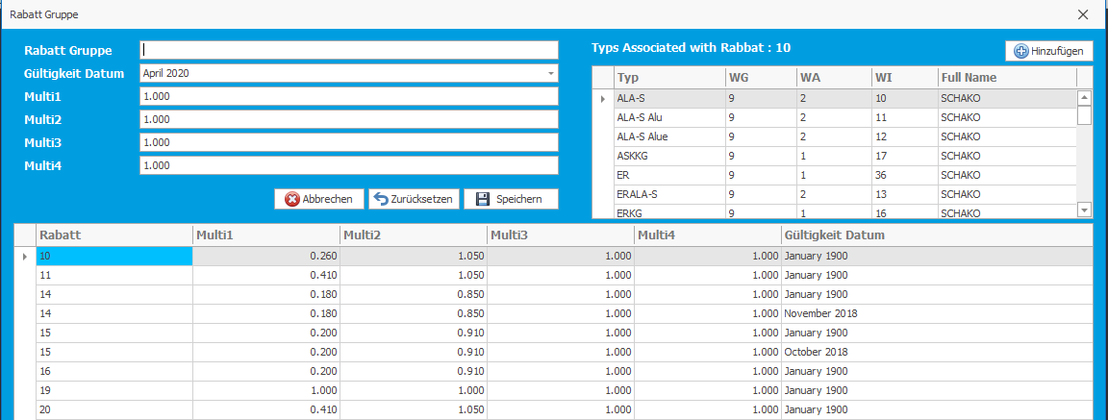

### Accessories

This is one kind of mapping multiple sub articles to base article. When user is assigning a base article to a base position, user need to enter dimensions and Quantity for sub articles. Then all the accessory positions will get created to it base position these are called detail KZ positions.

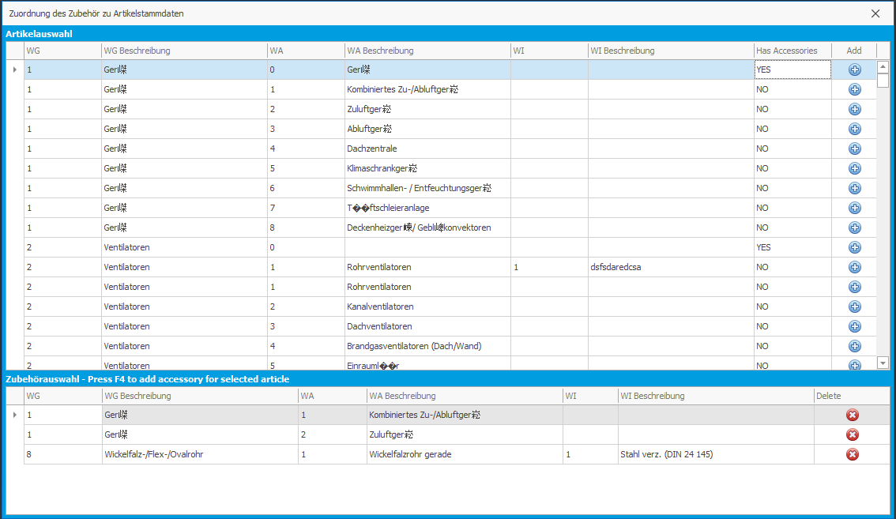

### Validity Date

Validity date field has major role in entire article master. Dimensions of an article will have multiple validity dates in the same way, Rabatt also will have multiple validity dates. Validity date will be compared with project submission date and material and Montage prices from dimensions and Multis from Rabatt will get populated.



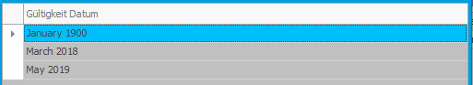

## User, Role and access

### User, Role and features Meta Data

#### Users

This section we can create a new user and edit existing user, it will have the user’s data like Name, Short Name, Username, address and contact information. We can also reset the password of particular user from this module.

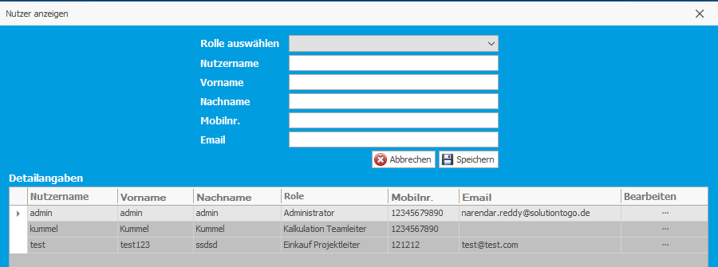

#### Roles

This section will have the roles info. As of now we don’t have any option create or edit role. We have six predefined roles. Users will get created under predefined roles.

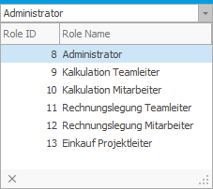

#### Access features

This section will have few predefined access features which are to be assigned to Roles based on his designation. This decision can be taken by administrator.

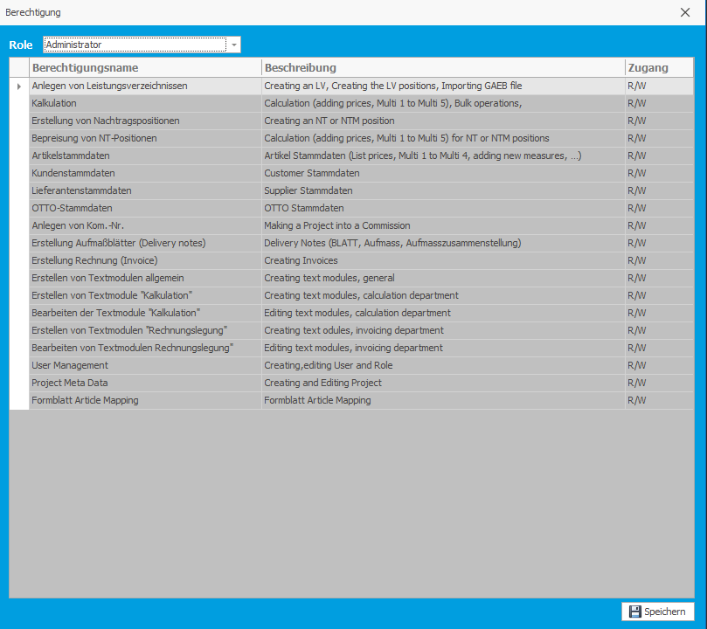

### Password Change

This is module is for changing the password of logged in user. User can change his password from his login by himself.

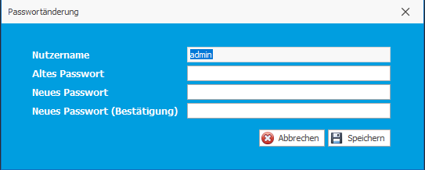

## Text Modules

This section is having the information about text areas used in Title Blatt. We have an word add-in for OTTOPro. We have integrated these text modules with word add-in in order to place predefined text in the Title blatts which saved as templates.

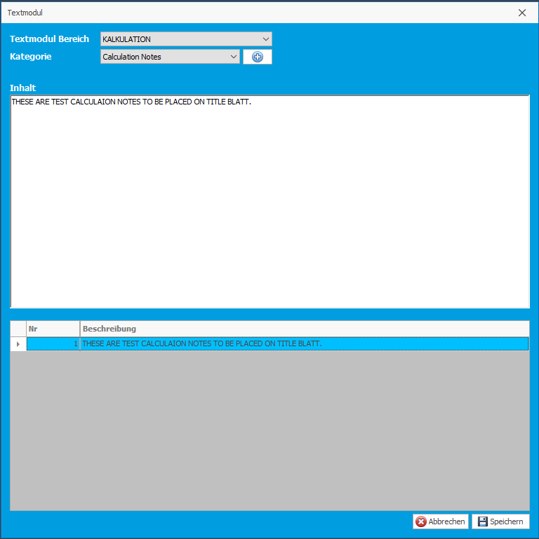

## Proposal Settings

This section will have the settings to generate proposal or tender. There are too many options to show data in proposals. We can see the options in below screenshot for reference.

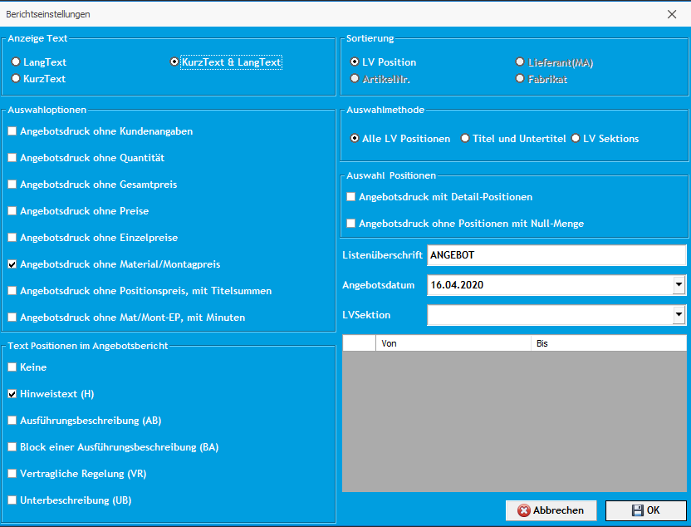

# Project

## New Project

This section is for creating a project. Initially user has to enter all meta data related to project. Below are the few fields to configure a project.

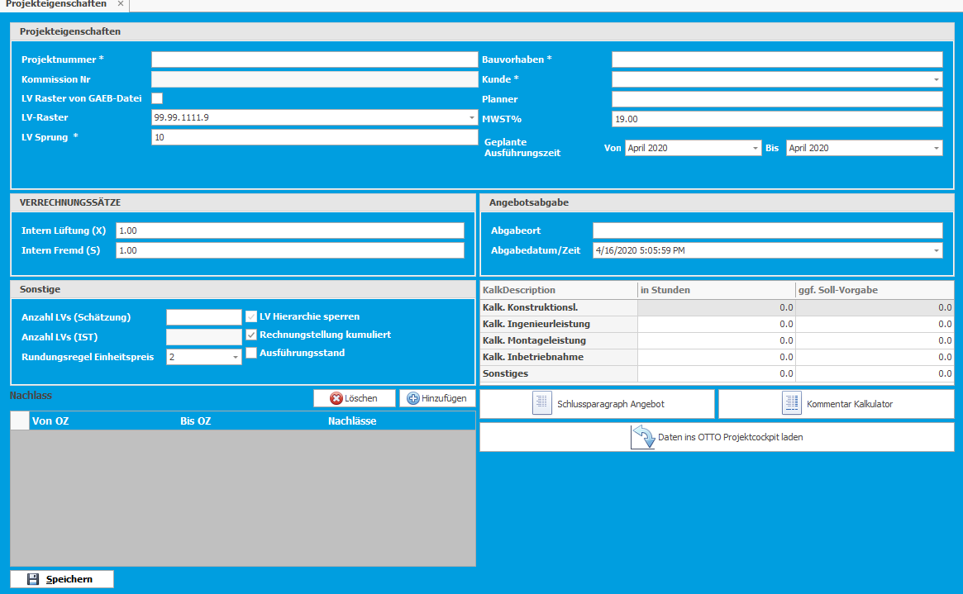

**LV Raster and LV Sprunge:**

LV Raster is used to configure LV position’s structure and LV Sprung is numerical diff between any two continuous positions.



Rounding price: this is useful for rounding the decimal values. Based on this value we will round EP and GB values in all modules.

It will also have fields for few other things like Vat percentage, Hourly rate, project duration, submit location, submission date and etc…

## Load Existing Project

We can load a project from list of project which already created or imported from GAEB file.

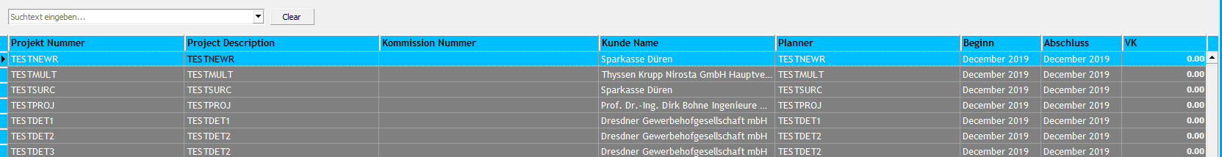

## Import Project

This section is for importing a project from GAEB file. We can import a GAEB fil in 3 ways.

* Import a GAEB file along with project meta data (By clicking import button main screen).

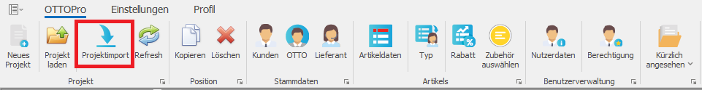

* Import a GAEB file on existing project(By clicking on import button in navigation bar).



* Import a GAEB file on price enquiry from supplier.

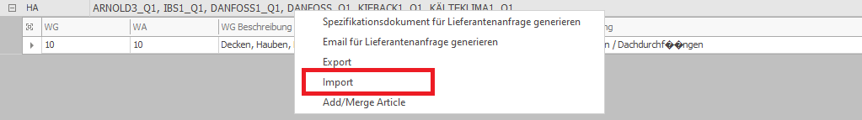

## Export Project

We can also export a project into GAEB file from OTTOPro. There are 2 ways to export positions.

* Complete project export by clicking export button placed in the navigation bar on Project form.



* Export positions which are added to supplier price enquiry.

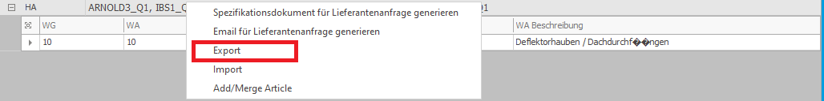

## Refresh Project

This section is for explaining about refreshing a project. If more than one agent or calculator is using the application, user can refresh a project. When user hit refresh button on main screen, it will refresh project selected tab which is active on tool.

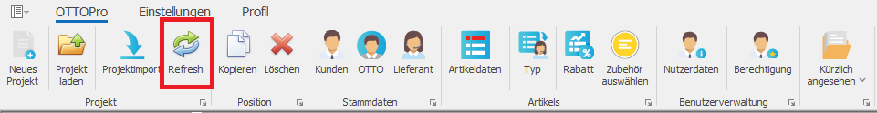

## Copy & Delete Project

We also have an option to copy a project as another project. This is nothing but a save as option to a project.

We can also delete a project along with its data from all other modules from list of projects.

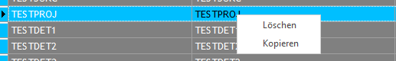

## Functional Modules

### Project Meta Data

This section will have the information about the project configuration and settings. It also has the info about the list of discount positions along with commentary. Below are the major fields which plays major role in project configuration.

* LV Raster
* LVSprunge
* Hourly Rate
* Decimal Rounding value
* Submission location and submission date.

And few other commentary sections which are used in Angebot and QuerCalculation Reports.

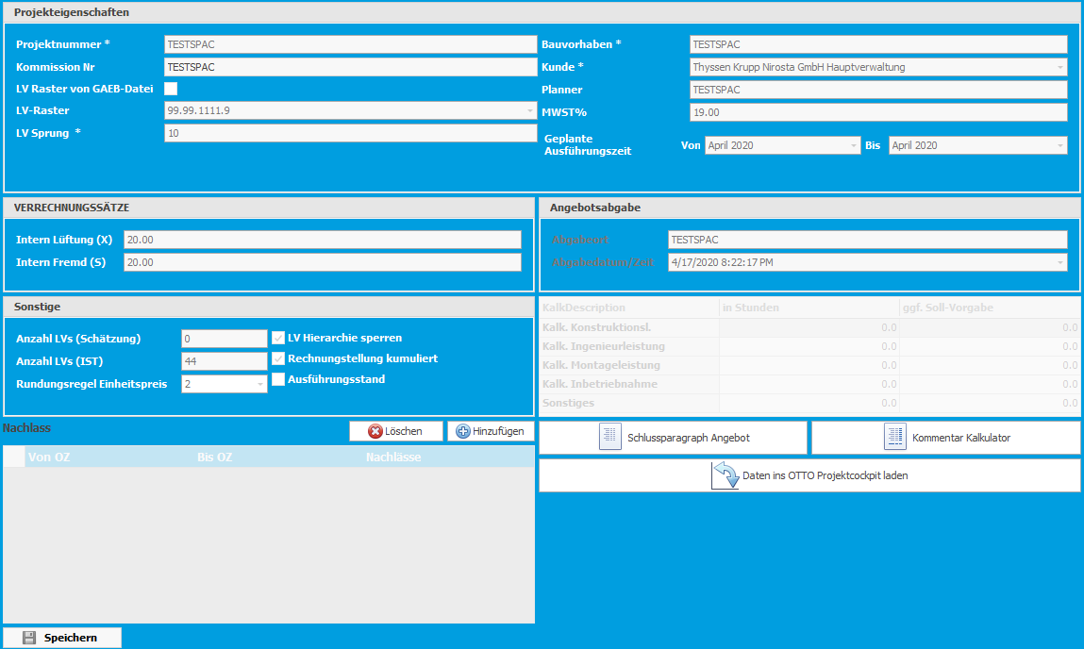

### LV Details

This section is major part of a project. User can create and edit all type of positions like Titles, Subtitles, Normal, Surcharge Positions and etc… fields will get enabled based on type of position. Incase surcharge position Surcharge percentage fields, FromOZ and ToOZ fields will be enabled,in other cases these will be disabled. Same behavior will be applicable for other type of positions too. Discount position can be created and edited from project meta data itself.Below are position OTTOPro will support.

* N-Normalposition
* ZS-Sum Position
* Z-Zuschlagsposition
* E-Bedarfspos. o. GB
* A-Alternativposition
* M-Bedarfspos. m. GB
* P-Pauschalposition
* H-Hinweistext
* NG-LV-Normalgruppe
* K-Kombiposition
* G-Grundposition
* B-Bezugsposition
* W-Wiederholungsposition
* L-Leitbeschreibung
* S-Stundenlohnarbeiten
* AB-Ausführungsbeschreibung
* BA-Block einer Ausführungsbeschreibung
* UB-Unterbeschreibung
* LO-Los
* VR-Vertragliche Regelung
* Z-Zuschlagsposition

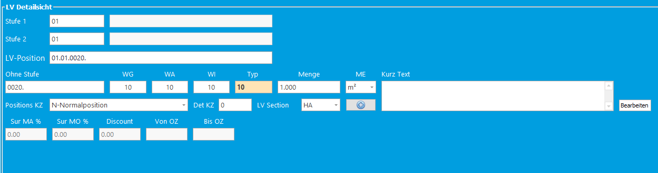

There is also a concept called detail KZ positions. By default, all positions will have detail KZ field as Zero, it means it is a base position. User can add sub positions for a base position and these are called as accessories in business language. These positions can be created in three ways

* Manually from LV details by entering value in Detail KZ field.
* Right clicking on a base position in tabular view, in this case tool will check for the existing detail KZ positions and allocate maximum value to newly created position.
* Through accessories feature which is there on article meta data.

Below is the screenshot of representation of detail KZ positions.

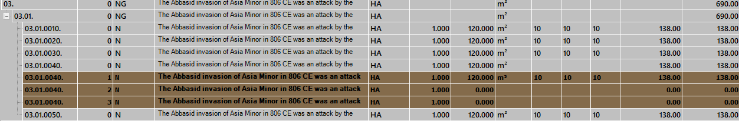

There is also another concept called LV Sections. User can create LV Sections as many as he required. By default, “HA” will be allocated to all positions and these called as initial positions. If any additional position requested by client, those will get added with custom LV section which is created by user. User can create new LV Sections by pressing add button as shown in below screenshot.

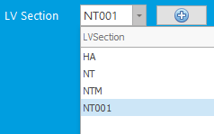

User can also allocate articles and its values to positions and long description too from this section

### Cost Details

In this user can allocate cost to positions created in LV Details. Here are few major operations user can do on positions using this mask.

#### Assigning articles

#### User can assign articles along with values from article master using article number i.e. WG, WA and WI orTyp.

#### If the article exists in article master, then a popup will be displayed will all the available dimensions and user has to select a dimension from list, then values will get assigned to position.

* If the article does not exist in article data, then tool will ask user to save newly entered article as project specific article and it will get assigned to position even if user not saving it.

#### Creating detail KZ Positions

User can also create detail KZ positon in this section using accessories feature from article. User has to select a base position enter an article which is having accessories, then a popup will get displayed with available articles and user has to enter dimensions if not available and quantity for every article.

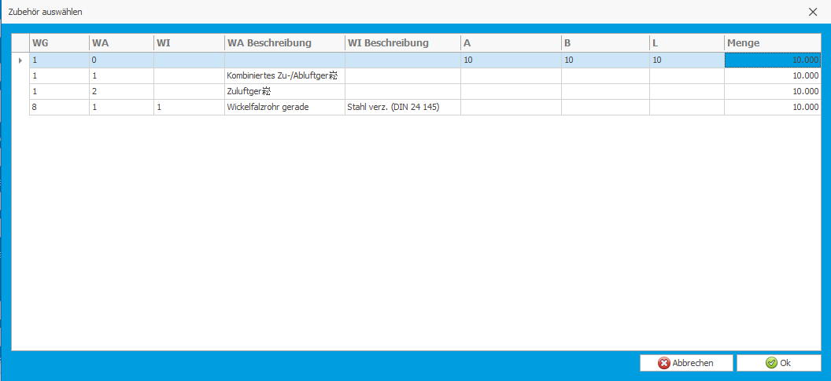

#### Long Description

User can update long description to positions using this section. There is a button to open long description mask. If any position is not having the short description, it will pick first 80 characters from long description as short description.



#### Docuware links

We can keep the documents related to a position in a specific storage and save the links in this fields. So that user can easily access them.

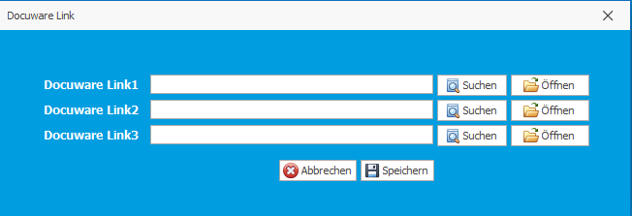

#### Cost Multipliers

User can add cost multipliers to positions independently to material and montage. Initially general Multis from Multi1-Multi4 and these values will also come from article meta data based on project submission date. Coming to other 2 Multis, one can be applied before Selbstkosten price and another before Verkaufskosten price. All these Multis can increase the price of position or decrease the price of position.

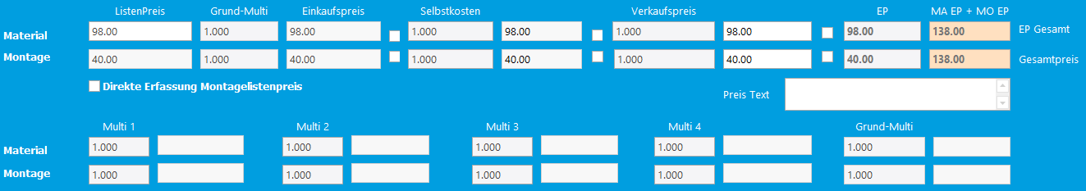

#### Position prices locking

User can also lock positions for editing the material and montage prices separately. These locks will start after Einkaufspreis. Below is the explanation about the same.

If a position is locked after Einkaufspreis, then user cannot edit any prices before Einkaufspreis and Einkaufspreis.

Above behavior is same for Selbstkosten locks and verkaufskosten.

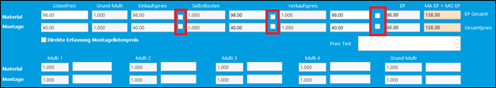

#### Delete Positions

User can also delete positions from a project. Once position is deleted all other dependent data will get deleted from other modules. User can delete a position in 3 ways below.

* Right click on a position and select delete option.
* Select a position and press Alt + F5 key combination.
* Select a position and click delete button on main form.

#### Copy Positions

User can copy a position by changing the OZ number in LV Details and Press F4 key. Then selected position will get copied with new OZ number.

Other ways to copy the positions

* Select a position and click Copy button on main form.
* Right click on a position and select Copy option.

Here is the complete screenshot of Cost details mask.

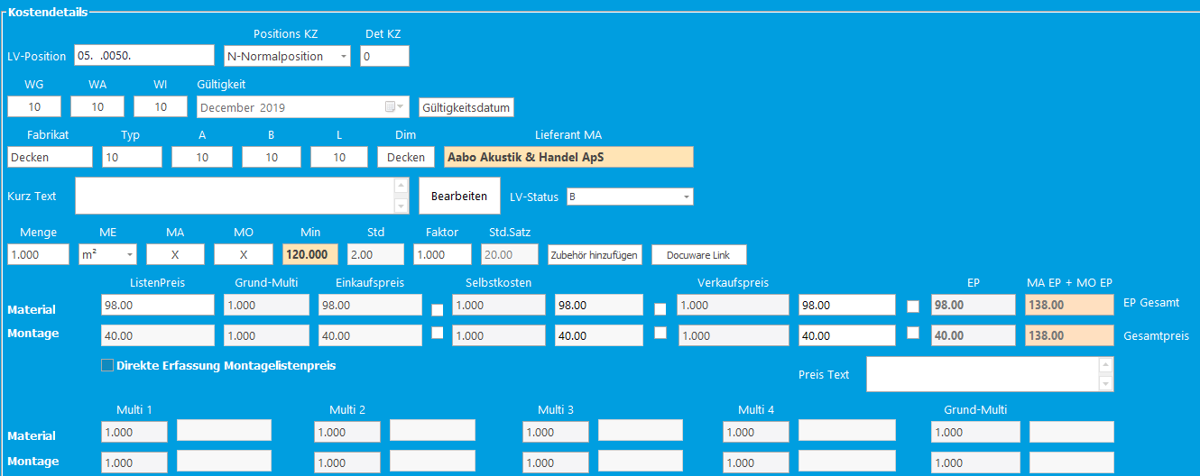

### Tabular View

Tool will display all the positions in a tree list with parent and child relationship. User also can edit positions like assigning the articles, Menge and etc… tree list will roll up the values of positions to titles and subtitles. Tree list will also support below operations

* Drag and drop positions within same parent and across the parents.
* Copy and paste LV position along with detail KZ positions.
* Copy and paste detail KZ positions.

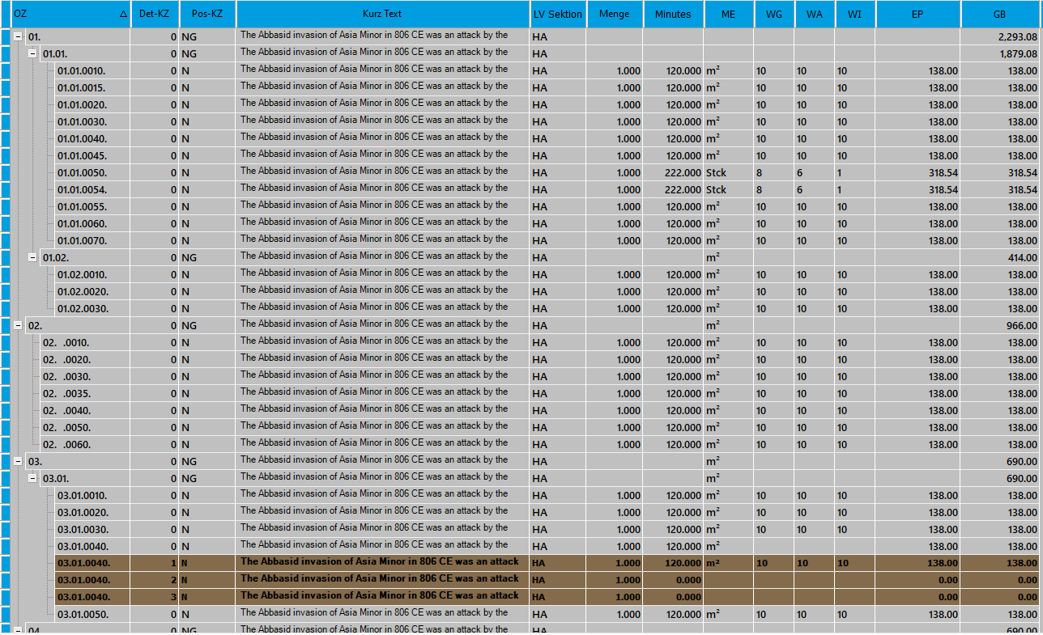

### Bulk Processing

This section is for updating multiple positions at a time. Here there will be two actions to update, in the action A, user can update Selbstkosten and verkuafskosten Multis for material and montage.In the action B, user can update Menge, MA KZ, MO KZ , Preis Text, Article Number, Typ and etc…

Here user can filter position in below 3 ways.

* By LV Positions
* By Titles and Sub Titles
* By Articles

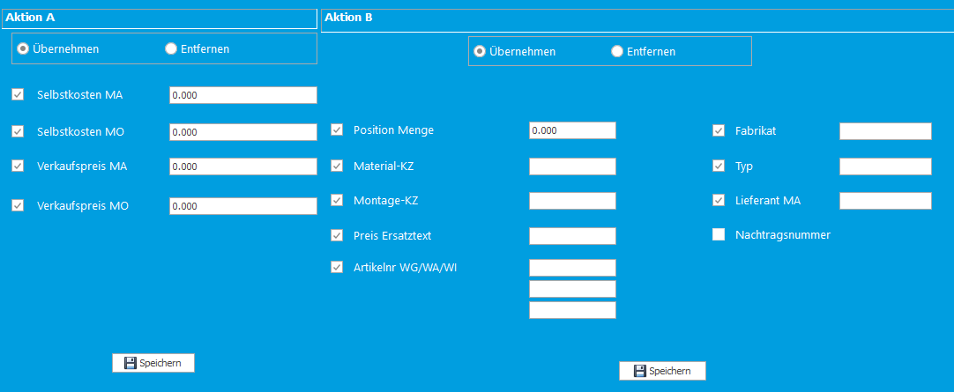

### Multi5

This is section is for analyzing and updating new Selbstkosten Multi to positions filtered by LV Sections. Here user can update factor by article and supplier wise. This can be done only for material.

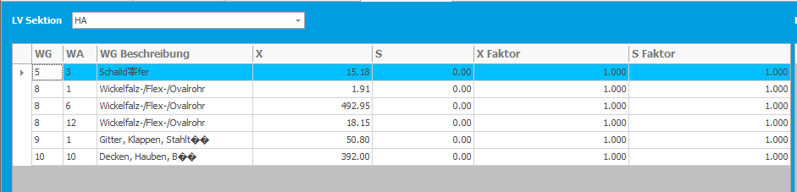

### Multi6

This is section is for analyzing and updating Verkuafskosten Multis to positions filtered by LV Sections. Here user can update factors by article and supplier wise. This can be done for material and montage.

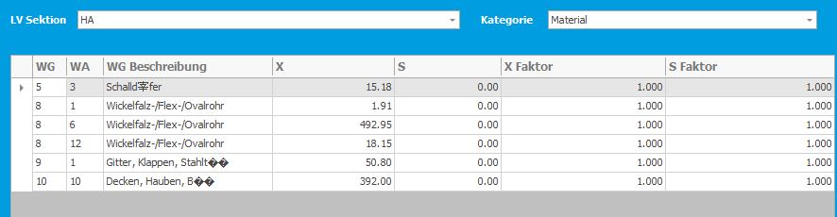

### Special Costs

This section is for distributing the special costs equally on all positions under project. If any positions are locked before selbskosten, then special cost will not be distributed.

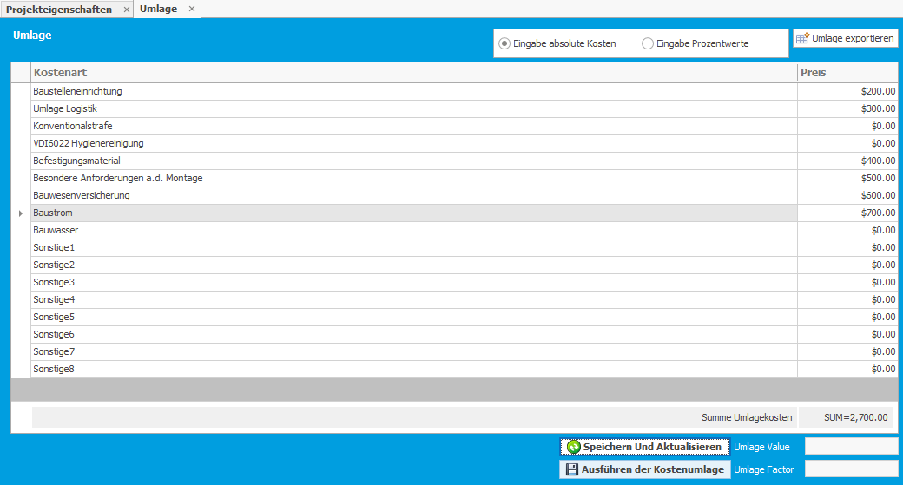

### Supplier Proposals/Price Enquiry

This section is for sending price enquiry with suppliers. User has to select LV section and then all the proposals i.e. saved and unsaved will be displayed. If it is unsaved proposal, on mouse click positions and suppliers related to selected article will be displayed. User can select multiple supplier up to 8 in supplier list box and click on save button to convert as saved proposal.

User can take a printout of saved proposal with all the positions. Also there are few other options like export to GEAB file, sending mail to supplier, Import GEAB file received from supplier on proposal.

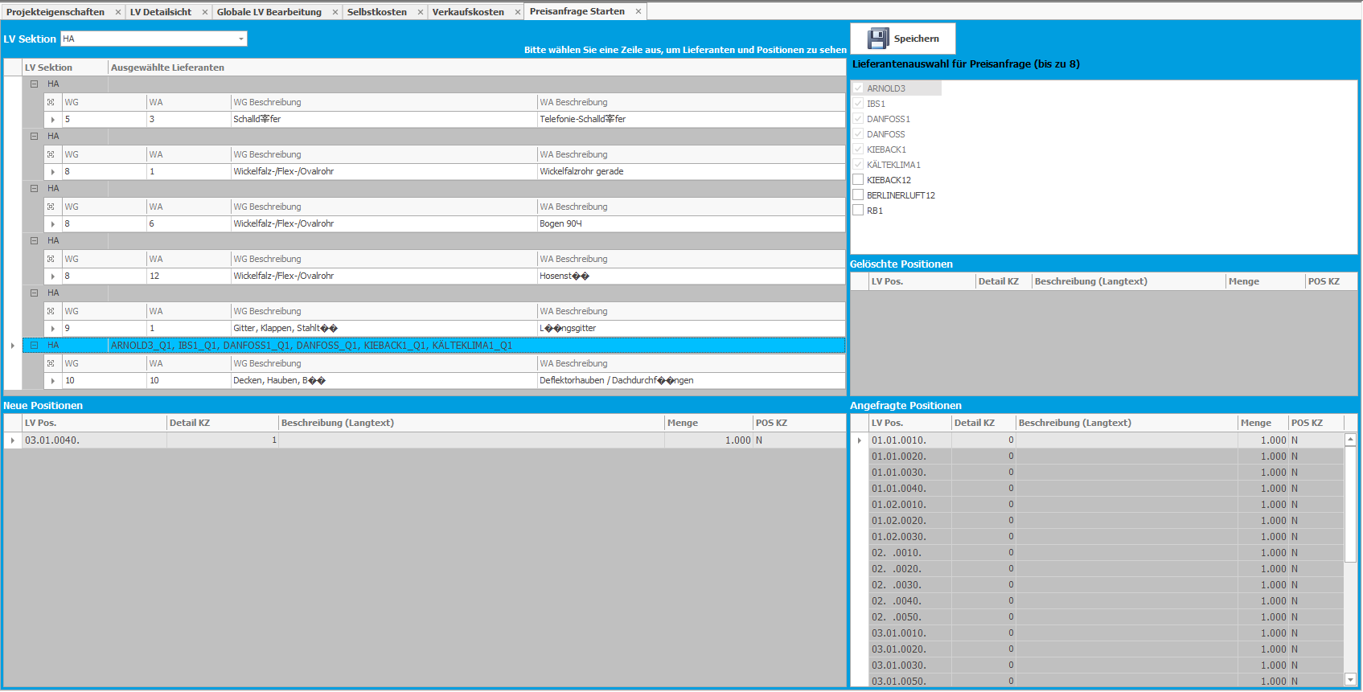

### Price Entry/Price Comparison

This is section is to enter prices for proposed positions once tender received from supplier. User has to enter prices for positions to each supplier individually.

Here user also can update values by filtering positions and user also can see the existing values of each position. There will be four views of positions below:

* View positions with List prices.
* View positions with List prices and Multis.
* View positons with List prices and Menge.
* View positions with List prices, Menge and Multis.

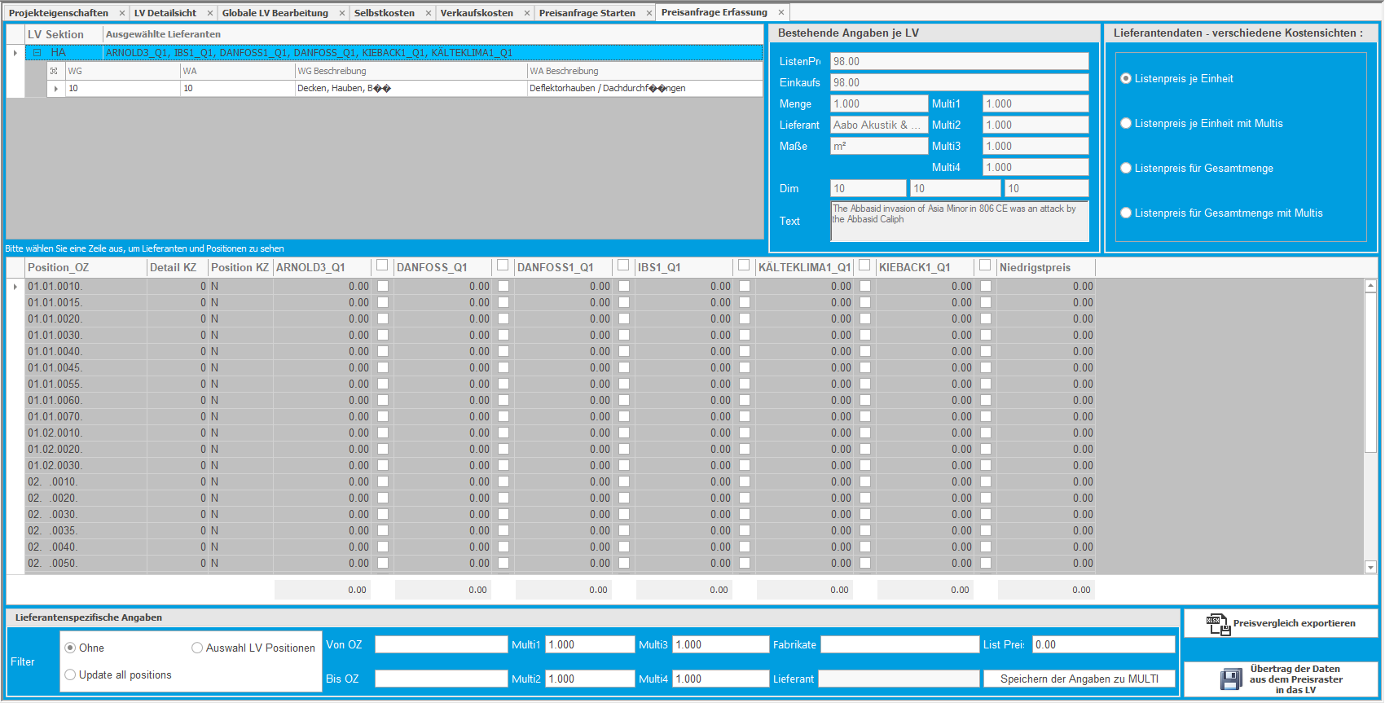

### Copy Positions from another project

In this module, user copy positions from another project. All data related to position will get copied to selected project. User has to drag and drop positions from project to project.

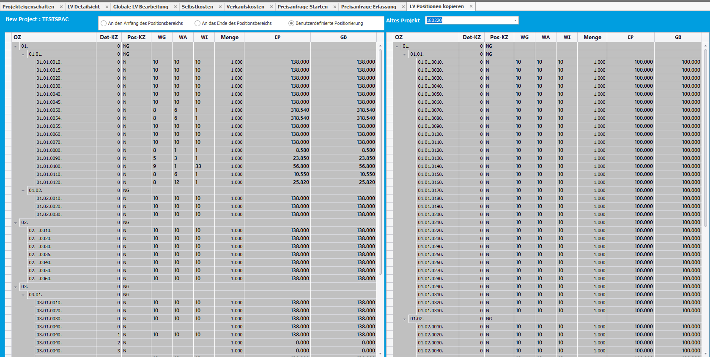

### Price Comparison of Articles

In this module user can compare prices of articles in the same project if it is assigned to multiple positions and across projects. There will be a toggle button to change the comparison between within project and across projects. This form is dock panel, user can doc on parent form wherever it is required.

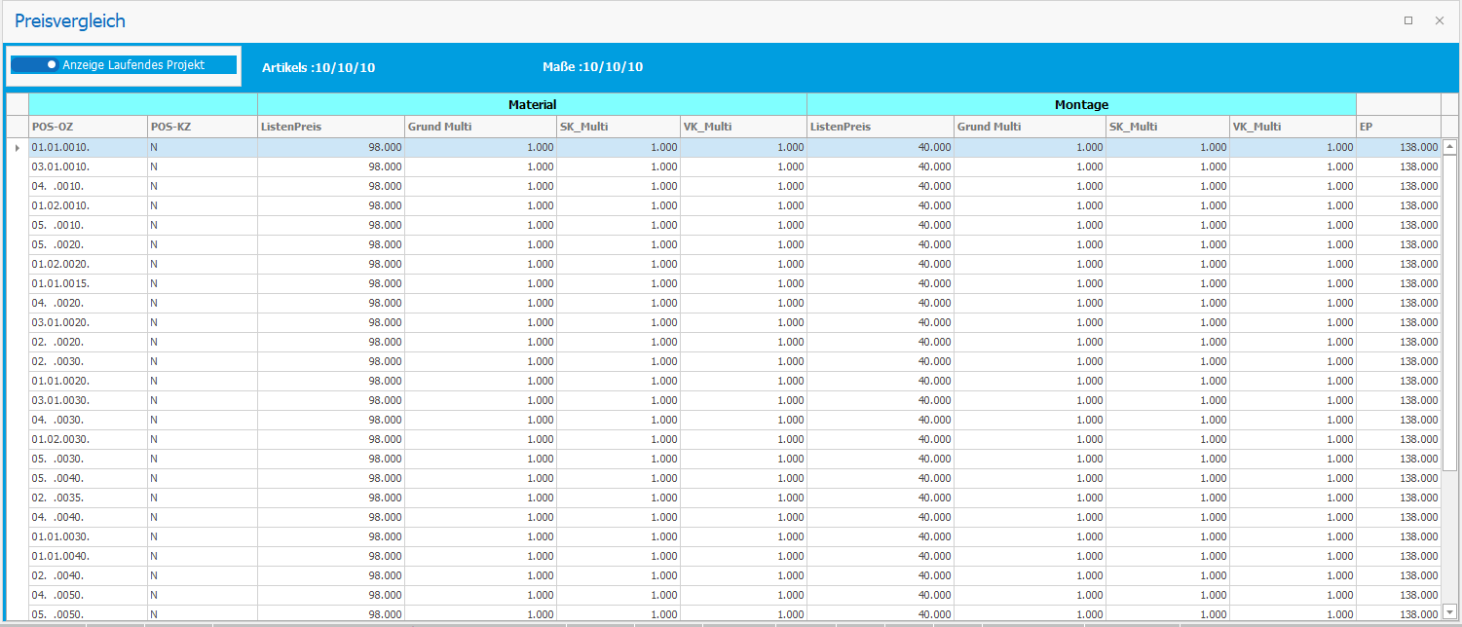

### Field Definitions/Settings of Article Values

This module is for settings for few fields, we can make the settings like a particular field can be populated in the cost details while assigning an article from article data.

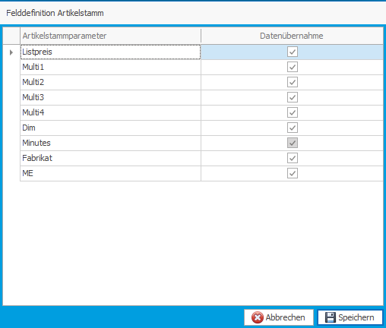

### Articles Mapping with Cost Types for Form Blatt Reports

In order to generate Form blatt 211 & 223 reports, user has to map articles available in project to different cost types. In this module user can map the articles for cost types.

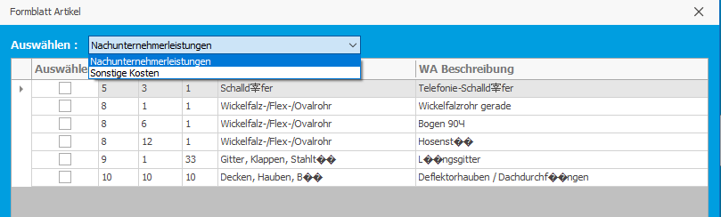

### Project Specific and Position Specific Articles

This module will have the data of project specific articles. When the user is assigning articles to positions which are not exist in article data, then these will get saved as project specific and position specific articles.

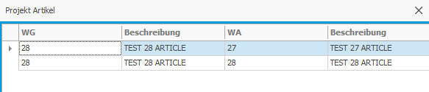

## Reports

### Angebot Report

This report is proposal or tender to be send to Customer. There are few settings before generating this report. This will have the prices and other information of positions. Here is the attachment of complete report.



### QuerCalculation

This report represents the data by articles. In this we have two versions, Version 1 will have the data with few columns and version will have few additional columns to represent special cost on each article. It is also having a filter form before generating report.

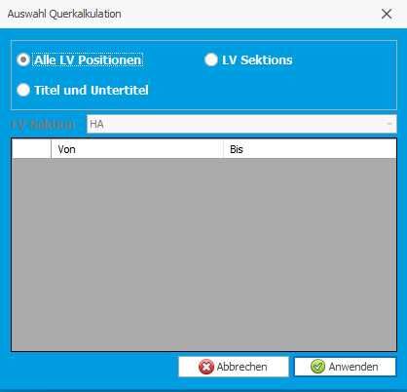

We can compare below attachments.

 

### Form Blatt 221& 223

This report is for differentiate the prices for below cost types.

* Nachunternehmerleistungen
* Sonstige Kosten

Articles will get assigned to these cost types in Form Blatt Articles form. Below are the sample reports.

 

### Einzelaufgliederung Beispiel (Breakdown Report)

This report will display the complete information of all the positons available in project. Below is the sample report generated using tool.



### Title Blatt

These are Title Blatts for reports which generate using templates. User has to design Title Blatt Templates using merge fields and text area provided in word add-in, then this will be generated individually for each project. We will look into Title Blatt Templates design in coming sections.

# Title Blatt Templates

### Path Configuration for Title Blatts and Templates

User has to configure a common path for saving the Titles Blatts and its templates. This should be accessible for all the users.

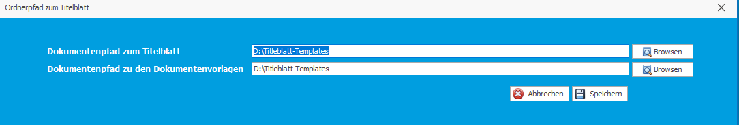

### Templates

In this module user can design templates for Title Blatt using OTTOPro add-in and inbuilt features of Microsoft word and these templates should be placed in configured folder.

# Shortcuts

This module will have the information about the shortcuts provided in tool.

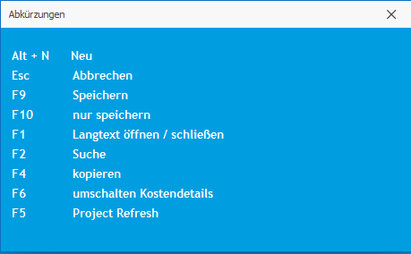

# Log File

Tool will also write the errors and exceptions to a log file using log4net package which is downloaded from nugget package and the log file will be saved in a folder which is configured in log4net package configuration file. We also provided a feature to send log file to support team by single click.

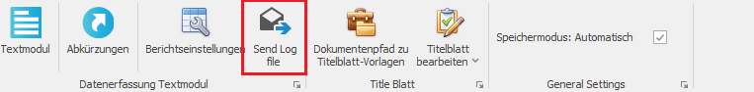

# Version matching implementation

This is more of a version control system. Whenever we release a new build to client tool will check for latest version which is saved in database and gets closed if it is not matching. Here is version we will show in the tool.



# Word Add-in

We have provided an add-in to design Title Blatt templates. Here is the add-in:

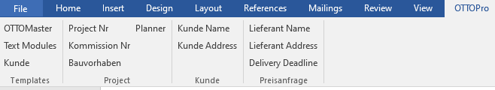

## Merge Fields

These merge fields play major role in template design. These are provided in word add-in and user has to insert fields in templates. Inserted fields will get replaced by project information while generating Title Blatt.

## Text Modules

Text modules are predefined text saved in tool. These can be accessed via word add-in while designing template.