**Some of the deviations that are found in the Ordering functionality as tested with the Excel:**

1. The Excel is removing the “.” when we split the ‘OZ’ using the “Text to Column” option in case of the numeric ‘OZ’(Eg : 5555.5) but this does not happen in case of text ‘OZ’(Eg: TEST.5)

Position ‘OZ’ : 5555.5

Position ‘OZ’ : TEST.5

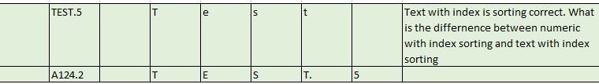

1. When there are two positions with the same ‘OZ’,
2. One position without index(Eg: 5555)
3. Second positions is with index(Eg: 5555.5)

Then the sorting is happening as follows

* 1. 5555.5
  2. 5555



1. Sorting with index (point2) is incorrect but the same scenario in case of the text is sorted correctly what is the reason.



1. Sorting cannot be applied in Excel in case of a blank/text position, because the blank entry will be sorted and displayed at the end. This needs to be handled.