Team Number 6: HACKR
Game Title: Solve Your Escape

TEAM MEMBERS
Team Leader:
Aidan Buffum aabuffum@wpi.edu

Other IMGD 4000 Students:
Hung Hong hphong@wpi.edu
Karl Rosenfeld kjrosenfeld@wpi.edu
Craig Bursey crbursey@wpi.edu

IMGD 4500 Student:
Regina Reynolds rcreynolds@wpi.edu

GAME
Elevator Pitch:
An escape the room type game set in an eerie and empty home. The player must solve various puzzles around the house to advance to new rooms and obtain new items. The player wins the game by ultimately solving all the necessary puzzles to enable their escape from the house.

Detailed Description:
The game takes place in an empty house during an unspecified time period. From the props and objects around the house the player can infer the game is set around present day.

The protagonist is an unnamed player character who wakes up to find himself in this house with no idea of how he ended up there. With all of the possible exits locked, he must explore the house to uncover a way out. The adversarial force of this game is the pressure to successfully escape the house.

The primary objective of the player is to explore the house and find a way out. This is accomplished by discovering various clues and solving puzzles scattered around the house. The player wins when they solve all of the puzzles necessary to facilitate their escape. Some of the puzzles planned at the moment include a keypad with a combination that the player discovers while searching the house, a lock the player must find the key to unlock, and a tile-sliding puzzle.

The general narrative of our game is that the protagonist, a young boy, has been kidnapped and trapped in an unfamiliar and hostile house. From the moment he wakes up, the only goal on his mind is to get out of the house and get help. When searching for an exit he quickly realizes all the windows in the room are boarded shut and the door out of the room requires a combination to open. He must search the room and then the rest of the house to find clues to solve the puzzles around him and escape the mysterious place he woke up in.

The basic mechanic of the game is the set of various clues and puzzles scattered around the house to find and solve. The implementation and solving method will change for each puzzle around the house and the player will have to use their wits to locate clues and derive meaning from them.

Artistically, this game varies from the majority of escape the room games in that it will be rendered in 3D. Additionally, the game will be played in an over the shoulder or fixed-camera third person perspective rather than in first person. This style of 3D third person puzzle game is reminiscent to the gameplay of games such as The Walking Dead or The Wolf Among Us in that the player character navigates the space to uncover items and solve puzzles in order to advance to upcoming stages. The atmosphere of the game is mysterious and ominous, leaving the player character with many questions about where they are and how they got there. This atmosphere mostly resembles games such as The Room, pictured below:
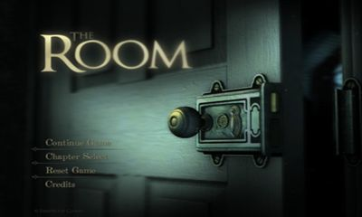

Due to the seven week time limit of this game, the scope will be limited to a handful of rooms instead of an entire house, but the game structure also lends itself well to possible future expansion, given the time. Below are images of an overhead view and a three-quarters view of the proposed map with placeholder assets:
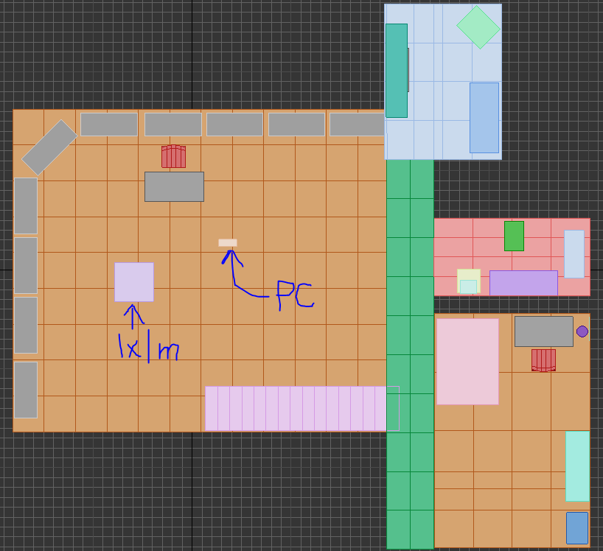

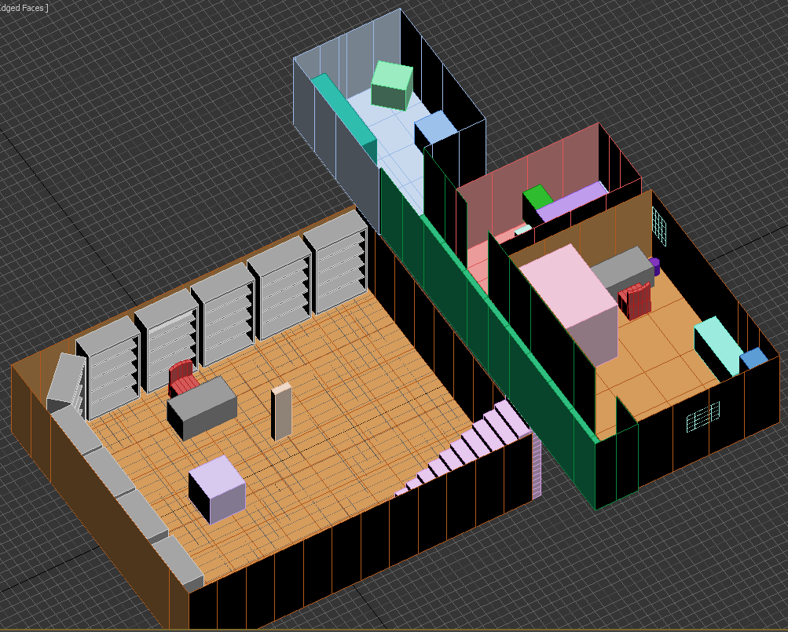

Looking at the overhead view, the proposed rooms are the study (leftmost orange rectangle) with stairs (pink) leading up the second floor hallway (green rectangle). Off of this hallway are the living room/den (top right), the bathroom (red rectangle) and the bedroom (bottom right). The player character is represented by the yellow rectangle labeled “PC,” and the light purple square is actually a 1x1x1 meter cube, as seen in the three-quarters view, to help give a sense of scale.

Technical Element List:
- The first technical element for the game is the movement of the player. Presently, we are torn between two ways of movement: point-and-click advanced pathfinding or manual steering. Our first idea for player movement is advanced pathfinding. For this method, the player would move around and interact with the environment with a point-and-click system. By clicking on the ground, the player would move to that location, pathfinding around any obstacles. By clicking on an interactive object, the player will navigate to the object and initiate an interaction with it. Our second idea for player movement is steering. For this method, the player would navigate the environment with standard WASD controls. To interact with objects, the player would be able to press a certain key or gamepad button when in range.
- The second technical element for the game is the control of the camera. We considered two possible ways to implement the camera. The first way would be implemented with a set of cameras that are constantly over the player’s position. The fixed cameras solution would coincide well with the point-and-click movement system. Cameras are limited in the rotation angle for a natural overview of the whole room and can be switched from one camera to another to complete the overall perspective of the room, as illustrated in the figure below:
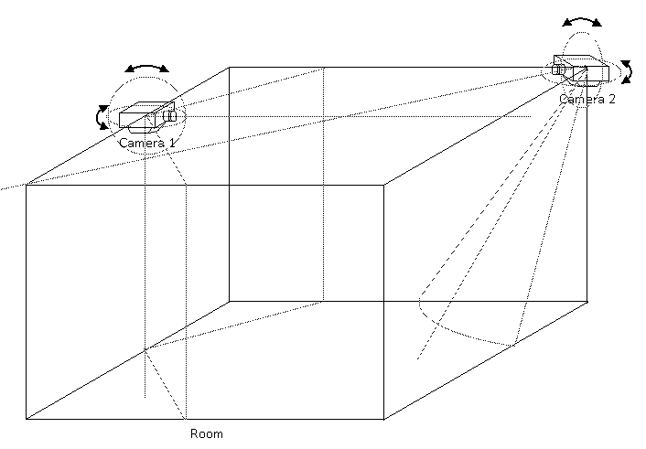
Fig. 1 Fixed Cameras with limited rotation at specific location

The second solution would use an orbiting camera that the player could control freely for efficient surveillance. The controllable, orbiting camera would be befitting for the steering movement system. In short, the system we use for controlling the camera would be determined by the chosen system for player movement. As illustrated in Fig. 2, the camera can rotate around the main character (indicated as Main object in Fig. 2) to provide a lot of freedom for the player to look around.
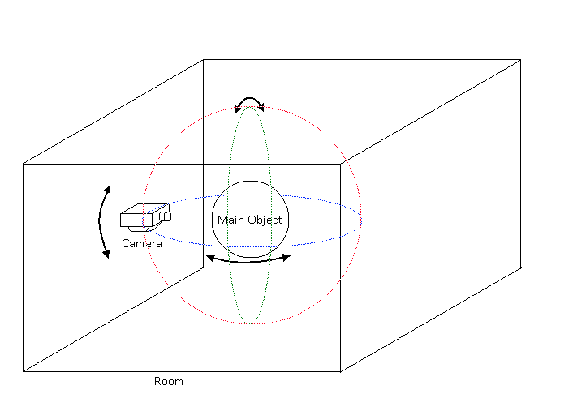
Fig. 2 Free Camera with controlled rotation around main object (player)

Eventually, we decided to focus on creating a fixed camera because control is essential for a puzzle game. Giving the player too much freedom for controlling the camera would be too much of an unnecessary burden, for us and for the player.
- The third technical element for the game is the audio. While there are no audio-dependent puzzles planned at the moment, interactions with objects will have relevant audio queues. There will be sounds that will play when a puzzle is solved and when an incorrect solution is given to name a couple. Sound effects will add up to the atmosphere of the game and improve immensely on the gaming experience. Voice-acting is also under our consideration.
- The fourth technical element for the game is the set of puzzles the player will have to solve to progress. The implementation of each puzzle will be different depending on its type. Many puzzles will also require the completion of another puzzle before they can be started or solved. We intend to link consecutive (a common theme, a hint for other puzzles, e.g.) instead of a discrete set of unrelated puzzles and in doing this, will ensure the setting of the game is clear and cohesive.
- The fifth technical element for the game is an inventory and progression-tracking system. The player will be able to collect several clues in the environment, some of which will unlock puzzles for the player to solve. To keep track of clues the player has gathered, the game will have an inventory viewing system that will also indicate the player’s progression in the game. Additionally, we are thinking of implementing a loading/saving system so the player can save the current progress. While the early version of our game should not be challenging, we believe for any future expansion the puzzle can become more complex and players may not be able to clear the game in one sitting. Thus, the system that helps saving player’s progress will be of great convenience.
- The sixth technical element for the game is the game interface, which includes loading screen, HUD, progress map, and inventory interface. We want to make the game system solid similar to many games in the industry, and we aim for an enjoyable gaming experience from the players as they progress in the game. The loading screen will be tightly linked with the aforementioned loading/saving system, allowing players to start a new game or return to an old save. The In-game HUD may include a clock for time-sensitive puzzles as well as other visual information about the current puzzle the player is working on. The inventory system will be open and close on a button press and will allow the player to view the clues they have collected as well as a map of the rooms they have discovered in the house. The progress map in the inventory window is tightly tied with the progression-tracking system, which will be updated (expanding the map) as the player moves through the game.

Art Asset Spreadsheet:
See attached

