REPORT ON PLAYTESTING - TEAM HAKR

I. Goals
- To understand where we are at so far for this project
- To put our game into judgement and see how players feel about the gameplay
- To validate our current art style and how it fits within the game
- To identify any glaring weaknesses of the project that need to be visited for the Beta version
- To sort out our priority for the completion of the game.
II. Survey Details
The survey is available on Google Form, which can be visited by following this link:
https://docs.google.com/forms/d/e/1FAIpQLScKKN5mwCaqQVzkXYUoMdPSmsMcLXD64P8Tlqs_ZnaLgjLDUw/viewform?c=0&w=1
There are in total 5 sections, in particular:
- Section 1 is for an introductory purpose. We want to brief the participants on what they are about to do, and their impact on our project. No question is asked in this section.
- Section 2 is dedicated to our technical concerns. We want to check the effectiveness of our technical elements so far by asking about opinions regarding several features. The questions asked are:
  - How do the controls feel?
  - How do the cameras feel?
  - Other technical concern(s) and/or recommendation(s)?
- Section 3 is dedicated to our artistic concerns. We want to make sure our art style is fitting and consistent. Many questions are being asked, having the concerns of the artist in mind:
  - Do the animations make sense?
  - What do you think of the current game models?
  - What do you think of the current game texture?
  - Is the art style cohesive?
  - Other artistic concern(s) and/or recommendation(s)?
- Section 4 is for an overview look of the game as a whole, hence questions asked focus on the current game progress and our next course of action based on the responses of the players.
  - Were you able to solve the first puzzle?
  - What other features do you think should be our highest priority
  - Any suggestions?
  - Additional Thoughts?
Overall, we feel that our current list of questions targets our concern towards the game very well. Here is what the survey actually looks like for each section:
Section 1:
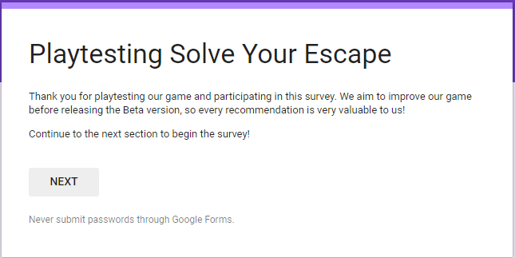
Section 2:
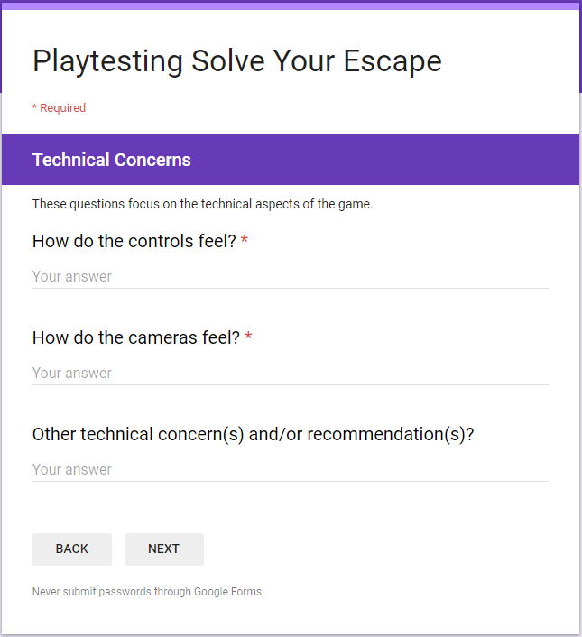
Section 3:
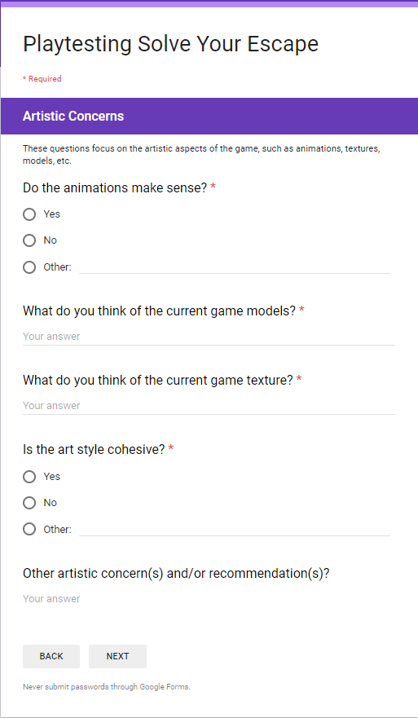
Section 4:
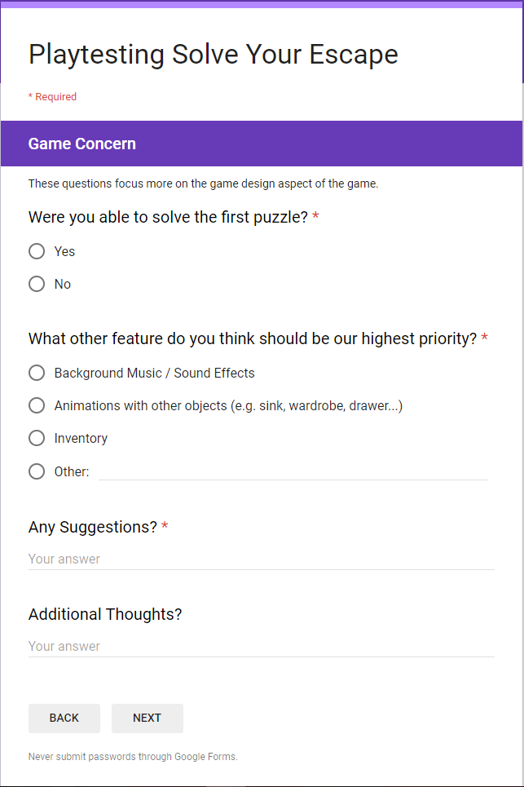
Section 5
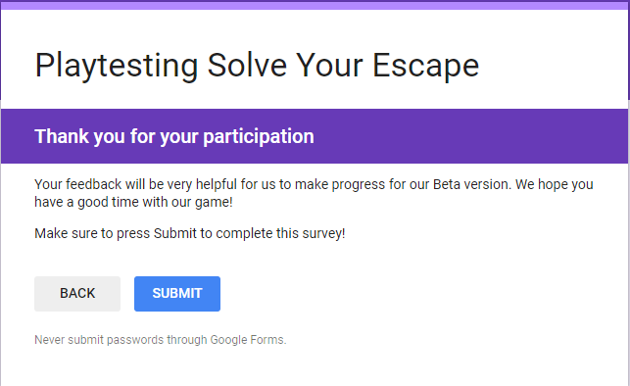

III. Survey Result
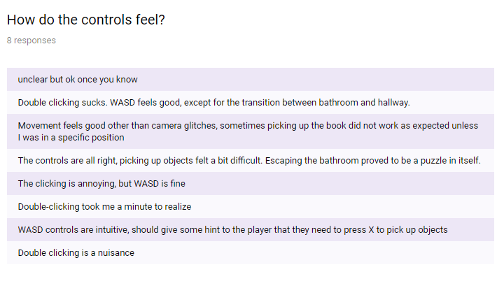
For this question, we receive several complain about the double-clicking issue of the game, which was caused by the lighting within Unreal itself. As annoying as it is, we are not able to fix the error in time since it turns out to be much harder than we expect.
As for the issue of picking, we decide to completely discard the pickup button and change it into a click system instead, since it will be more fitting to the current game mode which involves lots of clicking.
Other than that, most of the other concerns are already addressed, and the remaining parts of the control are in good position for the Beta version.
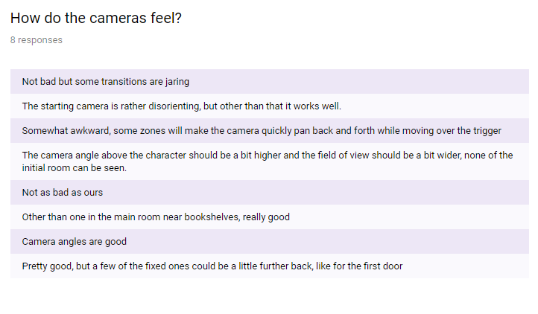
Overall, we see the positive responses of our play-testers as they generally think the camera system works great. We revisit several weaknesses that we have with the camera, in particular rapid camera shift that may cause confusion and several camera angles, to smooth out the camera transitions and improve the camera viewpoints.
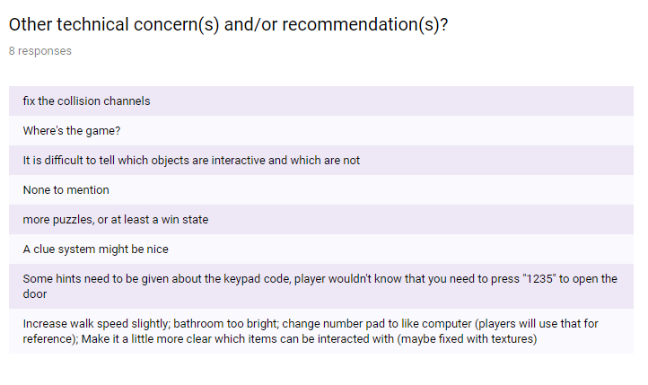
Some of the concerns are already addressed within the Playtesting version, such as identifying which objects are interactable and lighting. Our main concern is about the missing win state, so we prioritize on making the player able to complete the game. We thought about having more puzzles, but since it would put a strain on our artists since more models will be required, we decide not to proceed with the plan. As we have restricted time limit and many main concerns have not been addressed, some of the suggestions are left unvisited.
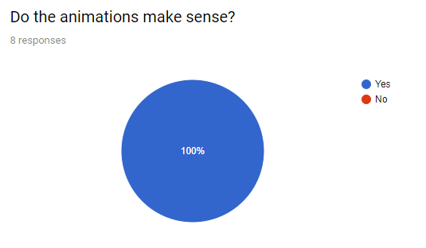
All participants are happy with our current animations as they fit well to the game without any bugs, so there is not much to talk about here.
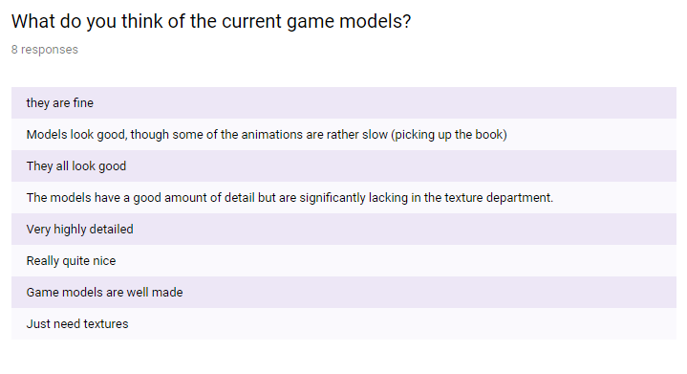
The models also receive well commendations from the players, as they are very detailed and well-made by our artist.
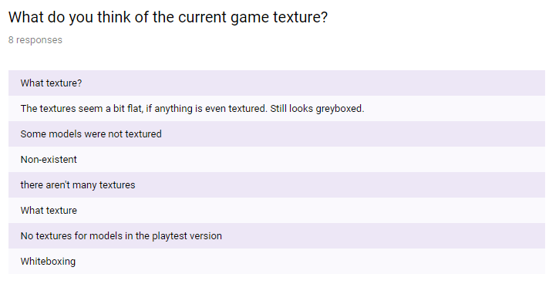
This is the main weakness of the artistic aspect of the game: Many of the textures are still missing. Thus, we make sure texture is of the highest priority for our artist to deal with.
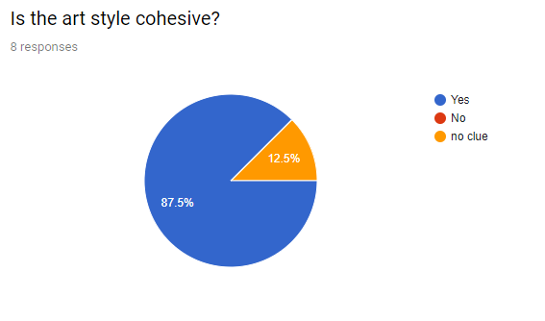
Overall, we receive a fair number of responses agreeing that the art style is consistent throughout the game.
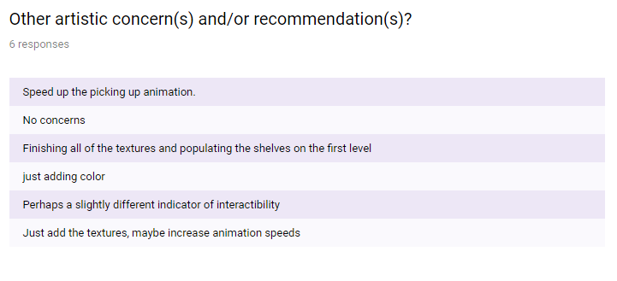
There are 2 main things that we can identify from here: Adding texture (which is already our top priority for Beta version) and increasing animation speed. We successfully address this issue for our Beta version.

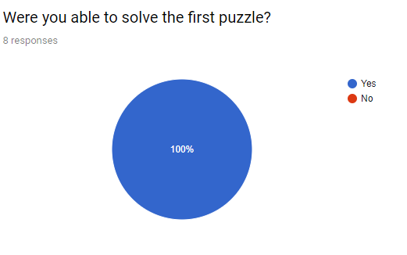
As the puzzle that is currently in the game, it is fairly easy and everybody is able to clear it with very few instructions from the facilitators.
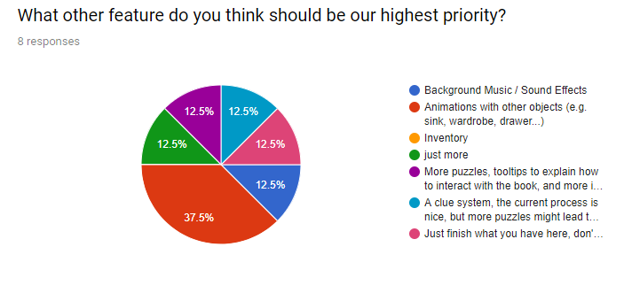
There is a dilemma going on right here: Some want us to make more things, while others just want us to complete our current missing assets. Due to the pressing time constraint and a lot of missing assets from the art side, we decide to focus polishing whatever we have right now and add just a few extensions to make the game feel more complete. Many other ideas are left under Future Work in case we want to revisit this project again.
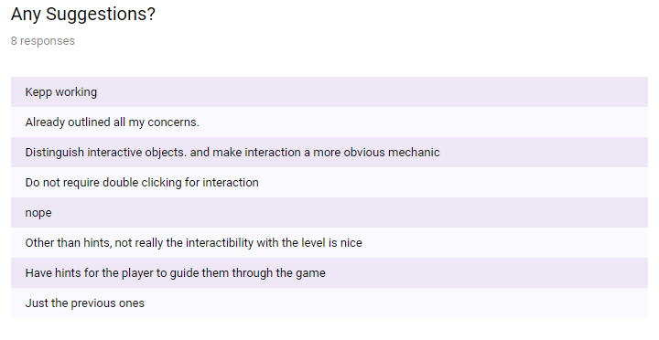
The responses simply repeat the concerns that have already been highlighted so far.

IV. Summary on Plans for Beta Version
Issues that we are focusing for the Beta Version:
- Fill in the missing textures for player and objects, as much as possible
- Smooth the camera transition
- Fix the interaction with other objects (such as book, bookshelf, etc.)
- Add an endgame condition to complete the game loop
- Several small fixes which are highlighted in the Beta Presentation
Issues that we identify, but decide to move on due to time constraint:
- Fix the double-clicking bugs in the game
- Add indicators for the gamepad
- Expand puzzle mechanics / difficulty
- Several additional models and textures for the expansion
Overall, we feel that the playtesting survey is successful in rectifying our focus and allow us to know our priorities for the Beta version.

