# CITY WITH E-VEHICLES

A city with a focus on electric vehicles integrates these vehicles into its transportation infrastructure to promote sustainability and reduce carbon emission. Many residents own or lease electric cars, replacing traditional gasoline-powered vehicles.

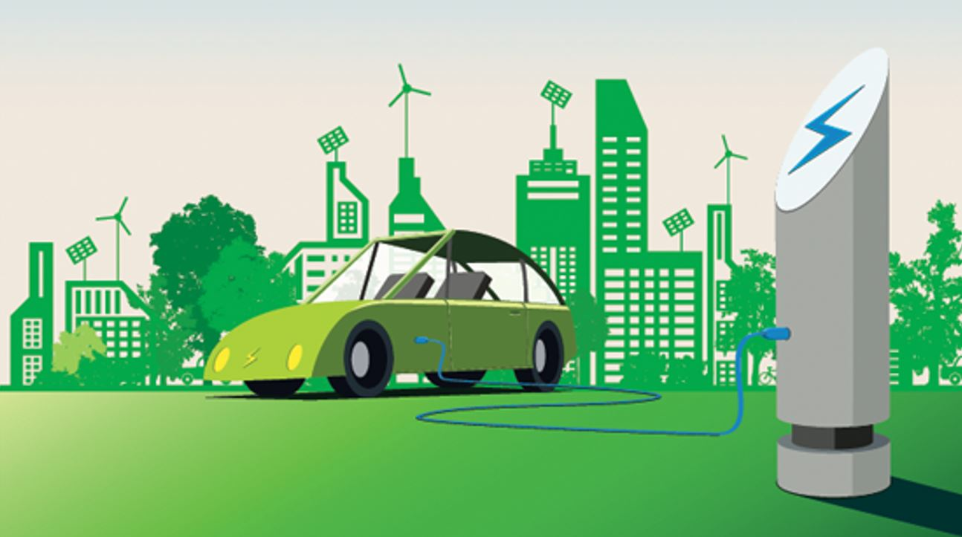

[This Photo](https://www.emobilitysimplified.com/2019/10/what-is-e-mobility-all-you-need-to-know.html) by Unknown Author is licensed under [CC BY-NC](https://creativecommons.org/licenses/by-nc/3.0/)

The city is equipped with numerous EV charging stations, both public and private, in parking lots, streets, and even residential areas. To support rapid charging, fast-charging stations are available, allowing drivers to recharge in shorter times.

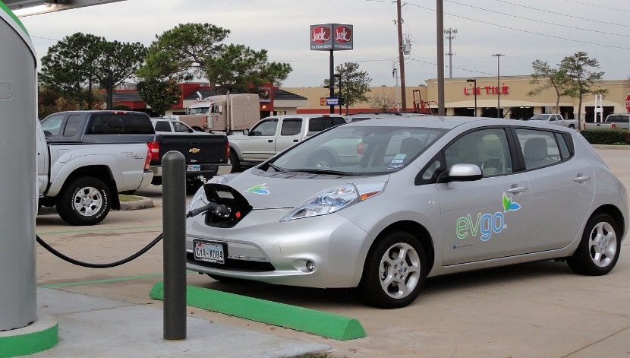

[This Photo](https://en.wikipedia.org/wiki/Battery_electric_vehicle) by Unknown Author is licensed under [CC BY-SA](https://creativecommons.org/licenses/by-sa/3.0/)

With fewer gasoline and diesel-powered vehicles, the city experiences lower air and less noise pollution.

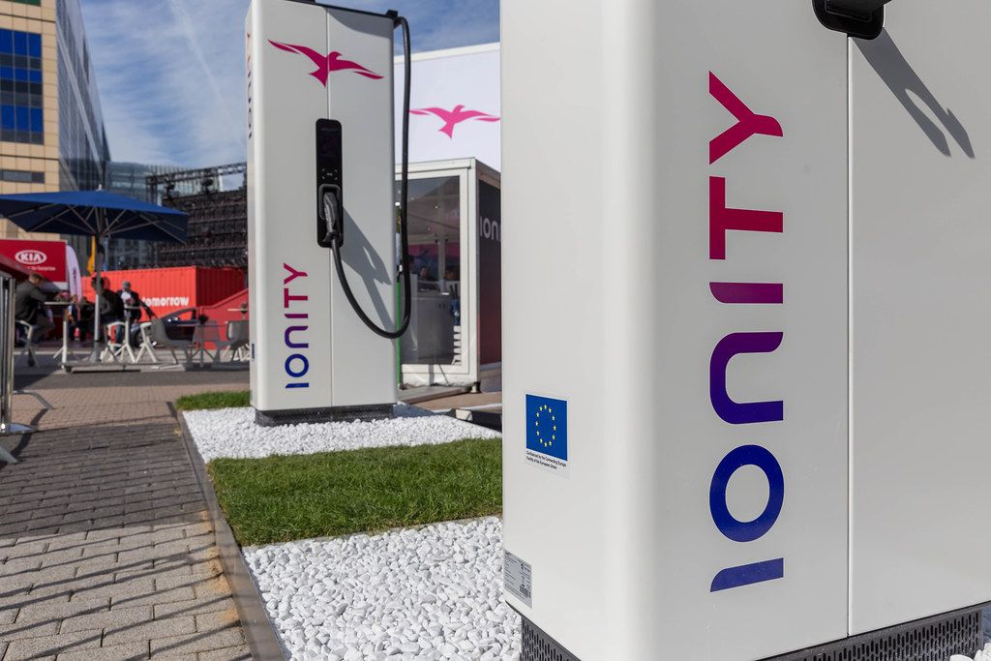

[This Photo](https://foto.wuestenigel.com/ionity-european-hpc-charging-station-for-electric-vehicles/) by Unknown Author is licensed under [CC BY](https://creativecommons.org/licenses/by/3.0/)

These initiatives are part of a broader movement toward creating smart, green cities that prioritize sustainability, reduce dependence on fossil fuels, and improve overall quality of life for residents. Electric car sharing may be come to available, offering an alternative to owing a personal vehicle.