**SOW/RFP**

Business leaders struggle to develop **statement of work** (SOW) that supports agile engagements. Lawyers and procurement groups have a difficult time writing SOWs that support iterative development without having a large set of requirements documented.

A **statement of work** (SoW) is a document routinely employed in the field of project management. It defines project-specific activities, deliverables and timelines for a vendor providing services to the client.

The **SOW** typically also includes detailed requirements and pricing, with standard regulatory and governance terms and conditions. It is often an important accompaniment to a master service agreement or **request for proposal (RFP)**.

A **request for proposal (RFP)** is a document that solicits proposal, often made through a bidding process, by an agency or company interested in procurement of a commodity, service, or valuable asset, to potential suppliers to submit business proposals. It is submitted early in the procurement cycle, either at the preliminary study, or procurement stage.

In principle, an RFP:

* Informs suppliers that an organization is looking to procure and encourages them to make their best effort.
* Requires the company to specify what it proposes to purchase. If the requirements analysis has been prepared properly, it can be incorporated quite easily into the Request document.
* Alerts suppliers that the selection process is competitive.
* Allows for wide distribution and response.
* Ensures that suppliers respond factually to the identified requirements.
* Is generally expected to follow a structured evaluation and selection procedure, so that an organization can demonstrate impartiality - a crucial factor in public sector procurements.

**A statement of work typically addresses these subjects.**

**Purpose:** Why are we doing this project? A purpose statement attempts to answer this.

**Scope of Work:** This describes the work to be done and specifies the hardware and software involved.

**Location of Work:** This describes where the work is to be performed, including the location of hardware and software and where people will meet to do the work.

**Period of Performance:** This specifies the allowable time for projects, such as start and finish time, number of hours that can be billed per week or month, where work is to be performed and anything else that relates to scheduling.

**Deliverables Schedule:** This part lists and describes what is due and when.

**Applicable Standards:** This describes any industry specific standards that need to be adhered to in fulfilling the contract.

**Acceptance Criteria:** This specifies how the buyer or receiver of goods will determine if the product or service is acceptable, usually with objective criteria. See Acceptance testing.

**Special Requirements:** This specifies any special hardware or software, specialized workforce requirements, such as degrees or certifications for personnel, travel requirements, and anything else not covered in the contract specifics.

**Type of Contract/Payment Schedule:** The project acceptance will depend on if the budget available will be enough to cover the work required. Therefore, a breakdown of payments by whether they are up-front or phased will usually be negotiated in an early stage.

**Miscellaneous:** Many items that are not part of the main negotiations may be listed because they are important to the project, and overlooking or forgetting them could pose problems for the project.

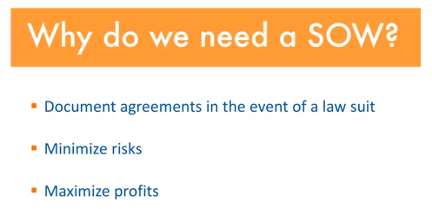

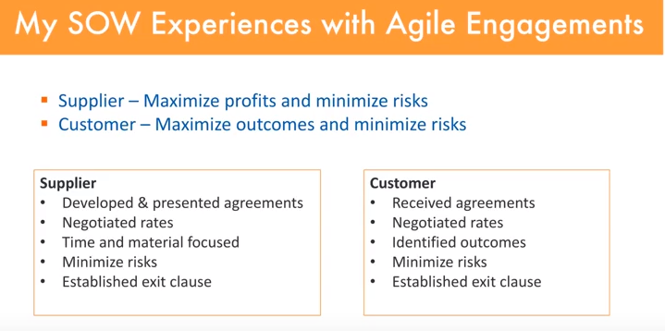

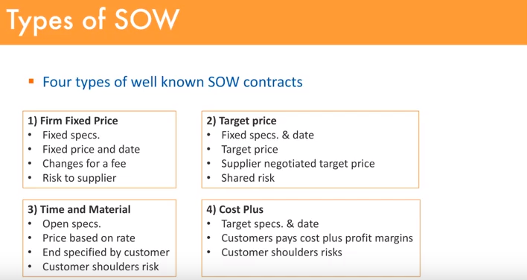

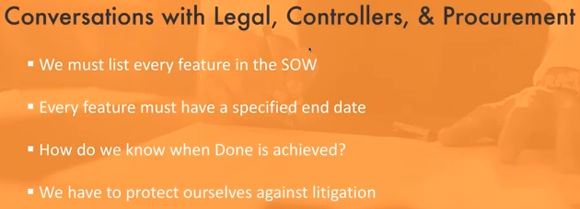

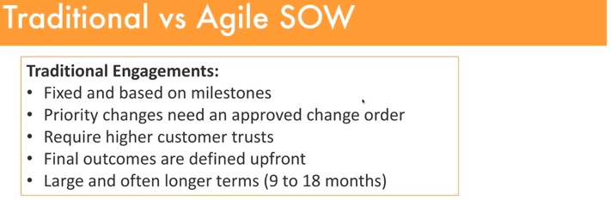

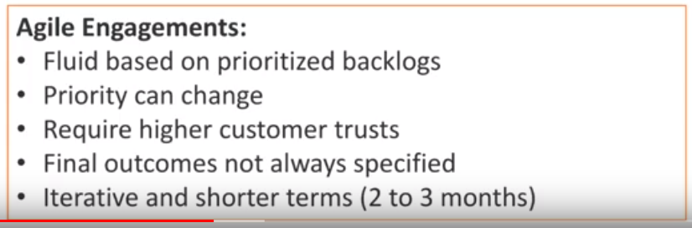

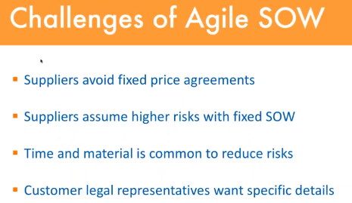



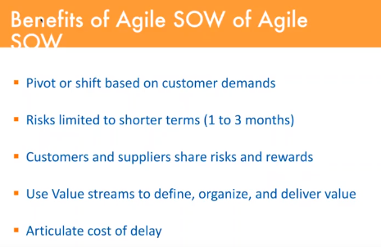

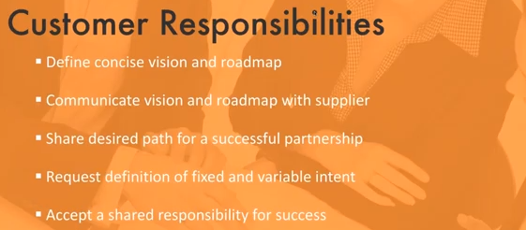

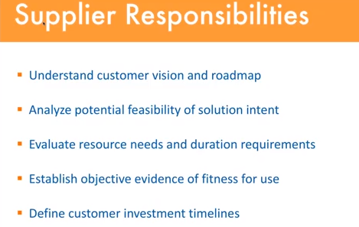

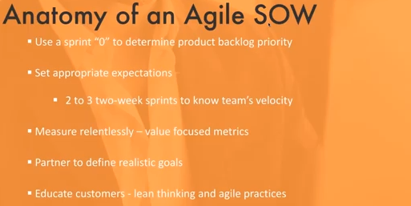

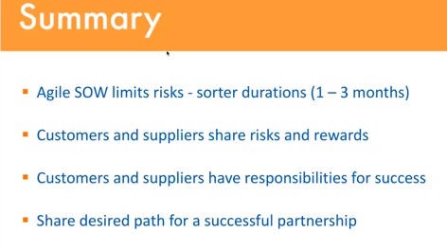

**Estimation Techniques**

The Project **Estimation** Approach that is widely used is Decomposition **Technique**. Decomposition **techniques** take a divide and conquer approach. Size, Effort and Cost **estimation** are performed in a stepwise manner by breaking down a Project into major Functions or related **Software Engineering** Activities.

The four basic steps in Software Project Estimation are −

* Estimate the size of the development product.
* Estimate the effort in person-months or person-hours.
* Estimate the schedule in calendar months.
* Estimate the project cost in agreed currency.

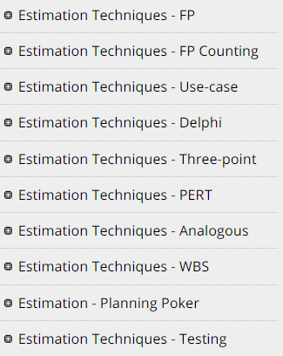

A **Function Point** (FP) is a unit of measurement to express the amount of business functionality, an information system (as a product) provides to a user. FPs measure software size. They are widely accepted as an industry standard for functional sizing.

For sizing software based on FP, several recognized standards and/or public specifications have come into existence. As of 2013, these are −

**ISO Standards**

* **COSMIC** − ISO/IEC 19761:2011 Software engineering. A functional size measurement method.
* **FiSMA** − ISO/IEC 29881:2008 Information technology - Software and systems engineering - FiSMA 1.1 functional size measurement method.
* **IFPUG** − ISO/IEC 20926:2009 Software and systems engineering - Software measurement - IFPUG functional size measurement method.
* **Mark-II** − ISO/IEC 20968:2002 Software engineering - Ml II Function Point Analysis - Counting Practices Manual.
* **NESMA** − ISO/IEC 24570:2005 Software engineering - NESMA function size measurement method version 2.1 - Definitions and counting guidelines for the application of Function Point Analysis.

## Object Management Group Specification for Automated Function Point

Object Management Group (OMG), an open membership and not-for-profit computer industry standards consortium, has adopted the Automated Function Point (AFP) specification led by the Consortium for IT Software Quality. It provides a standard for automating FP counting according to the guidelines of the International Function Point User Group (IFPUG).

**Function Point Analysis (FPA) technique** quantifies the functions contained within software in terms that are meaningful to the software users. FPs consider the number of functions being developed based on the requirements specification.

**Function Points (FP) Counting** is governed by a standard set of rules, processes and guidelines as defined by the International Function Point Users Group (IFPUG). These are published in Counting Practices Manual (CPM).

## Elementary Process (EP)

Elementary Process is the smallest unit of functional user requirement that −

* Is meaningful to the user.
* Constitutes a complete transaction.
* Is self-contained and leaves the business of the application being counted in a consistent state.

## Functions

There are two types of functions −

* Data Functions
* Transaction Functions

### **Data Functions**

There are two types of data functions −

* Internal Logical Files
* External Interface Files

Data Functions are made up of internal and external resources that affect the system.

**Internal Logical Files**

Internal Logical File (ILF) is a user identifiable group of logically related data or control information that resides entirely within the application boundary. The primary intent of an ILF is to hold data maintained through one or more elementary processes of the application being counted. An ILF has the inherent meaning that it is internally maintained, it has some logical structure and it is stored in a file. (Refer Figure 1)

**External Interface Files**

External Interface File (EIF) is a user identifiable group of logically related data or control information that is used by the application for reference purposes only. The data resides entirely outside the application boundary and is maintained in an ILF by another application. An EIF has the inherent meaning that it is externally maintained, an interface has to be developed to get the data from the file. (Refer Figure 1)

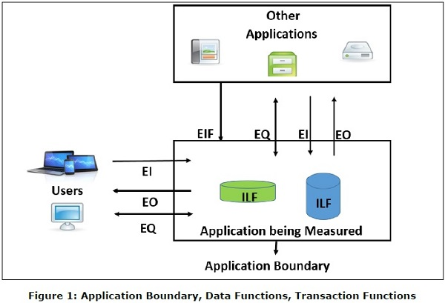

### **Transaction Functions**

There are three types of transaction functions.

* External Inputs
* External Outputs
* External Inquiries

Transaction functions are made up of the processes that are exchanged between the user, the external applications and the application being measured.

**External Inputs**

External Input (EI) is a transaction function in which Data goes “into” the application from outside the boundary to inside. This data is coming external to the application.

* Data may come from a data input screen or another application.
* An EI is how an application gets information.
* Data can be either control information or business information.
* Data may be used to maintain one or more Internal Logical Files.
* If the data is control information, it does not have to update an Internal Logical File. (Refer Figure 1)

**External Outputs**

External Output (EO) is a transaction function in which data comes “out” of the system. Additionally, an EO may update an ILF. The data creates reports or output files sent to other applications. (Refer Figure 1)

**External Inquiries**

External Inquiry (EQ) is a transaction function with both input and output components that result in data retrieval. (Refer Figure 1)

## Definition of RETs, DETs, FTRs

### **Record Element Type**

A Record Element Type (RET) is the largest user identifiable subgroup of elements within an ILF or an EIF. It is best to look at logical groupings of data to help identify them.

### **Data Element Type**

Data Element Type (DET) is the data subgroup within an FTR. They are unique and user identifiable.

### **File Type Referenced**

File Type Referenced (FTR) is the largest user identifiable subgroup within the EI, EO, or EQ that is referenced to.

The transaction functions EI, EO, EQ are measured by counting FTRs and DETs that they contain following counting rules. Likewise, data functions ILF and EIF are measured by counting DETs and RETs that they contain following counting rules. The measures of transaction functions and data functions are used in FP counting which results in the functional size or function points.

FP Counting Process involves the following steps −

* **Step 1** − Determine the type of count.
* **Step 2** − Determine the boundary of the count.
* **Step 3** − Identify each Elementary Process (EP) required by the user.
* **Step 4** − Determine the unique EPs.
* **Step 5** − Measure data functions.
* **Step 6** − Measure transactional functions.
* **Step 7** − Calculate functional size (unadjusted function point count).
* **Step 8** − Determine Value Adjustment Factor (VAF).
* **Step 9** − Calculate adjusted function point count.

**Note** − General System Characteristics (GSCs) are made optional in CPM 4.3.1 and moved to Appendix. Hence, Step 8 and Step 9 can be skipped.

## Step 1: Determine the Type of Count

There are three types of function point counts −

* Development Function Point Count
* Application Function Point Count
* Enhancement Function Point Count

### **Development Function Point Count**

Function points can be counted at all phases of a development project from requirement to implementation stage. This type of count is associated with new development work and may include the prototypes, which may have been required as temporary solution, which supports the conversion effort. This type of count is called a baseline function point count.

### **Application Function Point Count**

Application counts are calculated as the function points delivered, and exclude any conversion effort (prototypes or temporary solutions) and existing functionality that may have existed.

### **Enhancement Function Point Count**

When changes are made to software after production, they are considered as enhancements. To size such enhancement projects, the Function Point Count gets Added, Changed or Deleted in the Application.

## Step 2: Determine the Boundary of the Count

The boundary indicates the border between the application being measured and the external applications or the user domain. (Refer Figure 1)

To determine the boundary, understand −

* The purpose of the function point count
* Scope of the application being measured
* How and which applications maintain what data
* The business areas that support the applications

## Step 3: Identify Each Elementary Process Required by the User

Compose and/or decompose the functional user requirements into the smallest unit of activity, which satisfies all of the following criteria −

* Is meaningful to the user.
* Constitutes a complete transaction.
* Is self-contained.
* Leaves the business of the application being counted in a consistent state.

For example, the Functional User Requirement − “Maintain Employee information” can be decomposed into smaller activities such as add employee, change employee, delete employee, and inquire about employee.

Each unit of activity thus identified is an Elementary Process (EP).

## Step 4: Determine the Unique Elementary Processes

Comparing two EPs already identified, count them as one EP (same EP) if they −

* Require the same set of DETs.
* Require the same set of FTRs.
* Require the same set of processing logic to complete the EP.

Do not split an EP with multiple forms of processing logic into multiple Eps.

For e.g., if you have identified ‘Add Employee’ as an EP, it should not be divided into two EPs to account for the fact that an employee may or may not have dependents. The EP is still ‘Add Employee’, and there is variation in the processing logic and DETs to account for dependents.

## Step 5: Measure Data Functions

Classify each data function as either an ILF or an EIF.

A data function shall be classified as an −

* Internal Logical File (ILF), if it is maintained by the application being measured.
* External Interface File (EIF) if it is referenced, but not maintained by the application being measured.

ILFs and EIFs can contain business data, control data and rules based data. For example, telephone switching is made of all three types - business data, rule data and control data. Business data is the actual call. Rule data is how the call should be routed through the network, and control data is how the switches communicate with each other.

Consider the following documentation for counting ILFs and EIFs −

* Objectives and constraints for the proposed system.
* Documentation regarding the current system, if such a system exists.
* Documentation of the users’ perceived objectives, problems and needs.
* Data models.

### **Step 5.1: Count the DETs for Each Data Function**

Apply the following rules to count DETs for ILF/EIF −

* Count a DET for each unique user identifiable, non-repeated field maintained in or retrieved from the ILF or EIF through the execution of an EP.
* Count only those DETs being used by the application that is measured when two or more applications maintain and/or reference the same data function.
* Count a DET for each attribute required by the user to establish a relationship with another ILF or EIF.
* Review related attributes to determine if they are grouped and counted as a single DET or whether they are counted as multiple DETs. Grouping will depend on how the EPs use the attributes within the application.

### **Step 5.2: Count the RETs for Each Data Function**

Apply the following rules to count RETs for ILF/EIF −

* Count one RET for each data function.
* Count one additional RET for each of the following additional logical sub-groups of DETs.
  + Associative entity with non-key attributes.
  + Sub-type (other than the first sub-type).
  + Attributive entity, in a relationship other than mandatory 1:1.

### **Step 5.3: Determine the Functional Complexity for Each Data Function**

|  |  |  |  |
| --- | --- | --- | --- |
| **RETS** | **Data Element Types (DETs)** | | |
| **1-19** | **20-50** | **>50** |
| **1** | L | L | A |
| **2 to 5** | L | A | H |
| **>5** | A | H | H |

Functional Complexity: **L** = Low; **A** = Average; **H** = High

### **Step 5.4: Measure the Functional Size for Each Data Function**

|  |  |  |
| --- | --- | --- |
| **Functional Complexity** | **FP Count for ILF** | **FP Count for EIF** |
| **Low** | 7 | 5 |
| **Average** | 10 | 7 |
| **High** | 15 | 10 |

## Step 6: Measure Transactional Functions

To measure transactional functions following are the necessary steps −

### **Step 6.1: Classify each Transactional Function**

Transactional functions should be classified as an External Input, External Output or an External Inquiry.

### **External Input**

External Input (EI) is an Elementary Process that processes data or control information that comes from outside the boundary. The primary intent of an EI is to maintain one or more ILFs and/or to alter the behavior of the system.

All of the following rules must be applied −

* The data or control information is received from outside the application boundary.
* At least one ILF is maintained if the data entering the boundary is not control information that alters the behavior of the system.
* For the identified EP, one of the three statements must apply −
  + Processing logic is unique from processing logic performed by other EIs for the application.
  + The set of data elements identified is different from the sets identified for other EIs in the application.
  + ILFs or EIFs referenced are different from the files referenced by the other EIs in the application.

### **External Output**

External Output (EO) is an Elementary Process that sends data or control information outside the application’s boundary. EO includes additional processing beyond that of an external inquiry.

The primary intent of an EO is to present information to a user through processing logic other than or in addition to the retrieval of data or control information.

The processing logic must −

* Contain at least one mathematical formula or calculation.
* Create derived data.
* Maintain one or more ILFs.
* Alter the behavior of the system.

All of the following rules must be applied −

* Sends data or control information external to the application’s boundary.
* For the identified EP, one of the three statements must apply −
  + Processing logic is unique from the processing logic performed by other EOs for the application.
  + The set of data elements identified are different from other EOs in the application.
  + ILFs or EIFs referenced are different from files referenced by other EOs in the application.

Additionally, one of the following rules must apply −

* The processing logic contains at least one mathematical formula or calculation.
* The processing logic maintains at least one ILF.
* The processing logic alters the behavior of the system.

### **External Inquiry**

External Inquiry (EQ) is an Elementary Process that sends data or control information outside the boundary. The primary intent of an EQ is to present information to the user through the retrieval of data or control information.

The processing logic contains no mathematical formula or calculations, and creates no derived data. No ILF is maintained during the processing, nor is the behavior of the system altered.

All of the following rules must be applied −

* Sends data or control information external to the application’s boundary.
* For the identified EP, one of the three statements must apply −
  + Processing logic is unique from the processing logic performed by other EQs for the application.
  + The set of data elements identified are different from other EQs in the application.
  + The ILFs or EIFs referenced are different from the files referenced by other EQs in the application.

Additionally, all of the following rules must apply −

* The processing logic retrieves data or control information from an ILF or EIF.
* The processing logic does not contain mathematical formula or calculation.
* The processing logic does not alter the behavior of the system.
* The processing logic does not maintain an ILF.

### **Step 6.2: Count the DETs for Each Transactional Function**

Apply the following Rules to count DETs for EIs −

* Review everything that crosses (enters and/or exits) the boundary.
* Count one DET for each unique user identifiable, non-repeated attribute that crosses (enters and/or exits) the boundary during the processing of the transactional function.
* Count only one DET per transactional function for the ability to send an application response message, even if there are multiple messages.
* Count only one DET per transactional function for the ability to initiate action(s) even if there are multiple means to do so.
* Do not count the following items as DETs −
  + Attributes generated within the boundary by a transactional function and saved to an ILF without exiting the boundary.
  + Literals such as report titles, screen or panel identifiers, column headings and attribute titles.
  + Application generated stamps such as date and time attributes.
  + Paging variables, page numbers and positioning information, for e.g., ‘Rows 37 to 54 of 211’.
  + Navigation aids such as the ability to navigate within a list using “previous”, “next”, “first”, “last” and their graphical equivalents.

Apply the following rules to count DETs for EOs/EQs −

* Review everything that crosses (enters and/or exits) the boundary.
* Count one DET for each unique user identifiable, non-repeated attribute that crosses (enters and/or exits) the boundary during the processing of the transactional function.
* Count only one DET per transactional function for the ability to send an application response message, even if there are multiple messages.
* Count only one DET per transactional function for the ability to initiate action(s) even if there are multiple means to do so.
* Do not count the following items as DETs −
  + Attributes generated within the boundary without crossing the boundary.
  + Literals such as report titles, screen or panel identifiers, column headings and attribute titles.
  + Application generated stamps such as date and time attributes.
  + Paging variables, page numbers and positioning information, for e.g., ‘Rows 37 to 54 of 211’.
  + Navigation aids such as the ability to navigate within a list using “previous”, “next”, “first”, “last” and their graphical equivalents.

### **Step 6.3: Count the FTRs for Each Transactional Function**

Apply the following rules to count FTRs for EIs −

* Count a FTR for each ILF maintained.
* Count a FTR for each ILF or EIF read during the processing of the EI.
* Count only one FTR for each ILF that is both maintained and read.

Apply the following rule to count FTRs for EO/EQs −

* Count a FTR for each ILF or EIF read during the processing of EP.

Additionally, apply the following rules to count FTRs for EOs −

* Count a FTR for each ILF maintained during the processing of EP.
* Count only one FTR for each ILF that is both maintained and read by EP.

### **Step 6.4: Determine the Functional Complexity for Each Transactional Function**

|  |  |  |  |
| --- | --- | --- | --- |
| **FTRs** | **Data Element Types (DETs)** | | |
| **1-4** | **5-15** | **>=16** |
| **0-1** | L | L | A |
| **2** | L | A | H |
| **>=3** | A | H | H |

Functional Complexity: **L** = Low; **A** = Average; **H** = High

Determine the functional complexity for each EO/EQ, with an exception that EQ must have a minimum of 1 FTR −

|  |  |  |  |
| --- | --- | --- | --- |
| **EQ must have a minimum of 1 FTR**  **FTRs** | **Data Element Types (DETs)** | | |
| 1-4 | 5-15 | >=16 |
| **0-1** | L | L | A |
| **2** | L | A | H |
| **>=3** | A | H | H |

Functional Complexity: **L** = Low; **A** = Average; **H** = High

### **Step 6.5: Measure the Functional Size for Each Transactional Function**

Measure the functional size for each EI from its functional complexity.

|  |  |
| --- | --- |
| **Complexity** | **FP Count** |
| Low | 3 |
| Average | 4 |
| High | 6 |

Measure the functional size for each EO/EQ from its functional complexity.

|  |  |  |
| --- | --- | --- |
| **Complexity** | **FP Count for EO** | **FP Count for EQ** |
| **Low** | 4 | 3 |
| **Average** | 5 | 4 |
| **High** | 6 | 6 |

## Step 7: Calculate Functional Size (Unadjusted Function Point Count)

To calculate the functional size, one should follow the steps given below −

### **Step 7.1**

Recollect what you have found in Step 1. Determine the type of count.

### **Step 7.2**

Calculate the functional size or function point count based on the type.

* For development function point count, go to Step 7.3.
* For application function point count, go to Step 7.4.
* For enhancement function point count, go to Step 7.5.

### **Step 7.3**

Development Function Point Count consists of two components of functionality −

* Application functionality included in the user requirements for the project.
* Conversion functionality included in the user requirements for the project. Conversion functionality consists of functions provided only at installation to convert data and/or provide other user-specified conversion requirements, such as special conversion reports. For e.g. an existing application may be replaced with a new system.

**DFP = ADD + CFP**

Where,

**DFP** = Development Function Point Count

**ADD** = Size of functions delivered to the user by the development project

**CFP** = Size of the conversion functionality

**ADD** = FP Count (ILFs) + FP Count (EIFs) + FP Count (EIs) + FP Count (EOs) + FP Count (EQs)

**CFP** = FP Count (ILFs) + FP Count (EIFs) + FP Count (EIs) + FP Count (EOs) + FP Count (EQs)

### **Step 7.4**

Calculate the Application Function Point Count

**AFP = ADD**

Where,

**AFP** = Application Function Point Count

**ADD** = Size of functions delivered to the user by the development project (excluding the size of any conversion functionality), or the functionality that exists whenever the application is counted.

**ADD** = FP Count (ILFs) + FP Count (EIFs) + FP Count (EIs) + FP Count (EOs) + FP Count (EQs)

### **Step 7.5**

Enhancement Function Point Count considers the following four components of functionality −

* Functionality that is added to the application.
* Functionality that is modified in the Application.
* Conversion functionality.
* Functionality that is deleted from the application.

**EFP = ADD + CHGA + CFP + DEL**

Where,

**EFP** = Enhancement Function Point Count

**ADD** = Size of functions being added by the enhancement project

**CHGA** = Size of functions being changed by the enhancement project

**CFP** = Size of the conversion functionality

**DEL** = Size of functions being deleted by the enhancement project

**ADD** = FP Count (ILFs) + FP Count (EIFs) + FP Count (EIs) + FP Count (EOs) + FP Count (EQs)

**CHGA** = FP Count (ILFs) + FP Count (EIFs) + FP Count (EIs) + FP Count (EOs) + FP Count (EQs)

**CFP** = FP Count (ILFs) + FP Count (EIFs) + FP Count (EIs) + FP Count (EOs) + FP Count (EQs)

**DEL** = FP Count (ILFs) + FP Count (EIFs) + FP COUNT (EIs) + FP Count (EOs) + FP Count (EQs)

### **Step 8: Determine the Value Adjustment Factor**

GSCs are made optional in CPM 4.3.1 and moved to Appendix. Hence, Step 8 and Step 9 can be skipped.

The Value Adjustment Factor (VAF) is based on 14 GSCs that rate the general functionality of the application being counted. GSCs are user business constraints independent of technology. Each characteristic has associated descriptions to determine the degree of influence.

|  |  |
| --- | --- |
| **General System Characteristic** | **Brief Description** |
| Data Communications | How many communication facilities are there to aid in the transfer or exchange of information with the application or system? |
| Distributed Data Processing | How are distributed data and processing functions handled? |
| Performance | Did the user require response time or throughput? |
| Heavily Used Configuration | How heavily used is the current hardware platform where the application will be executed? |
| Transaction Rate | How frequently are transactions executed daily, weekly, monthly, etc.? |
| On-Line Data Entry | What percentage of the information is entered online? |
| End-user Efficiency | Was the application designed for end-user efficiency? |
| Online Update | How many ILFs are updated by online transaction? |
| Complex Processing | Does the application have extensive logical or mathematical processing? |
| Reusability | Was the application developed to meet one or many user’s needs? |
| Installation Ease | How difficult is conversion and installation? |
| Operational Ease | How effective and/or automated are start-up, back-up, and recovery procedures? |
| Multiple Sites | Was the application specifically designed, developed, and supported to be installed at multiple sites for multiple organizations? |
| Facilitate Change | Was the application specifically designed, developed, and supported to facilitate change? |

The degree of influence range is on a scale of zero to five, from no influence to strong influence.

|  |  |
| --- | --- |
| **Rating** | **Degree of Influence** |
| 0 | Not present, or no influence |
| 1 | Incidental influence |
| 2 | Moderate influence |
| 3 | Average influence |
| 4 | Significant influence |
| 5 | Strong influence throughout |

Determine the degree of influence for each of the 14 GSCs.

The sum of the values of the 14 GSCs thus obtained is termed as Total Degree of Influence (TDI).

**TDI = ∑14 Degrees of Influence**

Next, calculate Value Adjustment Factor (VAF) as

**VAF = (TDI × 0.01) + 0.65**

Each GSC can vary from 0 to 5, TDI can vary from (0 × 14) to (5 × 14), i.e. 0 (when all GSCs are low) to 70 (when all GSCs are high) i.e. 0 ≤ TDI ≤ 70. Hence, VAF can vary in the range from 0.65 (when all GSCs are low) to 1.35 (when all GSCs are high), i.e., 0.65 ≤ VAF ≤ 1.35.

### **Step 9: Calculate Adjusted Function Point Count**

As per the FPA approach that uses the VAF (CPM versions before V4.3.1), this is determined by,

**Adjusted FP Count = Unadjusted FP Count × VAF**

Where, unadjusted FP count is the functional size that you have calculated in Step 7.

As the VAF can vary from 0.65 to 1.35, the VAF exerts an influence of ±35% on the final adjusted FP count.

## Benefits of Function Points

Function points are useful −

* In measuring the size of the solution instead of the size of the problem.
* As requirements are the only thing needed for function points count.
* As it is independent of technology.
* As it is independent of programming languages.
* In estimating testing projects.
* In estimating overall project costs, schedule and effort.
* In contract negotiations as it provides a method of easier communication with business groups.
* As it quantifies and assigns a value to the actual uses, interfaces, and purposes of the functions in the software.
* In creating ratios with other metrics such as hours, cost, headcount, duration, and other application metrics.

A **Use-Case** is a series of related interactions between a user and a system that enables the user to achieve a goal.

Use-Cases are a way to capture functional requirements of a system. The user of the system is referred to as an ‘Actor’. Use-Cases are fundamentally in text form.

**Use-Case Points (UCP)** is a software estimation technique used to measure the software size with use cases. The concept of UCP is similar to FPs.

The number of UCPs in a project is based on the following −

* The number and complexity of the use cases in the system.
* The number and complexity of the actors on the system.
  + Various non-functional requirements (such as portability, performance, maintainability) that are not written as use cases.
  + The environment in which the project will be developed (such as the language, the team’s motivation, etc.)

Estimation with UCPs requires all use cases to be written with a goal and at approximately the same level, giving the same amount of detail. Hence, before estimation, the project team should ensure they have written their use cases with defined goals and at detailed level. Use case is normally completed within a single session and after the goal is achieved, the user may go on to some other activity.

The Use-Case Points counting process has the following steps −

* Calculate unadjusted UCPs
* Adjust for technical complexity
* Adjust for environmental complexity
* Calculate adjusted UCPs

## Use-Case Points Counting Process

The Use-Case Points counting process has the following steps −

* Calculate unadjusted UCPs
* Adjust for technical complexity
* Adjust for environmental complexity
* Calculate adjusted UCPs

### **Step 1: Calculate Unadjusted Use-Case Points.**

You calculate Unadjusted Use-Case Points first, by the following steps −

* Determine Unadjusted Use-Case Weight
* Determine Unadjusted Actor Weight
* Calculate Unadjusted Use-Case Points

**Step 1.1** − Determine Unadjusted Use-Case Weight.

**Step 1.1.1** − Find the number of transactions in each Use-Case.

If the Use-Cases are written with User Goal Levels, a transaction is equivalent to a step in the Use-Case. Find the number of transactions by counting the steps in the Use-Case.

**Step 1.1.2** − Classify each Use-Case as Simple, Average or Complex based on the number of transactions in the Use-Case. Also, assign Use-Case Weight as shown in the following table −

|  |  |  |
| --- | --- | --- |
| **Use-Case Complexity** | **Number of Transactions** | **Use-Case Weight** |
| **Simple** | ≤3 | 5 |
| **Average** | 4 to 7 | 10 |
| **Complex** | >7 | 15 |

**Step 1.1.3** − Repeat for each Use-Case and get all the Use-Case Weights. Unadjusted Use-Case Weight (UUCW) is the sum of all the Use-Case Weights.

**Step 1.1.4** − Find Unadjusted Use-Case Weight (UUCW) using the following table −

|  |  |  |  |
| --- | --- | --- | --- |
| **Use-Case Complexity** | **Use-Case Weight** | **Number of Use-Cases** | **Product** |
| Simple | 5 | NSUC | 5 × NSUC |
| Average | 10 | NAUC | 10 × NAUC |
| Complex | 15 | NCUC | 15 × NCUC |
| **Unadjusted Use-Case Weight (UUCW)** | | | 5 × NSUC + 10 × NAUC + 15 × NCUC |

Where,

NSUC is the no. of Simple Use-Cases.

NAUC is the no. of Average Use-Cases.

NCUC is the no. of Complex Use-Cases.

**Step 1.2** − Determine Unadjusted Actor Weight.

An Actor in a Use-Case might be a person, another program, etc. Some actors, such as a system with defined API, have very simple needs and increase the complexity of a Use-Case only slightly.

Some actors, such as a system interacting through a protocol have more needs and increase the complexity of a Use-Case to a certain extent.

Other Actors, such as a user interacting through GUI have a significant impact on the complexity of a Use-Case. Based on these differences, you can classify actors as Simple, Average and Complex.

**Step 1.2.1** − Classify Actors as Simple, Average and Complex and assign Actor Weights as shown in the following table −

|  |  |  |
| --- | --- | --- |
| **Actor Complexity** | **Example** | **Actor Weight** |
| Simple | A System with defined API | 1 |
| Average | A System interacting through a Protocol | 2 |
| Complex | A User interacting through GUI | 3 |

**Step 1.2.2** − Repeat for each Actor and get all the Actor Weights. Unadjusted Actor Weight (UAW) is the sum of all the Actor Weights.

**Step 1.2.3** − Find Unadjusted Actor Weight (UAW) using the following table −

|  |  |  |  |
| --- | --- | --- | --- |
| **Actor Complexity** | **Actor Weight** | **Number of Actors** | **Product** |
| Simple | 1 | NSA | 1 × NSA |
| Average | 2 | NAA | 2 × NAA |
| Complex | 3 | NCA | 3 × NCA |
| **Unadjusted Actor Weight (UAW)** | | | 1 × NSA + 2 × NAA + 3 × NCA |

Where,

NSA is the no. of Simple Actors.

NAA is the no. of Average Actors.

NCA is the no. of Complex Actors.

**Step 1.3** − Calculate Unadjusted Use-Case Points.

The Unadjusted Use-Case Weight (UUCW) and the Unadjusted Actor Weight (UAW) together give the unadjusted size of the system, referred to as Unadjusted Use-Case Points.

**Unadjusted Use-Case Points (UUCP) = UUCW + UAW**

The next steps are to adjust the Unadjusted Use-Case Points (UUCP) for Technical Complexity and Environmental Complexity.

### **Step 2: Adjust For Technical Complexity**

**Step 2.1** − Consider the 13 Factors that contribute to the impact of the Technical Complexity of a project on Use-Case Points and their corresponding Weights as given in the following table −

|  |  |  |
| --- | --- | --- |
| **Factor** | **Description** | **Weight** |
| T1 | Distributed System | 2.0 |
| T2 | Response time or throughput performance objectives | 1.0 |
| T3 | End user efficiency | 1.0 |
| T4 | Complex internal processing | 1.0 |
| T5 | Code must be reusable | 1.0 |
| T6 | Easy to install | .5 |
| T7 | Easy to use | .5 |
| T8 | Portable | 2.0 |
| T9 | Easy to change | 1.0 |
| T10 | Concurrent | 1.0 |
| T11 | Includes special security objectives | 1.0 |
| T12 | Provides direct access for third parties | 1.0 |
| T13 | Special user training facilities are required | 1.0 |

Many of these factors represent the project’s nonfunctional requirements.

**Step 2.2** − For each of the 13 Factors, assess the project and rate from 0 (irrelevant) to 5 (very important).

**Step 2.3** − Calculate the Impact of the Factor from Impact Weight of the Factor and the Rated Value for the project as

**Impact of the Factor = Impact Weight × Rated Value**

**Step (2.4)** − Calculate the sum of Impact of all the Factors. This gives the Total Technical Factor (TFactor) as given in table below −

|  |  |  |  |  |
| --- | --- | --- | --- | --- |
| **Factor** | **Description** | **Weight (W)** | **Rated Value (0 to 5) (RV)** | **Impact (I = W × RV)** |
| T1 | Distributed System | 2.0 |  |  |
| T2 | Response time or throughput performance objectives | 1.0 |  |  |
| T3 | End user efficiency | 1.0 |  |  |
| T4 | Complex internal processing | 1.0 |  |  |
| T5 | Code must be reusable | 1.0 |  |  |
| T6 | Easy to install | .5 |  |  |
| T7 | Easy to use | .5 |  |  |
| T8 | Portable | 2.0 |  |  |
| T9 | Easy to change | 1.0 |  |  |
| T10 | Concurrent | 1.0 |  |  |
| T11 | Includes special security objectives | 1.0 |  |  |
| T12 | Provides direct access for third parties | 1.0 |  |  |
| T13 | Special user training facilities are required | 1.0 |  |  |
| **Total Technical Factor (TFactor)** | | | |  |

**Step 2.5** − Calculate the Technical Complexity Factor (TCF) as −

**TCF = 0.6 + (0.01 × TFactor)**

### **Step 3: Adjust For Environmental Complexity**

**Step 3.1** − Consider the 8 Environmental Factors that could affect the project execution and their corresponding Weights as given in the following table −

|  |  |  |
| --- | --- | --- |
| **Factor** | **Description** | **Weight** |
| F1 | Familiar with the project model that is used | 1.5 |
| F2 | Application experience | .5 |
| F3 | Object-oriented experience | 1.0 |
| F4 | Lead analyst capability | .5 |
| F5 | Motivation | 1.0 |
| F6 | Stable requirements | 2.0 |
| F7 | Part-time staff | -1.0 |
| F8 | Difficult programming language | -1.0 |

**Step 3.2** − For each of the 8 Factors, assess the project and rate from 0 (irrelevant) to 5 (very important).

**Step 3.3** − Calculate the Impact of the Factor from Impact Weight of the Factor and the Rated Value for the project as

**Impact of the Factor = Impact Weight × Rated Value**

**Step 3.4** − Calculate the sum of Impact of all the Factors. This gives the Total Environment Factor (EFactor) as given in the following table −

|  |  |  |  |  |
| --- | --- | --- | --- | --- |
| **Factor** | **Description** | **Weight (W)** | **Rated Value (0 to 5) (RV)** | **Impact (I = W × RV)** |
| F1 | Familiar with the project model that is used | 1.5 |  |  |
| F2 | Application experience | .5 |  |  |
| F3 | Object-oriented experience | 1.0 |  |  |
| F4 | Lead analyst capability | .5 |  |  |
| F5 | Motivation | 1.0 |  |  |
| F6 | Stable requirements | 2.0 |  |  |
| F7 | Part-time staff | -1.0 |  |  |
| F8 | Difficult programming language | -1.0 |  |  |
| **Total Environment Factor (EFactor)** | | | |  |

**Step 3.5** − Calculate the Environmental Factor (EF) as −

**1.4 + (-0.03 × EFactor)**

### **Step 4: Calculate Adjusted Use-Case Points (UCP)**

Calculate Adjusted Use-Case Points (UCP) as −

**UCP = UUCP × TCF × EF**

**Advantages and Disadvantages of Use-Case Points**

### **Advantages of Use-Case Points**

* UCPs are based on use cases and can be measured very early in the project life cycle.
* UCP (size estimate) will be independent of the size, skill, and experience of the team that implements the project.
* UCP based estimates are found to be close to actuals when estimation is performed by experienced people.
* UCP is easy to use and does not call for additional analysis.
* Use cases are being used vastly as a method of choice to describe requirements. In such cases, UCP is the best suitable estimation technique.

### **Disadvantages of Use-Case Points**

* UCP can be used only when requirements are written in the form of use cases.
* Dependent on goal-oriented, well-written use cases. If the use cases are not well or uniformly structured, the resulting UCP may not be accurate.
* Technical and environmental factors have a high impact on UCP. Care needs to be taken while assigning values to the technical and environmental factors.
* UCP is useful for initial estimate of overall project size but they are much less useful in driving the iteration-to-iteration work of a team.

**Delphi Method** is a structured communication technique, originally developed as a systematic, interactive forecasting method which relies on a panel of experts. The experts answer questionnaires in two or more rounds. After each round, a facilitator provides an anonymous summary of the experts’ forecasts from the previous round with the reasons for their judgments. Experts are then encouraged to revise their earlier answers in light of the replies of other members of the panel.

* It is believed that during this process the range of answers will decrease and the group will converge towards the "correct" answer. Finally, the process is stopped after a predefined stop criterion (e.g. number of rounds, achievement of consensus, and stability of results) and the mean or median scores of the final rounds determine the results.

## Wideband Delphi Technique

In the 1970s, Barry Boehm and John A. Farquhar originated the Wideband Variant of the Delphi Method. The term "wideband" is used because, compared to the Delphi Method, the Wideband Delphi Technique involved greater interaction and more communication between the participants.

In Wideband Delphi Technique, the estimation team comprise the project manager, moderator, experts, and representatives from the development team, constituting a 3-7 member team. There are two meetings −

* Kickoff Meeting
* Estimation Meeting

## Wideband Delphi Technique – Steps

**Step 1** − Choose the Estimation team and a moderator.

**Step 2** − The moderator conducts the kickoff meeting, in which the team is presented with the problem specification and a high level task list, any assumptions or project constraints. The team discusses on the problem and estimation issues, if any. They also decide on the units of estimation. The moderator guides the entire discussion, monitors time and after the kickoff meeting, prepares a structured document containing problem specification, high level task list, assumptions, and the units of estimation that are decided. He then forwards copies of this document for the next step.

**Step 3** − Each Estimation team member then individually generates a detailed WBS, estimates each task in the WBS, and documents the assumptions made.

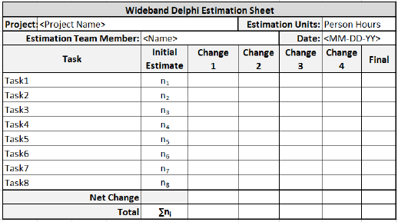

**Step 4** − The moderator calls the Estimation team for the Estimation meeting. If any of the Estimation team members respond saying that the estimates are not ready, the moderator gives more time and resends the Meeting Invite.

**Step 5** − The entire Estimation team assembles for the estimation meeting.

**Step 5.1** − At the beginning of the Estimation meeting, the moderator collects the initial estimates from each of the team members.

**Step 5.2** − He then plots a chart on the whiteboard. He plots each member’s total project estimate as an X on the Round 1 line, without disclosing the corresponding names. The Estimation team gets an idea of the range of estimates, which initially may be large.

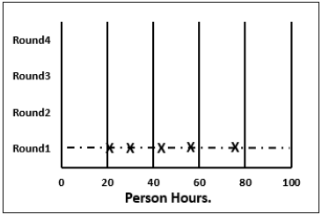

**Step 5.3** − Each team member reads aloud the detailed task list that he/she made, identifying any assumptions made and raising any questions or issues. The task estimates are not disclosed.

The individual detailed task lists contribute to a more complete task list when combined.

**Step 5.4** − The team then discusses any doubt/problem they have about the tasks they have arrived at, assumptions made, and estimation issues.

**Step 5.5** − Each team member then revisits his/her task list and assumptions, and makes changes if necessary. The task estimates also may require adjustments based on the discussion, which are noted as +N Hrs. for more effort and –N Hrs. for less effort.

The team members then combine the changes in the task estimates to arrive at the total project estimate.

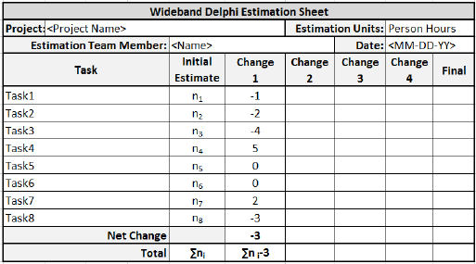

**Step 5.6** − The moderator collects the changed estimates from all the team members and plots them on the Round 2 line.

In this round, the range will be narrower compared to the earlier one, as it is more consensus based.

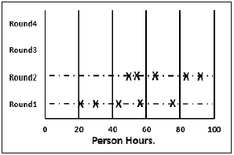

**Step 5.7** − The team then discusses the task modifications they have made and the assumptions.

**Step 5.8** − Each team member then revisits his/her task list and assumptions, and makes changes if necessary. The task estimates may also require adjustments based on the discussion.

The team members then once again combine the changes in the task estimate to arrive at the total project estimate.

**Step 5.9** − The moderator collects the changed estimates from all the members again and plots them on the Round 3 line.

Again, in this round, the range will be narrower compared to the earlier one.

**Step 5.10** − Steps 5.7, 5.8, 5.9 are repeated till one of the following criteria is met −

* Results are converged to an acceptably narrow range.
* All team members are unwilling to change their latest estimates.
* The allotted Estimation meeting time is over.

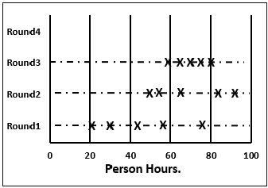

**Step 6** − The Project Manager then assembles the results from the Estimation meeting.

**Step 6.1** − He compiles the individual task lists and the corresponding estimates into a single master task list.

**Step 6.2** − He also combines the individual lists of assumptions.

**Step 6.3** − He then reviews the final task list with the Estimation team.

**Advantages and Disadvantages of Wideband Delphi Technique**

### **Advantages**

* Wideband Delphi Technique is a consensus-based estimation technique for estimating effort.
* Useful when estimating time to do a task.
* Participation of experienced people and they individually estimating would lead to reliable results.
* People who would do the work are making estimates thus making valid estimates.
* Anonymity maintained throughout makes it possible for everyone to express their results confidently.
* A very simple technique.
* Assumptions are documented, discussed and agreed.

### **Disadvantages**

* Management support is required.
* The estimation results may not be what the management wants to hear.

**Three-point Estimation looks at three values −**

* the most optimistic estimate (O),
* a most likely estimate (M), and
* a pessimistic estimate (least likely estimate (L)).

There has been some confusion regarding Three-point Estimation and PERT in the industry. However, the techniques are different. You will see the differences as you learn the two techniques. Also, at the end of the PERT technique, the differences are collated and presented. If you want to look at them first, you can.

Three-point Estimate (E) is based on the simple average and follows triangular distribution.

**E = (O + M + L) / 3**

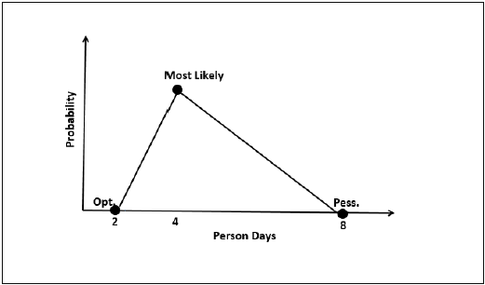

**Standard Deviation**

In Triangular Distribution,

Mean = (O + M + L) / 3

Standard Deviation = √ [((O − E)2 + (M − E)2 + (L − E)2) / 2]

### **Three-point Estimation Steps**

**Step 1** − Arrive at the WBS.

**Step 2** − For each task, find three values − most optimistic estimate (O), a most likely estimate (M), and a pessimistic estimate (L).

**Step 3** − Calculate the Mean of the three values.

**Mean = (O + M + L) / 3**

**Step 4** − Calculate the Three-point Estimate of the task. Three-point Estimate is the Mean. Hence,

**E = Mean = (O + M + L) / 3**

**Step 5** − Calculate the Standard Deviation of the task.

**Standard Deviation (SD) = √ [((O − E)2 + (M − E)2 + (L - E)2)/2]**

**Step 6** − Repeat Steps 2, 3, 4 for all the Tasks in the WBS.

**Step 7** − Calculate the Three-point Estimate of the project.

**E (Project) = ∑ E (Task)**

**Step 8** − Calculate the Standard Deviation of the project.

**SD (Project) = √ (∑SD (Task)2)**

The Three-point Estimate (E) and the Standard Deviation (SD) thus calculated are used to convert the project estimates to “Confidence Levels”.

The conversion is based such that −

* Confidence Level in E +/– SD is approximately 68%.
* Confidence Level in E value +/– 1.645 × SD is approximately 90%.
* Confidence Level in E value +/– 2 × SD is approximately 95%.
* Confidence Level in E value +/– 3 × SD is approximately 99.7%.

Commonly, the 95% Confidence Level, i.e., E Value + 2 × SD, is used for all project and task estimates.

**Project Evaluation and Review Technique (PERT)** estimation considers three values: the most optimistic estimate (O), a most likely estimate (M), and a pessimistic estimate (least likely estimate (L)). There has been some confusion regarding Three-point Estimation and PERT in the Industry. However, the techniques are different. You will see the differences as you learn the two techniques. Also, at the end of this chapter, the differences are collated and presented.

PERT is based on three values − most optimistic estimate (O), a most likely estimate (M), and a pessimistic estimate (least likely estimate (L)). The most-likely estimate is weighted 4 times more than the other two estimates (optimistic and pessimistic).

PERT Estimate (E) is based on the weighted average and follows beta distribution.

**E = (O + 4 × M + L)/6**

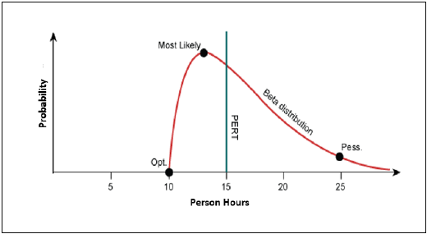

PERT is frequently used along with Critical Path Method (CPM). CPM tells about the tasks that are critical in the project. If there is a delay in these tasks, the project gets delayed.

**Standard Deviation**

Standard Deviation (SD) measures the variability or uncertainty in the estimate.

In beta distribution,

Mean = (O + 4 × M + L)/6

Standard Deviation (SD) = (L − O)/6

**PERT Estimation Steps**

**Step (1)** − Arrive at the WBS.

**Step (2)** − For each task, find three values most optimistic estimate (O), a most likely estimate (M), and a pessimistic estimate (L).

**Step (3)** − Calculate the PERT Mean of the three values.

PERT Mean = (O + 4 × M + L)/3

**Step (4)** − Calculate the Standard Deviation of the task.

Standard Deviation (SD) = (L − O)/6

**Step (6)** − Repeat steps 2, 3, 4 for all the tasks in the WBS.

**Step (7)** − Calculate the PERT estimate of the project.

E (Project) = ∑ E (Task)

**Step (8)** − Calculate the Standard Deviation of the project.

SD (Project) = √ (ΣSD (Task)2)

**Convert the Project Estimates to Confidence Levels**

PERT Estimate (E) and Standard Deviation (SD) thus calculated are used to convert the project estimates to confidence levels.

The conversion is based such that

* Confidence level in E +/– SD is approximately 68%.
* Confidence level in E value +/– 1.645 × SD is approximately 90%.
* Confidence level in E value +/– 2 × SD is approximately 95%.
* Confidence level in E value +/– 3 × SD is approximately 99.7%.

Commonly, the 95% confidence level, i.e., E Value + 2 × SD, is used for all project and task estimates.

**Analogous Estimation – Definition**

Analogous estimation is a technique which uses the values of parameters from historical data as the basis for estimating similar parameter for a future activity. Parameters examples: Scope, cost, and duration. Measures of scale examples − Size, weight, and complexity.

Because the project manager’s, and possibly the team’s experience and judgment are applied to the estimating process, it is considered a combination of historical information and expert judgment.

**Analogous Estimation Requirements**

For analogous estimation following is the requirement −

* Data from previous and on-going projects
  + Work hours per week of each team member
  + Costs involved to get the project completed
* Project close to the current project
* In case the current Project is new, and no past project is similar
  + Modules from past projects that are similar to those in current project
  + Activities from past projects that are similar to those in current project
  + Data from these selected ones
* Participation of the project manager and estimation team to ensure experienced judgment on the estimates.

**Analogous Estimation Steps**

The project manager and team have to collectively do analogous estimation.

* **Step 1** − Identify the domain of the current project.
* **Step 2** − Identify the technology of the current project.
* **Step 3** − Look in the organization database if a similar project data is available. If available, go to Step (4). Otherwise go to Step (6).
* **Step 4** − Compare the current project with the identified past project data.
* **Step 5** − Arrive at the duration and cost estimates of the current project. This ends analogous estimation of the project.
* **Step 6** − Look in the organization database if any past projects have similar modules as those in the current project.
* **Step 7** − Look in the organization database if any past projects have similar activities as those in the current project.
* **Step 8** − Collect all those and use expert judgment to arrive at the duration and cost estimates of the current project.

**Work Breakdown Structure (WBS),** in Project Management and Systems Engineering, is a deliverable-oriented decomposition of a project into smaller components. WBS is a key project deliverable that organizes the team's work into manageable sections. The Project Management Body of Knowledge (PMBOK) defines WBS as a "deliverable oriented hierarchical decomposition of the work to be executed by the project team."

WBS element may be a product, data, service, or any combination thereof. WBS also provides the necessary framework for detailed cost estimation and control along with providing guidance for schedule development and control.

**Representation of WBS**

WBS is represented as a hierarchical list of project’s work activities. There are two formats of WBS −

* Outline View (Indented Format)
* Tree Structure View (Organizational Chart)

Let us first discuss how to use the outline view for preparing a WBS.

**Outline View**

The outline view is a very user-friendly layout. It presents a good view of the entire project and allows easy modifications as well. It uses numbers to record the various stages of a project. It looks somewhat similar to the following −

* **Software Development**
  + **Scope**
    - Determine project scope
    - Secure project sponsorship
    - Define preliminary resources
    - Secure core resources
    - Scope complete
  + **Analysis/Software Requirements**
    - Conduct needs analysis
    - Draft preliminary software specifications
    - Develop preliminary budget
    - Review software specifications/budget with the team
    - Incorporate feedback on software specifications
    - Develop delivery timeline
    - Obtain approvals to proceed (concept, timeline, and budget)
    - Secure required resources
    - Analysis complete
  + **Design**
    - Review preliminary software specifications
    - Develop functional specifications
    - Obtain approval to proceed
    - Design complete
  + **Development**
    - Review functional specifications
    - Identify modular/tiered design parameters
    - Develop code
    - Developer testing (primary debugging)
    - Development complete
  + **Testing**
    - Develop unit test plans using product specifications
    - Develop integration test plans using product specifications
  + **Training**
    - Develop training specifications for end-users
    - Identify training delivery methodology (online, classroom, etc.)
    - Develop training materials
    - Finalize training materials
    - Develop training delivery mechanism
    - Training materials complete
  + **Deployment**
    - Determine final deployment strategy
    - Develop deployment methodology
    - Secure deployment resources
    - Train support staff
    - Deploy software
    - Deployment complete

Let us now take a look at the tree structure view.

### **Tree Structure View**

The Tree Structure View presents a very easy-to-understand view of the entire project. The following illustration shows how a tree structure view looks like. This type of organizational chart structure can be easily drawn with the features available in MS-Word.

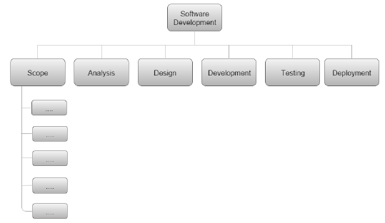

## Types of WBS

There are two types of WBS −

* **Functional WBS** − In functional WBS, the system is broken based on the functions in the application to be developed. This is useful in estimating the size of the system.
* **Activity WBS** − In activity WBS, the system is broken based on the activities in the system. The activities are further broken into tasks. This is useful in estimating effort and schedule in the system.

**Estimate Size**

**Step 1** − Start with functional WBS.

**Step 2** − Consider the leaf nodes.

**Step 3** − Use either Analogy or Wideband Delphi to arrive at the size estimates.

**Estimate Effort**

**Step 1** − Use Wideband Delphi Technique to construct WBS. We suggest that the tasks should not be more than 8 hrs. If a task is of larger duration, split it.

**Step 2** − Use Wideband Delphi Technique or Three-point Estimation to arrive at the Effort Estimates for the Tasks.

**Scheduling**

Once the WBS is ready and the size and effort estimates are known, you are ready for scheduling the tasks.

While scheduling the tasks, certain things should be taken into account −

* **Precedence** − A task that must occur before another is said to have precedence of the other.
* **Concurrence** − Concurrent tasks are those that can occur at the same time (in parallel).
* **Critical Path** − Specific set of sequential tasks upon which the project completion date depends.
  + All projects have a critical path.
  + Accelerating non-critical tasks do not directly shorten the schedule.

## Critical Path Method

Critical Path Method (CPM) is the process for determining and optimizing the critical path. Non-critical path tasks can start earlier or later without impacting the completion date.

Please note that critical path may change to another as you shorten the current one. For example, for WBS in the previous figure, the critical path would be as follows −

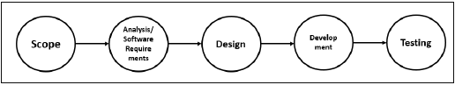

As the project completion date is based on a set of sequential tasks, these tasks are called critical tasks.

The project completion date is not based on the training, documentation and deployment. Such tasks are called non-critical tasks.

## Task Dependency Relationships

Certain times, while scheduling, you may have to consider task dependency relationships. The important Task Dependency Relationships are −

* Finish-to-Start (FS)
* Finish-to-Finish (FF)

### **Finish-to-Start (FS)**

In Finish-to-Start (FS) task dependency relationship, Task B cannot start till Task A is completed.

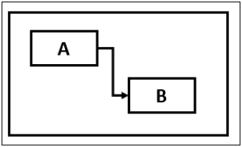

### **Finish-to-Finish (FF)**

In Finish-to-Finish (FF) task dependency relationship, Task B cannot finish till Task A is completed.

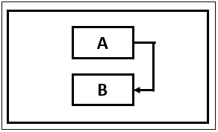

**Gantt Chart**

A Gantt chart is a type of bar chart, adapted by Karol Adamiecki in 1896 and independently by Henry Gantt in the 1910s, that illustrates a project schedule. Gantt charts illustrate the start and finish dates of the terminal elements and summary elements of a project.

You can take the Outline Format in Figure 2 into Microsoft Project to obtain a Gantt Chart View.

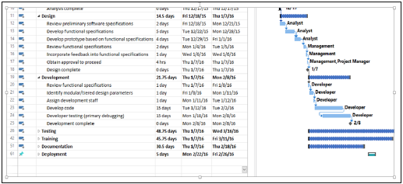

**Milestones**

Milestones are the critical stages in your schedule. They will have a duration of zero and are used to flag that you have completed certain set of tasks. Milestones are usually shown as a diamond.

For example, in the above Gantt Chart, Design Complete and Development Complete are shown as milestones, represented with a diamond shape.

Milestones can be tied to Contract Terms.

**Advantages of Estimation using WBS**

WBS simplifies the process of project estimation to a great extent. It offers the following advantages over other estimation techniques −

* In WBS, the entire work to be done by the project is identified. Hence, by reviewing the WBS with project stakeholders, you will be less likely to omit any work needed to deliver the desired project deliverables.
* WBS results in more accurate cost and schedule estimates.
* The project manager obtains team participation to finalize the WBS. This involvement of the team generates enthusiasm and responsibility in the project.
* WBS provides a basis for task assignments. As a precise task is allocated to a particular team member who would be accountable for its accomplishment.
* WBS enables monitoring and controlling at task level. This allows you to measure progress and ensure that your project will be delivered on time.

**Planning Poker Estimation**

Planning Poker is a consensus-based technique for estimating, mostly used to estimate effort or relative size of user stories in Scrum.

Planning Poker combines three estimation techniques − Wideband Delphi Technique, Analogous Estimation, and Estimation using WBS.

Planning Poker was first defined and named by James Grenning in 2002 and later popularized by Mike Cohn in his book "Agile Estimating and Planning”, whose company trade marked the term.

## Planning Poker Estimation Technique

In Planning Poker Estimation Technique, estimates for the user stories are derived by playing planning poker. The entire Scrum team is involved and it results in quick but reliable estimates.

* Planning Poker is played with a deck of cards. As Fibonacci sequence is used, the cards have numbers - 1, 2, 3, 5, 8, 13, 21, 34, etc. These numbers represent the “Story Points”. Each estimator has a deck of cards. The numbers on the cards should be large enough to be visible to all the team members, when one of the team members holds up a card.
* One of the team members is selected as the Moderator. The moderator reads the description of the user story for which estimation is being made. If the estimators have any questions, product owner answers them.
* Each estimator privately selects a card representing his or her estimate. Cards are not shown until all the estimators have made a selection. At that time, all cards are simultaneously turned over and held up so that all team members can see each estimate.
* In the first round, it is very likely that the estimations vary. The high and low estimators explain the reason for their estimates. Care should be taken that all the discussions are meant for understanding only and nothing is to be taken personally. The moderator has to ensure the same.
* The team can discuss the story and their estimates for a few more minutes.
* The moderator can take notes on the discussion that will be helpful when the specific story is developed. After the discussion, each estimator re-estimates by again selecting a card. Cards are once again kept private until everyone has estimated, at which point they are turned over at the same time.

Repeat the process till the estimates converge to a single estimate that can be used for the story. The number of rounds of estimation may vary from one user story to another.

**Test effort estimation** is a part of the **development estimation**. Only in the case of estimation techniques that use WBS, such as Wideband Delphi, Three-point Estimation, PERT, and WBS, you can obtain the values for the estimates of the testing activities.

If you have obtained the estimates as Function Points (FP), then as per Caper Jones,

**Number of Test Cases = (Number of Function Points) × 1.2**

Once you have the number of test cases, you can take productivity data from organizational database and arrive at the effort required for testing.

**Percentage of Development Effort Method**

Test effort required is a direct proportionate or percentage of the development effort. Development effort can be estimated using Lines of Code (LOC) or Function Points (FP). Then, the percentage of effort for testing is obtained from Organization Database. The percentage so obtained is used to arrive at the effort estimate for testing.

### **Estimating Testing Projects**

Several organizations are now providing independent verification and validation services to their clients and that would mean the project activities would entirely be testing activities.

Estimating testing projects requires experience on varied projects for the software test life cycle. When you are estimating a testing project, consider −

* Team skills
* Domain Knowledge
* Complexity of the application
* Historical data
* Bug cycles for the project
* Resources availability
* Productivity variations
* System environment and downtime

**Testing Estimation Techniques**

The following testing estimation techniques are proven to be accurate and are widely used −

* PERT software testing estimation technique
* UCP Method
* WBS
* Wideband Delphi technique
* Function point/Testing point analysis
* Percentage distribution
* Experience-based testing estimation technique

### **PERT Software Testing Estimation Technique**

PERT software testing estimation technique is based on statistical methods in which each testing task is broken down into sub-tasks and then three types of estimation are done on each sub-tasks.

The formula used by this technique is −

**Test Estimate = (O + (4 × M) + E)/6**

Where,

**O** = Optimistic estimate (best case scenario in which nothing goes wrong and all conditions are optimal).

**M** = Most likely estimate (most likely duration and there may be some problem but most of the things will go right).

**L** = Pessimistic estimate (worst case scenario where everything goes wrong).

Standard Deviation for the technique is calculated as −

**Standard Deviation (SD) = (E − O)/6**

### **Use-Case Point Method**

UCP Method is based on the use cases where we calculate the unadjusted actor weights and unadjusted use case weights to determine the software testing estimation.

Use-case is a document which specifies different users, systems or other stakeholders interacting with the concerned application. They are named as “Actors”. The interactions accomplish some defined goals protecting the interest of all stakeholders through different behavior or flow termed as scenarios.

**Step 1** − Count the no. of actors. Actors include positive, negative and exceptional.

**Step 2** − Calculate unadjusted actor weights as

**Unadjusted Actor Weights = Total no. of Actors**

**Step 3** − Count the number of use-cases.

**Step 4** − Calculate unadjusted use-case weights as

**Unadjusted Use-Case Weights = Total no. of Use-Cases**

**Step 5** − Calculate unadjusted use-case points as

**Unadjusted Use-Case Points = (Unadjusted Actor Weights + Unadjusted Use-Case Weights)**

**Step 6** − Determine the technical/environmental factor (TEF). If unavailable, take it as 0.50.

**Step 7** − Calculate adjusted use-case point as

**Adjusted Use-Case Point = Unadjusted Use-Case Points × [0.65 + (0.01 × TEF]**

**Step 8** − Calculate total effort as

**Total Effort = Adjusted Use-Case Point × 2**

**Work Breakdown Structure**

**Step 1** − Create WBS by breaking down the test project into small pieces.

**Step 2** − Divide modules into sub-modules.

**Step 3** Divide sub-modules further into functionalities.

**Step 4** − Divide functionalities into sub-functionalities.

**Step 5** − Review all the testing requirements to make sure they are added in WBS.

**Step 6** − Figure out the number of tasks your team needs to complete.

**Step 7** − Estimate the effort for each task.

**Step 8** − Estimate the duration of each task.

### **Wideband Delphi Technique**

In Wideband Delphi Method, WBS is distributed to a team comprising of 3-7 members for re-estimating the tasks. The final estimate is the result of the summarized estimates based on the team consensus.

This method speaks more on experience rather than any statistical formula. This method was popularized by Barry Boehm to emphasize on the group iteration to reach a consensus where the team visualized different aspects of the problems while estimating the test effort.

### **Function Point / Testing Point Analysis**

FPs indicate the functionality of software application from the user's perspective and is used as a technique to estimate the size of a software project.

In testing, estimation is based on requirement specification document, or on a previously created prototype of the application. To calculate FP for a project, some major components are required. They are −

* **Unadjusted Data Function Points** − i) Internal Files, ii) External Interfaces
* **Unadjusted Transaction Function Points** − i) User Inputs, ii) User Outputs & iii) User Inquiries
* **Capers Jones basic formula** −

Number of Test Cases = (Number of Function Points) × 1.2

* **Total Actual Effort (TAE)** −

(Number of Test cases) × (Percentage of Development Effort /100)

### **Percentage Distribution**

In this technique, all the phases of Software Development Life Cycle (SDLC) are assigned effort in %. This can be based on past data from similar projects. For example −

|  |  |
| --- | --- |
| **Phase** | **% of Effort** |
| Project Management | 7% |
| Requirements | 9% |
| Design | 16% |
| Coding | 26% |
| Testing (all Test Phases) | 27% |
| Documentation | 9% |
| Installation and Training | 6% |

Next, % of effort for testing (all test phases) is further distributed for all Testing Phases −

|  |  |
| --- | --- |
| **All Testing Phases** | **% of Effort** |
| Component Testing | 16 |
| Independent Testing | 84 |
| **Total** | **100** |

|  |  |
| --- | --- |
| **Independent Testing** | **% of Effort** |
| Integration Testing | 24 |
| System Testing | 52 |
| Acceptance Testing | 24 |
| **Total** | **100** |

|  |  |
| --- | --- |
| **System Testing** | **% of Effort** |
| Functional System Testing | 65 |
| Non-functional System Testing | 35 |
| **Total** | **100** |

|  |  |
| --- | --- |
| Test Planning and Design Architecture | 50% |
| Review phase | 50% |